Chapter 1 - Welcome

Welcome to Microsoft® Windows® 2000 Professional, the premier desktop operating system for businesses and organizations. Windows 2000 provides faster performance, greater reliability, improved security, and a more manageable desktop. With its broader support for hardware and applications, Windows 2000 is the best platform for running the latest software and hardware.
Contents
Windows 2000 Professional at a Glance
Where to Find Information
Resources Included with Windows 2000
Additional Resources
If You’re New to Windows
If You’ve Used Windows Before
Introducing Windows 2000 Professional
Easier-to-Use Desktop
Integration with the Web
Streamlined Network Connections
More Powerful Searching
New Ways to Communicate
Improved Printing Support
Latest Hardware Innovations
New Storage, Security, and Compatibility Features
For Power Users, Network Administrators, and Developers
Windows 2000 Professional at a Glance
Windows 2000 is the most manageable, reliable, and secure version of Windows ever. Improved hardware support and increased software compatibility make using Windows 2000 even easier. And enhancements to networking, printing, and storage help you find resources more quickly and work more efficiently.
Easiest Windows Yet
Desktop and window enhancements make Windows 2000 easy to use. You can customize menus and toolbars to tailor Windows 2000 to your needs. Microsoft Windows Explorer displays more information about files and folders, including thumbnail views and encryption information. Using the enhanced search capabilities, you can browse and see search results in the same window. In My Documents and My Pictures folders you have a convenient place to back up and store all of your work.
And Microsoft Internet Explorer gives you the best Internet experience and latest Web browsing features. For example, the AutoComplete feature finishes typing Internet addresses and previously-viewed files for you. The AutoDetect feature detects and configures a proxy server for your connection.
Windows 2000 includes hundreds of new printer, modem, and other hardware drivers, making hardware installation and setup easy and efficient. New wizards make configuring hardware simple. The Add/Remove Hardware wizard automatically detects and configures new devices. The Add Printer wizard helps you change printer settings from within applications. And Windows 2000 includes improved printing support—Internet printing, Image Color Management 2.0, and new font technologies.
Windows 2000 Professional is the best operating system for mobile users. The Network Connection wizard simplifies setting up network and dial-up connections. You can take network-based files and folders offline, making them available when you aren’t connected to the network. Likewise, you can save Web pages for offline browsing. And Synchronization Manager ensures that offline and network versions of a file are up-to-date.
Building on the Traditional Strengths of Windows NT
Windows 2000 significantly expands the existing capabilities of Windows NT, providing a more stable and responsive computing experience. The new Encrypting File System ensures that information is completely private and secure, even for users who share a computer. You can now more easily create a virtual private network to securely connect computers over the Internet. Windows 2000 supports the following scalable security technologies: Kerberos V5 protocol, smart card, public key cryptography, and Internet Protocol security (IPSec). You need only log on once to use all Windows 2000 Server network resources.
With the latest installation technology, you can install, customize, and remove programs more reliably. Windows Installer helps prevent system file conflicts, repairs incomplete installations, updates out-of-date components, and removes all traces of a program, including registry entries.
For more efficient disk space allocation, Windows 2000 now supports the file allocation table (FAT) 32 file system. The NTFS file system includes many performance enhancements and new features such as per-user disk quotas and file encryption.
Information travels faster with improved TCP/IP stack performance, reducing network traffic. Files built with dynamic Hypertext Markup Language (DHTML) load more quickly. You can accommodate the latest transmission technologies, including cable modems, through support for asynchronous transfer mode technology.
Best of Windows 98
Windows 2000 contains key Windows 98 features, such as Advanced Configuration and Power Interface power management, the DirectX® technologies, and Web integration. It’s as easy to install and use state-of-the-art hardware with Windows 2000 as it was with Windows 98 because Windows 2000 also supports Plug and Play, IEEE 1394, DVD, and the universal serial bus (USB) standards. And as in Windows 98, in Windows 2000 you can use multiple monitors with a single computer to dramatically increase the size of your workspace.
Windows 2000 is compatible with more applications than ever before, continuing to support software for previous versions of Windows—as well as older hardware. To ensure that you’re using the highest quality hardware drivers, the drivers are digitally signed by Microsoft after testing. Also, Windows 2000 is ideally suited to support the demands of new programs, including distributed programs written using Windows Distributed interNet Applications (Windows DNA) architecture.
Lower Total Cost of Ownership
Windows 2000 can reduce the total cost of ownership—the costs involved in administering personal computer networks—compared with that of other versions of Windows. Remote installation, a disk imaging tool, support for Windows 95 and Windows 98 upgrades, and the unattended Setup tools help administrators easily deploy Windows 2000, saving time and expense. With Windows Script Host, you can also automate tasks with language-independent scripts. And Microsoft Management Console (MMC) consolidates several administrative programs into a single interface you can use to manage and support local and remote computers.
The breakthrough IntelliMirror™ technology uses the power of Windows 2000 Server to make it easier for administrators to manage desktops remotely—each user’s documents, system files, and administrative settings are stored on a server. Administrators are able to quickly duplicate a Windows 2000 installation from one computer to another.
Whether administering small businesses or large corporations, you can manage desktops centrally using Active Directory™ directory service and its Group Policy support in Windows 2000. Administrators can deploy software applications using group policies. Support for Windows Management Instrumentation, a program management tool, reduces the maintenance cost of event reporting and makes managing device drivers easier.
And you can keep Windows 2000 current by using the Windows Update Web site, an extension of Windows 2000. From this Web site, you can download system enhancements, such as drivers and service packs.
Multilanguage technology lets you view, print, and share documents from any localized language supported in Windows 2000. A single version of Windows 2000 Professional can be deployed globally while still allowing users to access information in their preferred language.
Where to Find Information
Whether you’re new to Windows or upgrading from a previous version, the following resources can help you get the most out of your operating system.
Resources Included with Windows 2000
If you have a specific question about a feature or procedure or want general information, try the following resources, all of which are included with Windows 2000.
Windows 2000 Help
Windows 2000 Help is your principal source of information for learning how to use Windows 2000. Always available from the Start button, Help describes how to perform a wide variety of tasks—from setting up a printer to connecting to the Internet. Help also contains a glossary, keyboard shortcuts, troubleshooters, a version of this book, and links to Web-based resources.
To open Windows 2000 Help
1. Click the Start button.
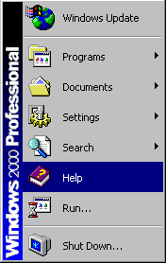
2. On the Start menu, click Help.
Windows 2000 Help appears. You can find topics listed on the Contents tab, look up words on the Index tab, search for text by using the Search tab, and bookmark useful topics using the Favorites tab.

You can also get information about a dialog box by clicking the question-mark button on the title bar and then clicking the dialog box area in question.
Getting Started online version
A copy of this book is available in Windows 2000 Help.
To open the Getting Started book
1. Click the Start button, and then click Help.
2. On the Contents tab, click Introducing Windows 2000 Professional, and then click Getting Started online book.
3. Follow the instructions that appear.

Readme Files
Readme files are supplemental documents containing late-breaking information that was unavailable when this book and Windows 2000 Help were written. The following readme documents are stored on your Windows 2000 CD.

File Contains

Read1st.txt Preinstallation notes vital to a successful installation and information about hardware conflicts and troubleshooting.
Readme.doc Information that supplements the Windows 2000 documentation.
Troubleshooters
Having a problem? Windows 2000 includes a wide range of troubleshooters that help you solve many common computer problems. For instance, if you’re having difficulty setting up a new printer, the Print troubleshooter can walk you through the process step by step.
To open troubleshooters in Windows 2000 Help
1. Click the Start button, and then click Help.
2. On the Contents tab, click Troubleshooting and Maintenance, and then click Use the interactive troubleshooters.

Additional Resources
The following Microsoft resources provide more information about Windows 2000.
Important If you want to visit World Wide Web sites, your computer must be connected to the Internet.
For more information, see “Connecting to the Internet” in Chapter 4.
Microsoft Product Support Services Web Site
Use the Product Support Services Web site to find answers to technical questions about Windows 2000. You just type in your question, and this interactive site gathers the resources most likely to solve your problem, such as technical articles, troubleshooting wizards, and downloadable patches and drivers. You can connect to Product Support Services by clicking the Web Help button in Windows 2000 Help or by visiting the Microsoft Product Support Services Web site at:
http://www.microsoft.com/support/
Windows Update Web Site
After you register your copy of Windows 2000, you can use Windows Update to keep your copy of Windows 2000 up-to-date. To download new system files, drivers, and so on, visit the Microsoft Windows Update Web site at:
http://windowsupdate.microsoft.com/
Software Compatibility Web Site
For the most recent information on compatible and certified programs for Windows 2000 Professional, visit the Microsoft Windows 2000 Professional Web site at:
http://www.microsoft.com/windows/professional/deploy/compatible/
Hardware Compatibility List
For a list of hardware that’s compatible with Windows 2000, you can view the Hardware Compatibility List (HCL) file (\Support\Hcl.txt) that’s included on your Windows 2000 Professional CD. To see the most recent version of this list, visit the Microsoft Web site:
http://www.microsoft.com/hcl
Microsoft Press Books and Kits
Microsoft Press® books and kits provide everything users, technicians, and network administrators need to get the most out of Microsoft products. Many Windows 2000 training resources are available through Microsoft Press.
For more information, visit the Microsoft Press Online Web site at:
http://mspress.microsoft.com/
If You're New to Windows
If you’re not familiar with Windows, it’s easy to get started. The following illustration shows the desktop, the workspace that appears on your screen. You use your desktop for almost any task: opening programs, copying files, connecting to a network or the Internet, reading your e-mail, and so on. What you see on your desktop varies depending on how Windows 2000 is set up on your computer.
For more information, see “What Is the Desktop?” in Chapter 4.
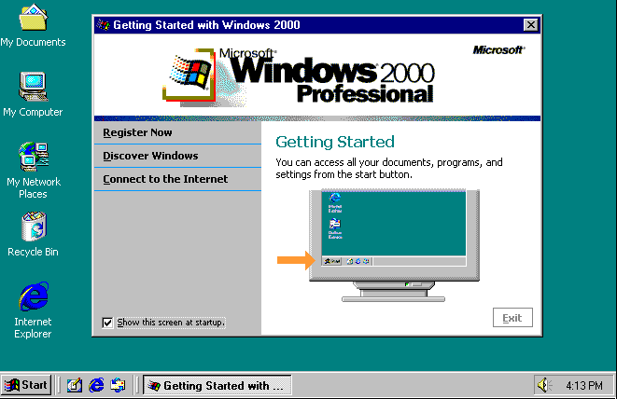
Note If you’re new to computers, you first need to know how to use a mouse. A mouse is the hand-held device that controls the pointer (usually an arrow) on the screen. You use the mouse to move the pointer over—and perform an action on—an item on your screen. The primary mouse button is usually the left button.
This book and Windows 2000 Help use the same terminology—click, double-click, right-click—to refer to actions you can perform using a mouse. Click means press the primary mouse button once, while double-click means rapidly press it twice. Right-click means press the secondary mouse button once.
Windows 2000 Help contains valuable tips and procedures to help you get started, whether you’re new to computers or just new to Windows. If you’re a novice, you should start by reading the topics included in “Introducing Windows 2000 Professional” in Help.
To open new user information in Help
1. Click the Start button, and then click Help.
2. On the Contents tab, click Introducing Windows 2000 Professional.
3. Click Tips for new users.

If You've Used Windows Before
If you’re already working in Windows, the transition to Windows 2000 Professional is smooth. If you upgrade from a previous version of Windows, you’ll retain your system settings, preferences, and programs. You’ll notice significant changes if you’re upgrading from Windows NT 3.51. Program Manager is replaced by the desktop, and all of your programs and system tools are now available from the Start menu. You can now browse through your computer by using My Computer or Windows Explorer, and you can use the taskbar at the bottom of the desktop to easily switch between open windows.
If you’re familiar with Windows 95, Windows 98, or Windows NT 4.0, you’ll immediately notice that some familiar elements have changed. Window toolbars look and act differently, and access to the Web is integrated throughout the operating system. Desktop enhancements include toolbars located conveniently on the taskbar, and two new icons: My Network Places—which replaces Network Neighborhood—and My Documents. Windows 2000 also includes an improved Internet Explorer and a powerful e-mail program, Outlook® Express.
Introducing Windows 2000 Professional
New features and enhanced support in Windows 2000 make it the easiest-to-use Windows operating system yet.
For more detailed information about any feature mentioned in this book, see Windows 2000 Help.
Easier-to-Use Desktop
Changes to the desktop, windows, and the Start menu make Windows 2000 even easier to learn and use.
• Easy-to-use interface. Windows 2000 Professional refines the look and design of the desktop. Improved windows provide quicker access to information, whether it’s on your computer, a network, or the Internet. Wizard improvements help you get through difficult tasks faster. Screen clutter is reduced since only your most frequently used items are displayed on the Start menu. Dialog box improvements help you save time by automatically completing words as you type them and by displaying your most recently used lists.
• Customizable toolbars. Now you can add one or more customizable toolbars to the taskbar for single-click access to the Internet, your desktop, and your favorite programs. For example, you can use the Quick Launch toolbar to open an Internet Explorer window or read your e-mail. Tailor your work environment by adding, removing, or changing the order of buttons.
• Show Desktop button. Switching between open windows and the desktop is easy with the new Show Desktop button, located on the taskbar.
• My Documents and My Pictures folders. My Documents provides a convenient default storage location for personal files and folders. My Documents contains the My Pictures folder, a convenient place for you to store your photos, scanned images, faxes, and bitmaps.
• Multilingual support. Regardless of which language version of Windows 2000 you install, you can write, edit, view, and print content in all supported languages. Windows 2000 detects and installs any necessary fonts or symbols to view multilingual information.
• Accessibility tools. You can use the Accessibility Settings wizard to adapt Windows options to your specific needs and preferences. Magnifier enlarges a portion of the screen for easier viewing, which can be useful for people who have impaired vision. Narrator uses text-to-speech technology to read the contents of the screen. On-Screen Keyboard makes it possible for those with limited dexterity to type by using a pointing device (such as a mouse) or a single-switch input device.

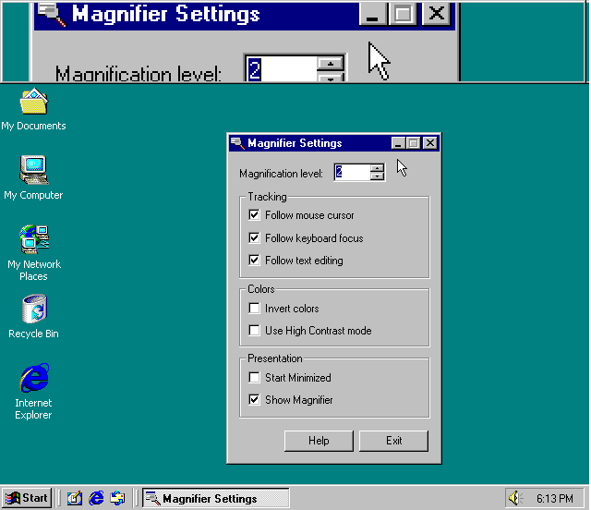
Integration with the Web
Because the Internet is integrated into Windows 2000, you can browse through your computer as effortlessly as you browse through the Web.
• Active Desktop. The Active Desktop™ is a customizable workspace on which you can display both Windows icons and HTML elements. You can also use Active Desktop to post company information such as announcements and meeting reminders.
• Improved browsing capability. Windows 2000 includes Forward and Back toolbar buttons that you use to navigate folders, documents, and Web sites. Through a single interface, you can view local, network, intranet, and Internet resources. Using the single-click option, you can browse through files and folders by clicking once—similar to clicking links on the Web.
• Offline browsing. You can simultaneously disconnect from the Internet and temporarily store the current Web page on your computer. Later, you can read the pages at your leisure, saving you connection time and expense.
• Web pages as window backgrounds. You can use a Web page or other HTML document as a background in individual windows.
• Address bar. You can get to the Internet—or any folder or drive—from any window, or even from the taskbar, by typing an address in the Address bar. As you start typing addresses, they’re automatically completed for you so you can browse more quickly.
• Offline viewing. By making a Web page available for offline viewing, you can schedule Windows 2000 to automatically download the page on a regular basis. This way, you can view the most current page offline at your leisure.
• Streaming media and other advanced technology. You can experience the most advanced technology available on the Web with Windows Media Player, including live, “streaming” media and full support for ActiveX® and other interactive content.

Streamlined Network Connections
Setting up your connections to other computers is simplified, which makes connecting to networks and the Internet even faster. Windows 2000 also supports the latest advancements in high-speed networking, infrared connections, and IP technology. Offline folders and synchronization ensure that you always have access to your current network files and folders.
• Network Connection wizard. The Network Connection wizard guides you through the creation of dial-up connections, virtual private network connections, direct serial connections, and incoming connections.
• Protocols and services for individual connections. Now you can set the necessary protocols and services for each individual connection. You gain greater control over your configurations, cleaner performance, and more streamlined setups.
• Internet Connection wizard. The Internet Connection wizard guides you through setting up an Internet service provider connection and installing any necessary software.
• My Network Places folder. You can use My Network Places to view recently visited network resources and create friendly names for network shares. A wizard helps you quickly map network drives and create shortcuts.
• Offline files and folders. When you’re disconnected from the network, you can still have access to network files, folders, and mapped network drives. Files are synchronized when you reconnect to the network. Using Synchronization Manager, you can make sure your offline files, including Web pages, are automatically updated when your network connection is re-established.

More Powerful Searching
You can easily look for the file or information you want, whether it’s on your computer, on a network, or on the Internet.
• Locate network resources. When you log on to a network running Active Directory, you can quickly find the network resources that you use.
• Search for people. Using the Find People feature, you can search both your local Windows Address Book and Web-based directory services—such as Yahoo!, WhoWhere, and Bigfoot—for a person’s address information.
• Find content on the Internet. By clicking the Search button in a window, you can view a Web page and your search results at the same time. Windows 2000 uses several different search engines for optimized searches.
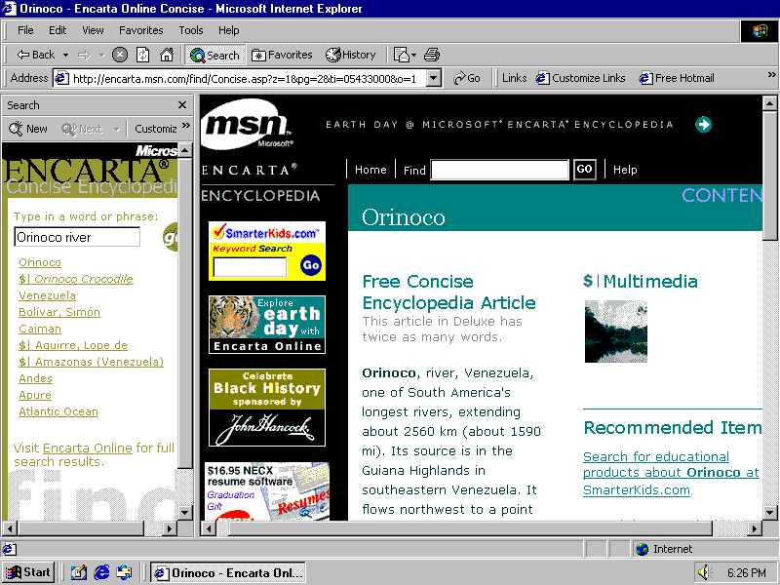

New Ways to Communicate
By using the new features that are built into Windows 2000, you can communicate over the Internet more easily by using various media, such as e-mail, newsgroups, fax, live conferences, video, and Web pages.
• Microsoft Outlook Express. Outlook Express, an e-mail program and newsreader, is included with Windows 2000.
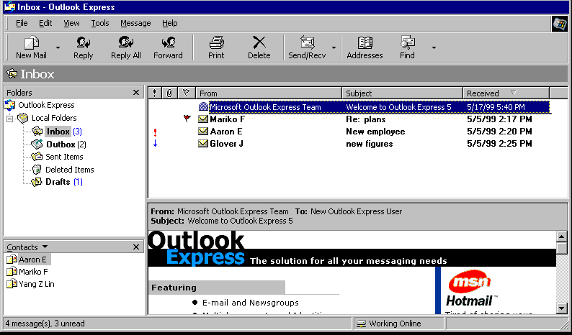
• Fax Service. Several easy-to-use fax tools help you send, receive, monitor, and manage faxes directly from your desktop. You can design your own cover page, route incoming faxes to your Inbox or printer, and send a document as a fax and an e-mail message at the same time.
• NetMeeting. You can use Microsoft NetMeeting® to hold live conferences and collaborate on documents with the participants over the Internet.
• Windows Media Player. Using Windows Media Player, you can bring live, “streaming” multimedia—from simple audio to sophisticated interactive Web-based applications—to your computer.
• Microsoft Telephony. You can use Telephony to send voice and video data over networks or the Internet, giving you the benefits of video conferencing at a low cost.

Improved Printing Support
With Windows 2000, printing is easier and more flexible. Windows 2000 includes support for hundreds of printers and for wireless, infrared printing.
• Internet printing. Using the improved Add Printer wizard, you can access printers over the Internet and through corporate intranets. Through your Internet connection, you can send documents to any printer on a Windows 2000 network. In addition, you can install printer drivers over the Internet and view printing status from your Web browser.
• Image Color Management 2.0. Now you can send high-quality color documents from your computer to your printer or to another computer faster and with greater reliability. New color profiles ensure that the colors you see on your monitor match those on your scanner and printer.
• Improved fonts. Windows 2000 includes a new universal font format, OpenType®, which combines the TrueType® and Type 1 font technologies.

Latest Hardware Innovations
Windows 2000 includes hundreds of new printer, modem, and other hardware drivers, making hardware installation and setup more efficient than ever.
• Add/Remove Hardware wizard. The improved Add/Remove Hardware wizard makes device management easier and faster. The wizard automatically finds and configures hardware and helps you safely add, remove, eject, upgrade, or troubleshoot hardware.
• Plug and Play. Plug and Play technology makes it easy to add new hardware. If you want to install Plug and Play hardware, just plug it into your computer—Windows 2000 automatically configures the device and installs any necessary drivers.
• Universal serial bus (USB). When you attach hardware to a USB port, Windows 2000 automatically detects the new device and installs the necessary drivers without restarting the computer.
• Advanced configuration and power interface (ACPI). On ACPI-compliant computers, Windows 2000 automatically uses the latest in power management features. You can dock and undock your laptop without restarting. The OnNow power-saving utility can put ACPI-compliant computers into a state of “hibernation,” then turn them on when you touch the keyboard. OnNow also reduces drive wear and noise.
• Support for new hardware technology. Windows 2000 supports new hardware standards, including Intel MMX, IEEE 1394, and the DirectX technologies. Using DVD Player, you can play DVDs—high-density discs that can contain much more information than CDs, such as entire movies.
• Multimedia. Windows 2000 supports OpenGL specifications, the 3-D graphics standard used for computer-aided design (CAD) and scientific applications.
• Multiple monitors. You can add monitors and increase the size of your desktop. Using multiple monitors can help you work on several applications at the same time—you can even have different display settings for each monitor.
• Imaging and scanning. Cameras and scanners are easy to install in Windows 2000. You can configure the Scanners and Cameras feature to automatically launch the program of your choice when you scan an image.
• Device Manager. Device Manager makes it easier to configure devices and resources on your computer, reducing administration time and costs.

New Storage, Security, and Compatibility Features
Storage enhancements and security features in Windows 2000 give you more options for storing your information and provide better compatibility with Windows 95 and Windows 98.
• Windows Backup. New Backup and Restore wizards make data protection easier and more reliable. You can now use Windows Backup with a wide variety of storage devices, including tape drives, removable disks, recordable CDs, logical drives, and network drives.
• FAT32 support. For efficient disk space allocation—and compatibility with Windows 95 OSR2 and later systems—Windows 2000 supports the FAT32 file system. By using FAT32, you can format disks larger than 2 gigabytes (GB) as a single drive.
• Disk Defragmenter. You can improve your drive performance by using Disk Defragmenter. Windows 2000 supports defragmentation of FAT, FAT32, or NTFS drives.
• Updated NTFS. The new version of NTFS offers many performance enhancements and a host of new features, such as per-user disk quotas, file encryption, and distributed link tracking. You can also add disk space to an NTFS volume without restarting the computer.
• Universal Disc Format. Windows 2000 adds support for Universal Disc Format, a new file system designed for interchanging information between DVD and CD-ROM media.
• Encrypting File System. An extension to NTFS, the Encrypting File System uses public key technology to encrypt files and folders. You can easily encrypt and decrypt individual files and folders to protect against data theft and ensure privacy.

For Power Users, Network Administrators, and Developers
Windows 2000 offers many advanced features for experienced computer users and network administrators. New tools consolidate administrative tasks, restore user information, and help you work efficiently.
• Administrative Tools. A new Administrative Tools control panel consolidates tools you commonly use to manage administrative tasks for local and remote computers.
• Microsoft Management Console. MMC provides you with a common area for viewing and using all administrative tools available in Windows 2000. Custom tool configurations of MMC consoles can be saved and opened by other users on their computers. You can customize the MMC window to include only the tools you need.
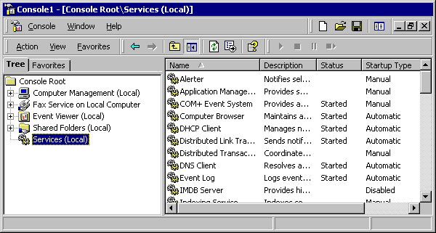
• IntelliMirror. Data management and retrieval are easier and more cost effective with IntelliMirror, which backs up information from workstations to the network, protecting critical files, administrative policies, and users’ computer preferences. This feature is invaluable if your hard disk fails, if you need to reconfigure a computer, or for network administrators. And when you reconnect to the network, your files are synchronized with the network.

