Chapter 4 - Windows Basics

Because there are many ways to set up Windows and do basic tasks, it’s important to know your options and to choose those that best fit your needs. In this chapter, you learn about basic features that help you get your work done, as well as how to explore and customize Windows 2000. You also learn about the Internet and how to get connected by using the Internet Connection wizard.
Contents
What Is the Desktop?
Getting Help
Exploring Your Computer
The Taskbar and the Start Button
My Computer
Windows Explorer
My Network Places
Getting Your Work Done
Working with Programs
Managing Files and Folders
Customizing Your Desktop
Using the Internet and the Web
Connecting to the Internet
Setting Up Your E-Mail Account
Sharing an Internet Connection Between Computers
Shutting Down Your Computer
What Is the Desktop?
The desktop is the area that first appears on the screen after you start Windows 2000. The desktop is your workspace. On the left side of your desktop are icons, small pictures that represent files such as documents, folders, or programs. When you want to open a file, double-click its icon.
Note The procedures in this book describe the double-click method of browsing. Your computer manufacturer may have selected a desktop style that uses the single-click option. If so, point to an icon to select a file, and single-click the icon to open the file.
Depending on how your computer is set up, your icons might be different from those in the illustration.
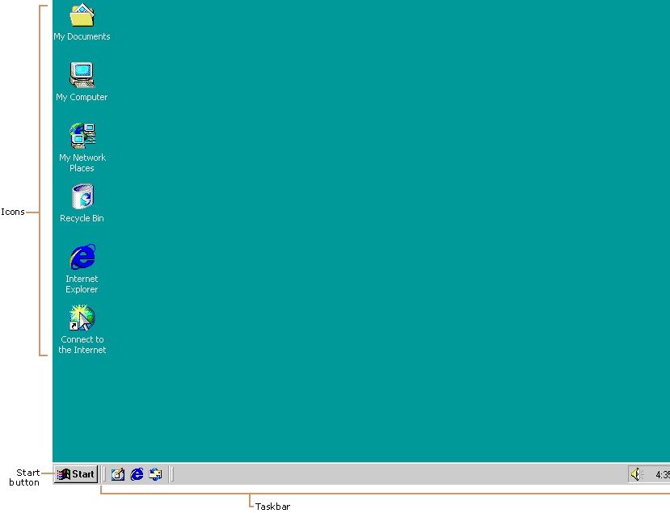
Getting Help
Windows 2000 Help is your principal source of information for learning how to use Windows 2000. Always available from the Start menu, Help describes how to perform a wide variety of tasks—from setting up a printer to connecting to the Internet. Help also contains a glossary, keyboard shortcuts, troubleshooters, an online version of this book, and links to Web-based resources.
To open Windows 2000 Help
1. Click the Start button.
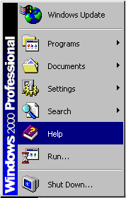
2. On the Start menu, click Help.
Windows 2000 Help appears. You can find topics listed on the Contents tab, look up keywords on the Index tab, and search for text by using the Search tab.

You can also get information about a dialog box by clicking the question mark button on the title bar and then clicking the dialog box area in question.
Exploring Your Computer
You can navigate in Windows 2000 by using the taskbar (including the Start button), My Computer, Windows Explorer, or My Network Places. In some cases, one way is more efficient than another. For example, it’s faster to start programs from the Start button than from Windows Explorer, but Windows Explorer gives you a more complete picture of all of the files on your computer. In other cases, the choice is personal preference. When browsing through folders (containers for documents and programs), for instance, you can use either My Computer or Windows Explorer—it’s a matter of how you prefer to display the contents of your computer. The following sections familiarize you with some of your choices.
The Taskbar and the Start Button
You can use the taskbar and the Start button, which usually appear at the bottom of your screen, to navigate in Windows 2000. Both features are always available on your desktop, regardless of how many windows you have open.
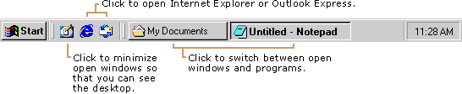
Buttons on the taskbar show you which windows and programs are open, even when some are minimized or hidden beneath another window. You can easily switch to a different window or program by clicking its taskbar button.
For more information, see “Customizing the Taskbar,” later in this chapter.
If you’re upgrading from Windows NT version 3.51, you’ll notice that your program groups now appear on the Start menu.
The Start button displays a list of commands and shortcuts (pointers to files) that you can use to accomplish almost any task. You can start programs, open documents, customize your system, get Help, search for items on your computer, and more. Some items on the Start menu have a right-facing arrow, which means that additional choices are available on a secondary menu, called a submenu. When you place your pointer over an item with an arrow, a submenu appears.
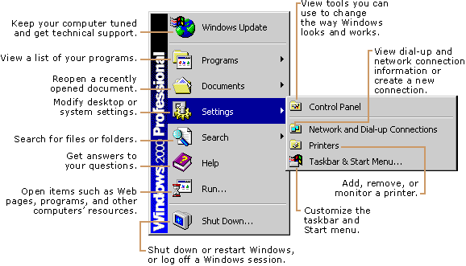
For more information, see “Customizing the Start Menu,” later in this chapter.
My Computer
Use My Computer when you want to view the contents of a single folder or disk. A disk is a device, such as a hard disk or floppy disk, on which you can store files. When you double-click My Computer on your desktop, icons representing the available drives appear in a new window. When you double-click a drive icon, a window displays the folders contained on that drive. You can then double-click an icon to open the folder or file.
Some of the following icons may appear in the My Computer window.

Double-click To

View the contents of the floppy disk, which is usually designated as A.
View the contents of the hard disk, which is usually designated as C.
View the contents of a network drive, if your computer is connected to one.
View the contents of a compact disc in the CD-ROM drive, if your computer has one.
View features you can use to modify your computer settings.
Set up a printer and view information about available printers and print job status.
Schedule or view tasks for computer maintenance.
View the contents of a folder.
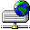 View files and folders on a Web server, if your computer is connected to one.
Windows Explorer
If you prefer to see files in a hierarchical structure (similar to a family tree), you’ll like using Windows Explorer. Instead of opening disks and folders in separate windows, you can browse through them in a single window. The left pane of the Windows Explorer window contains a list of your disks and folders, and the right pane displays the contents of the selected folder. You can use the View menu to change how the icons in the right pane appear.
To use Windows Explorer to view the contents of your local (hard) disk
1. Click the Start button, point to Programs, point to Accessories, and then click Windows Explorer.
2. In the left pane, click the plus sign next to My Computer, then the plus sign next to your local disk.
The contents of your hard disk appear in the right pane.
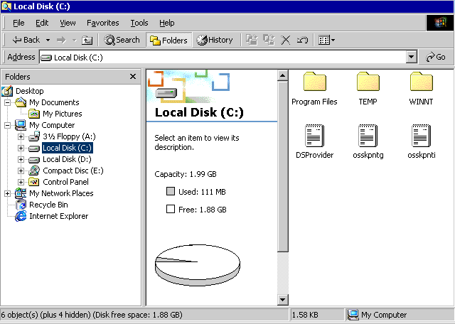

My Network Places
A network is a group of computers connected to one another so that they can share resources such as files and printers. If your computer is connected to a network, you can use My Network Places to browse network resources the same way you browse the contents of your own computer. When you double-click My Network Places on your desktop, icons representing network resources appear in a window.
Some of the following icons may appear in My Network Places.

Double-click To

Create a shortcut to a specific network location. Runs the Add Network Place wizard, which helps you create a connection to a shared folder, a Web folder on the Internet, or a FTP site.For more information, see “Working with Frequently Used Files,” later in this chapter.
Display all of the computers, printers, files and folders, and people on your organization’s network.
Display only those computers in your domain or workgroup.
To open network resources
1. On the desktop, double-click My Network Places.
2. If you want to browse shared resources in your workgroup, double-click Computers Near Me. The computers and resources in your workgroup appear.
If you want to view all of the resources available on the network, double-click Entire Network. Depending on how your network is set up, you may see computers arranged by domain or by workgroup.
3. Double-click the item you want to open, just as you would open drives and folders on your own computer.

Getting Your Work Done
Now that you’re familiar with the desktop and the different methods of navigating, you’re ready to learn how to perform everyday tasks, such as starting programs and managing your files.
Working with Programs
Windows 2000 makes it easy for you to add, remove, start, and quit your favorite programs.
Adding and Removing Programs
You can quickly add programs, such as a word processing program or game, by using Add/Remove Programs in Control Panel.
To add or remove a program
1. Click the Start button, point to Settings, and then click Control Panel.
2. Double-click Add/Remove Programs.
Add/Remove Programs opens.
3. Click Change or Remove Programs or Add New Programs, and then follow the instructions that appear.

Note You can also add and remove Windows components by clicking Add/Remove Windows Components in Add/Remove Programs and then following the instructions that appear.
Starting and Quitting Programs
Most of the programs installed on your computer are available from one convenient location—the Programs section of the Start menu. Depending on how your computer is set up, what you see on the Start menu varies.
For information about changing the Start menu, see “Customizing the Start Menu,” later in this chapter.
To start a program
1. Click the Start button, and then point to Programs.
The Programs menu appears.
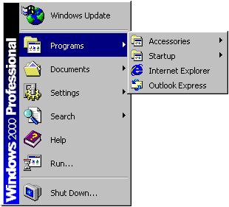
2. Point to the group (such as Accessories) that contains the program you want to start, and then click the program name.

To quit a program
• Click the Close button in the upper-right corner of the program window.
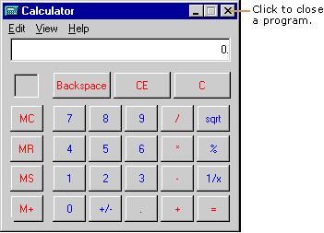

Managing Files and Folders
File names in Windows 2000 can be up to 255 characters, including spaces, but can’t contain any of the following characters:
\ / : * ? ” < > |
When you add a program or use a program and save your work, you create a file. For example, the Microsoft Word program is a file, and every document you create with Word is also a file. You can better organize your files by storing them in folders. For example, you may want to create a folder for each of your projects and keep files associated with the projects, such as documents and saved e-mails, in those folders. You can also move, rename, and delete files and folders.
For more information about using files and folders, see Windows 2000 Help.
Working with Frequently Used Files
For easy access to files and folders that you use frequently, you can create shortcuts to them. A shortcut doesn’t change the location of a file or folder, nor is it a copy—it’s a pointer you use to open the file or folder quickly. Deleting, moving, or renaming the shortcut doesn’t affect the original item.
To create a shortcut to a file
• Right-click the file, and then click Create Shortcut.

Another quick-access feature of the Start menu is Documents, which contains shortcuts to documents you’ve used recently.
Searching for Files and Folders
You can also search for computers, people, and Internet sites.
You can store files and folders in many locations—on the hard disk, a network drive, a floppy disk, and so on. To quickly locate them in any of these locations, use the Search command on the Start menu.
To search for a file or folder
1. Click the Start button, point to Search, and then click For Files or Folders.
2. Type the name of the file or folder for which you want to search, and then click Search Now.

Customizing Your Desktop
You can customize your desktop in a variety of ways. For example, you can:
• Use the features in Control Panel to customize your computer.
• Create and customize toolbars on the taskbar.
• Customize the Start menu by adding, reorganizing, and deleting shortcuts.
• Change the appearance and function of your desktop and windows. For example, you can use a Web page as a background on your desktop and in individual windows.

Using Control Panel
Control Panel is a convenient way to customize your computer. From Control Panel you can add and remove programs, fonts, and hardware; control how hardware, such as your mouse and modem, behaves; and select folder, display, and sound options.
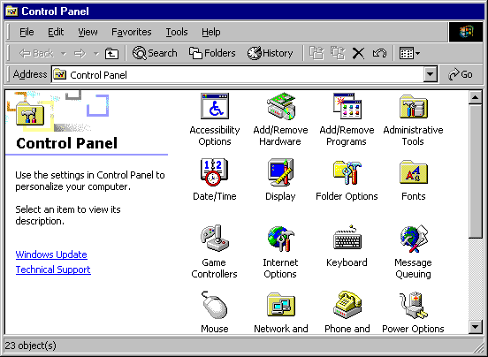
To open a Control Panel item
1. Click the Start button, point to Settings, and then click Control Panel.
2. Double-click the icon of the feature you want to open.

Choosing Folder Options
Use Folder Options in Control Panel to change how your desktop appears and how you browse through your files and folders. You can choose Web-style options, keep familiar options from earlier versions of Windows, or choose a combination of both.
You can use Folder Options to choose whether:
• The Active Desktop is on or off.
• Web-like content appears in folders.
• You browse folder content in multiple windows or a single window.
• You double-click or single-click to open files.

For more information about changing your folder options, see Windows 2000 Help.
To change your folder options
You can also double-click My Computer, and then on the Tools menu, click Folder Options.
1. Click the Start button, point to Settings, and then click Control Panel.
Control Panel appears.
2. Double-click the Folder Options icon.
The Folder Options dialog box appears.
3. On the General tab, click the folder options you want, and then click OK.

Customizing the Start Menu
You can customize the Start menu to help you work more efficiently. You can add shortcuts to folders or files that you open frequently, and you can create your own groups of files and programs. You can also remove items from the Start menu. Because the Start menu is a collection of shortcuts, removing a program from it doesn’t uninstall or remove the program from your computer.
To customize the Start menu
1. Click the Start button, point to Settings, and then click Taskbar & Start Menu.
The Taskbar and Start Menu Properties dialog box appears.
2. Click the Advanced tab.
3. Click the Add or Remove button, and then follow the instructions that appear.

Note You can also add items to the Start menu by dragging a file, folder, or program from a window or the desktop to the Start button. A shortcut to the item is automatically added at the top of the Start menu.
Customizing the Taskbar
The taskbar is located at the bottom of the desktop by default, but you can drag it to any edge of the desktop. You can also widen or narrow the taskbar. By changing the taskbar properties, you can hide the taskbar until you want to use it, or you can choose to display it always on top of other windows.
To move the taskbar
• Drag the taskbar to any edge of the desktop.

To widen or narrow the taskbar
• Move your pointer to the inside edge of the taskbar. When the pointer changes to a two-headed arrow, drag to change the taskbar width.

To change taskbar options
1. Click the Start button, point to Settings, and then click Taskbar & Start Menu.
The Taskbar and Start Menu Properties dialog box appears.
2. On the General tab, select the taskbar options you want, and then click OK.

Using Taskbar Toolbars
The power of the taskbar is in its flexible toolbars, which you can use to make common tasks faster and easier. The Quick Launch toolbar appears by default, and you can hide and show other toolbars as you need them. Some useful toolbars include:
• Address toolbar. Use this toolbar to type the path to a file. If you have Internet access, you can also type a Web page address to automatically open Internet Explorer and view that Web page.

• Links toolbar. Use the shortcuts on this customizable toolbar to quickly open a Web site. Add shortcuts to your favorite Web sites by dragging the link icon from the Address bar to the Links toolbar. You can also drag link icons from Web pages, the Favorites bar, or your desktop. Or you can drag shortcuts onto this toolbar.

• Desktop toolbar. Use this toolbar to quickly open desktop items such as My Computer and My Network Places, even if they’re underneath open windows.

• Quick Launch toolbar. Use this customizable toolbar to quickly open programs and files. Several shortcuts appear on the toolbar by default, but you can add additional shortcuts by dragging an icon onto the toolbar.

To show or hide a toolbar
• Right-click the taskbar, point to Toolbars, and then click the toolbar you want to hide or show.

Using the Internet and the Web
The Internet is essentially a large number of connected computers. A computer on the Internet can be located anywhere in the world, so you can communicate with someone over the Internet no matter where that person lives. The Internet offers several different types of information, including e-mail, newsgroups, and the World Wide Web.
Information on the Web is presented in the form of Web pages that can include text, graphics, movies, music, and animation and can be linked to other Web pages. Web pages are created in Hypertext Markup Language (HTML), and you have to use a program called a Web browser to view them. The Web browser interprets the HTML files and then formats and displays them as the Web pages you see on your screen.
Connecting to the Internet
By using the Internet Connection wizard, you can quickly set up an Internet account and connection. To use the Internet, you need a modem and a phone line or your computer has to be connected to a network. If you’re connecting by using a modem, you need to sign up with an Internet service provider or an online service. An Internet service provider (ISP) is a company that provides Internet connections. An online service—a subcategory of ISPs—provides the Internet connection and many additional services. Well-known online services include MSN™ Internet Access and America Online.
If your computer isn’t already connected to the Internet, the Connect to the Internet icon appears on your desktop. You can start the Internet Connection wizard by double-clicking the Connect to the Internet icon, or you can use the following procedure.
To start the Internet Connection wizard
• Click the Start button, point to Programs, point to Accessories, point to Communications, and then click Internet Connection Wizard.
The Internet Connection wizard appears.

Important You may be prompted to restart your computer during the Internet connection process, so save and close any open documents before you proceed.
Selecting Options in the Internet Connection Wizard
The Internet Connection wizard asks you to make some selections and provide certain information. The following sections describe the information required for each connection type.
Connecting Through a Modem
If you’re connecting to the Internet using a modem and an ISP, the following tables describe the information you’ll need to provide during Internet setup. Your ISP should be able to supply most of the listed information.
For a new Internet account

This information Is needed for

The ISP you want to use Choosing an ISP
Your address and billing information Payment for your ISP account
For an existing Internet account

This information Is needed for

The ISP you want to use Connecting to your ISP
Your e-mail or user name and password Logging on to your account
The Internet Connection wizard lists common ISPs. If your ISP isn’t listed, you might also need the information in the following table.

Information Needed for

ISP dial-in phone number Connecting to your ISP
Advanced settings such as the Internet Protocol (IP) or IP address An ISP that requires you to change these settings
E-mail address, the server type your ISP uses (POP3 or IMAP), the names of the servers that process your incoming mail and outgoing mail, whether your ISP requires Secure Password Authentication E-mail
Connecting Through a Network
If you’re connecting to the Internet through a local area network (LAN) or wide area network (WAN), your network administrator can supply the following information.

Information Needed for

Name of the proxy server and any proxy server exceptions Connecting to the Internet using a LAN that uses a proxy server
Connection name, user name, and password Logging on to a network
E-mail address, the server type your network uses (POP3 or IMAP), and the names of the servers that process your incoming mail and outgoing mail E-mail
Setting Up Your E-Mail Account
If you choose to set up an e-mail account in the Internet Connection wizard, you can use Outlook Express to send and receive e-mail over the Internet. If you already have e-mail, you don’t need to switch to Outlook Express. Switching converts all of your current mail options to work with Outlook Express.
After you set up Outlook Express, just double-click the Outlook Express icon on the taskbar to begin sending and receiving e-mail.
Exploring the Internet
When you use Internet Explorer, you don’t have to type http:// before the beginning of a Web address.
You can browse Web pages—or “surf the Net”—in several ways. You can open any Web page by typing its address in the Address box of your Web browsing software. And when you’re viewing a Web page, you can navigate the Internet by clicking links—underlined text or special pictures that, when clicked, cause you to go to another Web page. When you move the mouse pointer over a link, the mouse pointer changes to a hand. When you click a link, another Web page appears.
Sharing an Internet Connection Between Computers
With Windows 2000, you can connect several computers to the Internet through one connection. For example, you may have a home network that connects to the Internet through a dial-up connection. By using Internet connection sharing, several family members can connect to the Internet on different computers, individually or at the same time, using only one phone line.
Each connected computer has the ability to use virtually any of the Internet services it could normally access if connected directly. This includes activities like Internet browsing, e-mail, multiplayer gaming, and chat sessions, to name a few.
For more information about Internet connection sharing, see Windows 2000 Help.
Shutting Down Your Computer
When you finish working in Windows, use the Shut Down command on the Start menu. This command closes windows and programs and prepares your computer for shutting down. If you haven’t already saved your work, you’re prompted to do so.
For more information about shutting down your computer, see Windows 2000 Help.
Important Don’t turn off your computer until you see a message that the computer has been shut down. If you turn off your computer without shutting it down correctly, you risk losing information.
To shut down your computer
1. Click the Start button, and then click Shut Down.
2. Click the What do you want the computer to do? down arrow, select Shut down, and then click OK.
If your computer doesn’t turn off automatically, a message appears after a few moments telling you when you can safely turn off your computer.

