Chapter 14 - Printing

Printing is easier to use in Microsoft® Windows® 2000 and produces more consistent, higher quality results. Microsoft® Windows® 2000 Professional provides several ways to install, configure, and manage printers, each way designed to make the process more intuitive and efficient. Printing now also includes improved ways to send print jobs, including over the Internet or by using new port monitors. Most of the improvements to the Windows 2000 printing system are not obvious in the user interface, but these improvements are seen in improved performance, compatibility, and the use of automated wizards.
In This Chapter
Quick Guide to Printing
What’s New
Finding Printers
Installing Printers
Configuring Printers
Creating and Sending Print Jobs
Monitoring and Managing Print Jobs
Printer Pooling
Printing Concepts
Troubleshooting Printing Problems
Related Information in the Windows 2000 Professional Resource Kit
• For more information about setting permissions, see “Security” in this book. Permissions regulate printer access.
• For more information about determining a printer’s location, see “TCP/IP in Windows 2000 Professional” in this book.
• For more information about Plug and Play technology, see “Device Management” in this book.
• For more information about Integrated Color Management, see “Scanners and Cameras” in this book.

Quick Guide to Printing
Use this quick guide to locate information about printing. You will find information about finding, installing, configuring, using, and managing your printers, as well as detailed information about troubleshooting printing problems.
Find a printer.
Finding printers that are directly connected to your computer is easy, but finding the right network printing device can be challenging. Windows 2000 helps you find printers based on printer attributes.
• See “Finding Printers” later in this chapter.

Install a printer.
For printers to work properly, your computer must have the proper drivers and the printer must be registered with your computer. Windows 2000 offers many ways to install a printer, emphasizing automating as many of parts of the process as possible.
• See “Installing Printers” later in this chapter.

Configure your installed printer or fax.
You can establish default behavior for a printer or fax you have installed. Some common configuration options for printers include selecting whether to print in landscape or portrait, what size paper to use, and when the printer is available. For faxes, you can set the fax cover sheet to be used and the time that jobs must be sent.
• See “Configuring Printers” later in this chapter.

Send a print job.
There are new ways to print a document when using Windows 2000. Learn about the new print options and how you can use them to improve your printing process and output. Enhancements include a reworked Print dialog box, enhanced color printing, enhanced UniDriver and PostScript drivers, and the Standard Port Monitor.
• See “Creating and Sending Print Jobs” later in this chapter.

Monitor and manage printers and print jobs.
Depending on your privileges, you can choose to implement security for printers, establish times when the printer can be used, establish priority for users whose print jobs must print before everyone else’s, and manage some or all of the print jobs that have been sent to a printer.
• See “Monitoring and Managing Print Jobs” later in this chapter.

Troubleshoot printers.
Solve problems that arise with your printers.
• See “Troubleshooting” later in this chapter.

What's New
Windows 2000 Professional includes new features that make it easier to install, configure, and use printers. Tables 14.1 through 14.4 show the difference between features in Windows 2000 and Microsoft® Windows NT® version 4.0, Microsoft® Windows® 95, and Microsoft® Windows® 98.
Table 14.1 Printer Installation Features

Windows 2000 Windows NT 4.0 Windows 95 and Windows 98

Find a printer by entering the printer name (UNC), browsing the network, or typing a printer URL for printers with known locations. Find printers by using Search for Printers or Active Directory. Find a printer by entering the printer name (UNC) or browse the network to find the printer. Same as Windows NT 4.0.
Add network printers by using the Add Printer wizard or Point and Print. Point and Print automatically downloads and installs required printer drivers on the client computer. Add a network printer by using the Add Printer wizard. Point and Print enables printing and installs drivers. Add network printers by using the Add Printer wizard or using Point and Print. Point and Print automatically downloads printer drivers.
Add a local printer by using Plug and Play if supported by the printer or use the Add Printer wizard. You can prompt Windows 2000 to detect Plug and Play printers that use parallel connections using the Add Printer wizard. Add a local printer by using the Add Printer wizard. No Plug and Play. Add a local printer by using Plug and Play if supported by the printer or use the Add Printer wizard.
Point and Print available by right-clicking a printer in My Network Places, and then clicking Connect. All necessary drivers are automatically downloaded. All other Point and Print techniques available for Windows 98 are still supported. Connect to network printers by using the Add Printer wizard. Connect to network printers in My Network Places by using Point and Print, by entering the printer’s UNC path in the printer wizard, typing the print server’s path in the Run dialog box, or by opening the print queue using My Network Places or Windows Explorer.
Table 14.2 Printer Configuration Features

Windows 2000 Windows NT 4.0 Windows 95 and Windows 98

Printer settings configured by using Printing Preferences. Printer settings configured by using Document Defaults. Same as Windows NT 4.0.
Print preferences configured by using the Layout or Paper/Quality tabs. Print preferences configured by clicking Properties in the Print dialog box. Same as Windows NT 4.0.
Printer properties allow each user to set a unique set of persistent properties. Default Printer properties are set by the printer administrator and appear each time a user logs on. Printer properties are not persistent per user, so users must reapply printer settings each time they print. Same as Windows NT 4.0.
Table 14.3 Creating and Sending Print Jobs

Windows 2000 Windows NT 4.0 Windows 95 and Windows 98

Same as previous versions, plus allows Internet printing by using IPP v1.0 over HTTP connection. Allows for authentication before using printers. Supports network printing over a LAN by using RPC, TCP/IP using Lprmon, and a variety of print port monitors for proprietary systems. Supports network printing over a LAN by using RPC, TCP/IP using LPR, and a variety of port print monitors for proprietary systems.
Same as Windows 98, but can also drag the file to be printed to a printer shortcut on your desktop. You can send print jobs in the following ways:• Right-click the file to be printed, point to Send to, and then click the printer’s shortcut.• Right-click the file, and then click Print.• Select Print from the File menu of the document’s associated application. Same as Windows NT 4.0. You can also create a shortcut for a printer in the Send To folder in your user profile.
UniDriver enhanced to provide font subsetting, better performance, and better handling of 2-byte fonts. Universal driver exists, but without the optimization enhancements of the PostScript and UniDriver of Windows 2000. Universal driver exists, but without the optimization enhancements of the PostScript and UniDriver of Windows 2000.
Supports Image Color Management (ICM) 2.0 which is improved with more color space profiles. ICM not available. Windows 95: ICM 1.0 available.Windows 98: ICM 2.0 available.
Internet Protocol (IP) printing is handled by the Standard TCP/IP Port Monitor. LPR is still available. IP printing is handled by Line Printer Remote/Line Printer Daemon (LPR/LPD). IP printing is not supported.
Table 14.4 Printing Management Features

Windows 2000 Windows NT 4.0 Windows 95 and Windows 98

Same as Windows NT 4.0, but information is also available by holding the mouse pointer over printer icons. Double-click the printer icon to see the queue and view printing status. Same as Windows NT 4.0.
New and improved technologies available with Windows 2000 Professional are highlighted in the following section.
Enhanced Add Printer wizard The enhanced Add Printer wizard provides easier installation and use of a wider range of printers. The Add Printer wizard uses Active Directory™ directory service, allowing users to easily search for printers. Using Active Directory, administrators can assign users to groups that have access to certain printers, such as those in a specific locale or with specific features. This tailors the available printer list to the needs of the user and makes installing printers simpler.
Point and Print Point and Print allows users to initiate a connection to a network printer and loads any required drivers onto the user’s computer. When users know which network printer they want to use, Point and Print greatly simplifies the installation process.
Flexible, powerful network printer management Windows 2000 supports specific, detailed printer management. For example, users in an organization’s art department can be added to a group with permissions to access to a color printer, or users in Seattle can be added to a group with access to printers in Seattle, but without access to printers located elsewhere. By establishing user groups, you determine who can use certain printers and designate the security and authentication schemes required to access those resources.
Image Color Management (ICM) 2.0 ICM 2.0 ensures that colors appear as expected. Colors are accurately maintained, regardless of source, storage format, or output.
Internet printing Internet printing enables printing throughout the world by using the Internet Printing Protocol (IPP) version 1.0.
Improved bidirectional communication Bidirectional communication allows hardware devices to actively notify clients of problems such as paper jams or errors.
IEEE 1284.4 (DOT4) support DOT4 support for multi-function peripherals (MFPs) transparently provides more efficient device use.
Wider printer support Windows 2000 supports thousands of printers.
Fax printing Windows 2000 enables sending faxes through your fax modem.
Finding Printers
A networked printer can be used by many people and allows for better resource management and flexibility. With these benefits comes the challenge of finding a printer, which is much more difficult when it is not directly connected to your computer.
When printing over a Windows 2000-based network, you can choose between printers within your local area network (LAN) and printers available on the Internet.
The Find Printer wizard supports searching Active Directory, and the Add Printer wizard supports adding Internet printers.
Active Directory allows searching on a range of printer attributes to find a printer that meets your particular needs. If subnets are being used to define sites within your organization, Active Directory can find printers that are located near the user. This is a significant advancement, because finding the closest printer has long plagued both administrators and users.
To search for nearby printers
1. From the Start menu, point to Search, and then click For Printers.
2. In Location, type part or all of a printer location, based on the syntax that administrators have implemented for describing printer location in Active Directory, and then click Find Now.
For example, if you are in Los Angeles and you want to find all printers in your deployment in the city, type “US/LAX” in Location, assuming this fits with the printer location syntax used for describing printer locations in Active Directory. This might return results such as:
• US/LAX/1/101
• US/LAX/2/103

This would indicate that there are two printers available in Los Angeles. These results could indicate the printers are in buildings 1 and 2 and in rooms 101 and 103, if that matched the syntax that administrators applied.

Printer Locations and Active Directory
Active Directory can be used to find printers in two ways. First, you can search specific fields in the Active Directory for printers with properties you want. For example, you can search the location field to find a printer that had a specific location you want, such as New York. Second, you can use Active Directory to find printers that are well-connected to you, which typically includes those printers in your subnet. Subnets are used by Active Directory to establish areas of good connectivity, which typically means areas that are physically close. Note that good connectivity does not always mean physically close, but it typically does.
Searching Active Directory Fields
When searching for printers in large environments, you might need to use a specific format to find a printer in the location you want. Specific formats can be achieved by using a standardized format for the Location attribute of each printer, or by extending Active Directory to accommodate specific location information. Because the Location field allows for approximately 250 characters, printer locations can be described in numerous ways. For example, a printer in New York City, in Building 3, on Floor 5 can take a number of formats including:
• New York/Building 3/Floor 5
• NYC/Bldg III/Fifth floor
• NY/B3/F5

Understanding how printer location is formatted in Active Directory helps users to create searches that are more likely to yield useful results.
To search for printers with specific characteristics
1. Double-click My Computer, click Search in the toolbar, and then click Printers in the Search window.
2. Click the Features tab to search using a prepared set of criteria. Use Features to create searches for printers using a predefined set of commonly sought features.
– Or –
Click the Advanced tab to access advanced search options. Use Advanced to search Active Directory using Boolean operators. You can construct complex searches based on any available criteria.
3. Enter your search criteria, and then click Find Now.

Active Directory returns a list of all printers that match your query. Note that when a printer has characteristics other than those listed in Active Directory, you can receive misleading search results.
Searching Active Directory Locations
You can search Active Directory locations, but to make this effective enable the following technologies:
• Location tracking enabled by Group Policy for your organization.
• A standardized location naming convention that is assigned to each site, subnet, or computer object.
• Sites based on a subnet or subnets.

If these technologies are in place, you can quickly find printers in your location.
To search for printers using Active Directory locations
1. Double-click My Computer, click Search in the toolbar, and then click Printers in the Search window.
2. If your deployment uses location, your current location is automatically entered in the Location field. You can also click Browse to select an alternate location to find printers in other locations.
3. Enter other search criteria, if you have any, and then click Find Now. Active Directory returns a list of all printers that match your query. Other search criteria you might enter can include Printer Name or Model. For more information about general searching, see “Searching Active Directory Fields” earlier in this chapter.

To establish a system in which your users can search for nearby printers using subnets, your deployment must have the following:
• A directory service with more than one subnet.
• A network IP addressing scheme that roughly matches the physical layout of your enterprise.
• One or many subnet objects for each site. Create subnet objects and manage sites using Active Directory Sites and Services which is included with Microsoft® Windows® 2000 Server.

Your deployment can also use an extended schema, although in most cases, you should use location tracking rather than extend the schema. All objects in Active Directory have a base set of attributes, but this base set can be extended to accommodate the particular needs of your environment. If using an extended schema, users must construct Boolean searches using the Advanced tab in the Search dialog box. The Advanced tab provides the set of available Boolean operators and possible choices, when there is a limited set, such as when choosing the attribute of an Active Directory object on which to search.
Although using location tracking is typically an effective solution, as a last resort, administrators might extend the schema to include attributes such as Printer City, Printer Building, or Printer Floor. Early planning concerning how printer location is described in Active Directory will save you time later.
For more information about location tracking, see “Searching Active Directory Locations” in this chapter. For more information about setting up location tracking using sites on a Windows 2000 Server, see Windows 2000 Server Help.
Other Ways to Find Printers
You can also connect to network printers by entering their printer name (UNC) or URL. Using URLs to access printers is new to Windows 2000 and is dependent on Internet printing. You must know the UNC or URL of the printer to which you want to connect.
Plug and Play makes installing a local printer easier and is provided with Windows 2000 Professional. Finding Plug and Play printers typically is not difficult, because they must be physically plugged into your computer. For more information about installing local printers, see “Installing Local Printers” later in this chapter.
Installing Printers
Windows 2000 installs and configures printers in a several ways.
Support for Plug and Play printer devices makes it easier than ever to install printers that are attached directly to your computer. Simply attach the printer to the computer, and Windows 2000 automatically starts the Add Printer wizard. When installing printers over a network, Active Directory makes it easier to locate printers based on a range of criteria, such as the printer location or the printer’s color and resolution capabilities.
Installation using Point and Print automatically downloads all required printer drivers, making installing a printer as easy as opening the print server’s print queue by using My Network Places or Windows Explorer. After a print server is configured to support printers and to provide drivers to clients, users do not need to know which driver is required for the printer, or how to install the required drivers; Windows 2000 takes care of these issues for them.
If your printer and printer drivers support bidirectional communication, the device can actively report errors. If the printer is jammed or out of paper, Windows 2000 lets you know.
Installing Network Printers
There are several different ways to install network printers. Use the one that is most convenient for you.
Point and Print
Point and Print allows users to install a printer over a network. A user points to a print server by either opening its print queue by using My Network Places, by typing its path name in the Run dialog box on the Start menu, or by starting the Add Printer wizard. Windows 2000 receives printer-specific information from the server that can include:
• Printer driver files.
• The name of the server on which printer driver files are stored.
• Printer model information, which specifies which printer driver to retrieve from the Windows directory on a local computer or on the network.

To install a printer by using Point and Print
1. Open a Network print server, then open the print server’s Printers folder.
2. Right-click the printer to which you want to connect, and then click Connect.

Add Printer Wizard
The Add Printer wizard walks you through the steps necessary to install a printer.
To install a network printer by using the Add Printer wizard
1. From the Start menu, point to Settings, and then click Printers.
2. Double-click Add Printer, and then follow the instructions.

Enter Printer UNCs or URLs at the Run Dialog Box
If you know the name (UNC) or the URL of the printer you want to install, this option allows for a fast, direct installation.
To install a printer by using the Run dialog box
1. From the Start menu, click Run.
2. Type the UNC or URL of the printer, and then click OK.

Internet Printers
When planning to connect an Internet printer, you can view all printers available on a Microsoft Internet print server. To view these printers, enter the Internet print server’s URL in Internet Explorer. Figure 14.1 is an example of a list of printers available on an Internet print server.
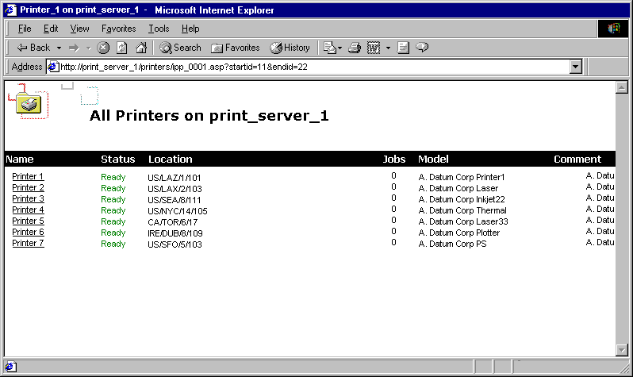
Figure 14.1 Printers Available on an Internet Print Server
For more information about any printer available on a Microsoft Internet print server, click the printer’s name. This displays a page with information that can include:
• Printer model
• Location
• Comment
• Network name
• Documents in the queue
• Maximum speed
• Whether color is supported
• Whether duplexing is available
• Maximum resolution

Figure 14.2 is an example of a Web page you might find with information about a specific printer.
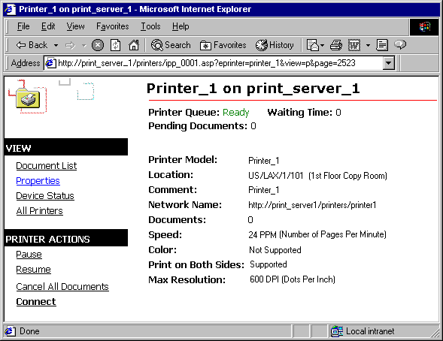
Figure 14.2 Information About a Printer on an Internet Print Server
To install an Internet printer by using the Connect button
1. Open Internet Explorer.
2. Type the print server’s URL in Address (for example, http://servername/printers), and then click Go.
3. Select the printer to which you want to connect, and then click Connect.

Installing Local Printers
There are several ways to install local printers. Use the one that is most convenient for you.
Add Printer Wizard
The Add Printer wizard facilitates printer setup. If you have connected a Plug and Play printer to your computer but it has not been automatically detected, you might want to use the Add Printer wizard to begin the installation process.
To install a local printer by using the Add Printer wizard
1. From the Start menu, point to Settings, and then click Printers.
2. Double-click Add Printer, and then follow the instructions.

Plug and Play Printers
Plug and Play is a set of specifications that allows a computer to automatically detect and configure a printer and install the appropriate drivers. This installation technique is only available for printers connected directly to your computer, and is not available for networked printers.
To initiate Plug and Play printer installation, plug your printer into your computer. The printer is automatically configured in most cases. Plug and Play automatically installs the appropriate drivers and does not require you to restart your computer. If a Plug and Play printer is not automatically installed, you can manually make your computer check for Plug and Play printers by using the Add Printer wizard or by using Device Manager.
Although Windows 2000 includes drivers for many popular printers, if your printer uses a driver that is not included with Windows 2000, you will need to provide the driver. For automatically detected Plug and Play printers, if your computer does not have right driver, you are prompted to provide it.
Most Plug and Play printers use USB or parallel connections.
Automatic Detection
When supported by the printer, Windows 2000 automatically detects printers and completes the entire printer installation process, including installing the proper drivers, updating the system, and allocating resources. No user intervention or restarting is required and the printer is ready to be used immediately.
All automatically detected Plug and Play printers use Universal Serial Bus (USB) connections, Institute of Electrical and Electronics Engineers (IEEE) 1394 cables, or Infrared Data Association (IrDA) transmission.
Manual Detection
Manually-detected Plug and Play is similar to automatically-detected Plug and Play in that Windows 2000 automatically completes printer installation, but you must restart your computer to prompt the automatic installation or use the Add Hardware wizard to prompt your computer to detect the printer. Upon restarting or prompting by using the Add Hardware wizard, Windows 2000 updates your computer, allocates resources, and installs drivers. If drivers for the printer are not available, you are prompted to provide them.
Manually-detected Plug and Play printers typically use parallel or serial cables.
For more information about Plug and Play, see “Device Management” in this book.
Installing Faxes
Fax modems are automatically detected by Windows 2000, but it is recommended that you refer to the documentation provided with your fax modem for information about any other steps you must take to install your fax modem. When a fax modem is connected to your computer, Windows 2000 detects and installs the fax printer. However, if this does not happen, you can manually add a fax printer.
To add a fax printer
1. From the Start menu, point to Settings, and then click Control Panel.
2. Double-click Fax, click the Advanced Options tab, and then click Add a Fax Printer.
3. Follow the instructions in the Add Printer wizard.

General Printer Installation Considerations
In general, printers that use USB ports are automatically-detected Plug and Play printers, whereas printers that use serial or parallel ports are not Plug and Play or are manually-detected Plug and Play printers that require that you use the Add Printer wizard to install them. To install printers, you must have administrative privileges.
Some printers require drivers that are not included with Windows 2000 Professional. If you are using a Plug and Play printer whose drivers are not included, you must use the Add Printer wizard, which allows you to provide printer drivers from sources such as floppy disk, a network share, or the printer vendor’s Web site.
If Microsoft does not supply a driver for your printer, ask the printer’s manufacturer for a printer driver. To ensure quality, use drivers that have passed Windows Hardware Quality Labs (WHQL) tests. Microsoft Product Support Services does not support systems with unapproved drivers. For more information about approved printer drivers, see the WHQL link on the Web Resources page at http://windows.microsoft.com/windows2000/reskit/.
You can also e-mail ntwish@microsoft.com to suggest support for a driver or feature. Please include the following information about yourself in your request:
• Name
• Business name
• Phone number or e-mail address
• Printer manufacturer
• Printer model
• Request (feature request or driver request)

Note This does not guarantee that Microsoft will write a driver for your printer.
Driver.cab File
When a Plug and Play device is installed, drivers are loaded from the Driver.cab file, if they are available.
Windows 2000 uses a cabinet file (.cab) called Driver.cab. This file is installed on Windows 2000 computers and is accessed as needed. The .cab file contains thousands of the most commonly used files, such as drivers, application extensions, and color profiles. These files enable Windows 2000 to work with a broad range of hardware devices and applications.
Installing Driver.cab as part of a standard installation of Windows 2000 avoids the need to provide the Windows 2000 operating system CD every time you want to install a new device.
Windows Update
If the drivers you need for a device are not available in the version of Windows 2000 you have installed, you might be able to get that driver from Windows Update. Windows Update updates your system with new Windows features, including device drivers and system updates.
To access Windows Update
• From the Start menu, click Windows Update.
– Or –
For more information about Windows Update, see the Windows Update link on the Web Resources page at http://windows.microsoft.com/windows2000/reskit/webresources.

Operating System Exceptions
When you install a network printer on a Windows 2000 Professional-based computer, that printer might be served by a print server that is not running Windows 2000. If the printer is using a non-Windows 2000 print server, you must install additional components so the client and server computers and the printer can effectively communicate and transfer the print job.
NetWare Print Servers
To use a printer that is connected to a NetWare server, you must have a client installed on your computer such as Microsoft Client Service for NetWare or Novell’s client, Novell Client 32. Such clients allow your computer to send print jobs to the NetWare server, which the server then relays to the printer.
For more information about working with NetWare, see “Interoperability with NetWare” in this book.
UNIX Print Servers
To print to a remote UNIX printer configured with Line Printer Daemon (LPD), you must first configure Windows 2000 Professional to print by using Line Printer Remote (LPR). This is done by installing Print Services for UNIX and installing and configuring a print driver to print with LPR as the printer port.
To install Print Services for UNIX
1. In Control Panel, double-click Network and Dial-Up Connections.
2. On the Advanced menu, click Optional Networking Components.
3. Highlight Other Network File and Print Services, and then click Details.
4. Select Print Services for UNIX, and then click OK.

To add an LPR port
1. In Control Panel, double-click Printers.
2. Double-click Add Printer, and then click Next.
3. Click Local printer, clear the Automatically detect my printer check box, and then click Next.
4. Click Create a new port, and then click Standard TCP/IP Port.
5. Click Next, and then enter the following information:
In Name or address of server providing LPD, type the Domain Name System (DNS) name or Internet Protocol (IP) address of the host for the printer you are adding.
In Name of printer or print queue on that server, type the name of the printer as it is identified by the host, which is either the direct-connect printer itself or the UNIX computer.
6. Follow the instructions on the screen to finish installing the TCP/IP printer.

For more information about working with UNIX, see “Interoperability with UNIX” in this book.
IBM Host Printers
IBM host printers are a component of Systems Network Architecture (SNA), which is a computer networking architecture developed by IBM. SNA provides a network structure for IBM mainframe, midrange, and personal computer systems. SNA defines a set of proprietary communication protocols and message formats for the exchange and management of data on IBM host networks.
To send print jobs to printers that are part of an SNA environment, use the Install Printer wizard to connect to the LPT port or print queue corresponding to the desired printer. Administrators must configure SNA hosts and printers to accept these connections before users can connect to them. For more information about configuring printers in a SNA environment, see the SNA documentation.
For more information about working with IBM, see “Interoperability with IBM Host Systems” in this book.
Macintosh Printers
You must have Print Server for Macintosh installed on the Windows 2000-based server that is hosting the network printer.
You also must have the port print monitor for Macintosh, Sfmmon, installed on the user’s computer. The AppleTalk Port Monitor, Sfmmon.dll, transmits print jobs over the network by using the AppleTalk protocol. It also lets you send jobs to AppleTalk spoolers, regardless of the print device to which the spooler is attached.
Configuring Printers
Configure printers through Printing Preferences, shown in Figure 14.3. (Printing Preferences was called Document Defaults in Windows 98 and Microsoft® Windows NT®.) Printing Preferences is used to configure the way documents are printed, and includes the following:
• Duplexing
• Orientation
• Paper Source
• Media
• Page Order
• Pages Per Sheet
• Paper Size

Depending on the printer, different advanced options are available. Some possible advanced options include the following:
• Copy Count
• Print Quality
• Scaling
• TrueType Fonts
• PostScript Output Option
• TrueType Font Download Option
• PostScript Language Level
• Send PostScript Error Handler
• Mirrored Output
• Negative Output
• Output Destination
• Resolution Enhancement
• EconoMode
• Fit to Page
• Levels of Gray
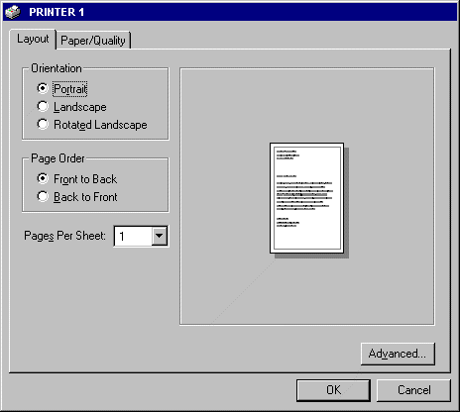
Figure 14.3 Layout Tab of Printing Preferences

To access Printing Preferences
Click the Layout or Paper/Quality tabs in the Print dialog box of the program you used to create the document.
– Or –
Right-click the name of a printer in the Printers folder, and then click Printing Preferences.
Printing Preferences settings are maintained across different documents, allowing you to establish a standard output for all documents. Printing Preferences determine default print job settings, but you can override these defaults in the Print dialog box.
Configuring Fax
If you are using Windows 2000 to send faxes, you can provide information about yourself and your fax. This information includes the following:
• Your full name
• Fax number
• E-mail address
• Title
• Company
• Office location
• Department
• Home phone
• Work phone
• Address
• Billing code

Fax Service Configuration
There are several attributes about your fax service that you might want to configure first, including security settings and determining how fax jobs are stored and sent.
To configure fax service options
1. From the Start menu, click Settings, and then click Control Panel.
2. Double-click Fax.
3. On the Advanced Options tab, click Open Fax Service Management Console.
4. Right-click Fax Service on Local Computer, and then click Properties.
5. Configure Fax Service on Local Computer Properties.

Using Fax Service Properties, you can configure features of your fax including the following:
• Fax retry options:
• Number of times a fax is retried
• Minutes between retries
• Days an unsent fax is kept

• Whether a banner is printed at the top of each page
• Whether to use the sending device TSID
• Whether personal cover pages are allowed
• Where outgoing faxes are archived
• What the discount rate hours are in your area

The Fax Service properties page is shown in Figure 14.4.
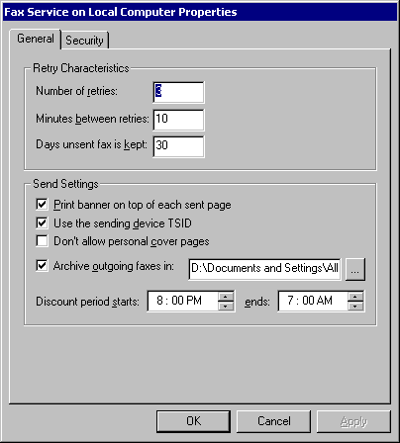
Figure 14.4 Fax Service Properties Page
Fax User Information
This information is filled in as the default for the fax coversheet when you are preparing to send a fax. The User Information tab is shown in Figure 14.5.
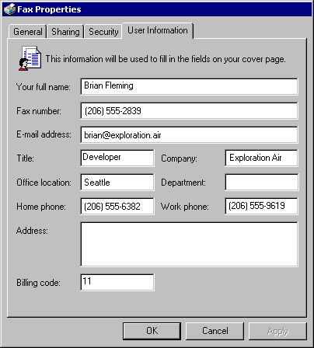
Figure 14.5 User Information Tab of the Fax Properties Dialog Box
To configure fax user information
1. From the Start menu, point to Settings, and then click Printers.
2. Right-click the fax, click Properties, and then click the User Information tab.
3. Enter your information.

Fax Printing Preferences
Configure default options for sending fax jobs to a particular fax printer. By configuring fax options, you can affect the following features:
• When the fax is sent.
• The fax’s printing options, including orientation, paper size, and image quality.
• Information about the sender of the fax, such as e-mail address.

Configuring fax job defaults
1. From the Start, point to Settings, and then click Printers.
2. Right-click a fax printer, click Properties, and then click Printing Preferences.
3. Enter your information in the Fax Printing Preferences properties page.

The Fax Printing Preferences dialog box is displayed in Figure 14.6.
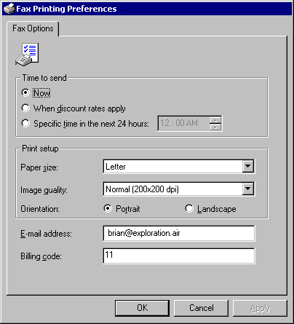
Figure 14.6 Fax Printing Preferences Dialog Box
The information you enter in the Fax Properties User Information tab and Fax Service Properties General tab, shown earlier, are the defaults that are offered to you by the Send Fax wizard when you prepare to send a fax. You can change these options when you prepare a fax job, but these are used as a starting point for the job.
For more information about creating and sending fax jobs, see “New Ways to Send Print Jobs” later in this chapter.
For more information about how the fax service makes fax calls, archives faxes, and determines when discount rates apply, see “Configuring Fax Service Configuration” earlier in this chapter.
Creating and Sending Print Jobs
Windows 2000 Professional supports many different ways to create and send a print job to the printer. You can send print jobs in the following ways:
• Drag the file you want to print to the printer’s icon in the Printer folder. This sends the file to the printer on which you dropped the file.
• Create a shortcut for a printer, and then add it to the Send To menu. Right-click a file, point to Send To, and click the name of the printer you want to use.
• Open the file you want to print in the program you used to create the file. Click File, and then click Print.
• Right-click the file you want to print, and then click Print. This prints directly to the default printer, and then closes the application when the file has printed.

Modifications to the Print Dialog Box
The Windows 2000 Print dialog box includes several modifications. Figure 14.7 shows the new appearance of the Print dialog box.
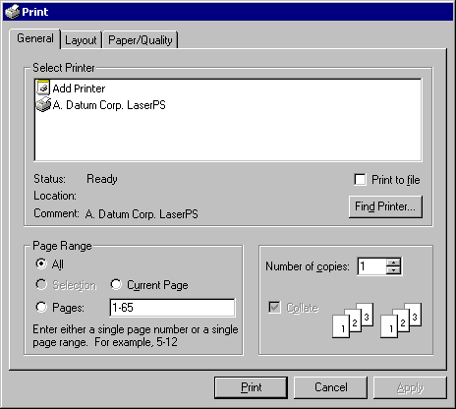
Figure 14.7 General Tab of the Print Dialog Box
The Print dialog box includes a number of improvements:
• The Layout and Paper/Quality tabs replace Preferences, which was available in previous versions of Windows.
• The Find Printer button allows browsing for printers not already installed on your computer. After you find a printer, you can use Point and Print to establish a connection with the printer and download any required drivers.

New Printer Properties Dialog Box
The new Printer Properties dialog box allows each user to set different properties for a printer. Because a users’ printer preferences are preserved for each user, there is no need to set preferences each time the printer is used.
Enhanced Printer Drivers
Printing enhancements are made possible in large part by the Universal driver and the PostScript driver.
Universal Driver
The Universal driver has been optimized to provide higher quality and performance printing. Color printing using ICM 2.0 ensures that color images are accurately maintained. The Generic Print Description (GPD) supports minidrivers, abstracting the details of each printer’s communications, thereby allowing unsupported printers to work with Windows 2000.
The Universal driver enhances font performance and capabilities. Printer font substitution results in better output, and 2-byte fonts are supported, enabling printing of extended character sets. The set of extended character fonts supported includes Latin, Greek, Cyrillic, Indic, Thai, Kana, and Hangul characters, punctuation marks, and ideographs.
The Universal driver is designed to support customization, allowing greater flexibility in the sorts of print devices that can be used with Windows 2000.
PostScript 5.0 Driver
The PostScript driver provides better performance through enhanced virtual memory management. Color printing with the PostScript driver uses ICM 2.0 ensuring that color images are faithfully maintained.
Microsoft has extended the PostScript driver to support more font formats and provide the structure for future customization.
PostScript continues to support the following:
• Support for PostScript levels 1, 2, and 3.
• ICM 2.0.
• Control over output data format, allowing for CTRL+D handling, Binary Communications Protocol (BCP), Tagged Binary Communications Protocol (TBCP), and pure binary (8-bit) channels (AppleTalk, for example).
• PPD version 4.2 and .wpd files.
• Simplified Printer Description (.spd) files.
• Tracking of virtual memory available to the printer.

Image Color Management 2.0
Image Color Management (ICM) 2.0 ensures that colors are accurately reproduced when printed. If you want to use ICM 2.0, your printer must support it. In some cases, you might want to use a third-party calibration tool to create or update a color profile for your printer. This will compensate for variations between different printers of the same type or variations that occur as a printer ages.
For more information about ICM 2.0, see “Scanners and Cameras” in this book.
New Ways to Send Print Jobs
Windows 2000 includes a number of new ways to send print jobs, including new port monitors and newly supported connection methods such as USB.
Standard Port Monitor
The new Standard Port Monitor connects clients to network printers that use the TCP/IP protocol. It replaces the LPR Port Monitor (Lprmon) as the preferred port monitor for TCP/IP printers connected directly to the network through a network adapter. The new standard port simplifies installation of most TCP/IP printers by automatically detecting the network settings needed to print. Printers connected to a UNIX or VAX host might still require Lprmon.
The Standard TCP/IP Port Monitor (SPM), which uses TCP/IP as the transport protocol, is the preferred port monitor in Windows 2000. SPM uses the Simple Network Management Protocol (SNMP) to configure and monitor the printer status. In addition to SPM, Internet printing adds a Hypertext Transport Protocol (HTTP) print provider. All port monitors that were included with Windows NT 4.0 are still present, except the Digital Network port monitor, Hewlett-Packard JetAdmin, and the Lexmark Port Monitors.
SPM communicates with network-ready printers, network adapters like Hewlett-Packard’s JetDirect, and external network print servers like Intel’s NetPort. SPM can support many printers on a single server and is faster and easier to configure than Lprmon.
SPM sends documents to a printer using either the RAW or LPR printing protocols. Together, these protocols support most current TCP/IP printers. Do not confuse these print protocols with the transport protocols such as TCP/IP or Data Link Control (DLC).
The RAW protocol is the default for most print devices. To send a RAW-formatted job, the print server opens a TCP stream to the printer’s port 9100 (or another port number) to select connections to multiport external devices. For example, on some devices port 9101 goes to the first parallel port, 9102 goes to the second parallel port, and so on.
SPM uses the LPR protocol when you specify it during port installation or reconfiguration, or when Port 9100 protocol cannot be established.
SPM deviates from the LPR standard in two ways. First, SPM does not conform to the RFC 1179 requirement that the source TCP port lie between port 721 and port 731. SPM uses ports from the general, unreserved pool of ports (ports 1024 and above). Second, the LPR standard states that print jobs must include information about the size of the job the port monitor sends. Sending a print job with job size information requires that the port monitor spool the job twice, once to determine size, and once to send the job to the spooler. Spooling the job only once improves printing performance, so SPM sends the job to the spooler without determining the actual job size, and claims the job is a default size, regardless of the job’s actual size.
SPM can send print jobs to the LPD service running on a print server. For more information about LPD, see “Print Components” later in this chapter.
Improved Status Information
SPM is compatible with RFC 1759, the standard for the Simple Network Management Protocol (SNMP). As a result, SPM can provide much more detailed status than Lprmon.
For more information about printing to devices located on other platforms, see “Operating System Exceptions” earlier in this chapter.
To configure a standard TCP/IP port by using SPM
1. Select an installed printer, click File, and then click Properties.
2. Click the Ports tab, and then click Add Port.
3. Click Standard TCP/IP Port, and then click New Port. This starts the Add Standard TCP/IP Printer Port wizard, shown in Figure 14.8.
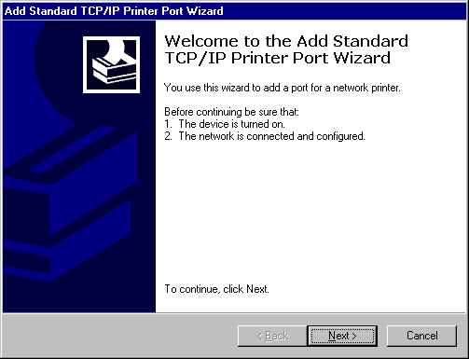
Figure 14.8 Standard TCP/IP Printer Port Wizard
4. Type a name or the IP address of a print device in the Printer Name or IP Address text box.
5. Type a host-resolvable port name, which can be any character string, in the Port Name text box, or use the default name that the wizard supplies, and then click Next.
The system sends an SNMP get command to the device. An SNMP get command asks for the status of a device, so in this case, the system uses the SNMP get command to request a status information from that printer. Using the SNMP values returned from the get command, the device details are determined and the appropriate device options are displayed for further selection (for example, you can select the correct printer port).
6. If prompted by the Additional Port Information Required dialog box, click Standard, and then select one of the devices listed.
– Or –
Click Custom, and then configure the port by using the Configure Standard TCP/IP Port Monitor dialog box. If you do not know details of the port, use Generic Network Card.
If the wizard cannot determine the protocol, it prompts you for the information. If you are not prompted, skip to step 8.
7. When prompted for the protocol, select either RAW or LPR. RAW is preferred.
If the wizard detects that the device supports multiple ports (indicated in the Tcpmon.ini file), it prompts you to select a port.
8. Select a port from the list and finish the wizard.
The new port is listed on the Ports tab of the Properties dialog box.

Reconfiguration
The SPM port can be reconfigured in the printer’s Properties dialog box. Click Configure Port on the Ports tab. The SPM has its own Configure dialog box that appears, as shown in Figure 14.9.
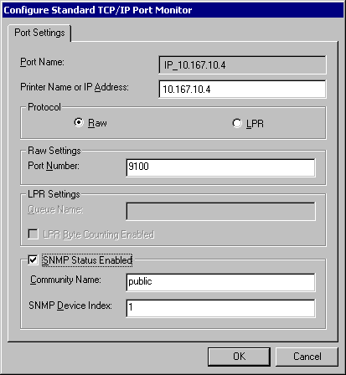
Figure 14.9 Configure Standard TCP/IP Printer Port Monitor Dialog Box
Caution The Configure Standard TCP/IP Port Monitor dialog box does not verify that the options you select are correct. If they are incorrect, the port does not work. Check with the printer manufacturer to see if the device supports SNMP.
Status Reporting
Printers return status over SNMP. Since SPM is compatible with SNMP, it allows detailed status reporting when the printer provides it. Printers that are not compliant with the SNMP standard do not return status information. Therefore, when there is an error during printing, the spooler displays a general printing error or does not detect any error at all.
Internet Printing
Windows 2000 supports Internet printing. This makes it possible to use printers located anywhere in the world by sending print jobs using Hypertext Transfer Protocol (HTTP). Using Microsoft® Internet Information Services or a Web Peer Server, Windows 2000 creates a Web page that provides information about printers and provides the transport for printing over the Internet. Using the Internet, printers can be used to replace fax machines or postal mail.
Use an Internet printer as you would any other Windows 2000 installed printer.
For more information about installing an Internet printer on your computer, see “Installing Network Printers” earlier in this chapter.
For more information about managing print jobs sent by using IPP, see “Internet Printing Management” later in this chapter.
USB
Windows 2000 supports printing to Universal Serial Bus (USB) printers. USB is comprised of an external bus architecture for connecting USB-capable peripheral devices to a host computer, as well as a communication protocol that supports serial data transfers between a host system and USB-capable peripherals.
IrDA
Infrared Data Association (IrDA) is a system of exchanging information between computers using infrared transmissions that do not require a cable connection. IrDA can occur between any two devices that support IrDA (such as computers and printers). Windows 2000 supports printing using IrDA.
IrDA is a point-to-point protocol based on TCP/IP and WinSock APIs. IrDA can be used to exchange data between non-Windows devices that use the IrDA protocol. IrDA exchanges data at rates approaching those typically provided by local area network (LAN) connections.
Support for the IEEE 1284.4 (DOT4) Protocol
Windows 2000 supports DOT4, enabling Windows 2000 print servers to send data to multiple parts of a single multifunction peripheral (MFP) device. DOT4 is a driver that creates different port settings for each device function, so a device with both printing and scanning capabilities can process both types of jobs simultaneously.
DOT4 is automatically installed when a DOT4-enabled device is detected, so no installation or configuration is required.
Sending Faxes
Windows 2000 integrates sending and receiving faxes through your computer’s fax modem in the same way it sets up a printer.
If your computer has a fax modem, install the modem by using the Add Printer wizard, the same as you install a printer.
When creating fax jobs, use the Send Fax wizard to provide information to send your fax. The fax wizard includes a number of pages that allow you to configure the following fax job attributes. The Send Fax wizard includes the following pages:
• Welcome page.
• Recipient and dialing information. Use this page to enter the phone number to which you want to send the fax (or multiple numbers, if desired), and special dialing rules, such as dialing 9.
• Adding a cover page. Use this page to add a cover page and note for the fax’s recipient.
• Scheduling transmission. Use this page to determine when to send the fax. By scheduling transmissions, you can take advantage of lower rates during specific times of day.
• Summary page. Use this page to confirm the configuration you have chosen before sending the fax.

After you use the Send Fax wizard, Windows 2000 automatically uses the modem to send your job to the fax numbers you have specified, unless you have specified that the job is to be sent at a later time. If the fax job is not successfully sent, Windows 2000 tries sending the fax job again at regular intervals, depending on the information set in Fax Service Properties.
For more information about configuring Windows 2000 to send faxes, see “Configuring Fax” earlier in this chapter.
Reverse Order Printing
Windows 2000 allows printing to begin on the last page of a document and end on the first page.
To print in reverse order
1. Open the document to be printed.
2. Click File, click Print, and then click the Layout tab.
3. Click Back to Front.
4. Click Print to print the document.

Number of Copies
Windows 2000 supports printing up to 10,000 copies of a document in one print job. Previously, some printers were limited to 255 copies per print job.
To select the number of copies to be printed
1. Open the document to be printed.
2. Click File, and then click Print.
3. On the General tab, type a number from 1 to 10,000 in Number of copies.
4. Click Print to print the document.

Printing Multiple Pages on a Single Page
You can print multiple pages of a document on a single piece of paper. This is called n-up printing, and is useful when you want to conserve paper when printing a document with a small amount of information on each page.
To set the number of pages to print on one piece of paper
1. Open the document to be printed.
2. Click File, click Print, and then click the Layout tab.
3. Select the number of pages to be printed on one piece of paper from the Pages Per Sheet box.
4. Click Print to print the document.

Monitoring and Managing Print Jobs
There are a range of permissions that affect how users manage printers and receive printer status.
Job Queue Security Options
Users have different levels of access to manage a printer job queue depending on their security permissions.
Users working with printer queues are typically separated into two groups:
• Administrative users: These users have Manage Printers and Manage Documents permissions. They have wide control over how the printer operates, regardless of where the print job originated.
• General users: These users have Print permissions, which include viewing general information about a printer and managing documents that they send to the printer. They cannot control other people’s print jobs.

Table 14.5 Defaults Rights for Printer Users

Task Administrative User General User

See all jobs X X
Pause or resume printer operation X O
Pause, cancel, reschedule, or redirect any job X O
Pause, cancel, reschedule, or redirect own job X X
Restart a job from the beginning X X
View and change job settings such as priority and person notified upon completion X X
View form, paper source, page orientation, number of copies X X
Scheduling
Print scheduling is established by users with administrative privileges by using the printer’s Advanced tab, which is shown in Figure 14.10.
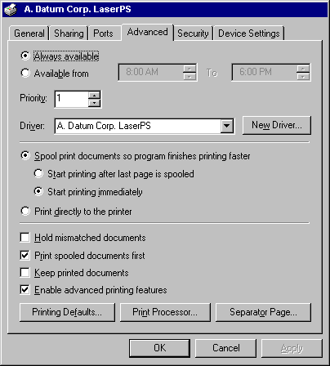
Figure 14.10 Advanced Tab of a Printer Properties Dialog Box
Users with administrative privileges can schedule printer availability, priority, and job priority. Print job priority only affects jobs in a printer’s queue, not how jobs get to a print queue. Printer priority can be used to affect how print jobs reach print queues.
Printer Availability
Printer availability can be set to make the printer always available or only available during certain times of day.
Printer Priority
Printer priority determines the likelihood that a printer is chosen relative to other printers.
When adding printers, think of physical printers as the actual printers that print documents and virtual printers as representations of physical printers. You send a document to a virtual printer on the network and that print job is printed on paper by a physical printer.
Printer priority only has an effect when it is set differently for different virtual printers that correspond to the same physical printer. Setting different printer priorities for different virtual printers that correspond to different physical printers has no effect.
A few facts about printer priority:
• Higher numbers correspond to higher priorities, so priority 1 printers are of the lowest priority.
• Printer priority has no effect on job priority, so multiple jobs sent to the same virtual printer are affected by their job priority, but not by the printer’s priority. Job priority can be set by viewing the properties of a job in a print queue, whereas print priority is set using the Priority field on the Advanced tab of a printer’s property page.
• Printer priority is only evaluated when determining which job to complete next. A printer does not stop processing a job it is already working on, even when the spooler receives a higher priority job, directed to a higher priority printer on the same port.

To set printer priorities for multiple virtual printers
1. Add a virtual printer using a specific port. For more information about how to add printers, see Windows 2000 Professional Help.
2. Repeat the process of adding virtual printers by using different names for the same physical printer until you have as many virtual printers as you need to accommodate your print prioritization needs.
3. Right-click a printer, click Properties, and set a Priority value. A greater priority value means that printer has higher, not lower priority. Repeat as necessary for other virtual printers that correspond to the same physical printer.
4. Using Computer Management, establish discrete groups to which you intend to add users, and associate with a printer. For more information about how to add groups, see Windows 2000 Professional Help.
5. Add groups to each virtual printer’s Security tab and set permissions to allow specific groups to use the printer. Remember to remove other groups or disable allowing other groups to use the printer if you want to restrict access.
6. Add users to groups that correspond with the level of printer priority you want them to have. Add users to whom you want to give priority printer access to the group with permissions to use the printer that has a higher priority. Add the users intended to have lower printer priority access to the group with access to the lower priority printer. For more information about adding users to groups, see Windows 2000 Professional Help.

Caution When working with groups, it is typically better to remove the Everyone group from the printer rather than to deny access to the Everyone group and then add other groups with permitted users. This is because the Deny setting overrides any Allow settings. Therefore, if a user is a member of both the Everyone group, which is denied access to a printer, as well as the printer group you have designated allowed to use the printer, the Deny setting overrides the Allow setting.
When users install printers, they can do so based on their group membership, ensuring that the right users have the right level of priority access to printers.
To set printer priority
1. Open Printers, right-click the printer whose priority you want to set, and then click Properties.
2. Enter a number in the Priority field in the Advanced tab of the printer’s Property page.
Note To set printer priority, you must have Manage Printer permissions for the printer in question.

Job Priority
Job Priority is set in the print queue and determines the priority for a particular document. After a job is printing, it is not affected by other higher priority print jobs, but when a printer finishes printing a job, it first chooses the job with the highest priority and then the job submitted first.
Consider the set of jobs that you might find in a printer’s queue shown in Table 14.6.
Table 14.6 Sample Jobs in a Print Queue

Job Status Priority

1 Printing 1
2 Spooled 10
3 Spooled 1
4 Spooled 10
5 Spooled 99
Assuming no other jobs are submitted, and no one changes the priority of their jobs, these jobs would be handled in the order shown in Table 14.7.
Table 14.7 Order in Which Jobs in Table 14.6 Are Printed

Order Explanation

Job 1 It is in the process of printing.
Job 5 It has the highest priority
Job 2 Of the jobs of priority 10, it has been waiting the longest.
Job 4 It has the highest priority of any job remaining.
Job 3 It is the only remaining job, and it has the lowest priority.
To set job priority on an existing print job
1. Open the print queue.
2. Double-click the job whose priority you want to set.
3. On the General tab, move the Priority slider to set the job priority.

Scheduling Faxes
You can configure your fax service to only send fax jobs at specific times, such as when lower phone rates apply. To learn how to configure your Fax Service to your specific discount periods, see “Configuring Fax Service Configuration” earlier in this chapter.
Spooler Settings
Print spooling is configured by users with administrative privileges by using the printer’s Advanced tab. Jobs can be sent to the spooler, or sent directly to the printer. If jobs are sent to the spooler, they can be configured to start printing as soon as possible or after the final page in a job has been sent to the spooler.
When you send a print job directly to the printer, your computer renders the entire job and then transfers it directly to the printer. When you send a print job to a spooler, your computer creates the job, including meta-information about how the job must be processed, and then sends the job to the spooler. The spooler then renders the job and sends it to the printer.
Sending a job directly to the printer is good because you remove a potential point of failure in printing documents, and all print job rendering is done on your computer, affording you more control, and you don’t have to wait for other jobs to complete, as you might if you were printing to a queue on a print server that was being used by many users. Conversely, rendering a print job on your computer consumes computing resources, so you might experience reduced performance or have to wait until the print job has completed before doing anything.
Sending a print job to a spooler is good because your computer does not have to render the print job, meaning your computer’s resource are more completely and immediately available. Conversely, sending a print job to a spooler fails if the print server with the spooler is unavailable, and you might have to wait for other jobs to finish spooling before your job is processed.
Spoolers can be configured to send print jobs as each page is rendered and ready for printing or to wait to begin printing until the entire job has been rendered. If the spooler is configured to print each page as soon as it is rendered, there might be a long wait between each printed page, resulting in slow print production, as the printer waits for each successive page to be rendered. Printers configured to print completely spooled jobs typically print faster after the job is started, but there can be a long wait while the job is spooled. If each spooler has many users, waiting until the entire job is spooled is typically best. If each spooler has few users, printing each page as it spools might be best.
Quick Printer Status
Windows 2000 allows you quick access to basic information about printers. Letting the mouse pointer hover over a printer displays that printer’s name, status, number of documents in its queue, and its location.
Internet Printing Management
Printers being hosted by Windows 2000 servers with IIS or a Peer Web Server can receive jobs sent to them over the Internet Printing Protocol. Windows 2000 Internet print servers provide information to clients about the status of jobs they have received, as well as about printers that are available.
Jobs on a server can be viewed and managed using the Internet print server’s Web pages. These pages provide information about jobs that are waiting in the queue, including the job’s name, status, owner, number of pages, size, and when it was submitted.
An example of the print queue provided by an Internet print server appears in Figure 14.11.
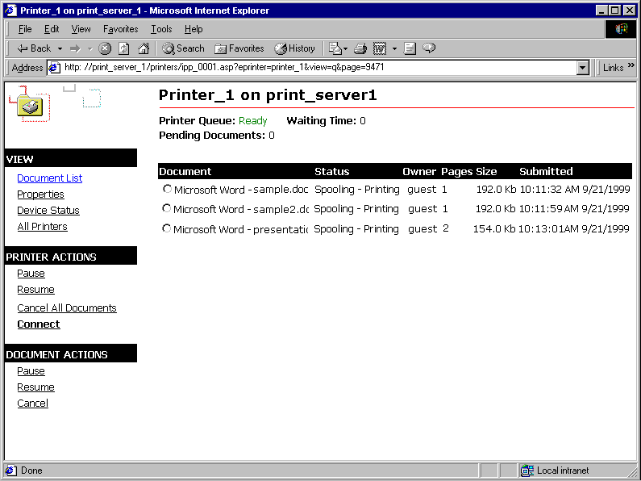
Figure 14.11 Sample Print Queue View for a Printer on an Internet Print Server
For more information about the status of a particular printer, view the printer’s device status. This page can provide a range of information including the following:
• The printer’s current status.
• The text the printer’s display is currently presenting.
• The printer’s paper tray capabilities and status. For example, this might display the approximate number of pages available in each of the printer’s trays.
• The console lights currently illuminated. Console lights might include Online, Data, or Attention.

An example of a device status on a Web page provided by an Internet print server appears in Figure 14.12.
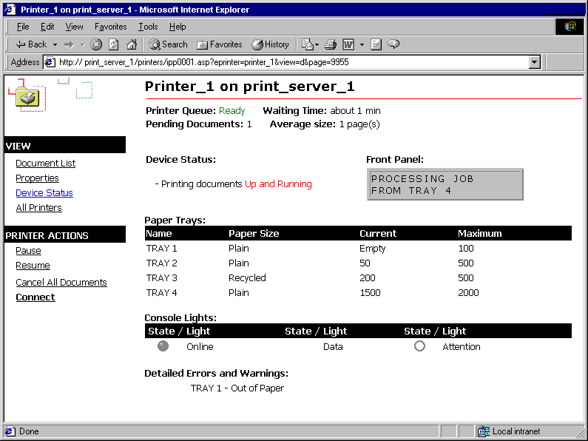
Figure 14.12 Sample Device Status for a Printer on an Internet Print Server
Printer Pooling
A printer pool associates two or more identical printers with one set of printer software. To set up such a pool, add a printer using the Add Printer wizard and assign that printer as many output ports as there are identical printers. Windows 2000 places no limit on the number of printers in a pool. When a document is sent to the printer pool, the first available printer receives and prints it. This configuration maximizes print device use while minimizing the time users wait for documents.
Efficient printer pools have the following characteristics:
• All printers in the pool are the same model.
• Printer ports can be of the same type or mixed (parallel, serial, and network).
• It is recommended that all printers be in one location. Because it is impossible to predict which printer will receive the document, keep all printers in a pool in a single location. Otherwise, users might have a hard time finding their printed document.

Note If one device within a pool stops printing, the current document is held at that device. The succeeding documents print to other devices in the pool, while the delayed document waits until the nonfunctioning printer is fixed.
Printing Concepts
When users print, the computer completes a set of steps that involve a set of components including executable files, drivers, device interfaces, and dynamic-link libraries which then work together to create printed output. Understanding how this process works will help you understand what is happening when you print a document and might help you resolve any problems that arise. Printing can be divided into the printing process and the print components that make the printing process possible. When printing to an Internet print server, the print server adds to the standard print process by creating an interface for users.
Printing Process
The printing process is divided into three groups of steps:
• Client processes
• Spooler processes
• Printer processes

These groups of broad steps include the following specific actions, represented in Figure 14.13.
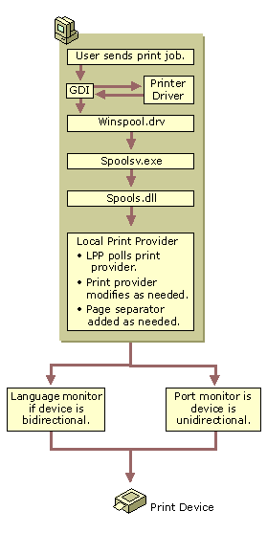
Figure 14.13 Print Process
The steps depicted in Figure 14.13 include the following:
Client Processes
• A user sends a print job from an application. The application calls the Graphics Device Interface (GDI). If print output is produced in RAW format, the GDI is not used.
• The GDI calls the printer driver for information, which the GDI uses to create a job in printer language.
• The GDI delivers the job to the spooler.

Spooler Processes
• The client side of the spooler (Winspool.drv) makes an RPC call to the server side spooler (Spoolsv.exe).
• Spoolsv.exe calls the print router (Spoolss.dll).
• The router (Spoolsv.dll) sends the print job to the local print provider (LPP) or remote print server if the job is being sent to a network printer.
• The LPP polls print processors to find one that can handle the data type of the job.
• The LPP sends the job to the print processor, which modifies the job as required to make it print properly.
• The print processor sends the job to the page separator. A separator page is added, as required.
• The job is sent to the appropriate port print monitor. If print is bidirectional, the job is first sent to the language monitor such as the Printer Job Language (PJL) monitor, and then sent on to the port monitor. If the job is unidirectional, the job is sent directly to the port monitor.

Printer Processes
The printer translates the print language into a bitmap, which it then prints.
Print Components
There are a number of components that work together to make the printing process possible. Different components are used at different times, depending on the type of print job being produced and the types of hardware being used.
Graphics Device Interface
The application calls the Graphics Device Interface (GDI) to begin the process of creating a print job. The GDI reads the driver information for the printer to get information about how to format the job. Using the document information from the application and the print device information from the printer driver, GDI renders the print job in the printer language of the printer.
Printer Drivers
Printer drivers contain information that is specific to the printer that is used. Printer drivers reside on user’s computers and are used by the GDI to render print jobs.
Windows 2000 includes the most common printer drivers, but you might need to provide printer drivers for some printers. When a Windows 2000 user connects to a printer or installs a Plug and Play printer, the necessary printer drivers are loaded onto the user’s computer, if they are available.
Print Spooler
The print spooler consists of a group of components, including the print router, the local and remote print provider, and the print processor. These components can reside on a computer sending a job and on a network print server receiving print jobs. The print spooler’s components take the print job that the GDI has created and modify it so it has all information and formatting necessary to print correctly. If part of the spooler is on a server, the server provides the processing resources for the print job, freeing the user’s computer and improving performance.
Different print servers have different spooler components. In Windows 2000, the print spooler is comprised of a router, remote print provider, local print provider, print processor, separator page processor, and port print monitors.
Print Router
The print router receives a print job and locates an available print provider that can handle the print job’s protocol. For example, the router might look for a print provider designed to handle RPC print jobs or jobs transferred using HTTP. When an acceptable print provider is found, the router relays the print job from the remote print provider to the chosen local print provider, where the job is modified, if necessary, before printing.
Remote Print Providers
The remote print provider is part of the client side of the print process. The router gives control of the print job to the first remote print provider the router finds that recognizes the destination printer. A remote print provider sends the print job to the server side part of the router.
Examples of remote print providers include the Windows Network Print Provider and the Novell NetWare Remote Print Provider. When a user sends a print job to a printer on a print server, the remote print provider is on the user’s computer and the local print provider is on the server, counter to how it might be perceived by users.
Local Print Providers
The local print provider receives the print job, writes it to a spool file, and keeps track of information about the job. Spooling a file to disk ensures that the job is saved and printed, even if printers are unavailable or there is a power failure. When a user sends a print job to a printer on a print server, the remote print provider is on the user’s computer and the local print provider is on the server, counter to how it might be perceived by users.
The local print provider has two components that are invoked as required by the printer type and settings:
• Print processor: The print processor makes any necessary modifications to the print job. This is necessary in instances where third-party printers have special requirements. Often, no modifications are required by the print processor.
• Separator page processor: The separator page processor adds separator pages, as required. You may specify different separator pages based on your needs. Most separator pages include information such as the user and computer that created the job or the date and time the job was created.

The escape codes used in creating a separator page are listed in Table 14.6.
Table 14.8 Separator Page Escape Codes and Functions

Escape Code Function

\ The first line of the separator file must contain only this character. The separator file interpreter considers this the separator file command delimiter.
\N Prints the user name of the person who submitted the job.
\I Prints the job number.
\D Prints the date the job was printed. The time is displayed in the format specified under Regional Options in Control Panel.
\Lxxx Prints the string of text that appears after the \L escape code. If you were to enter \LTest, the text “Test” would appear in the separator page.
\Fpathname Prints the contents of the file specified by pathname, starting on an empty line. The contents of this file are copied directly to the printer without processing.
\Hnn Sets a printer-specific control sequence, where nn is a hexadecimal ASCII code sent directly to the printer. To determine the specific numbers, see your printer manual.
\Wnn Sets the width of the separator page. The default width is 80 characters; the maximum width is 256. Any characters beyond this width are truncated.
\B\S Prints text in single-width block characters until \U is encountered.
\E Ejects a page from the printer. Use this code to start a new separator page or to end the separator page file. If you get an extra blank separator page when you print, remove this code from your separator page file.
\n Skips the number of lines specified by n (from 0 through 9). Skipping 0 lines simply moves printing to the next line.
\B\M Prints text in double-width block characters until \U is encountered.
\U Turns off block character printing.
After the local print provider has passed a job through the print processor and separator page processor, it sends the job from the spooler to the appropriate port print monitor.
Port Monitors
The Local Print Provider (Localspl.dll) provided with Windows 2000 includes the Local Port Monitor and Winprint print processor. The Local Port Monitor controls the parallel and serial ports to which printers are connected, and the Standard Port Monitor (SPM) is used for most network print jobs. Other ports, such as SCSI or Ethernet, are controlled by port monitors, such as the NetWare Port Monitor or AppleTalk Port Monitor.
Windows 2000 includes port monitors which enable printing to different types of printers in different network environments. Some of the port monitors included with Windows 2000 are described in further detail below:
• The preferred network port monitor in Windows 2000 is the Standard TCP/IP Port Monitor (SPM), which uses TCP/IP as the transport protocol. SNMP is used to configure and monitor the printer ports. In addition to SPM, Internet printing adds an Hypertext Transport Protocol (HTTP) Port Monitor. All other port monitors that were included with Windows NT 4.0 are also present. For more information, see “New Ways to Send Print Jobs” earlier in this chapter.
• Local Port Monitor is the standard monitor for use with printers connected directly to your computer. If you add a printer to your computer by using a serial or parallel port (such as COM1 or LPT1), this is the monitor that is used.
• LPR Port Monitor is used to send jobs over TCP/IP from the client running Lprmon.dll to a print server running an LPD service. LPR Port Monitor can be used as an alternative to SPM to enable Internet printing, UNIX print servers, or Windows 2000 print servers over a TCP/IP network. The LPR Port Monitor is a two-part port monitor, Lprmon.dll is used on the client side and Lpr.exe is used on the server side. When a job is sent over TCP/IP, the client must have the destination address for the print server, the name of the printer, and instructions on how to print the job. The server must have Lpr.exe installed to receive the job and pass it on to the appropriate printer. Use the LPR Port Monitor if you need an RFC compliant Line Printer Remote (LPR) or to receive jobs from UNIX clients. In any other case use SPM.
• AppleTalk Port Monitor (Sfmmon.dll) is used to send jobs over the AppleTalk protocol to printers such as LaserWriters or those configured with AppleTalk or any AppleTalk spoolers. To print to LaserWriters using Windows 2000 servers, the servers must have Services for Macintosh, which includes Sfmmon.dll.
• Hewlett-Packard Network Port Monitor (Hpmon.dll) sends jobs to Hewlett-Packard network adapters. Hpmon.dll uses the DLC network protocol to communicate. Print jobs sent through Hpmon.dll cannot be sent through routers.
• PJL Monitor (Pjlmon.dll) communicates in printer job language (PJL). Any bidirectional print device that uses PJL can use the PJL language monitor.

Internet Printing
A user on a Windows 2000 computer can access information about available printers, and send jobs to those printers available on a Windows 2000 print server, or any print server that supports IPP v1.0. The process of finding an Internet printer and sending a print job to that printer includes the following steps:
1. A client connects to a Windows 2000 print server over the Internet by entering a URL.
2. The print server can require the client to provide authentication information. This helps ensure that only authorized users print documents on your printer, rather than making it available to everyone with an Internet connection.
3. After a user is authorized to access the print server, the server presents the client with Active Server Pages (ASPs) containing information about the currently available printers. Figure 14.1 shows an example of such a page.
4. Windows 2000 users can connect to any of the available printers using ASPs or get information about each printer’s capabilities. Figure 14.14 shows an example of a printer’s properties page, as presented by an Internet print server.
Note Only computers running Windows 95 or Windows 98 with the Internet Printing Client or computers running Windows 2000 can connect to available printers. Windows NT and and Windows 3.11 will be unable to connect.
Figure 14.14 Printer Queue for a Printer on an Internet Printer Server
5. After users have connected to an Internet printer, they can print documents. Documents users print are sent using IPP v1.0 or RPC to the print server that uses RPC calls to send the job to the Internet printer of the users choice. Figure 14.15 shows potential steps included in the Internet printing process.

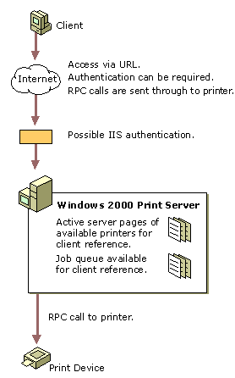
Figure 14.15 Internet Printing Process
Print Job Formats
Print jobs are sent in a variety of formats, each of which is suited to different computing environments.
EMF
Enhanced Metafile (EMF) is the standard format for print jobs created on Windows 2000. EMFs are very portable because the instructions for the print job are assembled on the user’s computer, but processing of the print job and its instructions is completed by the spooler. Because the spooler is associated with a specific printer, EMF files can be sent to any printer that has a spooler that handles EMFs.
EMF data is created by the GDI. After an EMF job is sent to the spooler, control is returned to the user and the spooler finishes processing the job. This limits the amount of time that the user’s computer is busy.
RAW
RAW is a common data type for non-Windows 2000 clients. RAW data is not modified by the spooler at all, but is sent directly to the printer.
RAW [FF Appended]
RAW [FF Appended] is exactly like the RAW data type except that a form feed character is automatically appended to the end of each print job. The last page of a RAW document does not print on a Printer Control Language (PCL) printer, so appending a form feed is necessary.
RAW [FF Auto]
RAW [FF Auto] is exactly like the RAW data type, except the spooler checks the document for a form feed character at the end of the job. If there is no form feed, the spooler adds one.
Text
Text tells the spooler that the data is ANSI text and that it must not be modified. Text is printed using the printer’s default font.
Text data is composed of values from 0 to 255, each value representing a different character. This data type is based on the ANSI standard, so if the data was created with an application using another character set, it won’t be printed. This is more often a problem in the extended character range, represented by values above 127.
PSCRIPT1
This data type is created by Macintosh clients printing in Level 1 monochrome PostScript. The spooler interprets the data, creates a bitmap of the page, translates the image to the printer language, and sends the information to the printer where the output is produced.
Troubleshooting Printing Problems
This troubleshooting section provides different approaches to solving printing problems. The first section describes common printing problems and their solutions. You can solve problems by matching the problems you are having to common problems encountered with printing. The second section describes the different parts of the print process. You can learn how printing works, determine where the printing problem is occurring, and fix that part of the process.
Common Printing Problems
Plug and Play printer is not automatically installing
You can instruct your computer to automatically detect and install Plug and Play printers when using the Add Printer wizard.
Windows 2000 comes with more printer drivers than ever before, but if the printer driver you need is not included with Windows 2000, your printer is not automatically installed, even if it is Plug and Play. To install such a printer, use the Add Printer wizard, and click Have Disk to provide the needed drivers.
If required drivers are available, you might want to restart your computer. Some printers are manually-detected Plug and Play devices, which require that you restart your computer before the printer is installed. Manually-detected Plug and Play printers typically use parallel port connections.
Cannot find a printer when searching by location
Searching by location requires that you use Windows 2000 or some other Active Directory-enabled client.
Make sure you are creating searches that match the printer location format used in your environment. For more information about printer location formats, see “Printer Locations and Active Directory” earlier in this chapter.
Bidirectional printer problem
If you encounter a problem with bidirectional printing, disable bidirectional printing and resend your print job.
To disable bidirectional printing, do the following:
1. Click Start, point to Settings, and then click Printers.
2. Right-click the bidirectional printer, and then click Properties.
3. Click the Ports tab, clear Enable bidirectional support, and then click OK.

You do not have required permissions
If a printer requires security permissions, you must have the appropriate rights as provided by your user account or by a user group to which you belong.
Choose an alternate printer that does not require permissions, or that requires permissions that you have, or ask your administrator to grant you permissions to use the printer.
Bad printer port or improperly formatted data
Incorrectly configured ports can cause printing to fail. Typically, LPR ports include an IP address or a fully qualified domain name (FQDN) and let DNS resolve the address followed by a queue name. In such a situation, there can be a resolution error for the FQDN or users might enter the Windows 2000 queue name, rather than the LPD’s queue name. If either of these events occur, errors such as “Bad printer port” or “Improperly formatted data” can occur.
To find out if an incorrect FQDN name is being used, review the event log for your computer for event ID 2004. Event ID 2004 indicates that the target LPD did not respond as expected, which can occur with an incorrect FQDN.
A bad printer port or improperly formatted data error can also occur if users configure their computer to print directly to the printer or to use bidirectional communication, when the hardware they are using does not support these functions.
To solve these problems with the TCP/IP port you are using for the printer, try configuring the Standard TCP/IP Port Monitor for your printer.
To configure Standard TCP/IP Port Monitor
1. From the Start menu, point to Settings, and click Printers.
2. Right-click the printer whose TCP/IP port monitor you want to configure, and then click Properties.
3. On the Ports tab, click the TCP/IP Port your printer uses, and then click Configure Port.

The dialog box you use to configure the TCP/IP Port Monitor appears in Figure 14.16.
Figure 14.16 Configure Standard TCP/IP Port Monitor Dialog Box
To solve problems with the TCP/IP port you are using for a printer, try the following changes:
• Check Port Name, Printer Name, or IP Address in the Configure Standard TCP/IP Port Monitor dialog box and correct them, if necessary.
• Try toggling from one protocol to another. Some printers require you use one or the other.
• Try enabling LPR Byte Counting. Some printers required that jobs accurately represent their size. For more information about byte counting, see “New Ways to Send Print Jobs” earlier in this chapter.

Printer jobs go to the queue, but do not print
If you are using a multifunction peripheral (MFP), DOT4 might not have properly detected your print device at startup. Shut down your computer and printer, then turn on your printer followed by your computer. Typically, DOT4 now recognizes all features of your MFP.
Graphic images do not print as expected
• Disable enhanced metafile spooling (EMF).
• Try printing to the PostScript driver, if the printer supports it. If this works, the problem is with the UniDriver.
• If PostScript fails, there is a problem with the GDI or the UniDriver that is working with the application to created the print job. To verify that it is an application-related problem, try printing another document from another application.
• Try printing shorter jobs or fewer jobs at a time. You might be exceeding the print spooler’s capacity.

Pages are only partially printed
• Check that there is sufficient memory to print the document.
• Pages only partially print when the page size of the document you are trying to print is bigger than the page size available for the printer to print.
• If text is missing, verify whether the missing text uses a font which is valid and is installed.
• The printer might not have adequate toner. Try replacing the printer’s toner cartridge.

Printing is slow
• If the print server is taking an unusually long time to render the job, try defragmenting the server’s disk and check that there is adequate space for temporary files on the hard disk.
• If you are using printer pooling to handle a large number of jobs, and print jobs are taking a long time to get to the top of queue, consider adding more printers to the pool to distribute the print jobs over a larger set of printers.

PostScript printer returns an “Out of Memory” error
To print the current document, you must allocate more memory for the printer or send smaller print jobs.
To add more PostScript memory, modify Available PostScript Memory on the Device Settings tab in Printer Properties. You must have Manage printer rights to change Available PostScript Memory.
Break large print jobs into smaller parts. For example, for a 10-page print job, you can send the first five pages in one print job and then send the last five pages in a second print job. This reduces the amount of printer memory required.
Computer stalls while printing
For local printers:
• Check that the appropriate printer driver is installed. Reinstall if necessary.
• Check for adequate space on the hard disk.

For printers on a network:
• Check that the server has enough free hard disk space.
• Try disabling EMF spooling, and send the job in RAW format.

Troubleshooting the Printing Process
There are a series of steps that take place to allow a print job to be completed. Understanding these steps and their significance will help you solve problems you encounter. These steps are as follows:
• Administrator creates a print share on a print server.
• Client system connects to the share.
• Client system creates a print job.
• Client system sends job to the print share.
• Print server receives, spools, and modifies the print job.
• Print server sends job to the printer.
• Printer interprets the job and prints it.

Administrator creates a print share on print server
This makes the printer available to the network. Necessary drivers are stored on the server for distribution to clients and the print server waits to receive jobs to be produced by the printer.
If this step is not completed properly, users might be unable to connect to the printer on the server, despite installing the printer properly.
Client system connects to the share
Using any of the Windows 2000 techniques, such as Point and Print, the Add Printer wizard, or finding the printer in My Network Places, the client connects to the printer. If necessary, appropriate drivers are downloaded to the client’s computer and information about the printer is recorded.
If this step is not completed properly, the user might not locate the printer you want in the list of available printers.
Client system creates a print job
Users initiate this process by choosing to print a document. If the printer drivers are not available on the user’s computer, the GDI cannot properly create the print job.
Client system sends job to the print share
A network connection between client and print server must be available.
Print server receives, spools, and modifies the print job
The print server must have enough space to accommodate print jobs.
Print server sends job to the printer
Proper port or language monitor must be available for printer type. Network connection between print server and printer must be working.
Printer interprets the job and prints it
The printer must be turned on, online, connected to the network, and functioning properly.
Troubleshooting When Printing to a Non-Windows Print Server or Printer
UNIX
If printing through a UNIX server fails, make sure that the Standard Port Monitor (SPM) or Lprmon is installed. If it is not installed, you might not be able to produce print information that is usable by the server. For more information about installing SPM, see “New Ways to Send Print Jobs” earlier in this chapter. For more information about working with UNIX, see “Operating System Exceptions” earlier in this chapter or “Interoperability with UNIX” in this book.
NetWare
If printing through a NetWare server fails, make sure that you have a client installed on your computer such as Microsoft Client Service for NetWare or Novell’s client, Novell Client 32. Such clients allow your computer to send print jobs to the NetWare server, which the server then relays to the printer. If this is not installed, you might not be able to produce print information that is usable by the server. For more information, see “Operating System Exceptions” earlier in this chapter or “Interoperability with NetWare” in this book.
IBM
If printing through an IBM server fails, make sure that you have connected to the LPT port that corresponds to the printer to which you are sending the job. For more information about SPM, see “New Ways to Send Print Jobs” earlier in this chapter. If your clients need to communicate with a mainframe computer, ensure that 3270 emulation software is installed. If your clients need to communicate with an AS/400, ensure that 5250 emulation software is installed.
For more information about working with IBM servers, see “Operating System Exceptions” earlier in this chapter or “Interoperability with IBM Host Systems” in this book or for more information about working with IBM, see “Interoperability with IBM Host Systems” in this book.
Macintosh
If printing to a printer using the AppleTalk protocol fails, make sure that Services for Macintosh and the AppleTalk Port Monitor, Sfmmon, are installed on your computer.
For more information about working with Macintosh printers, see “Operating System Exceptions” earlier in this chapter.
Additional Resources
• For information about Active Directory, see chapters under “Active Directory” in the Microsoft® Windows® 2000 Server Resolurce Kit Distributed Systems Guide. Active Directory can be used to help users find a printer based on its attributes, such as location.

