Chapter 15 - Scanners and Cameras

Microsoft® Windows® 2000 Professional supports a wide range of scanners and cameras, and has been optimized to produce more accurate reproductions of images and their colors. For example, IrTran-P is provided to enable easier transfer of image information from digital cameras to computers and pushbutton scanning simplifies acquiring images.
In This Chapter
Quick Guide to Scanners and Cameras
What’s New
Installing Scanners and Cameras
Configuring Scanners and Cameras
Scanner and Camera Concepts
Troubleshooting
Related Information in the Windows 2000 Professional Resource Kit
• For more information about using printers, see “Printing” in this book.
• For more information about Plug and Play devices, see “Device Management” in this book.

Quick Guide to Scanners and Cameras
Use this quick guide to locate information about scanners or cameras. You will find information about installing and configuring scanners or cameras, information about troubleshooting problems with your scanner or camera, and detailed information about imaging architecture.
Install your scanner or camera.
The first step to using a scanner or camera is installing it on your computer.
See “Installing Scanners and Cameras” later in this chapter.
Configure your scanner or camera.
You might need to configure your scanner or camera, depending on the type you are using. If you have an automatically detected Plug and Play scanner or camera, such as one that uses a USB connection, you might not need to configure your device. However, if you have a manually detected Plug and Play scanner or camera, a scanner that provides pushbutton scanning, or a camera that uses IrTran-P, you might need to configure the device further.
• See “Configuring Scanners and Cameras” later in this chapter.

Understand your imaging architecture.
Familiarize yourself with the Windows 2000 imaging architecture. Understanding the architecture can help you solve problems, and understand how different technologies work together to capture and manipulate images.
• See “Scanner and Camera Concepts” later in this chapter.

Troubleshoot scanners and cameras.
Solve any problems that arise with your scanner or camera.
• See “Troubleshooting” later in this chapter.

What's New
Table 15.1 describes new imaging features with Microsoft® Windows® 2000.
Table 15.1 Comparison of Imaging Features

Windows 2000 Windows NT 4.0 Windows 95/98

Image Color Management (ICM 2.0) with improved color space profiles. ICM not available. ICM 1.0 available for Microsoft® Windows® 95. ICM 2.0 available for Microsoft® Windows® 98.
Plug and Play available for local devices. No Plug and Play available. Same as Windows 2000.
Still imaging architecture adds enhanced ICM 2.0, and continues to support universal serial bus (USB) and small computer system interface (SCSI) drivers and serial ports. Still imaging architecture provided entirely through third-party products. Still imaging architecture is the same as Windows 2000 for Windows 98. Windows 95 supports ICM 1.0.
Standard scanner and camera control panel provided. No standard control panel for scanners and cameras. Same as Windows 2000.
IrTran-P is supported for image transfer, when enabled by hardware. No IrTran-P image transfer support. No IrTran-P image transfer support.
Expanded scanner and digital camera support through a wider range of drivers. Microsoft® Windows NT® does not include imaging drivers. Windows 98 includes some imaging drivers.
Support for pushbutton scanning added as a standard image acquisition technique. Scanned images acquisition initiated through image applications such as Microsoft® Picture It!® Same as Windows 2000 for Windows 98.No pushbutton support provided by Windows 95.
The following section describes, in greater detail, new technologies available with Windows 2000 Professional.
Easier Installation and Maintenance Windows 2000 supports Plug and Play for easy scanner and camera installation. An enhanced hardware installation wizard walks users through configuration steps. Scanners and Cameras in Control Panel offers configuration options, as well as troubleshooting that works by means of user feedback to isolate problems and suggest solutions.
Color Matching: ICM 2.0 Image Color Management (ICM) 2.0 ensures that colors are accurately captured and stored by scanners and cameras. You must complete an initial setup of ICM 2.0 and your camera or scanner must support it. Initial setup of ICM 2.0 associates color profiles with scanners and cameras. This association can be completed either by the device vendor or the administrator, and once configured, can be modified by users with the appropriate permissions.
ICM 2.0 is mostly transparent for end-users, so when an application supports ICM 2.0, Windows 2000 uses it to produce high-quality color reproductions without requiring user intervention.
Scanner manufacturers might list their scanners as being standard RGB (sRGB) compliant (IEC 61966-2-1:1999). Most scanner vendors accurately support sRGB as the default color space, producing good colors for most users. If you require exceptionally precise color accuracy, use a third-party calibration tool to create custom profiles, and use software that operates effectively with ICM 2.0. For more information about ICM 2.0 and color profiles, see “Image Color Management 2.0” later in this chapter.
Pushbutton Scanning Scanning can be initiated on some scanners simply by pressing a Scan button on the hardware. Pressing the button launches scanning software, scans the image, and displays the image on the computer’s screen.
Pushbutton scanning is configured in Scanners and Cameras in Control Panel.
IrTran-P Images can be transferred from cameras to Windows 2000 Professional using infrared transmissions. This makes a physical cable connection unnecessary.
Installing Scanners and Cameras
Scanners and cameras use Plug and Play and the Scanner and Camera Installation wizard to complete the installation process.
Plug and Play
Most scanners are Plug and Play devices and are installed automatically when they are connected to the user’s computer. If a scanner is not installed automatically when it is connected, use the Scanner and Camera Installation wizard.
Scanner and Camera Installation Wizard
Use the Scanner and Camera Installation wizard if you have an imaging device that is not Plug and Play. If you are installing a device that is Plug and Play, but the drivers required for that device are not available on your computer, the Scanner and Camera Installation wizard prompts you to provide the drivers.
To run the Scanner and Camera Installation wizard
1. From the Start menu, point to Settings, click Control Panel, and then double-click Scanners and Cameras.
2. Click Add.

The drivers provided with Windows 2000 might not be the most recent drivers available for the device you are using. For the most current drivers, visit the manufacturer’s Web site.
Configuring Scanners and Cameras
Configuration of your camera or scanner is completed during Setup. For basic information about the scanner or camera, or to complete basic configuration after Setup, use Scanners and Cameras in Control Panel.
To configure basic scanner or camera properties
1. From the Start menu, point to Settings, click Control Panel, and then double-click Scanners and Cameras.
2. Select a scanner or camera from the list, and then click Properties, shown in Figure 15.1
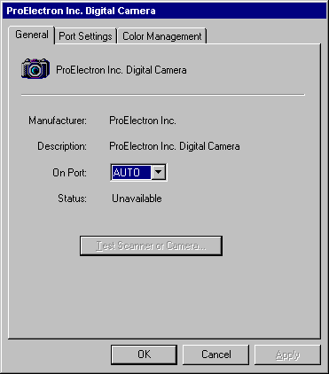
Figure 15.1 General Tab of the Digital Camera Properties Dialog Box
3. Click Test Scanner or Camera to test the device, or select the port the device uses from the On Port list.

Ports
For serial devices, the port tab displays the port being used by the scanner or camera and allows you to configure the baud rate. Change the baud rate to be faster for faster image transfer or slower to accommodate hardware limitations. Do not set the baud rate higher than the fastest speed supported by the hardware, or the image transfer will fail.
To set a serial baud rate
1. From the Start menu, point to Settings, click Control Panel, and then double-click Scanners and Cameras.
2. Select the scanner or camera you want to configure from the list of installed scanners and cameras, and then click Properties.
3. Click the Port Settings tab, shown in Figure 15.2, and then select from the Serial baud rate list box.
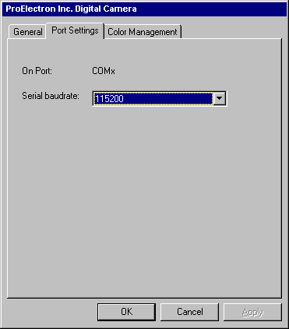
Figure 15.2 Port Settings Tab of the Digital Camera Properties Dialog Box

Image Color Management
The standard color profile for Image Color Management (ICM 2.0) on the World Wide Web, in Microsoft Windows, in Microsoft Office, and in similar display-centric workflows is sRGB, but you can add, remove, or select an alternate color profile for a device.
To add, remove, or select a color profile for a camera or scanner
1. From the Start menu, point to Settings, and then click Control Panel.
2. Double-click Scanners and Cameras.
3. Click the device for which you want to configure color profiles, and then click Properties.
4. Click the Color Management tab, shown in Figure 15.3.
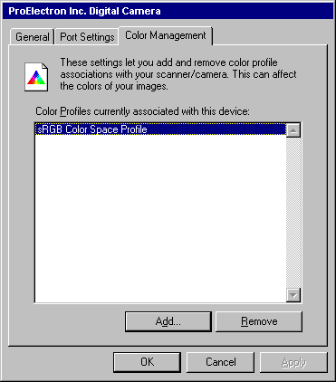
Figure 15.3 Color Management Tab of the Digital Camera Properties Dialog Box
5. To select a color profile, click the profile, and then click OK.
– Or –
Click Add to add a color profile.
– Or –
Click Remove to delete a color profile.

IrTran-P
IrTran-P sets up a session and sends images to Windows 2000 using infrared technology. A camera that supports IrTran-P has a Send button on it that, when pressed, causes the camera to send its stored images to Windows 2000. When the Send button is pressed, the IrTran-P server in Windows 2000 detects the connection the camera is attempting to establish, begins a session, accepts the images, and stores them in the My Pictures folder.
To use IrTran-P, you need an imaging device, typically a camera, that can produce infrared transmissions and a computer that can receive infrared transmissions. IrTran-P devices are generally self-configuring.
To configure IrTran-P devices
1. From the Start menu, point to Settings, click Control Panel, and then double-click Scanners and Cameras.
2. Click Wireless Device, shown in figure 15.4.
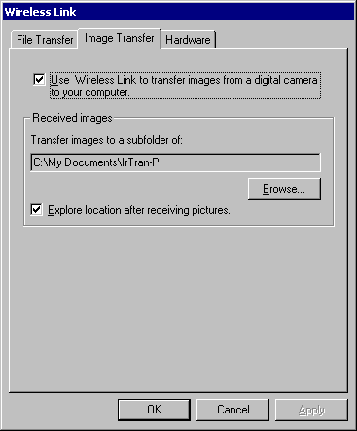
Figure 15.4 Image Transfer tab of the Wireless Link Dialog Box
3. Configure the device as necessary, and then click OK.

Pushbutton Scanning
Pushbutton scanning is typically configured during device installation. However, you might need to associate an application with a push button, if this is not done automatically.
To associate an application with a push button
1. From the Start menu, point to Settings, click Control Panel, and then double-click Scanners and Cameras.
2. Select the scanner that is not working, and click Properties.
3. Click the Events tab, shown in figure 15.5, and associate an application with the pushbutton event.
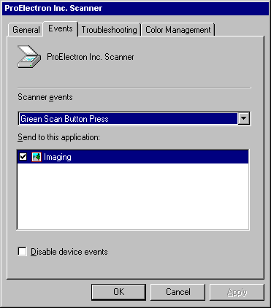
Figure 15.5 Events Tab of the Scanner Properties Dialog Box

Scanner and Camera Concepts
Scanners and cameras use a number of technologies to capture high-quality images, which are then transferred to your computer for editing and use. These technologies include the still imaging architecture, TWAIN, and ICM 2.0.
Still Imaging
Windows 2000 supports still image devices, such as scanners and cameras, by using a set of components that make up the still imaging architecture. Figure 15.6 is a graphical representation of the Windows 2000 still imaging architecture.
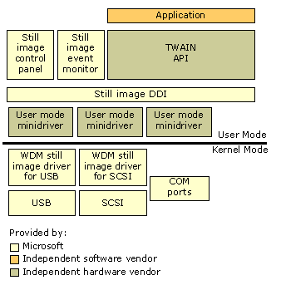
Figure 15.6 Still Imaging Architecture
The still imaging architecture is made up of the following components:
• The application layer appears at the top of the imaging architecture. Users interact directly with the application to initiate image acquisition and manipulate images.
• TWAIN or another application programming interface (API), which acquires images from a device such as a scanner or camera.
• Still scanners and cameras that support ICM 2.0 accurately, which capture still image colors, enabling accurate color information for pictures.
• Scanners and Cameras in Control Panel, which lets you add or remove scanners and cameras, configure ports and baud rates, and add, remove, or and select color profiles.
• The still image event monitor, which waits for device events, such as a user pushing the button on a scanner. When the still image event monitor detects such an event, it launches the default application associated with handling image data.
• The still image device driver interface (DDI), which communicates with devices to send commands. The DDI provides support of SCSI, parallel, serial, infrared, and USB devices. Support for Institute of Electrical and Electronics Engineers (IEEE) 1394 is incorporated using the Win32 Driver Model (WDM). Support for multifunction peripheral (MFP) devices is incorporated into the IEEE 1284.4 (DOT4) driver. For more information, see “Printing” in this book.
• User mode minidrivers are supplied by device manufacturers to implement specific DDI functionality in the manufacturer’s particular hardware. User mode minidrivers inform the DDI about the specific devices capabilities, such as test or status.
• WDM still image drivers. These drivers use the Win32 Driver Model to enable delivery on USB or SCSI buses. Devices that use COM ports do not require WDM drivers. For more information, see “Hardware Management” in this book.

TWAIN
TWAIN is an API. It facilitates seamless communication between imaging devices and software, without requiring that each image device and software combination have a different driver or API implementation. Each scanner or camera has one TWAIN driver that can be used by any application designed to manipulate images. Each layer of the TWAIN architecture works with adjacent layers to pass image data from an input device, such as a camera or scanner, to an application, such as Picture It! Windows 2000 includes version 1.6.1.3 of the TWAIN source manager. The TWAIN source manager lists possible sources of imaging data, such as specific types of scanners or cameras.
TWAIN Architectural Layers
TWAIN is comprised of a number of architectural layers, each of which serve a different function in transferring an image from a scanner or camera to an application. The TWAIN layers are as follows:
• Application layer: An application such as Microsoft Picture It!, which is used to acquire an image from a TWAIN-compliant input device, such as a scanner or digital camera. The application requesting an image sends the request to the TWAIN data source.
• TWAIN data source: A software component written by a hardware vendor to translate between TWAIN commands and device driver commands. Depending on the application, the data source may present a dialog for the user to select settings on the hardware device.
• Device driver: The driver issues commands it receives from the TWAIN data source to the hardware to acquire an image and to check the status of the device.
• Still image device: The physical input device, such as a scanner or digital camera.

Image Color Management 2.0
If a user takes a photograph by using a digital camera and then loads that image onto their computer, the image should look the same on the monitor as it did when it was captured. When this same image is sent to a printer, the printed image should accurately reproduce the appearance of the colors seen by the camera and produced by the monitor.
Because different brands of monitors or printers present colors differently, it can be very difficult to produce images with accurate colors. ICM 2.0 ensures quality results by storing standard, objective color characteristics for each output device.
ICM 2.0 is an application programming interface (API) that conveniently ties together diverse technologies including scanning, capturing, displaying, and printing color pictures to yield consistent, high-quality color images without the user intervention required in the past. Color management solutions software works with profiles. Profiles are data about each device’s representation of color. These profiles provide the operative information that enables the color management software to prepare an accurate color reproduction.
ICM supports international and industry standards, ensuring cross-platform compatibility. Image Color Management is based on the industry standard ICC profile, standardized Color Management Module (CMM), and the default sRGB color space (IEC 61966-2-1: 1999). Although this flexible system allows the use of any CMM, ICM uses LinoColor CMM by default. This makes Windows applications that use ICM 2.0 compatible with other platforms with respect to color management.
ICM provides ease-of-use for applications. For users who don’t need to make advanced configuration choices, ICM 2.0 on Windows 2000 is set up to run transparently for printing. For users wanting to ensure color consistency with different devices and platforms, ICM provides full manual control with easy-to-use selection of alternative color profiles.
ICM has a modular, extensible architecture. Applications have the ability to support two levels of API — one that deals only in RGB, and one that works in multiple color spaces. As developers take advantage of these enhanced capabilities, advanced users are able to manage custom device profiles, work with CMYK, and select an alternate CMM for their color transformations.
ICM supports standard RGB (sRGB). Standard RGB (sRGB) complements current color management strategies by enabling a default method of handling color in the operating system and on the Internet. It efficiently provides good quality color representation and backward compatibility. Based on a calibrated colorimetric RGB color space, which is well-suited to monitors, television, scanners, digital cameras and printing systems, sRGB can be supported with minimum cost to software and hardware vendors.
Standard RGB is an international standard (IEC 61966-2-1: 1999), and is the default color space in Windows HTML, Cascading Style Sheets (CSS), .exif files which are produced by most digital cameras, and .png files. It is freely available to any software or hardware vendor. For more information about IEC 61966-2-1: 1999, see the International Electrotechnical Commission (IEC) link on the Web Resources page at http://windows.microsoft.com/windows2000/reskit/.
Standard RGB is the default color space in Windows 2000 for all color images that do not have another embedded profile or are not specifically tagged with other color information.
Table 15.2 highlights how ICM uses sRGB to handle colors when the application being used supports ICM 2.0. For example, the source might be a scanner or camera, and the destination might be a monitor or printer.
Table 15.2 Comparison of Color Profile Outcomes

Image has source color profile Image has no source color profile

Destination has color profile Both profiles in the color mapping are used. sRGB is used as the source profile and use the destination profile in the color mapping.
Destination has no color profile The source profile is used and sRGB is used as the destination profile in the color mapping. No ICM is used. Nothing is done (assume sRGB is the profile for source and destination).
Troubleshooting
The following are some of the most common problems you might encounter when using scanners or cameras and some possible solutions.
Can’t Access Scanner or Digital Camera
You might need to provide scanner drivers to complete the installation. Use the Scanner and Camera Installation wizard to install or reinstall the device that is not working.
To start the Scanner and Camera Installation wizard
1. In Control Panel, double-click Scanners and Cameras.
2. Click Add.

Alternately, if you are using a multifunction peripheral (MFP) device, Windows 2000 might not have properly detected your scanning device at startup. Shut down your computer and MFP, then turn on your MFP first, followed by your computer. This might help Windows 2000 recognize all the features of your MFP.
Finally, some older parallel port drivers that worked on Windows NT, and VXD drivers that worked on Windows 98, do not work with Windows 2000. If you are using drivers from older versions of Windows, contact the hardware manufacturer for updated drivers.
Pushbutton Scanning Fails
Pushbutton scanning most commonly fails because no applications are associated with the push button. To associate an application with the push button, see “Pushbutton Scanning” earlier in this chapter.
General Troubleshooting
Use the Troubleshoot button in Scanners and Cameras Properties to diagnose common scanner errors.

