Chapter 22 - TCP/IP in Windows 2000 Professional

Microsoft has adopted TCP/IP as the strategic enterprise network transport for its platforms. TCP/IP for Microsoft® Windows® 2000 is a high-performance, scaleable implementation of the industry-standard TCP/IP protocol. This chapter provides technical and configuration details about the Microsoft TCP/IP protocol as implemented in Microsoft® Windows® 2000 Professional.
In This Chapter
TCP/IP Configuration Quick Guide
Overview of Windows 2000 TCP/IP
Install TCP/IP
Configure IP Address Assignment
Configure TCP/IP Name Resolution
Configure Multihoming
Configure Local IP Routing Table
Configure Internet Connection Sharing
Configure IP Security and Filtering
Configure Quality of Service
Perform TCP/IP Troubleshooting
Related Information in the Windows 2000 Resource Kit
• For more information about installing and configuring a DHCP server, see “Dynamic Host Configuration Protocol” in the Microsoft® Windows® 2000 Server Resource Kit TCP/IP Core Networking Guide.
• For more information about IP routing, address translation and IP packet handling, see “Unicast IP Routing” in the Microsoft® Windows® 2000 Server Resource Kit Internetworking Guide.

TCP/IP Configuration Quick Guide
This chapter provides information about installing, configuring and troubleshooting the TCP/IP protocol in Windows 2000 Professional. Additionally, there is information to assist you in planning and deploying TCP/IP installation on a Windows 2000 – based computer. Use the following Quick Guide to determine where to find the information you need to configure TCP/IP to meet your networking requirements.
Understand your network requirements for TCP/IP.
An understanding of the features found in the Windows 2000 Professional implementation of TCP/IP will assist in your implementation of the protocol on a client, as well as illustrate how it compares to other Microsoft operating systems, such as Microsoft® Windows NT®.
• See “Overview of Windows 2000 TCP/IP” later in this chapter.

Verify that TCP/IP is properly installed.
TCP/IP is installed as the default protocol in a clean install of Windows 2000 Professional. If you have installed Windows 2000 Professional over an existing client, or performed a custom installation, make sure to confirm TCP/IP installation.
• See “Install TCP/IP” later in this chapter.

Choose and configure an IP addressing method.
Depending on your home, small business, or enterprise network configuration, two methods of IP address assignment are available for a Windows 2000 Professional– based client: automatically obtain an IP address or manually specify an IP address. When you configure TCP/IP to automatically obtain an IP address, either Dynamic Host Configuration Protocol (DHCP) or Automatic Private IP Assignment (APIPA) is used to provide an IP address (default setting). Select and configure the addressing method that best meets your needs.
• See “Configure IP Address Assignment” later in this chapter.

Choose and configure a name resolution method.
Depending on the type of network access needed by your Windows 2000 Professional– based client, one or more of the following methods can be used to identify your computer by name, rather than IP address: Domain Name System (DNS), Windows Internet Name Service (WINS), Lmhosts/Hosts file, or B-node (broadcast) name resolution.
• See “Configure TCP/IP Name Resolution” later in this chapter.

Configure multihoming, if needed.
If your Windows 2000 Professional configuration requires multiple network adapters, is connected logically to multiple networks, or uses different network connection types, configure TCP/IP addressing for each logical connection.
• See “Configure Multihoming” later in this chapter.

Configure local routing table.
The local IP routing table on your Windows 2000 Professional computer must be configured to enable communication with other computers outside the local subnet. Depending on the enterprise configuration, the local route table can be automatically configured by using routers meeting specifications for ICMP Router Discovery or Routing Information Protocol (RIP). Otherwise, default gateways and the routing table might be necessary.
• See “Configure Local Routing Table” later in this chapter.

Install and configure Internet Connection Sharing, if needed.
For small business and home office configurations, Internet Connection Sharing (ICS) can be installed and configured to allow computers in a private network to share a single public IP address and Internet connection to access the Internet.
• See “Configure Internet Connection Sharing” later in this chapter.

Configure IP security methods, if needed.
To secure information within the network, IP filtering can be enabled on the Windows 2000 Professional– based client to limit the type of IP packets received. On a stand-alone computer or a member of a Windows 2000 domain, IP security can be enabled to provide data validation and encryption at the packet layer.
• See “Configure IP Security and Filtering” later in this chapter.

Configure Quality of Service, if needed.
In a Windows 2000 – based enterprise with QoS-aware devices, enabling QoS at the Windows 2000 – based client can assist in the management of network bandwidth and allow prioritization of data within the network.
• See “Configure Quality of Service” later in this chapter.

Diagnose network failures by troubleshooting your configuration.
Follow the troubleshooting guidelines to recover from an installation or configuration failure or to perform other diagnostic functions related to TCP/IP.
• See “Perform TCP/IP Troubleshooting” later in this chapter.

Overview of Windows 2000 TCP/IP
Transmission Control Protocol/Internet Protocol (TCP/IP) provides communication across interconnected networks that use diverse hardware architectures and various operating systems. TCP/IP can be used to communicate with computers running Windows 2000, with devices using other Microsoft networking products, or with non-Microsoft systems such as UNIX.
TCP/IP in Windows 2000 Professional improves upon the functionality that TCP/IP provided in Microsoft® Windows NT® Workstation version 4.0. Table 22.1 shows Windows 2000 TCP/IP features:
Table 22.1 Features of TCP/IP in Windows 2000

Feature Benefit

Logical and physical multihoming Allows association of multiple IP addresses to a single or multiple network adapters for internetwork connectivity.
Internal IP routing capability Allows a Windows 2000 Professional workstation to route packets between multiple network adapters.
Multiple configurable default gateways Allows configuring multiple default gateways to improve network reliability and uptime.
Dynamic Host Configuration Protocol (DHCP) Simplifies host configuration through automatic configuration of IP address and other parameters.
Virtual private networking Permits secured transmission of data across public networks through encapsulated and encrypted packets.
Windows Sockets Version 2 (Winsock2) interface Standard application programming interface (API) permits access to networking features.
Domain Name System (DNS) A server-based mapping of friendly names to IP addresses.
NetBIOS interface The use of NetBIOS sessions, datagrams, and name management over TCP/IP.
Windows Internet Name Service (WINS) A server-based mapping of NetBIOS names to IP addresses.
Microsoft browsing support Browser-enabled services can view resources on a TCP/IP internetwork.
Simple Network Management Protocol (SNMP) agent Permits performance and resource monitoring of a TCP/IP-based client.
TCP/IP connectivity tools Finger, Ftp, Rcp, Rexec, Rsh, Telnet and Tftp commands allow access to heterogeneous hosts across a TCP/IP-based network.
TCP/IP simple services Chargen, daytime, discard, echo, and Quote of the Day client and server utilities.
TCP/IP management and diagnostic tools Arp, Ipconfig, Nbtstat, Ping, Route, Nslookup, Tracert, and Pathping provide maintenance and diagnostic features.
TCP/IP network printing Permits printing on non-Windows connected devices, such as UNIX-connected devices.
What's New in Windows 2000 TCP/IP
TCP/IP in Windows 2000 builds upon the networking strengths found in Windows NT Workstation 4.0 and Microsoft® Windows® 98. These improvements result in a scalable networking platform that can be implemented in a variety of environments, from a small office/home office configuration, to a powerful workstation within a multidomain enterprise.
The improvements made in Windows 2000 Professional can be categorized into five areas, each presented in this chapter:
• Address assignment and IP packet handling
• Name resolution
• IP security
• Quality of Service (QoS)
• TCP Performance

Address Assignment and IP Packet Handling
Windows 2000 makes setting up small office/home office (SOHO) configurations easier through two new features. Automatic Private IP Addressing (APIPA) assigns an IP address and subnet mask to a Windows 2000 Professional computer if a DHCP server is not available. Access to outside networks is also facilitated through Internet Connection Sharing (ICS), which translates private IP addresses to a single public IP address, which can access other intranets or the Internet.
Configuration of large enterprise networks is facilitated through the addition of several new features. ICMP Router Discovery automatically configures a default gateway for a Windows 2000 Professional host. ICMP Router Discovery allows clients to discover gateways dynamically. TCP/IP over ATM permits the use of Asynchronous Transfer Mode (ATM) adapters connected to ATM-based, packet-switched networks.
Name Resolution
Windows 2000 Professional includes several modifications to its IP address/name resolution process to make it an Internet-ready client. DNS is the default name resolution method for the Windows 2000 environment, replacing NetBIOS as the default name management method for Windows-based domains.
To facilitate maintenance of DNS record databases, Microsoft® Windows® 2000 Server supports dynamic update, as specified in Request for Comments (RFC) 2136. Windows 2000 Professional provides dynamic update of DNS servers that are compliant with RFC 2136, providing address and domain name updates directly or through a DHCP server.
A number of additional improvements have been made in DNS, including support for an extended character set (RFC 2181), client-side caching, connection-specific domain names, and improved performance through subnet prioritization.
IP Security
Windows 2000 provides network security through the implementation of IP security (IPSec). IPSec is a set of rules and protocols defined by the Internet Engineering Task Force (IETF) that provide encryption, data authentication, and data integrity at the packet level. These features are enabled below the network layer, requiring no change to the existing network and application infrastructure to deploy IP security. Local and domain-based IPSec policies can be created to implement IP security.
Quality of Service
As multimedia-rich applications such as video conferencing and video-on-demand become more pervasive within a network, the issues of network bandwidth and the quality of data transmission become more critical. Windows 2000 Professional addresses this through its implementation of Quality of Service (QoS), a set of specifications that determine the network requirements needed by a multimedia or qualitative application. Windows 2000 Professional also implements the Resource Reservation Protocol (RSVP), which allows an application or service to reserve a specific amount of bandwidth needed for data transmission.
TCP Performance
Windows 2000 Professional includes enhancements to TCP that improve the performance of TCP/IP-based networks. Larger default TCP receive window size increases performance on high-speed networks. Window scaling, as documented in RFC 1323, allows the use of a very large TCP receive window in high bandwidth, high delay environments. To improve performance in high-loss environments such as the Internet, selective acknowledgments (SACKs) enables a receiving host to selectively acknowledge only the data it has received.
Comparison of Windows 2000 Features
Table 22.2 displays the new features implemented in Windows 2000, compared to Windows 98 and Microsoft® Windows NT® version 4.0.
Table 22.2 Comparison of Windows 2000 TCP/IP Features

Windows 2000 TCP/IP Feature Windows 98 Windows NT 4.0

Address Assignment/Packet Handling
Automatic Private IP Addressing (APIPA) yes no
Shared Internet connection yes (SE) no
ICMP Router Discovery yes no
IP multicasting (IGMP version 2) yes yes (IGMP version 1)
TCP/IP over ATM no no
Name Resolution
Dynamic update of DNS no no
Support for extended character set (RFC 2181) yes no
Connection-specific domain names yes no
DNS integration with Active Directory no no
Security Features
IP packet-level security no no
Rules-based security policies no no
Data encryption no no
Kerberos authentication method no no
Public and private key authentication yes yes
Data authentication no no
PPTP yes yes
L2TP no no
Quality of Service
QoS packet scheduling no no
RSVP support no no
TCP/IP Performance
Larger default window sizes no no
Scalable window sizes no no
Selective acknowledgment yes no
Install TCP/IP
Setup installs TCP/IP by default if you have accepted the default Windows 2000 Professional installation options. If you are upgrading to Windows 2000 Professional, however, Setup replaces your existing network configuration.
If your original Windows installation included a third-party TCP/IP protocol stack, Setup replaces the existing TCP/IP protocol. If there are features that are required by your third-party stack you must determine whether they are supported by Windows 2000 TCP/IP. If these features are required, you must install the third-party stack by using the installation tool provided by your network vendor.
To install Windows 2000 TCP/IP after Windows 2000 Professional Setup
1. In Control Panel, double-click Network and Dial-up Connections.
2. Right-click the connection you want to modify.
3. Select Properties.
4. On the General tab, click Install.
5. Select Protocol.
6. Click Add.
7. In Network Protocol, select TCP/IP and click OK
8. When prompted, click Yes to restart the computer.

Configure IP Address Assignment
This section provides an overview of the methods available for assigning IP addresses to individual Windows 2000 Professional – based clients in a TCP/IP network. It presents an explanation of each configuration method, including issues you might want to consider when implementing each method.
Choose an IP address assignment method. Windows 2000 Professional provides three methods for assignment of IP addresses to TCP/IP clients: Dynamic Host Configuration Protocol (DHCP), which automatically configures clients in an enterprise with a DHCP server; Automatic Private IP Addressing (APIPA), which automatically assigns an IP address to clients in a single-subnet environment; and manual configuration of IP addresses. Choose the method that meets your environment and client requirements. See “Overview of IP Address Assignment” later in this chapter.
If automatic host configuration is desired, and a DHCP server is available, enable DHCP. DHCP provides automatic configuration of IP addresses and other configuration options for clients in a network with one or more DHCP servers. It is the default addressing method in Windows 2000 Professional. See “Configure DHCP” later in this chapter.
If automatic IP address assignment is desired, but no DHCP server is available, enable DHCP to use Automatic Private IP Addressing (APIPA). APIPA provides automatic IP address assignment for computers on networks without a DHCP server. A Windows 2000 Professional– based client assigns itself an IP address from a reserved class B network (169.254.0.0 with the subnet mask of 255.255.0.0), which cannot directly communicate with hosts outside this subnet, including Internet hosts. This option is most suitable for small, single-subnet networks, such as a home or small office. APIPA is configured by default if no DHCP servers are available on the network. See “Configure Automatic Private IP Addressing” in this chapter.
If DHCP or APIPA cannot be used, configure IP address manually. If your network does not include a DHCP server, and APIPA cannot be used, use manual IP addressing. You must configure the IP address and subnet mask to meet your client’s connectivity requirements. See “Configure IP Address Manually” in this chapter.
Overview of IP Address Assignment
Each computer on a TCP/IP network must be identified by a unique 32-bit IP address to be able to communicate on a private network or the Internet. IP addresses can be grouped into two classes of IP addresses, public IP addresses and private IP addresses. These address classes are assigned by the Internet Assigned Numbers Authority (IANA), which is responsible for the management and assignment of IP addresses on the Internet and to private organizations.
Public IP addresses
On the Internet, the IANA assigns groups of IP addresses to organizations. The organizations can then assign IP addresses within those groups to individual computers. This prevents multiple computers from having the same IP address. For a computer to be visible on the Internet, it must be reachable through a public IP address.
The public IP address for your Windows 2000 Professional– based computer can be assigned through a Dynamic Host Configuration Protocol (DHCP) server available in your enterprise network, configured manually, or provided by an Internet service provider (ISP) through a dial-up connection.
Private IP addresses
The IANA has reserved a certain number of IP addresses that are never used on the global Internet. These private IP addresses are used for networks that do not want to directly connect to the Internet, but require IP connectivity. For example, a user wanting to connect multiple Windows 2000 Professional– based computers in a home network can use the Automatic Private IP Addressing (APIPA) feature to allow each computer to automatically assign itself a private IP address. The user does not need to configure an IP address for each computer, nor is a DHCP server needed.
Internet connectivity can be obtained in a network by using private IP addressing through the use of a computer with proxy or network address translator (NAT) capabilities. Windows 2000 Professional includes the Internet Connection Sharing (ICS) feature that provides NAT services to clients in a private network. For more information about Internet Connection Sharing, see “Configure Internet Connection Sharing” later in this chapter.
Dynamic Host Configuration Protocol
A configured DHCP server provides a database of available IP addresses. The server can also be set up to provide configuration options for DHCP clients, including addresses of DNS and WINS servers, gateway addresses, and other information.
At startup, each DHCP client requests configuration data from the server, permitting automatic configuration of the IP address, subnet mask and other options. The IP address is assigned to each client for an amount of time determined at the server, called a lease, which can be periodically renewed. At conclusion of the lease, the client attempts to renew the lease, or the IP address is returned to the database and is made available to other DHCP clients. DHCP provides an efficient IP configuration option for larger networks, providing simplified client configuration, and reuse of IP addresses.
Automatic Private IP Addressing
Automatic Private IP Addressing (APIPA) is appropriate for simple networks that have only one subnet. With APIPA, if no DHCP server is available, the computer automatically assigns itself a private IP address. If a DHCP server later becomes available, the computer changes its IP address to one obtained from a DHCP server. Computers using APIPA addresses can communicate only with other computers using APIPA addresses, on the same subnet. They are not directly reachable from the Internet.
Static IP Addressing
With static IP addressing, you must manually configure the IP address. This method can be time-consuming and prone to error, especially on medium to large networks. It is recommended if DHCP and APIPA are not available or feasible.
Configure DHCP
In an effort to make implementing the TCP/IP protocol more manageable, Microsoft worked with other industry leaders to create an Internet standard called Dynamic Host Configuration Protocol (DHCP) for the automatic allocation of TCP/IP configuration. DHCP is not a Microsoft standard, but a public Request for Comments (RFC) 2131 that Microsoft has implemented.
Implementing a DHCP server within an enterprise allows a network administrator to establish a range of valid IP addresses to be used per subnet and a series of options providing configuration beyond the IP address such as the subnet mask, the default gateway, and DNS and WINS server addresses. An individual IP address from the range and its associated options are assigned dynamically to any DHCP client requesting an address. If DHCP is available company-wide, users can move from subnet to subnet and always have a valid IP address. DHCP also allows the establishment of a lease time that defines how long an IP address configuration is to remain valid. A Microsoft® Windows NT® Server version 3.5 or later computer running the DHCP service can act as a DHCP server.
Note For more information about installation and configuration of the DHCP service on Windows 2000 Server, see “Dynamic Host Configuration Protocol” in the TCP/IP Core Networking Guide.
DHCP Lease Process
The first time a Windows 2000 Professional– based client with DHCP enabled starts and attempts to join a network, it automatically follows an initialization process to obtain a lease from a DHCP server. Figure 22.1 shows the lease process.
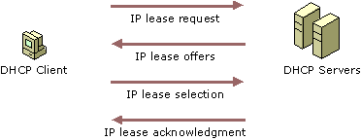
Figure 22.1 The DHCP Lease Process
1. The Windows 2000 Professional DHCP client requests an IP address by broadcasting a message (known as a DHCPDiscover message) to the local subnet.
2. The client is offered an address when a DHCP server responds with a message containing an IP address and configuration information for lease to the client (DHCPOffer). If no DHCP server responds to the client request, the Windows 2000 Professional– based client can proceed in two ways:
• If the Automatic Private IP Addressing (APIPA) feature has not been disabled, the client self-configures a unique IP address from the range 169.254.0.1 to 169.254.255.254. For more details, see “Configure Automatic Private IP Addressing” in this chapter.
• If APIPA has been disabled, the client network initialization fails. The client continues to resend DHCPDiscover messages in the background until it receives a valid lease from a DHCP server. The client makes four attempts to obtain a lease, one every five minutes.

3. The client indicates acceptance of the offer by selecting the offered address and replying to the server with a DHCPRequest message.
4. The client is assigned the address and the DHCP server sends an acknowledgment message (DHCPAck), approving the lease. Other DHCP option information, such as default gateway and DNS server addresses might be included in the message.
5. After the client receives acknowledgment, it configures its TCP/IP properties using any DHCP option information in the DHCPAck message, and completes the initialization of TCP/IP.

In rare cases, a DHCP server might return a negative acknowledgment to the client. This can happen if a client requests an invalid or duplicate address. If a client receives a negative acknowledgment (DHCPNak), the client must begin the entire lease process again.
Restarting a DHCP Client
When a Windows 2000 Professional– based client that previously leased an IP address restarts, it broadcasts a DHCPRequest message, containing a request for the previously assigned IP address. If the requested IP address is available, the DHCP server responds with an acknowledgment message, and the client joins the network.
If the IP address cannot be used by the client because it is no longer valid, in use by another client, or invalid because the client has been physically moved to a different subnet, the DHCP server responds with a negative acknowledgment (DHCPNak). If this occurs, the client must restart the lease process.
DHCP Lease Renewals
To ensure that addresses are not left in an assigned state when they are no longer needed, the DHCP server places an administrator-defined time limit, known as a lease duration, on the address assignment.
Halfway through the lease period, the DHCP client requests a lease renewal, and the DHCP server extends the lease. If a computer stops using its assigned IP address (for example, if a computer is moved to another network segment or is removed), the lease expires and the address becomes available for reassignment.
Configuring the Windows 2000 Professional DHCP Client
When TCP/IP is first installed, Windows 2000 Professional automatically enables the option to obtain an IP address from a DHCP server. You can disable this option if you want to manually enter IP addresses. For more information about disabling DHCP, see “Configure IP Address Manually” late in this chapter.
The IP configuration tool (Ipconfig) allows users or administrators to examine the current IP address configuration assigned to the computer, the IP address lease time, and other useful data about the TCP/IP configuration.
Configure Automatic Private IP Addressing
The new IP address autoconfiguration feature of TCP/IP in Windows 2000, known as Automatic Private IP Addressing (APIPA), allows home users and small business users to create a functioning, single subnet TCP/IP network without having to manually configure the TCP/IP protocol or set up a DHCP server.
APIPA allows a Windows 2000 Professional DHCP client to assign itself an IP address in the following circumstances:
• The client is configured to obtain a lease DHCP, but a DHCP server cannot be found, is unavailable, or is not used (for example, in a small office/home office network).
• The client used DHCP to obtain a lease, but attempts to renew the lease through a DHCP server have failed.

For more information about the DHCP lease and renewal process, see the previous discussion in “Configure DHCP” earlier in this chapter.
In these circumstances, a Windows 2000 Professional DHCP client autoconfigures the TCP/IP protocol with a selected IP address from the Internet Assigned Numbers Authority (IANA)-reserved class B network 169.254.0.0 with the subnet mask 255.255.0.0. The DHCP client performs duplicate address detection to ensure that the IP address it has chosen is not already in use. If the address is in use, it selects another IP address and reselects addresses up to 10 times. After the DHCP client has selected an address that is verifiably not in use, it configures the interface with this address. The client continues to check for a DHCP server in the background every five minutes, and if a DHCP server is found, the autoconfiguration information is abandoned and the configuration offered by the DHCP server is used instead.
To determine whether Automatic Private IP Addressing is currently enabled
• At the command prompt, type ipconfig /all. The resulting text identifies your IP address and other information. Check the line that reads “Autoconfiguration Enabled.” If the text reads “YES” and the IP address lies in the 169.254.x.x range, Automatic Private IP Addressing is enabled.

You can disable automatic private IP addressing in one of two ways:
• You can manually configure TCP/IP by following the procedure outlined in the section “Configure IP Address Manually” later in this chapter. This method also disables DHCP.
• You can also disable automatic private IP addressing for a given adapter (but not DHCP) by editing the registry.

You do this by adding the registry entry IPAutoconfigurationEnabled with a value of 0x0 (REG_DWORD data type) in the following subkey:
HKEY_LOCAL_MACHINE\SYSTEM\CurrentControlSet\Services \Tcpip\Parameters\Interfaces\<adapter>
Use a registry editor to add this entry, then shut down and restart the computer.
This registry entry is specific to each adapter. If multiple adapters are installed, you can disable APIPA for all installed adapters by setting the value of the IPAutoconfigurationEnabled entry to 0 (REG_DWORD data type) in the following registry subkey:
HKEY_LOCAL_MACHINE\SYSTEM\CurrentControlSet\Services \Tcpip\Parameters
Caution Do not use a registry editor to edit the registry directly unless you have no alternative. The registry editors bypass the standard safeguards provided by administrative tools. These safeguards prevent you from entering conflicting settings or settings that are likely to degrade performance or damage your system. Editing the registry directly can have serious, unexpected consequences that can prevent the system from starting and require that you reinstall Windows 2000. To configure or customize Windows 2000, use the programs in Control Panel or Microsoft Management Console (MMC) whenever possible.
Note APIPA only assigns an IP address and subnet mask. APIPA does not assign a default gateway, the IP addresses of DNS server, or the IP addresses of WINS servers. Use APIPA only on a single subnet network that contains no routers. If your small office or home office network is connected to the Internet or an organization intranet, then do not use APIPA.
Configure IP Address Manually
If you cannot use DHCP or APIPA for IP address and subnet assignment, the IP address for the Windows 2000 Professional– based client must be manually configured. The required values include the following:
• The IP address for each network adapter installed on the computer.
• The subnet mask corresponding to each network adapter’s local network.

To configure TCP/IP manually
1. In Control Panel, open Network and Dial-up Connections.
2. Right-click the local area connection you want to modify.
3. Select Properties.
4. In the General dialog box, select Internet Protocol (TCP/IP).
5. Click Properties.
6. In the General dialog box, select the Use the following IP address option.
7. Type the IP address, subnet mask, and default gateway in the respective boxes.
The network administrator must provide these values for individual users, based on the IP addressing plan for your site.
• The value in the IP Address box identifies the IP address for the interface.
• The value in the Subnet Mask box is used to identify the network ID for the selected network adapter.

8. Click OK to save the IP addressing information.
9. Click OK to save the connection properties.

Configure TCP/IP Name Resolution
This section provides an overview of the methods available for configuring TCP/IP name resolution on a Windows 2000 Professional– based client. It presents an explanation of each configuration method, including issues you might want to consider when implementing each method.
Choose name resolution method. Windows 2000 Professional provides four methods for resolving names to IP addresses:
• Domain Name System (DNS) for applications and services that require host-to-IP name resolution, such as Active Directory
• Windows Internet Name Service (WINS), for compatibility with applications and services that require NetBIOS-to-IP name resolution, such as browsing functions of previous versions of Windows
• Hosts and Lmhosts files, which provide host-to-IP and NetBIOS-to-IP name resolution via manually-maintained local files; and b-node broadcasts, which can be used for NetBIOS name resolution within the local subnet.

Choose the methods that meet your environment and client requirements. See “Overview of TCP/IP Name Resolution” later in this chapter.
If DNS is used, configure settings. DNS is the default name resolution method for Windows 2000 – based clients, and is required for integration in a Windows 2000 Active Directory domain. To use this name resolution method, it must be properly configured. Use Table 22.3 to find information on the area of DNS you are configuring.
Table 22.3 DNS Configuration Topics

To configure this DNS setting . . . . . . refer to this section

Configure client name “Configuring Host and DNS Domain Names”
Configure primary DNS suffix “Configuring Host and DNS Domain Names”
Configure connection-specific DNS suffix “Configuring Host and DNS Domain Names”
Specify the addresses of available DNS servers “Specifying DNS Servers”
Configure the way the DNS client resolves host names “Configuring DNS Query Settings”
Optimize the local DNS cache “DNS Performance and Security”
Prevent DNS client from accepting non-queried servers “DNS Performance and Security”
Configure dynamic update, if used “Configure Dynamic Update”
If Hosts file is used for host name resolution, edit file. For networks without access to a DNS name server, creation of a Hosts file can provide host name resolution for applications and services. This file can also be used in an environment where name servers are available, but not all hosts are registered; for example, a server that is not available for general use, but is only to be accessed by a limited number of clients. This file must be manually created and updated as host names and addresses change. See “Configure Hosts File” later in this chapter.
If WINS is used, configure settings. WINS provides name-to-IP resolution for applications and services using the NetBIOS command set for networks with a WINS server. If your network environment meets these requirements, the IP addresses of WINS servers needs to be configured on your Windows 2000 Professional– based client to provide NetBIOS name resolution. In a network where dynamic update is not available, a WINS server can provide a DNS server configured for WINS lookup with dynamic updates of host names, provided that WINS is enabled at each client. See “Configure NetBIOS Name Resolution” later in this chapter.
If Lmhosts file is used, modify file and configure settings. For networks without access to a WINS name server, creation of an Lmhosts file can provide NetBIOS name resolution for application and services. This file can also be used in an environment where name servers are available, but not all hosts are registered; for example, a server that is not available for general use, but is only to be accessed by a limited number of clients. This file must be manually created and updated as computer names and addresses change. See “Configure NetBIOS Name Resolution” later in this chapter.
If none of the above name resolution methods are enabled or successful in name resolution, local broadcasts are used. To resolve NetBIOS names within the local subnet, b-node, or broadcast name resolution, can be used to determine the IP address for a NetBIOS name. See “Configure NetBIOS Name Resolution” later in this chapter.
Overview of TCP/IP Name Resolution
TCP/IP-based services use IP addresses to identify each other, but users and applications frequently require computer names for host identification. A name resolution mechanism must be available on a TCP/IP network to resolve names to IP addresses.
When a request for name-to-IP address resolution is made, the Windows 2000 resolver first submits the name query to DNS. If DNS name resolution fails, the resolver checks to see whether the name is longer than 15 bytes. If it is longer, resolution fails. If not, the resolver then checks to see if NetBIOS is running. If it is not running, resolution fails. If it is running, the resolver then tries NetBIOS name resolution.
Figure 22.2 and Figures 22.6 and 22.7 show an overview of the process.
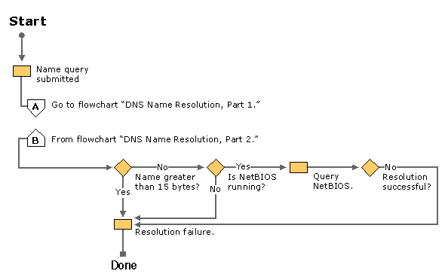
Figure 22.2 Overview of Name Resolution
Windows 2000 Professional provides several different types of name resolution, including DNS, WINS, name resolution using Hosts or Lmhosts files, and broadcast name resolution. Generally, a Windows 2000 Professional– based computer uses a combination of these name resolution types, summarized in this section.
Domain Name System Name Resolution
The Domain Name System (DNS) is a global, distributed database based on a hierarchical naming system. DNS name resolution is used on the Internet to map friendly names to IP addresses, and vice versa. DNS replaces the functionality of the Hosts file, which requires manual maintenance at each workstation.
In previous versions of Windows, NetBIOS was used as the primary method of name-to-IP resolution. In Windows 2000, DNS is the default name resolution method. The hierarchical naming structure of DNS compliments the hierarchical planning structure implemented in the Active Directory™ directory service, and is used as its naming service. Active Directory is integrated into DNS in other ways as well, for example, system administrators can integrate DNS zones into Active Directory, which provides greater fault tolerance.
Windows 2000 Professional supports DNS dynamic update. Dynamic update is a new standard, specified in RFC 2136, that provides a means of dynamically updating host data in a DNS database. Updates can come from DNS clients and servers, DHCP servers, or Active Directory domain controllers. For more information about dynamic update, see “Configure Dynamic Update” later in this chapter.
Windows Internet Name Service
Windows Internet Name Service (WINS) name resolution provides mapping of static and dynamic NetBIOS names to IP addresses. Computers running Windows 2000 TCP/IP can use WINS if one or more Microsoft® Windows NT® Server– based computers configured as WINS servers are available. WINS is a dynamic replacement for the Lmhosts file.
WINS client support is configured with Windows 2000 Professional to maintain compatibility with non-Windows 2000 – based hosts, including clients and servers running previous versions of Windows.
Hosts and Lmhosts Files
Hosts and Lmhosts files, also called host tables, are files that Windows 2000 Professional can use for local name resolution when other methods are not available. An Lmhosts file is a list of NetBIOS name and IP address mappings. When WINS is not available, it is used as a WINS equivalent to resolve remote NetBIOS names to IP addresses. Likewise, a Hosts file is a list of host name to IP address mappings. It is used as a local name resolution resource to resolve host names to IP addresses. You must manually enter the name-to-IP address mappings in Hosts and Lmhosts files.
Broadcast Name Resolution
Computers running Windows 2000 TCP/IP can use local broadcast name resolution, which is a NetBIOS-over-TCP/IP mode of operation defined in RFC 1001/1002 as b-node. It is restricted to the local subnet. This method relies on IP subnet and media access control (MAC)-level broadcasts by a host for name registration and announcement on the network. Each computer in the broadcast area is responsible for challenging attempts to register a duplicate unique name and for responding to name queries for its registered unique name.
Determining Which Name Resolution Method to Use
You need to determine whether Windows 2000 Professional– based clients must be configured to use DNS, WINS, or a combination of the two. In general, DNS is recommended under the following circumstances:
• The client is a member of a Windows 2000 domain that uses Active Directory.
If the Windows 2000 Professional– based computer is to be made a member of a Windows 2000 domain, DNS must be configured. Active Directory is tightly integrated with DNS, and DNS is used by Active Directory as its locator service. A locator service assists clients in a Windows 2000 domain to find other hosts and services by knowing only the domain name.
• Internet or intranet access using DNS is required.
You must use DNS if you are using TCP/IP to communicate over the Internet or if your private internetwork uses DNS to resolve host names. If the DNS server is not dynamic update-compliant, DNS can be used in conjunction with WINS to automatically resolve host names.

NetBIOS over TCP/IP (NetBT) support is provided as part of Windows 2000 Professional configuration to provide name resolution and connection services for clients using earlier versions of the Windows operating system, applications and services. If a WINS server is available within your network, configure your Windows 2000 Professional– based computer to use WINS under the following circumstances:
• The client is a member of a non-Windows 2000 domain or workgroup.
• The client is a member of a Windows 2000 workgroup where a DNS server is not available.
• The client is part of a network where the DNS server uses WINS lookup for dynamic name resolution.
• The client uses applications or services that require NetBIOS name resolution.

If a WINS server is not available, configure the Windows 2000 Professional– based client to use a Hosts file for DNS host name resolution, or Lmhosts for NetBIOS name resolution. Otherwise, broadcasts are used to provide NetBIOS name resolution, which cannot resolve host names outside the local subnet.
You also need to determine if automatic configuration is available at the DHCP server. If you use DHCP for automatic configuration, a DHCP server can provide client configuration details (DNS and WINS server addresses, host name). If you do not use DHCP, you must manually configure these parameters.
Configure DNS Name Resolution
The Domain Name System (DNS) provides name-to-IP mapping by a distributed database. A Windows 2000 Professional– based client configured for DNS name resolution can query one or more DNS servers for name resolution services. This section describes the procedures for performing the following tasks:
• Configuring DNS Host and Domain Names
• Configuring DNS Query Settings
• Specifying DNS Servers
• DNS Performance and Security

Configure DNS Host and Domain Names
Table 22.4 summarizes the differences between each kind of name used in TCP/IP under Windows 2000, using the example fully qualified domain name (FQDN) client1.reskit.com.
Table 22.4 DNS and NetBIOS Names

Name Type Description

NetBIOS name A NetBIOS name is used to uniquely identify a NetBIOS service listening on the first IP address that is bound to an adapter. This unique NetBIOS name is resolved to the IP address of the server through broadcast, WINS, or the Lmhosts file. By default, it is the same as the host name up to 15 characters, plus any spaces necessary to make the name 15 characters long, plus the service identifier.The NetBIOS name is also known as a NetBIOS computer name.For example, a NetBIOS name might be Client1.
Host name The term host name can mean either the FQDN or the first label of an FQDN. In this chapter, host name refers to the first label of an FQDN.For example, the first label of the FQDN client1.reskit.com is client1.
Primary DNS suffix Every Windows 2000–based computer can be assigned a primary DNS suffix to be used in name resolution and name registration. The primary DNS suffix is specified on the Network Identification tab of the properties page for My Computer.The primary DNS suffix is also known as the primary domain name and the domain name.For example, the FQDN client1.reskit.com has the primary DNS suffix reskit.com.
Connection-specific DNS suffix The connection-specific DNS suffix is a DNS suffix that is assigned to an adapter.The connection-specific DNS suffix is also known as an adapter DNS suffix.For example, a connection-specific DNS suffix might be reskit.com.
Fully qualified domain name (FQDN) The FQDN is a DNS name that uniquely identifies the computer on the network. By default, it is a concatenation of the host name, the primary DNS suffix, and a period.The fully qualified domain name is also known as the full computer name.For example, an FQDN might be client1.reskit.com.
Computer and NetBIOS Names The DNS host name is taken from the computer name assigned to it during Windows 2000 Professional installation. The host name can be 63 characters long, and uses the character set specified in RFC 2181, as shown in Table 22.5. The host name is used in combination with the primary domain name to form the fully qualified domain name (FQDN).
The NetBIOS computer name is used to identify the local computer for authentication by hosts and tools that use NetBIOS over TCP/IP (NetBT) for name resolution. NetBIOS names contain 15 characters, with an additional character used as the service descriptor. In a new Windows 2000 Professional installation, the NetBIOS name is initially taken from the assigned DNS host name. If the DNS host name exceeds 15 characters, the host name is truncated to form the NetBIOS computer name. Figure 22.3 shows the naming restrictions for NetBIOS names.
Figure 22.3 shows an example of a computer that has a DNS host name of serverislongerthan15bytes. Note that the NetBIOS name is truncated to 15 characters.
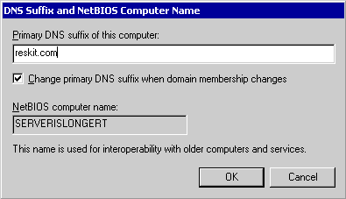
Figure 22.3 NetBIOS and DNS Domain Names
The DNS host name can be changed after installation by means of the Network Identification tab in the System control panel. The NetBIOS computer name changes also, based on the restrictions of NetBIOS.

To change the host name for DNS
1. In Control Panel, double-click System.
2. Select the Network Identification tab.
3. Click Properties.
4. Type the new host name in the Computer name text box and click OK.
5. When prompted, click OK.
6. Click 0K.
7. When prompted, click Yes to restart the computer.

Note If you enter a DNS name that includes characters not listed in RFC 1123 during the setup for Windows 2000 DNS, a warning message appears suggesting that you use characters specified by RFC 1123.
Computer names in previous versions of Windows are based on NetBIOS names. If a Windows 2000 Professional– based computer has been migrated from a previous version of Windows, its DNS host name is taken from the previous NetBIOS-based computer name. In a network that contains non-Windows 2000 – based hosts, this might present problems.
Primary DNS Suffix The primary DNS suffix is the name of the domain in which the host resides. If a Windows 2000 Professional– based computer is a member of a Windows 2000 domain, its primary DNS domain name is identical to its Windows 2000 domain. This information is provided during Windows 2000 Professional installation, migration, or when the computer joins a Windows 2000 domain.
If a computer is a member of workgroup, or a member of a Windows NT domain, the primary domain name is manually specified by using the Network Identification tab in the System control panel.
To set or change the primary DNS suffix
1. In Control Panel, double-click System.
2. Select the Network Identification tab.
3. Click Properties.
4. Click More.
5. In the Primary DNS suffix of this computer text box, type the primary DNS suffix, and then click OK.

When a Windows 2000 Professional– based computer changes Windows 2000 domains, its DNS domain membership can be changed as well. To allow Windows 2000 to automatically change the primary DNS domain name when its Windows 2000 domain membership changes, select Change DNS domain name when domain membership changes.
Connection-Specific DNS Suffix Windows 2000 also permits each adapter to have a unique domain name, known as the connection-specific domain name.
For example, suppose the computer Client1 has the primary DNS domain name reskit.com, and it is connected to both the Internet and the corporate intranet. For each connection, you can specify a connection-specific domain name. For the connection to the corporate intranet, you specify the name reskit.com, and the FQDN is then Client1.reskit.com. For the connection to the Internet, you specify the name isp01.com, and the FQDN is then Client1.isp01.com.
Figure 22.4 shows this configuration.
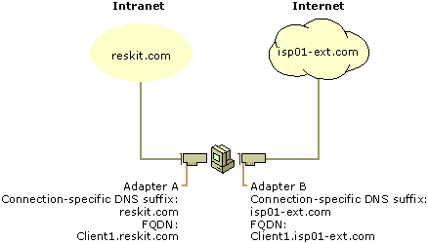
Figure 22.4 Connection-Specific Domain Names
Connection-specific domain names for each adapter are specified on the DNS tab of the Advanced TCP/IP Settings page. From that page, you can also specify whether a dynamic update client registers the computer’s fully qualified domain name or the adapter-specific name. For more information, see “Configure Dynamic Update” later in this chapter.
To set or change the connection-specific DNS suffix
1. In Control Panel, double-click Network and Dial-up Connections.
2. Right-click the local area connection you want to modify, and then select Properties.
3. Select Internet Protocol (TCP/IP), and then click Properties.
4. Click Advanced.
5. Select the DNS tab.
6. In the DNS suffix for this connection text box, type the domain name for the connection.

Fully Qualified Domain Name By default, the DNS domain name is used with the primary host name to create a fully qualified domain name (FQDN) for the computer. During DNS queries, the local domain name is appended to short names. A short name consists of only a host name, such as client1. When querying the DNS server for the IP address of client1, the domain name is appended to the short name, and the DNS server is actually asked to resolve the FQDN of client1.reskit.com.
Note If an entry is specified in the Search these DNS domains (in order) box in the DNS section of Advanced TCP/IP settings dialog box, that entry is used instead of the domain and host name to create an FQDN.
For detailed information about how the FQDN is used to perform name-to-IP address resolution, refer to “Configure DNS Name Resolution” earlier in this chapter.
DNS Naming Restrictions
Different DNS implementations impose different character and length restrictions. Table 22.5 shows the restrictions for each implementation.
Table 22.5 Naming Restrictions

Restriction Standard DNS (including Windows NT 4.0) DNS in Windows 2000 NetBIOS

Characters Supports RFC 1123, which permits A- Z, a-z, 0-9, and the hyphen (-). Supports RFC 2044, which permits more characters than RFC 1123, but it is best to use only the characters permitted by RFC 1123. Unicode characters, numbers, white space, symbols: ! @ # $ % ^ & ’ ) ( . - _ { } ~
Computer/host name length 63 bytes per label and 255 bytes for FQDN 63 bytes per label and 255 bytes for FQDN; domain controllers are limited to 155 bytes for FQDN. 15 characters
According to RFC 1123, the only characters that can be used in DNS labels are A-Z, a-z, 0-9, and the hyphen (-). (The “.” character is also used in DNS names, but only between DNS labels and at the end of a FQDN.) Many DNS servers, including Windows NT 4.0 DNS servers, follow RFC 1123.
However, adherence to RFC 1123 can present a problem on Windows 2000 networks that still use NetBIOS names. NetBIOS names can use additional characters, and it can be time-consuming to convert all the NetBIOS names to standard DNS names.
To simplify the migration process from Windows NT 4.0, Windows 2000 supports a wider character set. RFC 2181, “Clarifications to the DNS Specification,” extends the character set allowed in DNS names. Based on this definition, the Windows 2000 DNS service has been adjusted to accommodate a larger character set: UTF-8 character encoding, as described in RFC 2044. UTF-8 character encoding is a superset of ASCII and a translation of the UCS-2 (also known as Unicode) character encoding. The UTF-8 character set includes characters from most of the world’s written languages, allowing a far greater range of possible names.
However, before using the extended character set, consider the following issues:
• If a client name containing UTF-8 characters is to be used, all DNS servers to which the client is to be registered must support RFC 2181. Avoid using UTF-8-compliant host names if your network includes servers that do not comply with this standard.
• Some third-party resolver software supports only the characters listed in RFC 1123. If there are any computers in your network that use third-party resolver software, that software probably cannot look up Windows 2000 – based clients with names that have nonstandard characters.

Configuring DNS Query Settings
The DNS resolver adds a domain name suffix to a name specified in a query that meets either of the following conditions:
• The name is a single-label unqualified name.
• The name is a multiple-label unqualified name and the resolver cannot resolve it as a fully qualified domain name.

The query process is shown in Figures 22.5 and 22.6.
Note The flowcharts in Figures 22.5 and 22.6 direct you to other flowcharts in other figures. To locate the correct flow chart, see the figure captions.
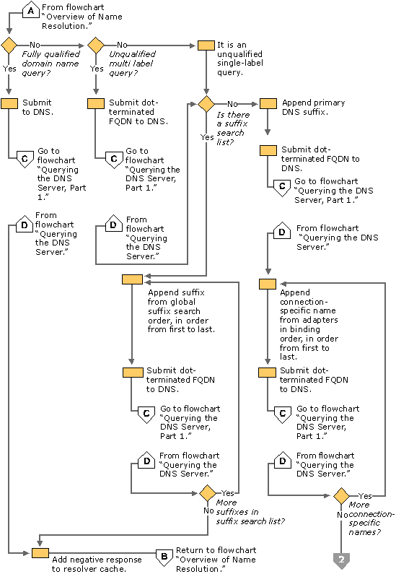
Figure 22.5 DNS Name Resolution, Part 1
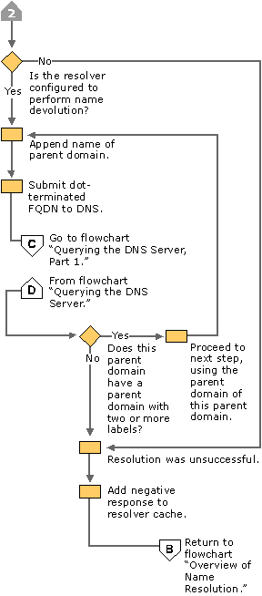
Figure 22.6 DNS Name Resolution, Part 2
You can configure how suffixes are added to queries from the Advanced TCP/IP Settings page, in Network and Dial-up Connections in Control Panel. Figure 22.7 shows the Advanced TCP/IP Settings:
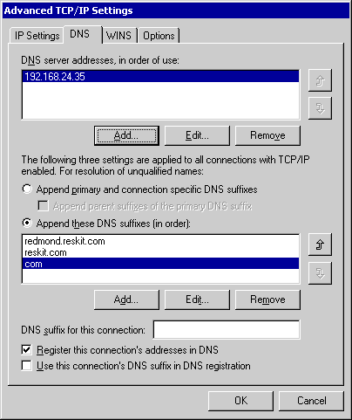
Figure 22.7 DNS Query Settings
By default, the option Append primary and connection specific DNS suffixes is selected. This option causes the resolver to append the client name to the primary domain name, as defined in the Network Identification tab of the system properties, as well as the domain name defined in the DNS domain name field of each network connection. For example, if your primary DNS suffix is dom1.acquired01-int.com, the resolver queries for the following FQDN:

client1.dom1.acquired01-int.com

Next, if that query fails and if you have specified a connection-specific DNS suffix in the DNS suffix for this connection box, it appends that name. For example, if you entered the name acquired01-ext.com in the DNS suffix for this connection box and then queried for the unqualified, single-label name client1, the resolver queries for the following FQDN:

client1.acquired01-ext.com.

Next, if you select the check box Append parent suffixes of the primary DNS suffix, the resolver performs name devolution on the primary DNS suffix, stripping off the leftmost label, and attempting the resulting domain name until only two labels remain. For example, if your primary DNS suffix is dom1.acquired01-int.com, and you selected the check box Append parent suffixes of the primary DNS suffix and then queried for the unqualified, single-label name client1 the resolver queries in order the following FQDNs:

client1.dom1.acquired01-int.com.
client1.acquired01-int.com.

To disable name devolution
1. In Control Panel, double-click Network and Dial-up Connections.
2. Right-click the local area connection you want to change, and then select Properties.
3. Select Internet Protocol (TCP/IP), and then click Properties.
4. Click Advanced.
5. Click the DNS tab.
6. Clear the check box Append parent suffixes of the primary DNS suffix, and then click OK.

The box labeled Append these DNS suffixes (in order) allows you to specify a list of domains to try, called a domain suffix search list. If you enter a domain suffix search list, the resolver adds those domain name suffixes in order and does not try any other domain names. For example, if the Append these DNS suffixes (in order) box includes the names listed in Figure 22.7 and you enter the unqualified, single-label query “coffee”, the resolver queries in order for the following fully qualified domain names:

coffee.com.
coffee.reskit.com.
coffee.redmond.reskit.com.

To add entries to the domain suffix search list
1. In Control Panel, double-click Network and Dial-up Connections.
2. Right-click the local area connection you want to change, and then select Properties.
3. Select Internet Protocol (TCP/IP), and then click Properties.
4. Click Advanced.
5. Click the DNS tab.
6. Select Append these DNS suffixes (in order).
7. Click Add, and then type the domain suffix you want to include.
8. Click Add.
• To remove a domain suffix from the list, select it, and then click Remove.
• To change the domain suffix search order, select it, then click the up or down arrows.

Specifying DNS Servers
When a name is submitted to DNS, if the resolver is caching names, the resolver first checks the cache. If the name is in the cache, the data is returned to the user. If the name is not in the cache, the resolver queries the DNS servers that are listed in the TCP/IP properties for each adapter.
The resolver can query through all adapters in the computer, including remote access adapters. In Windows NT 4.0, the resolver queried all servers through all adapters. In Windows 2000, however, you can specify a list of DNS servers to query for each adapter.
Figures 22.8, 22.9, and 22.10 illustrate the process by which the resolver queries the servers on each adapter.
Note The flowcharts in Figures 22.8, 22.9, and 22.10 direct you to other flowcharts in other figures. To locate the correct flow chart, see the figure captions.
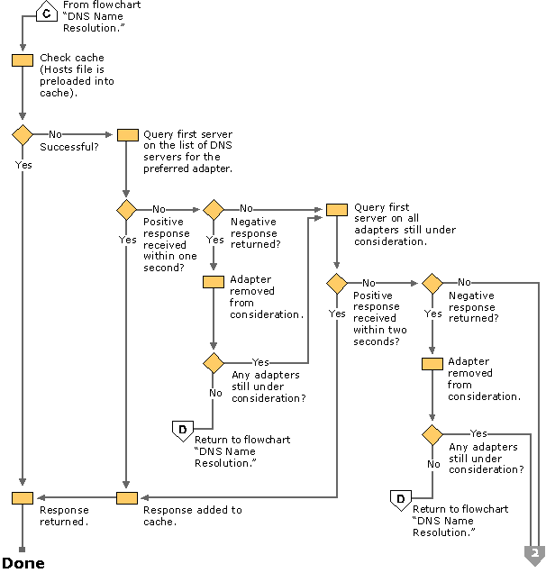
Figure 22.8 Querying the DNS Server, Part 1
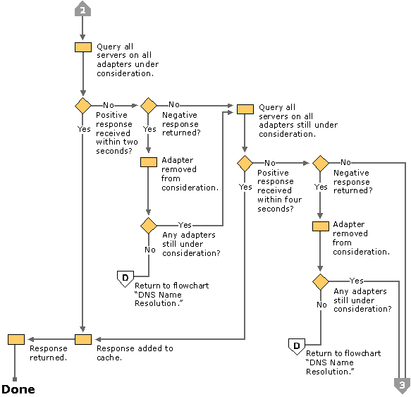
Figure 22.9 Querying the DNS Server, Part 2
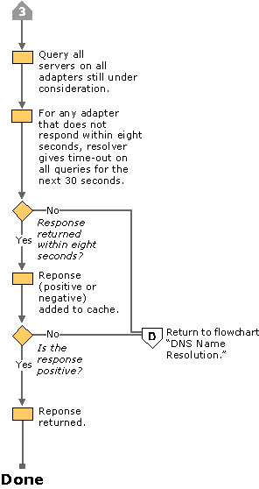
Figure 22.10 Querying the DNS Server, Part 3
Windows 2000 Professional allows multiple DNS servers to be specified. The first DNS server, known as the preferred DNS server, can be followed by an unlimited number of alternate DNS servers. The resolver queries the DNS servers in the following order:
1. The resolver sends the query to the first server on the preferred adapter’s search list and waits for one second for a response.
2. If the resolver does not receive a response from the first server within one second, it sends the query to the first DNS servers on all adapters still under consideration and waits two seconds for a response.
3. If the resolver does not receive a response from any server within two seconds, the resolver sends the query to all DNS servers on all adapters still under consideration and waits another two seconds for a response.
4. If the resolver still does not receive a response from any server, it sends the query to all DNS servers on all adapters still under consideration and waits four seconds for a response.
5. If it still does not receive a response from any server, the resolver sends the query to all DNS servers on all adapters still under consideration and waits eight seconds for a response.

If the resolver receives a positive response, it stops querying for the name, adds the response to the cache and returns the response to the client.
If it has not received a response from any server by the end of the eight-second time period, the resolver responds with a time-out. Also, if it has not received a response from any server on a specified adapter, then for the next 30 seconds, the resolver responds to all queries destined for servers on that adapter with a time-out and does not query those servers.
If at any point the resolver receives a negative response from a server, it removes every server on that adapter from consideration during this search. For example, if in step 2, the first server on Alternate Adapter A gave a negative response, the resolver would not send the query to any other server on the list for Alternate Adapter A.
The resolver keeps track of which servers answer queries more quickly, and might move servers up or down on the list based on how quickly they reply to queries.
Figure 22.11 shows how the resolver queries each server on each adapter.
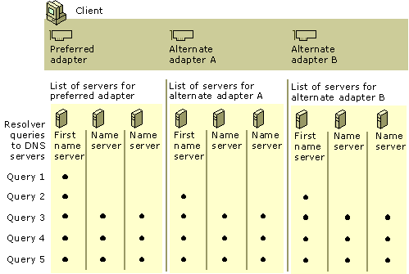
Figure 22.11 Multihomed Name Resolution
To specify a preferred and alternate DNS server
1. In Control Panel, double-click Network and Dial-up Connections.
2. Right-click the local area network connection you want to change, and then click Properties.
3. Select Internet Protocol (TCP/IP), and then click Properties.
4. In the General page, select the method to be used to access the DNS servers for your network:
• If a DHCP server is available for automatic IP addressing and is configured to provide parameters for automatic DNS server configuration, select Obtain DNS server address automatically.
• If the IP addresses for the DNS servers are to be manually configured, select Use the following DNS server addresses option button. Type the IP addresses of the preferred and alternate DNS servers in the appropriate boxes.

To specify additional alternate DNS servers
1. In the General section of the Network and Dial-up connections properties sheet, click Advanced.
2. Click the DNS tab.
3. Under DNS server addresses, in order of use, click Add.
4. Type the IP address of the DNS server you want to add.
5. Click Add.

To remove an IP address from the list, select it, and then click Remove.
The order of the IP addresses can be rearranged as needed to reflect changes in name server availability, performance, or to implement load balancing.
To set the DNS server search order
1. In Control Panel, double-click Network and Dial-up Connections.
2. Double-click Local Area Connections.
3. In the General dialog box, click Advanced.
4. Click the DNS tab.
5. In the DNS Server Search Order box, select the IP address of the DNS server you want to reposition.
6. Click the up or down buttons to reposition the selected IP address within the list of DNS servers.

DNS Performance and Security
The default settings of DNS might need to be changed in order to optimize the performance and security of the Windows 2000 Professional DNS client. The following sections describe the configuration changes that can be made to:
• Configure caching and negative caching
• Configure subnet prioritization
• Prevent the resolver from receiving responses from nonqueried servers

Configuring Caching and Negative Caching
When the Windows 2000 resolver receives a positive or negative response to a query, it adds that positive or negative response to its cache. The resolver always checks the cache before querying any DNS servers, so if a name is in the cache, the resolver uses the name from the cache rather than querying a server. This expedites queries and decreases network traffic for DNS queries.
You can use the Ipconfig tool to view and flush the cache.
To view the resolver cache
• At the command prompt, type:
ipconfig /displaydns

Ipconfig displays the contents of the DNS resolver cache, including names preloaded from the Hosts file and any recently queried names resolved by the system.
After a certain amount of time, specified in the Time to Live (TTL) associated with the name, the resolver discards the name from the cache. You can also flush the cache manually. After you flush the cache, the computer must query DNS servers again for any names previously resolved by the computer.
To flush the cache manually by using Ipconfig
• At the command prompt, type:
ipconfig /flushdns

The local Hosts file is preloaded into the resolver’s cache and reloaded into the cache whenever Hosts is updated.
The length of time for which a positive or negative response is cached depends on the values of entries in the following registry subkey:
HKEY_LOCAL_MACHINE\SYSTEM\CurrentControlSet\Services \DNSCache\Parameters
Positive responses are cached for the number of seconds specified in the query response the resolver received, but never for longer than the value of the entry MaxCacheEntryTtlLimit (REG_DWORD data type). The default value is 86,400 seconds (1 Day).
Negative responses are cached for the number of seconds specified in the NegativeCacheTime entry (DWORD data type). The default value is 300 seconds. If you do not want negative responses to be cached at all, set the value of this entry to 0.
If all DNS servers on an adapter are queried and none reply, either positively or negatively, all subsequent name queries to any server listed on that adapter fail instantly and continue to fail for a default of 30 seconds. This feature decreases network traffic.
Configuring Subnet Prioritization
If the resolver receives multiple IP address mappings (A resource records) from a DNS server, and some have IP addresses from networks to which the computer is directly connected, the resolver orders those resource records first. This reduces network traffic across subnets by forcing computers to connect to network resources that are closer to them.
For example, suppose there are three Web servers that all host the Web page for www.reskit.com, and they are all located on different subnets. The DNS name server for the network contains the following resource records:

www.reskit.com. IN A 172.16.64.11
www.reskit.com. IN A 172.17.64.22
www.reskit.com. IN A 172.18.64.33

When a Windows 2000 Professional– based computer queries www.reskit.com, its resolver puts IP addresses from subnets to which the computer is directly connected first in the list. For example, if a computer with the IP address 172.17.64.93 queried for www.reskit.com, the resolver returns the resource records in the following order:

www.reskit.com. IN A 172.17.64.22
www.reskit.com. IN A 172.16.64.11
www.reskit.com. IN A 172.18.64.33

Subnet prioritization prevents the resolver from choosing the first IP address returned in the DNS query and using the DNS server round robin feature defined in RFC 1794. With round robin, the server rotates the order of resource record data returned in a query answer in which multiple resource records of the same type exist for a queried DNS domain name. Thus, in the example described earlier, if a user queried for www.reskit.com, the name server replies to the first client request by ordering the addresses as the following:

172.16.64.11
172.17.64.22
172.18.64.33

It replies to the second client response by ordering the addresses as the following:

172.17.64.22
172.18.64.33
172.16.64.11

If clients are configured to use the first IP address in the list they receive, then different clients use different IP addresses, balancing the load among multiple network resources with the same name. However, if the resolvers are configured for subnet prioritization, the resolvers reorder the list to favor IP addresses from networks to which they are directly connected, reducing the effectiveness of the round robin feature.
Although subnet prioritization does reduce network traffic across subnets, in some cases you might prefer to have the round robin feature work as described in RFC 1794. If so, you can disable the subnet prioritization feature on your clients by adding the PrioritizeRecordData entry with a value of 0 (REG_DWORD data type) in the following registry subkey:
HKEY_LOCAL_MACHINE\SYSTEM\CurrentControlSet\Services \DnsCache\Parameters
Preventing the Resolver from Accepting Responses from Nonqueried Servers
By default, the resolver accepts responses from servers it did not query. This presents a possible security liability, as unauthorized DNS servers might pass along invalid A resource records to misdirect DNS queries. If you want to disable this feature, add the registry entry QueryIpMatching with a value of 1 (REG_DWORD data type) to the following registry subkey:
HKEY_LOCAL_MACHINE\SYSTEM\CurrentControlSet\Services \DnsCache\Parameters
Configure Dynamic Update
Windows 2000 contains an implementation of dynamic update that follows RFC 2136. Dynamic update allows clients and servers to register DNS domain names (PTR resource records) and IP address mappings (A resource records) to an RFC 2136 – compliant DNS server. This frees administrators from the time-consuming process of manually updating DNS entries.
Note A Windows 2000 Professional– based computer can be a member of a Windows 2000 domain without dynamic update, but the network administrator's workload increases significantly because of the work involved in manually updating DNS information.
In Windows 2000, clients can send dynamic updates for three different types of network adapters: DHCP adapters, statically configured adapters, and remote access adapters. Regardless of which adapter is used, the DHCP client service sends dynamic updates to the authoritative DNS server. The DHCP client service runs on all computers regardless of whether they are configured as DHCP clients.
Configuring Dynamic Update for DHCP Clients
By default, Windows 2000–based DHCP clients are configured to request that the client register the A resource record and the server register the PTR resource record. By default, the name used in the DNS registration is a concatenation of the computer name and the primary DNS suffix. You can change this default from within the TCP/IP properties of your network connection.
To change the dynamic update defaults on the dynamic update client
1. Right-click My Network Places, and then click Properties.
2. Right-click the connection you want to configure, and then click Properties.
3. Select Internet Protocol (TCP/IP), click Properties, click Advanced, and then select the DNS tab.
4. By default, Register this connection’s address in DNS is selected and Use this connection’s DNS suffix in DNS registration is not selected, causing the client to request that the client register the A resource record and the server register the PTR resource record. In this case, the name to be used in DNS registration is a concatenation of the computer name and primary DNS suffix of the computer.

You can also select the check box Use this connection's DNS suffix in DNS registration. If you choose this option, the client requests that the server update the PTR record, using the name that is a concatenation of the computer name and the connection-specific DNS suffix. If the DHCP server is configured to register DNS records according to the client's request, the client will then register the following records:
• The PTR record, using the name that is a concatenation of the computer name and the primary DNS suffix.
• The A record, using the name that is a concatenation of the computer name and the primary DNS suffix.
• The A record, using the name that is a concatenation of the computer name and the connection-specific DNS suffix.

To configure the client to make no requests for DNS registration, deselect Register this connection’s address in DNS. If this configuration is chosen, the client will not attempt to register any A or PTR DNS records corresponding to this connection.
Statically Configured and Remote Access Clients
Statically configured clients and remote access clients do not communicate with the DHCP server. Statically configured Windows 2000 – based clients dynamically update their A and PTR resource records every time they start, in case the records become corrupted in the DNS database. Remote access clients dynamically update A and PTR resource records when a dial-up connection is made. They also attempt to deregister the A and PTR resource records when the user closes down the connection. However, if a remote access client fails to deregister a resource record within four seconds, it closes the connection, and the DNS database will contain a stale record. If the remote access client fails to de-register a resource record, it adds a message to the event log, which you can view by using the Event Viewer. The remote access client never deletes stale records.
Multihomed Clients
If a dynamic update client is multihomed (has more than one adapter and associated IP address), by default it registers all its IP addresses with DNS. If you do not want it to register all of its IP addresses, you can configure it to not register one or more IP addresses from the properties page for the network connection.
To prevent the computer from registering all its IP addresses
1. Right-click My Network Places, and then click Properties.
2. Select the connection you wish to configure, and then click Properties.
3. Select Internet Protocol (TCP/IP), click Properties, click Advanced, and then select the DNS tab.
4. Clear the Register this connection’s address in DNS check box.

The dynamic update client does not register all IP addresses with all DNS servers. For example, Figure 22.12 shows a multihomed computer, client1.noam.reskit.com, that is connected to both the Internet and the corporate intranet. Client1 is connected to the intranet by adapter A, a DHCP adapter with the IP address 172.16.8.7. Client1 is also connected to the Internet by adapter B, a remote access adapter with the IP address 131.107.99.1. Client1 resolves intranet names by using a name server on the intranet, NoamDC1, and resolves Internet names by using a name server on the Internet, ISPNameServer.
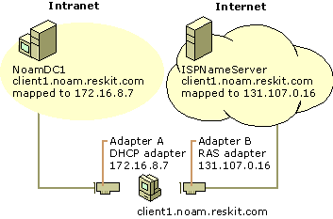
Figure 22.12 Dynamic Update for Multihomed Clients
Notice that although Client1 is connected to both networks, the IP address 172.16.8.7 is reachable only through adapter A, and the IP address 131.107.99.1 is reachable only through adapter B. Therefore, when the dynamic update client registers the IP addresses for Client1, it does not register both IP addresses with both name servers. Instead, it registers the name-to-IP address mapping for adapter A with NoamDC1 and the name-to-IP address mapping for adapter B with ISPNameServer.
You can also configure the computer to register its domain name in DNS. For example, if you have a client that is connected to two different networks, and you want it to have a different domain name on each network, you can configure it to do so.
Disabling Dynamic Update
Dynamic update is configured on Windows 2000 Professional– based clients by default. Dynamic update can be disabled by adding the DisableDynamicUpdate registry entry with a value of 0x1 (REG_DWORD data type) to the following registry subkey:
HKEY_LOCAL_MACHINE\SYSTEM\CurrentControlSet\Services\ Tcpip\Parameters
to disable dynamic update for all network interfaces on the computer, or
HKEY_LOCAL_MACHINE\SYSTEM\CurrentControlSet\Services\ Tcpip\Parameters\Interfaces\<interface>
to disable dynamic update for the network interface card with the device ID of <interface>.
Configure Hosts File
TCP/IP in Windows 2000 can be configured to search Hosts (the local host table file) for mappings of remote host names to IP addresses. The Hosts file format is the same as the format for host tables in the 4.3 Berkeley Software Distribution (BSD) UNIX /etc/hosts file. For example, the entry for a computer with an address of 192.176.73.6 and a host name of client1.reskit.com looks like this:

192.176.73.6 client1.reskit.com

By using a text editor, you can create and change the Hosts file because it is a simple text file. An example of the Hosts format is provided in the file named Hosts in the Windows 2000 %SystemRoot%\System32\Drivers\Etc directory. Edit the Hosts file (created when you install TCP/IP) to include remote host names and IP addresses for each computer with which you communicate.
Configure NetBIOS Name Resolution
Microsoft TCP/IP uses NetBIOS over TCP/IP (NetBT) as specified in RFCs 1001 and 1002, which define a software interface that supports name resolution for NetBIOS client and server programs in the LAN and WAN environments. Although DNS is the default name resolution method for Windows 2000, NetBT is still provided as a method of providing name resolution for older clients, and for Windows 2000 domains and workgroups that do not implement Active Directory.
The following section describes the type of name resolution methods that are available through NetBIOS over TCP/IP, including WINS. Procedures for configuring the different resolution methods are provided throughout this discussion.
NetBIOS Name Resolution Basics
RFCs 1001 and 1002 define the following four node types:
• B-node. Uses broadcasts to resolve names.
• P-node. Uses point-to-point communications with a NetBIOS server (such as a WINS server) to resolve names.
• M-node. Uses broadcasts first (b-node), then directed name queries (p-node) if broadcasts are not successful.
• H-node. Uses name queries first (p-node), and then uses broadcasts (b-node) if the name server is unavailable or if the name is not registered in the WINS database.
• Microsoft-enhanced. Uses the local Lmhosts file plus Windows Sockets gethostbyname( ) calls (using standard DNS and/or local Hosts files) in addition to standard node types.

Microsoft includes a NetBIOS name server known as the Windows Internet Name Service (WINS). If WINS is enabled on a Windows 2000 Professional– based computer, the system uses h-node by default. Without WINS, the system uses b-node by default. Non-WINS clients can access WINS through a WINS proxy, which is a WINS-enabled computer that listens to name query broadcasts and then query the WINS server on behalf of the requesting client.
To see which node type is configured on a Windows 2000 Professional– based computer
1. At the command prompt, type:
ipconfig /all
2. The node type is indicated to the right of the heading Node type.

Using a name server to locate resources is generally preferable to broadcasting for two reasons:
• Broadcasts are not usually forwarded by routers. Therefore, only local subnet NetBIOS names can be resolved.
• Broadcast frames are processed by all computers on a subnet.

Figures 22.13 and 22.14 illustrate the NetBIOS name resolution methods used by Windows 2000.
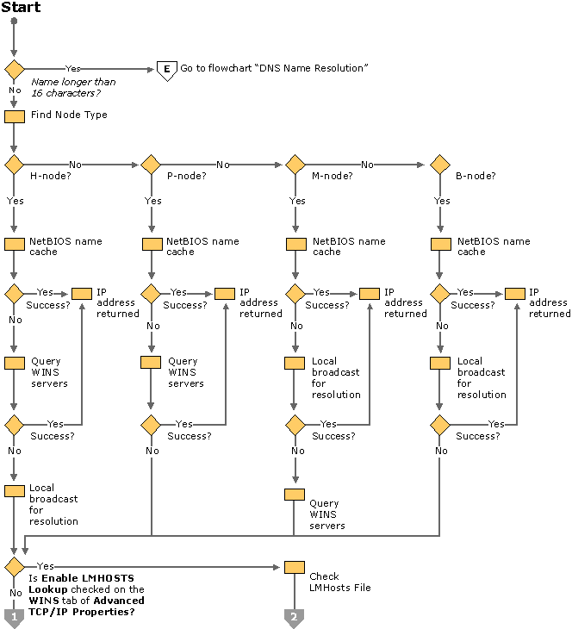
Figure 22.13 NetBIOS Name Resolution Flowchart (Part 1 of 2)
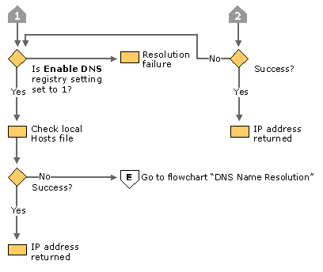
Figure 22.14 NetBIOS Name Resolution Flowchart (Part 2 of 2)
Name Resolution Using WINS
Windows Internet Name Service (WINS) is a service that runs on Windows 2000 Server to provide NetBIOS name resolution. It provides a database for registering and querying dynamic NetBIOS name-to-IP address mappings in a routed network environment. You can use WINS either alone or in conjunction with DNS.
WINS reduces the use of local broadcasts for name resolution and allows users to locate computers on remote networks. Furthermore, when dynamic addressing through DHCP results in new IP addresses for computers that move between subnets, the changes are updated automatically in the WINS database. Neither the user nor the network administrator needs to make manual accommodations for name resolution.
WINS consists of two components: the WINS server, which handles name queries and registrations, and the client software (NetBIOS over TCP/IP), which queries for computer name resolution. A WINS server is a Microsoft® Windows NT® Server version 3.5 or later computer running the WINS server service. When Microsoft TCP/IP is installed under Windows 2000 Professional, WINS client software is installed automatically.
If there are WINS servers installed on your network, you can use WINS in combination with broadcast name queries to resolve NetBIOS computer names to IP addresses. If you do not use this option, Windows 2000 Professional can use name query broadcasts (b-node mode of NetBIOS over TCP/IP), and the local Lmhosts file to resolve computer names to IP addresses. However, broadcast resolution is limited to the local network.
Additionally, a WINS server can be used in conjunction with a DNS server to provide dynamic registration of hosts in an environment without DNS update. When configured to use WINS lookup, a DNS server can forward queries to a WINS server for resolution of unknown A resource records for all WINS clients.
If DHCP is used for automatic configuration, WINS server parameters can be provided by the DHCP server. Otherwise, you must configure information about WINS servers manually. WINS configuration is global for all network adapters on a computer.
Configuring WINS
The following procedure describes how to configure WINS and how to enable DHCP.
To configure a computer to use WINS for name resolution
1. In Control Panel, double-click Network and Dial-up Connections.
2. Right-click Local Area Connections.
3. Select Internet Protocol (TCP/IP), and then click Properties.
4. If a DHCP server is available that is configured to provide information on available WINS servers, select Obtain an IP address automatically.
The addresses of available WINS servers are provided as part of the configuration parameters for the client.
5. If DHCP is not used, or the WINS address is to be manually configured, click Advanced.
6. Select the WINS tab.
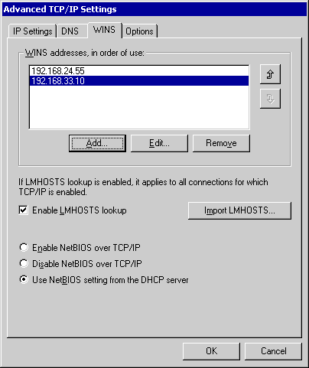
7. Click Add.
8. Enter the address of the WINS server, and click Add.

The order of the IP addresses can be rearranged as needed to reflect changes in name server availability, performance, or to implement load balancing.
To set the WINS server search order
1. On the WINS tab, under the WINS addresses, in order of use box, select the IP address of the WINS server you want to reposition.
2. Click the up or down buttons to reposition the selected IP address within the list of WINS servers.

B-Node Broadcasts and Lmhosts
By installation default, a Windows 2000 – based computer not configured as a WINS client or WINS server, is a b-node computer. A b-node computer is one that uses IP broadcasts for NetBIOS name resolution.
IP broadcast name resolution can provide dynamic name resolution. However, the disadvantages of broadcast name queries include increased network traffic and ineffectiveness in routed networks. Resources located outside the local subnet do not receive IP broadcast name query requests because IP-level broadcasts are not passed to remote subnets by the router (default gateway) on the local subnet.
As an alternate method to IP broadcasts, Windows 2000 enables you to manually provide NetBIOS name and IP address mappings for remote computers by using the Lmhosts file. Selected mappings from the Lmhosts file are maintained in a limited cache of NetBIOS computer names and IP address mappings. This memory cache is initialized when a computer is started. When the computer needs to resolve a name, the cache is examined first and, if there is no match in the cache, Windows 2000 uses b-node IP broadcasts to try to find the NetBIOS computer. If the IP broadcast name query fails, the complete Lmhosts file is parsed to find the NetBIOS name and the corresponding IP address. This strategy enables the Lmhosts file to contain a large number of mappings, without requiring a large amount of static memory to maintain an infrequently-used cache.
The Lmhosts file can be used to map computer names and IP addresses for computers outside the local subnet, an advantage over the b-node broadcast method. You can use the Lmhosts file to find remote computers for network file, print, and remote procedure services. The Lmhosts file is typically used for smaller networks that do not have name servers.
The Lmhosts file is a local text file that maps IP addresses to NetBIOS names. It contains entries for Windows-networking computers located outside the local subnet. The Lmhosts file is read when WINS or broadcast name resolution fails; resolved entries are stored in a local cache for later access.
You can create an Lmhosts file by using a text editor. Lmhosts is a simple text file. An example of the Lmhosts format is provided in the file named Lmhosts.sam in the Windows 2000 %SystemRoot%\System32\Drivers\Etc directory. This is only an example file. To active the Lmhosts file, rename Lmhosts.sam to Lmhosts. Edit the Lmhosts file to include remote NetBIOS names and IP addresses for each computer with which you communicate.
The keywords listed in Table 22.6 can be used in the Lmhosts file in Windows 2000 Professional.
Table 22.6 Lmhosts Keywords

Keyword Description

\0xnn Support for nonprinting characters in NetBIOS names. Enclose the NetBIOS name in double quotation marks and use \0xnn notation to specify a hexadecimal value for the character. This enables custom applications that use special names to function properly in routed topologies. However, Microsoft® LAN Manager TCP/IP does not recognize the hexadecimal format.Note that the hexadecimal notation applies only to one character in the name. Pad the name with blanks so that the special character is last in the string (character 16).
#BEGIN_ALTERNATE Used to group multiple #INCLUDE statements. Any single successful #INCLUDE statement causes the group to succeed.
#END_ALTERNATE Used to mark the end of an #INCLUDE statement grouping.
#DOM:<domain> Part of the computer name-to-IP address mapping entry that indicates that the IP address is a domain controller in the domain specified by <domain>. This keyword affects how the Browser and Logon services behave in routed TCP/IP environments. To preload a #DOM entry, you must first add the #PRE keyword to the line. #DOM groups are limited to 25 members.
#INCLUDE <file name> Forces the system to seek the specified <file name> and parse it as if it were local. Specifying a Uniform Naming Convention (UNC) <file name> allows you to use a centralized Lmhosts file on a server. If the server on which the specified <file name> exists is outside of the local broadcast subnet, you must add a preloaded entry for the server.
#MH Part of the computer name-to-IP address mapping entry that defines the entry as a unique name that can have more than one address. The maximum number of addresses that can be assigned to a unique name is 25. The number of entries is equal to the number of network adapters in a multihomed computer.
#PRE Part of the computer name-to-IP address mapping entry that causes that entry to be preloaded into the name cache. (By default, entries are not preloaded into the name cache but are parsed only after WINS and name query broadcasts fail to resolve a name.) The #PRE keyword must be appended for entries that also appear in #INCLUDE statements; otherwise, the entry in the #INCLUDE statement is ignored.
#SG <name> Part of the computer name-to-IP address mapping entry that associates that entry with a user-defined special (Internet) group specified by <name>. The #SG keyword defines Internet groups by using a NetBIOS name that has 0x20 in the 16th byte. A special group is limited to 25 members.
The following example shows how all of these keywords are used:

192.176.94.102 "appname \0x14" #special app server
192.176.94.123 printsrv #PRE #source server
192.176.94.98 localsrv #PRE
192.176.94.97 primary #PRE #DOM:mydomain #PDC for mydomain

#BEGIN_ALTERNATE
#INCLUDE \\localsrv\public\lmhosts #adds Lmhosts from this server
#INCLUDE \\primary\public\lmhosts #adds Lmhosts from this server
#END_ALTERNATE

In the preceding example:
• The servers named printsrv, localsrv, and primary are defined by using the #PRE keyword as entries to be preloaded into the NetBIOS cache at system startup.
• The servers named localsrv and primary are defined as preloaded and also identified in the #INCLUDE statements as the location of the centrally maintained Lmhosts file.
• Note that the server named "appname \0x14" contains a special character after the first 15 characters in its name (including the blanks), and so its name is enclosed in double quotation marks.
• The number sign (#), when not used with a keyword, designates the start of a comment.

Disabling NetBT
Windows 2000 file and print sharing components uses NetBIOS over TCP/IP to communicate with prior versions of Windows and other non-Microsoft clients. However, the Windows 2000 file and print sharing components (the redirector and server) now support direct hosting for communicating with other computers running Windows 2000. With direct hosting, DNS is used for name resolution. No NetBIOS name resolution (WINS or broadcast) is used and no NetBIOS sessions are established.
By default, both NetBIOS and direct hosting are enabled, and both are tried in parallel when a new connection is established. The first to succeed in connecting is used for any attempt. NetBIOS support can be disabled to force all traffic to use direct hosting.
To disable NetBIOS support
1. From Network and Dial-up Connections, select the connection you want to modify, and then right-click Properties.
2. Select Internet Protocol (TCP/IP), and then click Properties.
3. Click Advanced.
4. Select the WINS Address tab.
5. Select Disable NetBIOS over TCP/IP.

Note Applications and services that depend on NetBIOS over TCP/IP no longer function after this is done, so it is important that you verify that clients and applications no longer need NetBIOS over TCP/IP support before you disable it. Disabling NetBIOS over TCP/IP can prevent the creation of file and print sharing connections with non-Windows 2000 clients and servers.
Configure Multihoming
When a computer is configured with more than one IP address, it is referred to as a multihomed system. Multihoming is supported in two different ways:
• Multiple network adapters or media types per physical network.
The network adapters can be for similar or dissimilar networks. For example, a host with one Ethernet and one Token Ring adapter installed, each linked to a separate network, requires IP addresses to be bound to both adapters. There are no restrictions other than hardware.
• Multiple IP addresses per network adapter.
A computer can access multiple subnets that are logically separated, but bound to a single network adapter. Such a configuration might be used in an environment where a host requires access to different divisions of a corporation network that are separated by different subnets.
Windows 2000 Professional allows an unlimited number of IP address/subnet mask pairs.
Figure 22.15 shows an example of a Windows 2000 Professional computer using multihoming to connect to two subnets. These subnets can be physically separated by disparate or disconnected cabling, or logically separated through subnetting.

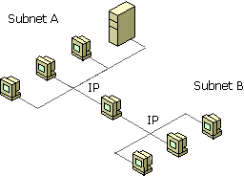
Figure 22.15 Multihomed Windows 2000 Professional Computer Connected to Two Separate Networks
Configure Multiple Network Adapters or Media Types
Windows 2000 Professional places no restrictions on physically multihomed computers, so you can add as many network adapters as the computer hardware can accommodate, and assign each a separate address.
As each new network adapter is installed, Windows 2000 Plug and Play autodetects the adapter. The device drivers for each adapter are installed, and any internal resources are automatically configured. The network adapter is bound to the TCP/IP protocol. If the network adapter is not Plug and Play – compliant, the adapter software must be installed and configured manually, using the manufacturer’s instructions.
For a multihomed computer that uses multiple network adapters for physical connections to the LAN, each adapter appears as a separate adapter in the Network and Dial-up Connections folder.
For a system configured to support multiple network or media types, there are no restrictions for this type of configuration other than hardware and media support. Microsoft Windows 2000 TCP/IP supports the following:
• Ethernet (Ethernet II and IEEE 802.3 SNAP encapsulation).
• Token Ring (IEEE 802.5 encapsulation).
• Asynchronous Transfer Mode (ATM).
• Fiber Distributed Data Interface (FDDI).
• WAN, using circuit-switched media such as ISDN and dial-up or dedicated asynchronous lines and virtual-circuit wide-area media such as X.25 and Frame Relay.

By default, each new network adapter is configured to use DHCP to assign an IP address to it.
To manually configure IP addresses on a multihomed system
1. In Control Panel, double-click Network and Dial-up Connections.
2. Right-click the local area network connection you want to modify, and then select Properties.
3. Add TCP/IP configuration information for the network adapter, as described in “Configure IP Address Manually.”

Configure Multiple IP Addresses on a Network Adapter
Windows 2000 Professional supports multihoming through multiple addresses on a single network adapter. This configuration is useful in an environment where a single physical network is logically divided into subnets.
To configure a multihomed system using a single network adapter
1. In Control Panel, double-click Network and Dial-up Connections.
2. Right-click the local area connection you want to modify, and then select Properties.
3. Add TCP/IP configuration information for the first IP address, as described in “Configure IP Address Manually.”
4. Click Advanced.
5. Click Add to enter the IP address and subnet mask for each additional subnet.
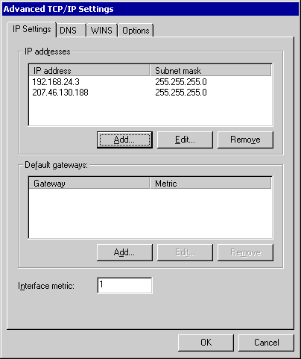

Each IP address and subnet mask pair is stored in the registry entries IPAddress and SubnetMask, in the subkey HKEY_LOCAL_MACHINE\SYSTEM\CurrentControlSet\Services\Tcpip \Parameters\Interfaces\<adapter>.
Windows 2000 Professional allows an unlimited number of IP address/subnet mask pairs.
Multihoming Considerations
If TCP/IP is configured for multiple network adapters, or for a single network adapter with multiple IP addresses, you must consider the following issues:
NetBIOS over TCP/IP (NetBT) binds to the first IP address for each network adapter only.
When a NetBIOS name registration is sent out, only one IP address is registered per adapter. This registration occurs over the IP address that is listed first in the properties of the TCP/IP protocol for the adapter.
A unique IP address and subnet mask are defined for each adapter.
For each network adapter, an instance of TCP/IP is bound to the adapter. You can choose to have IP addresses dynamically assigned by DHCP (or APIPA if a DHCP server is not present) or defined manually as static addresses.
Domain Name System (DNS) configuration settings are global.
The settings on the DNS tab in Advanced TCP/IP Properties are used for all adapters on the computer. Therefore, for a multihomed computer, you must carefully define options for DNS that are applicable for all adapters using TCP/IP. Usually, this means that if you want to use DNS for name resolution with any TCP/IP connection, make sure DNS is configured.
Windows Internet Name Service (WINS) configuration settings are defined for each adapter.
The settings on the WINS configuration tab are used only for the adapter you are configuring. For example, NetBIOS over TCP/IP (NetBT) can be enabled or disabled for each network adapter. If you enable the option Disable NetBIOS over TCP/IP for a LAN adapter, this option is enabled only for that adapter, not for other LAN adapters on the computer.
The default gateway can be different for each adapter.
While it is possible to configure a default gateway IP address for each network interface, there is only a single active default route in the IP route table. If there are multiple default routes in the IP route table (assuming a metric of 1), then the specific default route is chosen randomly when TCP/IP is initialized. This behavior can lead to confusion and loss of connectivity.
It is recommended that when you are configuring a computer to be multihomed on two disjoint networks, configure a default gateway IP on the interface that is attached to the portion of the IP internetwork that contains the most network segments. Then, either add static routes or use a routing protocol to provide connectivity to remote networks reachable through the other interfaces.
Only one default gateway is used at a time.
Although you can have a different default gateway for each adapter, Windows 2000 Professional uses only one default gateway at a time. This means that only certain hosts are reachable:
• Hosts on the local subnet
• Hosts that are reachable by the default gateway

As a result, in some cases you might lose network connectivity. For example, suppose your computer is first connected to the corporate TCP/IP network and you make a PPP dial-up connection to the Internet. Your computer stops using the default gateway that connects your computer to the corporate network and instead uses the default gateway that connects your computer to the Internet. Therefore, you can reach hosts on your local subnet, but you cannot reach other hosts on your network.
To discover methods to access multiple gateways, see “Configure Local Route Table” later in this chapter.
Configure Local IP Routing Table
A Windows 2000 Professional computer uses its local IP routing table to determine how to forward an IP packet to reach a designated host. The local routing table can be configured in the following ways:
• The routing table is manually maintained at the Windows 2000 Professional– based computer.
• The routing table that is automatically maintained at the Windows 2000 Professional– based computer by means of Routing Information Protocol (RIP) broadcasts from routers on the subnet.
• The default gateway is manually configured, or specified through the Dynamic Host Configuration Protocol (DHCP).
• The default gateway is automatically configured and maintained through Internet Control Message Protocol (ICMP) Router Discovery.

Determine the methods needed to identify gateways and manage routing paths. In an enterprise with multiple subnets, a route to non-local destinations must exist to communicate with hosts in other networks. Windows 2000 Professional supports manual entry of the default gateways and the use of ICMP Router Discovery to find and specify default gateways. Routing is supported by means of manual configuration of the routing table and a Routing Information Protocol (RIP) Listener to permit manual and automated maintenance of the local routing table. Select the methods that reflect your network configuration. See “Overview of IP Routing” later in this chapter.
Configure default gateways. Specify the default gateways to be used to direct IP packets if ICMP Router Discovery-enabled routers or RIP-enabled routers are not available in your network. For multihomed computers, the default gateways are used for all adapters, and you might need to manually configure the local route table for separate default gateways. See “Configure Default Gateways” later in this chapter.
Configure ICMP Router Discovery, if ICMP-enabled routers are available. ICMP Router Discovery automates the discovery and configuration of the default gateways for a Windows 2000 Professional– based client. If ICMP-enabled routers are used within the network, use this method of specifying default gateways. See “Configure ICMP Router Discovery” later in this chapter.
Manually edit the routing table, if necessary. If you want to manually specify the optimal route for IP packets, or have a multihomed computer and need to maintain separate default gateways, use the route command to display, add, and edit the local route tables for your Windows 2000 Professional– based computer. See “Manually Edit the Route Table” later in this chapter.
Install RIP listening support, if RIP-enabled routers are available. RIP-enabled routers simplify administration of the routing tables of Windows 2000 Professional– based clients by automatically updating the routing table as necessary. Enable RIP listening support on the client when RIP is supported in your network. See “Configure RIP Listening Support” later in this chapter.
Overview of IP Routing
Multiple TCP/IP networks are interconnected by routers, devices that forward IP packets from one subnet to another.
When IP prepares to send a packet, it inserts the local (source) IP address and the destination address of the packet in the IP header. It then examines the destination address, compares it to a locally maintained route table, and takes appropriate action based on what it finds. There are three possible actions:
• IP can pass the packet up to a protocol layer above IP on the local host.
• The packet can be forwarded through one of the locally attached network adapters.
• The packet can be discarded.

IP finds a match of the destination address in the routing table from the specific to the general in the following order:
• An exact match (host route).
• A match for the locally attached subnet (subnet route).
• A match for the default gateway (default route)
• If a default gateway has not been specified, the packet is discarded.

Because the default gateway contains information about the network IDs of the other networks in the internetwork, it can forward the packet to other routers until the packet is eventually delivered to a router connected to the subnet of the destination. This process is known as routing and is illustrated in Figure 22.16.
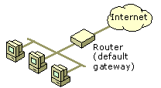
Figure 22.16 Routing
For each Windows 2000 Professional– based computer on a TCP/IP network, you can maintain a table with an entry for every other computer or network with which the local computer communicates. For a limited number of IP hosts, this method can be used for network interconnectivity. But for most networks this is not a practical solution, due to the large number of IP hosts and networks that must be listed and maintained in the route table. Instead, you can configure other methods to direct IP packets:
• IP packets are forwarded to an IP address by using a route table maintained by Router Information Protocol (RIP)-enabled routers.
If your network contains RIP-enabled routers, you can install RIP listening support on the Windows 2000 Professional– based client to permit automatic configuration and maintenance of the local route table.
• IP packets are forwarded to a user-specified default gateway, which provides the routing information for the packet.
The gateway address can also be automatically configured by DHCP. Multiple routers can be specified as default gateways.
• IP packets are forwarded to a default gateway identified by ICMP Router Discovery.
If your network contains routers that meet the ICMP Router Discovery specifications, defined in RFC 1256, you can configure your Windows 2000 Professional– based computer to “listen” for available gateways.

Configure Default Gateways
If the local route table cannot provide a path for handling an IP packet, it is directed to the default gateway. Windows 2000 Professional allows you to specify multiple default gateways. You can list them in order, based on availability, load balancing, or other criteria. You can also assign a value to each gateway, the cost metric, which determines the cost of forwarding an IP packet to the specific router. The lowest metric is the most preferred entry in the routing table.
To specify default gateways
1. In Control Panel, open Network and Dial-up Connections.
2. Select the local area connection you want to modify, and then click Properties.
3. Select Internet Protocol (TCP/IP), click Properties, and then click Advanced.
4. Under the Default gateways box, click Add.
5. Type the IP address and metric for the default gateway.
The metric is the cost of using a specified route. The gateway with the lowest metric is used first. The default metric value for each gateway is 1.
6. Click OK.
7. Click OK when you have specified all the default gateways for the connection.

Gateway addresses and metrics can also be provided by means of a DHCP server. Gateway configuration information specified in the connection properties override addresses provided through DHCP. For information about configuring DHCP, see “Configure DHCP” in this chapter.
Configure ICMP Router Discovery
As specified in RFC 1256, Windows 2000 provides host support for ICMP Router Discovery. Router discovery provides an improved method of detecting and configuring default gateways. Instead of configuring a default gateway manually or through DHCP, Windows 2000 – based computers can dynamically discover the best default gateway to use on their subnet and can automatically switch to another default gateway if the current default gateway fails or the network administrator changes router preferences.
When a Windows 2000 Professional– based computer configured for ICMP Router Discovery initializes, it joins the all-hosts IP multicast group (224.0.0.1) and listens for ICMP Router Advertisement messages. RFC 1256 – compliant routers periodically send ICMP Router Advertisements containing their IP address, a preference level, and a time after which they can be considered down. Hosts receive the ICMP Router Advertisements and select the router with the highest preference level as their default gateway.
A Windows 2000 Professional– based computer can also send ICMP Router Solicitation messages to the all-routers IP multicast address (224.0.0.2) at initialization or when it has not received a router advertisement from the router for the current default gateway within the router’s advertised lifetime. Windows 2000 – based hosts send a maximum of three solicitations at intervals of approximately 600 milliseconds.
ICMP Router Discovery is determined by the values of two registry entries PerformRouterDiscovery in the subkey HKEY_LOCAL_MACHINE\SYSTEM\CurrentControlSet\Services\Tcpip\Parameters and SolicitationAddressBcast in the subkey HKEY_LOCAL_MACHINE\SYSTEM\CurrentControlSet\Services\adaptername\Parameters\Tcpip. To enable ICMP Router Discovery, add the two entries to the registry, each with a value of 0x1 (REG_DWORD).
The Router Advertisement parameters are controlled from a RFC 1256 – compliant router. Windows 2000 Server and the Routing and Remote Access service support router discovery. For more information, see “Unicast IP Routing” in the Internetworking Guide.
Manually Edit the Route Table
There are several instances where you might need to manually edit the local route table for your Windows 2000 Professional– based computer:
• The computer has multiple network adapters (multihomed), and must access different default gateways for each adapter.
If your computer is multihomed and has connections to two separate IP networks, such as the corporate network and the Internet, the default gateway for only one network is used. For the computer to be able to communicate with the other network, routes must be manually added to the route table.
• The computer is multihomed, and has no access to a default gateway.
The computer in this case must provide the routing information to send IP packets from one network to the next, because no router is provided to perform this task.
• The required routing information is not provided by any default gateway, or a different route is wanted.

You can display the current route table to determine whether any changes are required. To see the route table for your computer, at the command prompt type route print.
The following example is a sample route table from a single-homed Windows 2000 Professional– based computer.

route print
========================================================================
Interface List
0x1 ........................... MS TCP Loopback interface
0x2000002 ...00 c0 4f 49 f3 b2 ...... 3Com EtherLink PCI (QoS Packet
Scheduler)
========================================================================
========================================================================
Active Routes:
Network Destination Netmask Gateway Interface Metric
0.0.0.0 0.0.0.0 157.59.0.1 157.59.4.120 1
127.0.0.0 255.0.0.0 127.0.0.1 127.0.0.1 1
157.59.0.0 255.255.248.0 157.59.4.120 157.59.4.120 1
157.59.4.120 255.255.255.255 127.0.0.1 127.0.0.1 1
157.59.255.255 255.255.255.255 157.59.4.120 157.59.4.120 1
224.0.0.0 224.0.0.0 157.59.4.120 157.59.4.120 1
255.255.255.255 255.255.255.255 127.0.0.1 127.0.0.1 1
Default Gateway: 157.59.0.1
========================================================================
Persistent Routes:
None

This example shows a computer with the IP address 157.59.4.120, subnet mask of 255.255.248.0, and a default gateway of 157.59.0.1. The table contains the following seven entries:
1. The first entry is the default route. This is the route to which the computer sends IP packets when the other route entries do not specify where to send them.
2. The second entry is the loopback route. This is the route a host uses when sending packets to itself.
3. The third entry is a subnet route for the locally attached subnet.
4. The fourth entry is a host route for the local host (the route for this host computer).
5. The fifth entry is a host route for a special type of IP broadcast address called the all-subnets directed broadcast.
6. The sixth entry is the IP multicast route. This is the route used when the computer sends packets to reach an IP multicast group.
7. The seventh entry is a host route for the limited broadcast address.

The following sections describe the columns shown in the “Active Routes” section of the net print command.
Network Address
The network address in the route table is the destination address. The network address column can have three different types of entries, listed here in the order in most to least specific.
1. Host address (a route to a single, specific destination IP address).
2. Subnet address (a route to a subnet).
3. Default route (a route used when there is no other match).

If no match is found, the packets are discarded.
Netmask
The netmask defines which portion of the network address must match in order for that route to be used. When the mask is written in binary, a 1 indicates a bit that must match and a 0 indicates a bit that does not have to match.
For example, the mask of all 255s (all 1s) means that the destination address of the packet to be routed must exactly match the network address in order for this route to be used. For another example, if the network address 172.20.232.0 has a netmask of 255.255.255.0, then the first three octets must match exactly, but the last octet need not match.
Gateway Address
The gateway address is the forwarding IP address of where the packet must be sent. This can be the IP address of the host or the address of a gateway (router) on the local subnet. If the gateway address of the route is the host IP address, then the forwarding IP address is set to the destination IP address in the IP datagram.
Interface
The interface is the address of the network adapter over which the packet must be sent. 127.0.0.1 is the software loopback address.
Metric
The metric indicates the cost of the route and is commonly the number of hops to the destination. Anything on the local subnet is one hop, and each router crossed after that is an additional hop. The metric is used to determine the best route among multiple routes that most closely match the destination.
To add static routes, use the following format:

Route add <subnet> mask <netmask> <gateway> metric <metric> if
<interface>

The following is an example route:

Route add 172.20.255.0 mask 255.255.255.0 172.20.234.232 metric 2 if 3

The route in this example means that to get to the subnet 172.20.255.0 with a mask of 255.255.255.0, use gateway 172.20.234.232, and that the route has a cost metric of 2 (for example, the subnet is 2 hops away), using interface 3.
Manual maintenance of route tables is error-prone. An error in one of the routes can prevent accessibility to a network location. Additionally, the status of many routes is dynamic – routers can go down or online, new routers might be added, or the metric of a route might change. Each change in the status of a route necessitates an equivalent alteration in the route table. Finally, the challenges of manually maintaining local route tables is multiplied when supporting a large number of computers in a department or enterprise.
Configure RIP Listening Support
To address the challenges of supporting routing in an enterprise environment, Routing Information Protocol, or RIP, can be used. If one or more of the routers on the subnet uses RIP to send routing information, the computer can be configured to “listen in” to RIP messages. Your computer can learn other routes on the network by listening to RIP messages and then add the appropriate routes to the IP routing table. This process is called RIP listening or silent RIP.
Network administrators can use RIP listening on multihomed hosts to solve the multiple default gateway problem without manually adding routes to the route table. Figure 22.17 shows an example of a multihomed host that uses RIP listening.
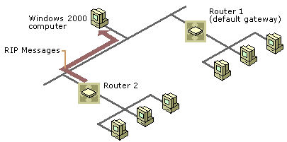
Figure 22.17 Multihomed Host Using RIP Listening
Router 2 sends RIP messages, and the Windows 2000 Professional– based computer listens in on those messages. Router 1 does not send RIP messages, so the Windows 2000 Professional– based computer is configured to use Router 1 as the default gateway. Thus, the Windows 2000 Professional– based computer can communicate with hosts on both networks without the use of ICMP Redirect messages from Router 1.
The route table chosen by the Windows 2000 Professional– based host computer is based on the hop count of the sending RIP server. The hop count is the number of routers that must be crossed in order to reach the wanted destination. The hop count is used as the metric, or the measurement by which routes are selected. Routes with the lowest metric are selected first.
Windows 2000 Professional supports routers using either RIP version 1 or RIP version 2 as long as the RIP messages are sent as subnet-level broadcasts. RIP v2 messages sent as multicasts are not received by the RIP listener.
RIP listening support is installed as an optional service to Windows 2000 Professional.
To install RIP listening support
1. In Control Panel, double-click Add and Remove Programs.
2. Select Add/Remove Windows Components.
3. In the Windows Component wizard, click Next.
4. Select Networking Services.
5. Click Details.
6. Select the RIP Listener check box.
7. Click OK.
8. Click Next.

Configure Internet Connection Sharing
Internet Connection Sharing (ICS) allows multiple computers in a small office or home office to access an Internet connection using a single public IP address. For example, you may have a computer in an intranet that connects to the Internet by using a dial-up connection. By enabling ICS on the computer that uses the dial-up connection, you can provide Internet access to all computers in the network. ICS provides network address translation, address allocation, and name resolution services for all computers on your network. ICS can also be enabled for high-speed networks, such as Integrated Services Digital Network (ISDN), Digital Subscriber Line (DSL), and cable-based Internet connections.
ICS is a version of a network address translator (NAT). A network address translator is an IP router defined in RFC 1631 that can translate IP addresses and TCP/UDP port numbers of packets as they are being forwarded. Consider a small business network with multiple computers connecting to the Internet. A small business normally has to obtain an Internet Service Provider (ISP)–allocated public IP address for each computer on its network. With a NAT, however, the small business can use private addressing (as described in RFC 1918) and have the NAT map its private addresses to a single or to multiple public IP addresses as allocated by its ISP. ICS uses the private network 192.168.0.0 with a subnet mask of 255.255.255.0 for all computers in an ICS-enabled network, permitting a maximum of 254 hosts.
Figure 22.18 shows an example of a small business intranet using ICS. The small business has obtained a public IP address of 207.46.140.35 by its ISP. ICS assigns IP addresses from the private network address 192.168.0.0 for all computers in the business intranet.
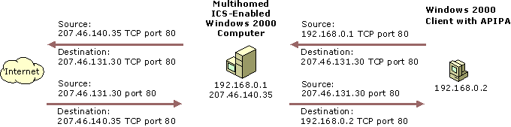
Figure 22.18 Internet Connection Sharing Procedure
1. When a user on the small business intranet connects to an Internet resource, the user’s TCP/IP protocol creates an IP packet with the following values set in the IP and TCP or UDP headers (bold text indicates the fields changed by ICS):
• Destination IP Address: Internet resource IP address
• Source IP Address: Private IP address
• Destination Port: Internet resource TCP or UDP port
• Source Port: Source application TCP or UDP port

2. The computer forwards this IP packet to ICS, which translates the addresses of the outgoing packet as follows:
• Destination IP Address: Internet resource IP address
• Source IP Address: ISP-allocated public address
• Destination Port: Internet resource TCP or UDP port
• Source Port: Remapped source application TCP or UDP port

3. ICS sends the remapped IP packet over the Internet. The responding computer sends back the response to ICS. When received by ICS, the packet contains the following addressing information:
• Destination IP Address: ISP-allocated public address
• Source IP Address: Internet resource IP address
• Destination Port: Remapped source application TCP or UDP port
• Source Port: Internet resource TCP or UDP port

4. When ICS maps and translates the addresses and forwards the packet to the intranet client, it contains the following addressing information:
• Destination IP Address: Private IP address
• Source IP Address: Internet resource IP address
• Destination Port: Source application TCP or UDP port
• Source Port: Internet resource TCP or UDP port

For outgoing packets, the source IP address and TCP/UDP port numbers are mapped to a public source IP address and a possibly changed TCP/UDP port number. For incoming packets, the destination IP address and TCP/UDP port numbers are mapped to the private IP address and original TCP/UDP port number.
ICS includes a DHCP allocator service to assign private IP addresses, and a proxy DNS server to perform name resolution services on behalf of all computers in the intranet.
Note Do not enable ICS in an existing network that has DNS servers, gateways, DHCP servers, or computers configured with static IP addresses. If your Windows 2000 Professional– based computer is in a network where one or more of these conditions exist, you must use Windows 2000 Server network address translation. For more information, see “Unicast IP Routing” in the Internetworking Guide.
Enable Internet Connection Sharing
To enable ICS, you must be logged on to an account that has administrative rights.
To enable Internet Connection Sharing
1. In Control Panel, open Network and Dial-Up Connections.
2. Right-click the connection you want to share (the connection that connects to the Internet), and then click Properties.
3. On the Sharing tab, select the Enable Internet Connection Sharing for this connection check box.
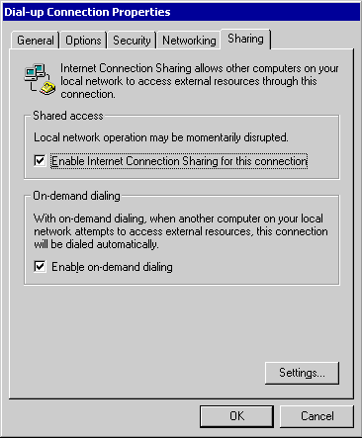
If the shared connection is a dial-up connection and you want the connection to dial automatically when another computer on your network attempts to use external resources, select the Enable on-demand dialing check box.
4. Click OK.
A dialog box is displayed, indicating that the intranet’s connection’s IP address is set to 192.168.0.1, and warns that connectivity with other computers on the network might be lost.
5. Click Yes.

Note If your office users need to gain access to a corporate network via a VPN server that is connected to the Internet, they need to create a PPTP-based virtual private network (VPN) connection to tunnel from the computer on the intranet to the corporate VPN server on the Internet. The VPN connection is authenticated and secure, and creating the tunneled connection allocates proper IP addresses, DNS server addresses, and WINS server addresses for the corporate network. For more information about configuring a VPN connection, see “Local and Remote Networking” in this book.
When ICS is enabled, the TCP/IP configuration is modified on the computer with the shared connection, and services related to network translation are started. Table 22.7 shows the modified system configuration on the sharing computer:
Table 22.7 ICS System Configuration Modifications

Modified Configuration ICS Setting

IP address Configured for the reserved private IP address 192.186.0.1, subnet 255.255.255.0.
IP routing Created when the shared connection is established.
DHCP allocator Enabled with the default range of 192.168.0.0, subnet 255.255.255.0.
DNS proxy Enabled through ICS
Internet Connection Sharing service Started
Autodial feature Enabled
Note You cannot modify the default configuration of ICS. This includes items such as disabling the DHCP allocator or modifying the range of private IP addresses that are handed out. If you want to modify any of these items, you must use Windows 2000 Server network address translation. For more information about network address translation as implemented in Windows 2000 Server, see “Unicast IP Routing” in the Internetworking Guide.
All computers on your network that access the Internet by means of Internet Connection Sharing must reconfigure their TCP/IP configurations to use DHCP. Each computer in the network is reassigned an IP address from the reserved IP address range 192.168.0.2 to 192.168.0.254, with a subnet mask of 255.255.255.0. As with the ICS-enabled computer, the change in IP address might cause you to lose connectivity with other computers in the network that use static addressing.
Configure Applications and Services
You might need to configure Internet Connection Sharing to provide access to remote programs and services to users in your network. For example, if users on your intranet want to use a videoconferencing application such as NetMeeting, ICS must be configured to support the application on the connection in which shared access is enabled.
Conversely, you might want to provide services to applications and services on remote computers. Services that you provide must be configured so that Internet users can gain access to them. For example, if you are hosting a Web server on your home network and you want Internet users to be able to connect to it, you must configure ICS to provide the Web Server service.
ICS provides support for remote services and applications via ports. Ports are used by TCP and UDP to identify the ends of logical connections to deliver data to applications. For the purpose of providing services to unknown callers, a service contact port is defined. The contact port is sometimes called the well-known port. For a list of standard UDP and TCP ports, see “Well Known Port Numbers” in RFC 1700, “Assigned Numbers.”
To configure applications to access remote services
1. From Network and Dial-up Connections, right-click the shared connection, and then select Properties.
2. On the Sharing tab, verify that the Enable Internet connection sharing for this connection check box is selected, and then click Settings.
3. To configure a network application for the computers sharing the connection, on the Applications tab, click Add, and then do the following:
• In Name of application, type an easily recognized name for the application.
• In Remote server port number, type the port number of the remote server where the application resides, and then click either TCP or UDP.
• In TCP or UDP or both, type the port number for the port on your home network to which the application connects. Some applications require TCP and UDP port numbers.

To configure services for remote applications
1. From Network and Dial-up Connections, right-click the shared connection, and then select Properties.
2. On the Sharing tab, verify the Enable Internet connection sharing for this connection check box is selected, and then click Settings.
3. Click the Services tab, and then select the standard services in the Services box.
– Or –
To add a service that is not in the list, click Add, and then do the following:
• In Name of Service, type an easily recognized name for the service.
• In Service port number, type the port number of the computer where the service resides, and then click either TCP or UDP.
• In Name or address of server computer on private network, type the name or TCP/IP address of the computer on your network where the service is located.

Configure IP Security and Filtering
Windows 2000 Professional incorporates two primary methods for securing IP packets: IP security and TCP/IP filtering. IP security is a new feature of Windows 2000 Professional. IP security protects data by securing and optionally encrypting IP packets prior to transmission on the network. The following section discusses the features of IP security, and describes the methods for installing and configuring this feature. TCP/IP filtering, known as TCP/IP Security in Windows NT 4.0, is also discussed as a method of controlling the IP traffic received by the network interface.
Determine IP security method to be implemented. Windows 2000 Professional supports two methods to secure and control the transmission of IP packets: IP security, an industry-defined set of standards that verifies, authenticates, and optionally encrypts data at the IP packet level; and TCP/IP filtering, which controls the ports and packet types for incoming local host data. Either or both of these methods can be implemented within the same Windows 2000 Professional– based client. For more information about IP security, see “Overview of IPSec,” “Considerations for IPSec,” and “Configure IP Filtering” in this chapter.
Enable and configure IP Security, if required. IP Security may be enabled in the registry of the Windows 2000 Professional computer through local policies, or implemented via Active Directory group policies in an enterprise environment. If implemented locally, built-in or custom policies created via the Policy Manager snap-in can determine the rules required for negotiating and starting communications with other hosts. See “Configuring IPSec Policies” later in this chapter.
Enable IP filtering, if required. You may wish to restrict the type of IP traffic that can be received by a Windows 2000 Professional– based client. IP filtering allows the creation of rules that limit packet reception by TCP and UDP port, or by IP protocol type. See “TCP/IP Filtering” later in this chapter.
Overview of IPSec
The need for Internet Protocol (IP)-based network security is already evident. In today’s massively interconnected business world of the Internet, intranets, branch offices, and remote access, sensitive information constantly crosses the networks. The challenge for network administrators and other information service professionals is to ensure that this traffic is:
• Safe from data modification while en route.
• Safe from interception, viewing, or copying.
• Safe from being accessed by unauthenticated parties.

These issues are known as data integrity, confidentiality, and authentication. In addition, replay protection prevents acceptance of a packet that has been captured and later resent.
For these reasons, Internet Protocol security, or IPSec, was designed by the Internet Engineering Task Force (IETF). IPSec supports network-level authentication, data integrity and encryption. IPSec integrates with the inherent security of the Windows 2000 operating system to provide the ideal platform for safeguarding intranet and Internet communications.
IP security uses industry-standard encryption algorithms and a comprehensive security management approach to provide security for all TCP/IP communications on both sides of an organization’s firewall. The result is a Windows 2000, end-to-end security strategy that defends against both external and internal attacks.
IP security is deployed below the transport layer, sparing network managers (and software vendors) the difficulty and expense of trying to deploy and coordinate security one application at a time. By simply deploying Windows 2000 IP security, network managers provide a strong layer of protection for the entire network, with applications automatically inheriting from IPSec-enabled servers and clients.
How IP Security Prevents Network Attacks
Without security measures and controls in place, data might be subjected to an attack. Some attacks are passive, meaning information is simply monitored; others are active, meaning the information is altered with intent to corrupt or destroy the data or the network itself. Table 22.8 presents some common security risks found in today’s networks.
Table 22.8 Types of Network Attacks

Attack type Description How IPSec prevents

Eavesdropping (also called sniffing, snooping) Monitoring of cleartext or unencrypted packets. Encapsulated packets can also be monitored if attacker has access to key and packets are unencrypted. Data is encrypted before transmission, preventing access even if the packet is monitored or intercepted. Only the intended receiving party can decrypt the data.
Data modification Alteration and transmission of modified packets. Data hashing attaches a digital “signature” to each packet, which is checked by the receiving computer to detect modification.
Identity spoofing Use of constructed or captured packets to falsely assume the identity of a valid address. Kerberos v5, MS-CHAP, and other authentication methods secure Windows 2000 – based computers.
Denial-of-service Preventing access of network by valid users. An example is to flood the network with packet traffic. Authentication methods limit access from unauthorized users.
Man-in-the-middle Diversion of IP packets to an unintended third party, to be monitored and possibly altered. Anti-replay mechanisms, data hashing.
Known-key Access or construction of a security key, used to decrypt or modify data. A compromised key might be used to create additional keys. Under Windows 2000, public keys are periodically refreshed, reducing the possibility that a captured key can be used to gain access to secure information.
Application layer attack Mainly directed at application servers, this attack is used to cause a fault in a network’s operating system or applications or to introduce viruses into the network. Since IPSec is implemented at the network layer, packets that do not meet the security filters at this level are never filtered upwards, protecting applications and operating systems.
IPSec prevents the previous type of attacks by using cryptography-based mechanisms. Cryptography allows information to be transmitted securely by hashing (digitally signing data) and encrypting (encoding) the information.
A combination of an algorithm and a key is used to secure information:
• The algorithm is the mathematical process by which the information is secured.
• A key is the secret code or number required to read, modify, or verify secured data.

IPSec uses a policy-based mechanism to determine the level of security required during a communications session. Policies can be distributed throughout a network by means of Windows 2000 domain controllers, or created and stored locally within the registry of a Windows 2000 Professional– based computer.
Before the transmission of any data, an IPSec-enabled computer negotiates the level of security to be maintained during the communications session. During the negotiation process, the authentication method is determined, a hashing method is determined, a tunneling method is chosen (optional), and an encryption method is determined (optional). The secret authentication keys are determined locally at each computer by using information exchanged at this time; no actual keys are ever transmitted. After the key is generated, it is used to authenticate the session, and secured data exchange can begin.
The resulting level of security can be low or high, based on the IP security policy of the sending or receiving computer. For example, a communications session between a Windows 2000 Professional– based computer and a non-IPSec host might not require a secure transmission channel. Conversely, a communications session between a Windows 2000 server containing sensitive information and a dial-in host might be high, using data encryption by means of a securing transmission.
An Example of IPSec
Figure 22.19 provides an overview of the procedure of establishing an IP security session:
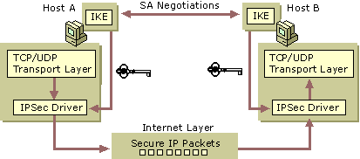
Figure 22.19 Overview: the IPSec Process
1. An application on Computer A generates outbound packets to send to Computer B across the network.
2. IPSec checks IP Security Group Policy settings on Computer A to determine the computer’s active IP Security policy. The default policies allow a computer to demand secure communication, to request secure communication but proceed unsecurely if necessary, or to never request IP security.
3. Computer A begins security negotiations with Computer B. The two computers exchange public keys and establish a shared, secret key that is created independently at both ends without being transmitted across the network.
4. The IPSec driver on Computer A signs the outgoing packets for integrity, and optionally encrypts them for confidentially. It transmits the packets to Computer B.
5. Routers and servers along the network path from Computer A to Computer B do not require IPSec. They simply pass along the packets in the usual manner.
6. The IPSec driver on Computer B checks the packets for integrity and decrypts their content if necessary. It then transfers the packets to the receiving application.

Although routers and switches can freely forward encrypted IP packets, firewalls, security routers, and proxy servers must enable IP forwarding to ensure packet delivery. For more information about IP forwarding, see “Unicast Routing Overview,” in the Internetworking Guide.
Considerations for IPSec
IP security provides encryption of outgoing IP packets, but at the cost of local computer performance. On a computer with IP encryption enabled, packets are encrypted before being passed to the network, which is a processor-intensive procedure. Although IPSec implements symmetric encryption of network data, encryption of a large amount of IP packets can tax all but the fastest workstations.
IPSec supports processing offload by the network adapter. Many network adapters include onboard processors that perform many of the tasks that are normally performed by the computer’s central processor, including packet encryption. Consult the product documentation for your network adapter to see if it supports encryption processing offload.
Configuring IPSec Policies
IPSec policies, rather than applications or operations systems, are used to configure IPSec services. The policies provide variable levels of protection for most traffic types in most existing networks.
There are two storage locations for IPSec policies:
1. Active Directory in a Windows 2000 domain controller.
2. Locally defined in the registry for computers that are not part of a Windows 2000 domain.

Your network security administrator can configure IPSec policies to meet the security requirements of a user, group, application, domain, site, or global enterprise from a Windows 2000 domain controller. IPSec policy can also be implemented in a non-Windows 2000– based domain environment through local IPSec policies.
The IPSec policies are based on your organization’s guidelines for secure operations. Through the use of security actions, called rules, one policy can be applied to heterogeneous security groups of computers or organizational units. Windows 2000 Professional provides an MMC console called Local Security Policy to create and manage IPSec policies.
This section describes the procedure for configuring domain-based and local IPSec policies on a Windows 2000 Professional– based computer. For detailed information on planning, creating and implementing IPSec policies on a Windows 2000 domain controller, see “Internet Protocol Security” in the TCP/IP Core Networking Guide.
Configuring Domain-based IPSec Policies
For an organization that wishes to implement IP security, creating IP security policies at the domain controller provides the most efficient method of controlling enterprise security policy. Windows 2000 provides an administrative interface, the Local Security Policy snap-in, to create and administer security policies. An IP security administrator can create security policies at varying levels or granularity, from the site, domain, organizational unit, user or computer levels. Different security policies can be applied for different groups, based on identified needs for security.
After an IPSec policy has been created at the domain controller, security policy can be applied to members of a specific container. For example, if Sally is a member of an organizational unit (OU) that has a security policy applied to it, the OU’s security policy is automatically applied at startup. No user intervention is required. Using domain-based policies ensure that the proper security is always implemented at users’ machines, regardless of the existence of local security policies.
When a computer that is normally a member of a Windows 2000 domain is temporarily disconnected, the security policy information is cached in the local registry.
IPSec Precedence Rules
IP security policy precedence is identical to that of other Group Policy settings. In a domain, Group Policy is applied hierarchically from the least restrictive object (site) to the most restrictive object (organizational unit).
For more information about Active Directory and Group Policy, see chapters under “Active Directory” and “Desktop Configuration Management” in the Distributed Systems Guide.
Configuring Local IPSec Policies
Local IPSec policies can be selected and stored locally at a Windows 2000 Professional– based computer. This can be done to implement local IP security in the following situations:
• The computer is a member of a Windows 2000 domain that does not implement IPSec policies.
• The computer is a member of a Windows NT domain.
• The computer is part of a workgroup.
• The computer is not a member of any domain or workgroup, but is connected to other hosts by means of an enterprise intranet or the Internet.

By implementing local IP security, the Windows 2000 Professional– based computer can transfer IP packets based on the security policy stored in its registry. Three preconfigured local IPSec policies are provided at system installation: Client, Server, and Secure Server. Table 22.9 summarizes the attributes of the default security policies.
Table 22.9 Default Local IP Security Policies

Policy Name Security Requirements
Attributes

Client (Respond Only) Low For computers that do not require secure communications, this policy enables a Windows 2000 Professional– based computer to respond to requests for secured communications. Unsecured communications are available with non-IPSec hosts.
Server (Request Security) Moderate Enables a Windows 2000 Professional– based computer to accept unsecured communications, but attempt to establish a secure channel by requesting security from the sending host. Communications are unsecured if the requesting host is not IPSec-enabled.
Secure Server (Require Security) High Requires that all communications with a Windows 2000 Professional– based computers be secured. All unsecured incoming communications are rejected, and all outgoing communications are secured.
The default security policies can be used as -is, eliminating the need to create custom policies unless you have special requirements. You must have administrative privileges in order to select or change IP security policies.
By default, no local IPSec policies are active. To select one of the default local IPSec policies, use the following procedure.
To activate a local IPSec policy
1. In Control Panel, double-click Network and Dial-up Connections.
2. Right-click Local Area Connection, and then select Properties.
3. Select Internet Protocol (TCP/IP), and then click Properties.
4. Click Advanced, and then click the Options tab.
5. Select IP security, and then click Properties.
6. Select Use this IP security policy, and then select the IPSec policy you want from the list.
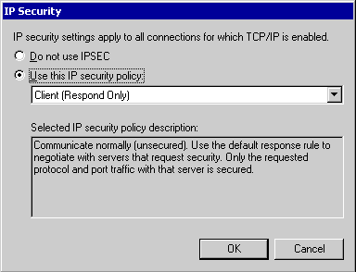

For any Windows 2000 Professional– based computer that is a member of a domain, IPSec policies assigned at the domain override any local IPSec policy when that computer account is connected to the domain.
IPSec Policy Management Snap-in
The Microsoft Management Console (MMC) IP Security Policy Management snap-in allows you to perform the following tasks:
• Create and manage local and domain-based IPSec policies
• Manage IP filter lists and filter actions
• Check IPSec policies
• Restore default IPSec policies
• Import and export IPSec policies

The IP Security Policy Management snap-in is not loaded in Windows 2000 Professional by default. To install the IP Security Policy Management snap-in, perform the following steps while logged on to an account with administrative rights.
To install the IP Security Policy Management snap-in
1. In an empty or existing MMC console, select Console/Add/Remove Snap-in.
2. In the Standalone dialog box, click Add.
3. In the Available Standalone Snap-ins box, select IP Security Policy Management, and then click Add.
4. In the Select which computer this Snap-in will manage dialog box, select the option that matches the security policy environment to be managed by the target computer.
5. From the target computer, you can manage the security policy of the target computer (stored in its registry), the IP security policy of the local or another domain (if appropriate permissions have been granted) or manage the local security policy of another computer, stored in its registry.
6. Click Finish.

Creating Local IPSec Policies
New IPSec policies can be created by selecting Create IP Security Policy from the Actions menu of the IP Security Policy Management console, or by right-clicking the details panel of the console, and then selecting Create IP Security Policy. This action starts the IP Security Policy wizard.
The IP Security Policy wizard prompts you for the information needed to configure the initial response rule for the new policy. The following information is required:
• Policy name and description
• Application of default rule
A security rule determines how IPSec policy secures communication. Selection of this option specifies that a default rule is created for use as the response rule if no other rule exists or applies.
Additional rules can be created after the default rule by editing the IP security policy.
• Authentication method for default rule
An authentication method for the two computers must be determined before secure communications can begin. Use this option to select the method of authentication for the default rule, if chosen:
• Kerberos v5
• Certificate-based
• Preshared key

A detailed discussion of the creation of IP security policies is beyond the level of this section. For more information on IP policy and rule creation, refer to Windows 2000 Help and “Internet Protocol Security” in the TCP/IP Core Networking Guide.
TCP/IP Filtering
Windows 2000 Professional includes support for TCP/IP filtering (known as TCP/IP Security in Windows NT 4.0). TCP/IP filtering allows you to specify exactly which types of incoming IP traffic are processed for each IP interface. This feature is designed to isolate the traffic being processed by Internet and intranet clients in the absence of other TCP/IP filtering provided by the Routing and Remote Access service or other TCP/IP applications or services. TCP/IP filtering is disabled by default.
TCP/IP filtering is a set of input filters for nontransit TCP/IP traffic. Nontransit traffic is traffic that is processed by the host because the destination IP address of inbound IP datagrams are addressed to an assigned interface address, appropriate subnet broadcast address, or multicast address. TCP/IP filtering does not apply to transit or routed traffic that is forwarded between interfaces.
TCP/IP filtering allows you confine nontransit inbound TCP/IP traffic based on the:
• Destination TCP port
• Destination UDP port
• IP protocol

To configure TCP/IP filtering
1. In Control Panel, double-click Network and Dial-up Connections select Local Area Connection, and then right-click Properties.
2. On the General tab, click Internet Protocol (TCP/IP) in the list of components, and then click Properties.
3. Click Advanced.
4. Click the Options tab, TCP/IP filtering, and then Properties.

TCP/IP filtering can be enabled and disabled for all adapters by means of a single check box. This can help troubleshoot connectivity problems that might be related to filtering. Filters that are too restrictive do not allow expected kinds of connectivity. For example, if you do not include the RIP protocol, then the RIP Listener service will not function.
Configure Quality of Service
Quality of Service (QoS) facilitates the deployment of media-rich applications, such as video conferencing and Internet Protocol (IP) telephony. QoS also improves the performance of traditional mission-critical (qualitative) software such as Enterprise Resource Planning (ERP) applications. Through the full implementation of QoS in a Windows 2000 domain, QoS-aware applications running on Windows 2000 – based clients can be provided a guaranteed or prioritized level of delivery service, while allowing centralized management of network resources.
Understand the purpose and function of Quality of Service and how it is implemented in your network. Although largely implemented through a collection of servers, switches, and routers, an understanding of QoS in Windows 2000 is critical to the successful implementation of QoS at a Windows 2000 Professional– based client. This section explains the architecture of QoS, the protocols used, and provides a scenario to demonstrate these concepts. See “Overview of Quality of Service” and “Windows 2000 QoS Components” in this chapter.
Verify that the client meets requirements to implement QoS, and install the QoS Packet Scheduler. In order to successfully implement QoS on a Windows 2000 Professional– based client, the client must meet hardware and software requirements. In addition, the QoS Packet Scheduler must be installed for each Windows 2000 Professional– based client that requests QoS. See “QoS Configuration Requirements” in this chapter.
Overview of Quality of Service
Multimedia streams, such as those used in IP telephony or videoconferencing, can be extremely bandwidth- and delay-sensitive, imposing unique demands on the underlying networks that carry them. Conversely, enterprise network administrators might be primarily concerned with the quality of network transmissions for mission-critical applications, such as Enterprise Resource Planning (ERP) applications, and secondarily concerned with providing sufficient bandwidth for multimedia applications.
To deploy real-time applications over IP networks with an acceptable level of quality, specific network requirements must be met. These requirements are bandwidth, latency, and jitter. In addition, the traffic must coexist with traditional data traffic on the same network. Table 22.10 summarizes these requirements.
Table 22.10 Network Requirements for Real-Time Applications

Network Requirement Effect

Bandwidth Multimedia data, especially video, requires larger amounts of bandwidth than traditional networks can handle. Even compressed, a handful of multimedia streams can completely overwhelm any other traffic on the network.
Latency The amount of time that a multimedia packet takes to get from the source to the destination has a major impact on the perceived quality of the call. Latency must be minimized to maintain a certain level of interactivity and to avoid pauses in conversation.
Jitter Variations in packet arrival time must be below a certain threshold to avoid dropped packets, resulting in gaps in audio and video transmission. Jitter, by determining receive buffer sizes, also affects latency.
Coexistence In comparison with multimedia traffic, data traffic arrives in unpredictable chunks. Aggregations of such bursts cause gaps in teleconferencing applications. Multimedia bandwidth must be protected from data traffic, and vice versa.
QoS is a combination of mechanisms that cooperatively provide a specific quality level to application traffic crossing a network or multiple, disparate networks. Implementing QoS means combining a set of technologies defined by the Internet Engineering Task Force (IETF), designed to reduce the problems caused by shared network resources and finite bandwidth.
QoS provides two distinct benefits:
• A mechanism for applications to request service quality parameters, such as low latency and jitter.
• Higher levels of administrative control over congested subnet bandwidth resources.

Implementing QoS enables network administrators to make the most efficient use of subnet bandwidth when deploying resource-intensive applications. A QoS-enabled network can provide guarantees of sufficient network resources for some traffic, and the ability to prioritize other important traffic, giving a congested, shared network segment a level of service approaching that of a private network. Different classes of applications have varying degrees of tolerance for delay in network throughput. An accepted QoS request can ensure that an application can transmit data in an acceptable way, in an acceptable time frame so that the transmission is not delayed, distorted, or lost.
To enable end-to-end QoS requires cooperation from the sending host, the receiving hosts and routers and switches between the two end nodes. Without QoS, each of these network devices treat all data equally and provide service on a first-come, first-served basis, known as best-effort delivery. In addition, for an application to make use of QoS, it must have some level of QoS awareness so that it can request bandwidth and other resources from the network.
The efficient use and allocation of bandwidth is critical for productivity. Real-time applications, media-rich applications, and Enterprise Resource Planning applications require a large amount of uninterrupted bandwidth for transmission to be successful, and therefore can strain existing network resources. When traffic is heavy, overall performance degrades, which results in traffic and packet loss. This degradation causes problems with video conferencing, real-time audio, and interactive communication, causing distortion of voices and images. Because media-rich applications use large quantities of bandwidth, traditional mission-critical applications suffer from the lack of available resources. QoS provides a delivery system for network traffic that can guarantee limited delays and data loss, or allow certain types of traffic to receive priority queuing over other types of traffic.
It is important to realize that QoS cannot create bandwidth; it can only efficiently partition bandwidth based on differing parameters.
Windows 2000 QoS Components
The Windows 2000 QoS architecture is built upon a tightly-integrated set of industry standard protocols, services, and mechanisms that control access to network resources, classify and schedule network traffic, and protocols that signal network devices to apply QoS by handling specific traffic flows with greater priority. Figure 22.20 illustrates the Windows 2000 QoS architecture.
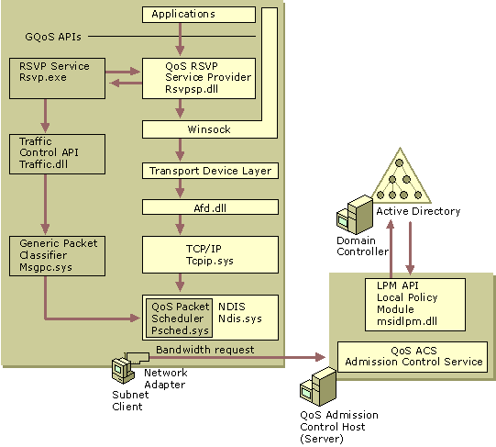
Figure 22.20 Windows 2000 QoS Components
All of these components work together seamlessly to provide QoS on a network. Appearing as shaded boxes in this figure are the Windows 2000 QoS components. Not pictured in Figure 22.20 are the elements in the network infrastructure required to fully ensure QoS end-to-end. All routers and switches between the sender and receiver must also support one of several possible QoS mechanisms, such as RSVP, 802.1p, or DiffServ, otherwise traffic receives best-effort delivery on that segment.
Generic QoS API (GQoS API)
Applications can use the Generic QoS application programming interface (GQoS API) to specify or request bandwidth requirements, such as preventing latency when streaming audio. They can also use the GQoS API to prioritize traffic generated by mission-critical applications.
GQoS is part of the Windows Sockets 2.0 (Winsock2) API. The abstraction of the QoS API enables applications to invoke QoS without a full knowledge of the QoS mechanisms available or the specific underlying network media. As such, QoS can be implemented in a variety of diverse media, such as Ethernet or IP over Asynchronous Transfer Mode (ATM).
Resource Reservation Protocol
When QoS is requested, GQoS calls upon the services of the underlying QoS service provider, Resource Reservation Protocol Service Provider (Rsvpsp.dll). The RSVP SP issues RSVP signaling to participating network devices along the data path of the bandwidth requirements, traffic control, and Admission Control support.
Resource Reservation Protocol (RSVP) is an IETF-defined signaling protocol that carries QoS requests for priority bandwidth through the network. RSVP (Rsvp.exe) bridges the gap between the application, the operating system, and the media-specific QoS mechanisms. RSVP sends messages in a format that is media-independent, so that end-to-end QoS is possible over networks that combine different types of low-layer network devices.
Traffic Control
Traffic control creates and regulates data flows by using defined QoS parameters, such as transmission latency and delay variation. It also facilitates the creation of filters to direct selected packets through a data flow. The capabilities of traffic control are accessed via the Traffic Control API, implemented through the dynamic link library Traffic.dll. Traffic control is called upon by the GQoS API.
The Generic Packet Classifier (Msgpc.sys) determines the service class to which an individual packet belongs. Table 22.11 shows the possible service classes for a packet.
Table 22.11 Windows 2000 Service Classes

Service Class Definition

Best Effort Network devices make reasonable effort to deliver packets (standard service level).
Controlled Load Approximates the standard packet error loss of the transmission medium. Approximates the behavior of best-effort service in lightly loaded (not heavily loaded or congested) network conditions.
Guaranteed Guarantees the ability to transmit data at a determined rate for the duration of the connection.
Qualitative Although not implemented, the qualitative service class is designed for applications that require prioritized traffic but cannot to quantify their resource needs. The level of service is determined by an entry in a policy server by a network administrator.
Packets are then queued by service class, managed by the QoS Packet Scheduler. The QoS Packet Scheduler (Psched.sys) enforces QoS parameters for a particular data flow. Traffic is marked with a particular priority by the QoS Packet Scheduler, differentiated by priority and by device type. 802.1p provides prioritization of packets for devices that correspond to Layer 2 of the OSI model, such as switches. For Layer 3 devices such as routers, the Differentiated Class of Service enables packets that pass through network devices to have their relative priority differentiated from one another.
The QoS Packet Scheduler then determines the delivery schedule of each packet queue and handles competition between queued packets that need simultaneous access to the network.
QoS Admission Control Service
To deploy real-time multimedia or qualitative applications with an acceptable traffic rate, a network must commit to some level of guaranteed resource availability. In addition, the subnet management service must find some way for this priority traffic to coexist with traditional data traffic.
The QoS Admission Control Service (QoS ACS), located in a designated ACS server, solves this problem by allowing the network administrator to centrally designate how, by whom, and when shared network resources are used. A QoS ACS server performs logical allocation of network resources based on policies located in Active Directory on the domain controller. Note that the ACS server does not allocate the physical network resources, but performs the policy and Admission Control function of accepting or rejecting requests. After a request has been accepted, the sending host can mark the packets accordingly. Figure 22.21 illustrates this procedure.
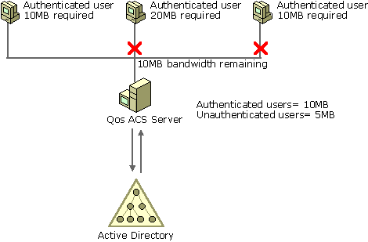
Figure 22.21 How QoS ACS Works
As each request for network resources is received by the QoS ACS server:
• The QoS ACS verifies whether network resource levels are adequate. The ACS can verify for the sender, receiver, or both.
• The requesting user identity is verified by using the Kerberos protocol, the default Windows 2000 authentication service.
• The QoS ACS policy for that user is retrieved from Active Directory or from the local ACS policy cache.
• The QoS ACS server checks the policy to see whether the user has adequate rights for the request.
• The QoS ACS approves or rejects the request.

A single QoS ACS server can be configured to manage multiple subnets. Typically, QoS ACS servers are implemented on an enterprise’s most congested segments, often at the ingress to an expensive WAN link.
QoS ACS policies are defined in Active Directory by the network administrator by using the ACS MMC snap-in. Policies can be defined at varying levels of granularity, from specific (a particular user policy in a domain) to general (any authenticated user in the enterprise). QoS ACS policies are processed hierarchically, from most specific to least specific. Additionally, enterprise-level policies can be differentiated between authenticated users (users with valid domain accounts) and unauthenticated users (users who have access to the network, but are not authenticated by a Windows 2000 domain controller).
Note For more information about planning and implementing a QoS ACS server in an Active Directory domain, see “Quality of Service” in the TCP/IP Core Networking Guide, and “Group Policy” in the Distributed Systems Guide.
The Local Policy Module (LPM) is a component of the QoS ACS that provides a means of retrieving policy information from Active Directory. When a Windows 2000 Kerberos ticket is received by the ACS server, the QoS ACS invokes the LPM dynamic-link library Msidlpm.dll. The LPM extracts the user name from the RSVP message and looks up the user’s Admission Control policy in Active Directory.
Putting It All Together: A QoS Scenario
IP telephony provides an excellent example of the need for Quality of Service controls. When a user initiates a teleconference call to another user, the success of the communication relies on available priority bandwidth. Any new IP telephony sessions have the potential to degrade the quality of the first call that is still in progress, because these calls must share the same bandwidth. To guarantee QoS and successful throughput of the original call, the various components of QoS are put to use:
• A QoS-enabled sending application initiates a session with a receiving client, signaling a request for desired resource requirements.
• The Admission Control Service verifies the user’s right to request a bandwidth reservation.
• A receiving client accepts or rejects the request, and if accepted, sends a Reservation Confirmation (RESV) message back to the sending client.
This RESV message from the receiver traverses back along the same path as the sending message, and routers along the way that understand RSVP also have the opportunity to accept or reject the request. If the request is accepted by a network entity, then the requested bandwidth is allocated on that device. Admission Control can also be applied on the receiver.
• Traffic Control prioritizes and schedules IP packets between the two clients when the RESV message reaches the sender’s system.

This section describes how these components work together in a common QoS scenario. Figure 22.22 illustrates a common QoS deployment.
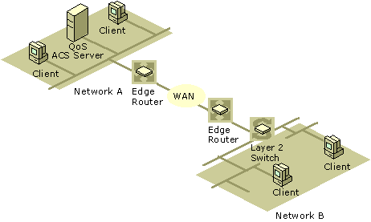
Figure 22.22 How QoS Works
1. A user on a client in Network A starts a videoconferencing session with a user in Network B. The application used to transmit data is QoS-enabled. The application requests QoS from the RSVP SP.
2. The RSVP SP requests the RSVP service to signal the necessary bandwidth requirements, and notifies traffic control that QoS has been requested for this flow. Traffic is currently sent at a best-effort delivery level.
3. An RSVP message is sent to the QoS ACS server, requesting a reservation. Note that it is RSVP messages that are passed to the QoS ACS, not the data packets that are ultimately transmitted from sender to receiver.
4. The QoS ACS server verifies that enough network resources are available to meet the QoS level requested, and that the user has the policy rights to request that amount of bandwidth. The Local Policy Module uses the Kerberos ticket in the RSVP request to authenticate the user identity and look up the user policy in Active Directory. Note that the QoS ACS can verify resources for the sender, receiver, or both.
5. After verification is complete, the QoS ACS server approves the request and logically allocates bandwidth. The QoS ACS server forwards the request to the receiver of the videoconferencing session on the client in Network B.
6. When the RSVP request passes the edge router for Network A, the router keeps track of the resources (bandwidth) that are requested, although the bandwidth is not yet physically allocated. RSVP is a receiver-initiated protocol and bandwidth can only be reserved by the receiver. The same process is repeated on the edge router for Network B.
7. The request is passed through each network device in the data path before it arrives at the receiver. The receiving client indicates that it wants to receive the data and returns an RSVP message requesting a reservation.
8. When the receiver’s request for bandwidth passes through the edge router for Network B, it already has cached the information about the requested bandwidth (from the sender’s request). The router matches the receiver request with the sender’s request, and installs the reservation by physically granting the bandwidth. The same process is repeated on the edge router for Network A.
9. The reservation is sent back to the sender. The Layer 3 network devices (the edge routers) are capable of approving and allocating the physical bandwidth. The reservation simply passes through the Layer 2 switch.
10. During this process, the traffic is sent by traffic control on the sender as best-effort. Upon receiving the reservation message, the traffic control on the sending host begins the process of classifying, marking, and scheduling the packets to accommodate the QoS level requested. The QoS Packet Scheduler performs the priority marking for RSVP, 802.1p for prioritization on Layer 2 devices (shown as the switch in Figure 22.22), and for Differentiated Class of Service for Layer 3 devices (shown as the edge routers).
11. The QoS Packet Scheduler begins sending the prioritized traffic. The data is handled as priority by all devices along the data path, providing greater speed of throughput and a more successful videoconference session between the clients on networks A and B.

Note that this example is a general description. Variations are possible depending on network topology as well as the presence of different network devices.
QoS Configuration Requirements
To maintain the integrity of RSVP reservations on a shared subnet, it is important that any client that can issue RSVP messages is a QoS Subnet Bandwidth Manager client. On Windows 2000 Professional, the required QoS client software must be configured and enabled to request bandwidth. The requesting applications installed on the Windows 2000 Professional– based client must also be QoS-enabled. Applications that are not QoS-aware do not interact with the QoS ACS server, and receive best-effort service traffic levels from the network.
To fully implement QoS, there are several considerations that must be met by the Windows 2000 Professional– based client.
Hardware Network adapters must be compatible with the IEEE 802.1p standard, and must support 802.1p to allow prioritization over a shared subnet. This standard provides the mechanism necessary for traffic control.
Admission Control Policies Verify with your network administrator that a valid Admission Control policy exists for your user or group in the domain. The ACS policy determines the level or service to be provided to each user or group account, and directly affects the level of service provided. Also, check to see what the enterprise policy for nonauthenticated users is – for example, a member of a workgroup within the enterprise. Depending on enterprise policy, unauthenticated users are allowed access to network services at a lower policy-defined level, at best-effort levels, or no access at all.
QoS Packet Scheduler The QoS Packet Scheduler service must be installed on every Windows 2000 Professional– based client on which you want to have traffic control services. The QoS Packet Scheduler must be installed on all end-systems that make reservations on subnets where you are running a QoS Admission Control Service.
To install the QoS Packet Scheduler
1. From Control Panel, double-click Network and Dial-up Connections.
2. Right-click the local area connection you want to modify, and then select Properties.
3. Click Install.
4. Click Service.
5. Select QoS Packet Scheduler, and then click OK.
6. Click Close.

Perform TCP/IP Troubleshooting
Many network troubleshooting tools are available to assist in diagnosing TCP/IP problems for Windows 2000 Professional. This section summarizes the most common and most helpful tools included with the operating system, and provides an organized approach for deploying them.
Assess the situation. After assessing the TCP/IP problem, create a plan to determine the true nature of the problem: IP addressing and routing, host name resolution, NetBIOS name resolution, or IP security. A flowchart is provided to assist you in this task in Figures 22.24 through 22.26. See “TCP/IP Troubleshooting Overview” in this chapter.
Determine and obtain required troubleshooting tools. After you have determined the possible source of the problem, obtain the tools that you need to prove your hypothesis and resolve the problem. See “TCP/IP Troubleshooting Tools” in this chapter.
Determine and resolve name resolution problems. First, determine whether the error condition was caused by a failure in host (for example, www.reskit.com) or NetBIOS (for example, \\computername) name resolution. Use the tools to determine the nature of the IP-to-name resolution problem. See “Troubleshooting Name Resolution” in this chapter.
Determine and resolve IP addressing problems. If name resolution is not the nature of the TCP/IP problem, verify that IP addressing, routing, IP security and filtering have been correctly configured on the Windows 2000 Professional– based client. Additionally, confirm that the route to the remote computer is properly configured and available. See “Troubleshooting IP Addressing” in this chapter.
Determine and resolve IP routing problems. If the nature of the TCP/IP problem occurs outside the current subnet, or is related to access of a remote host or router, verify the configuration of the routing table gateways, and check the status of routers along the route path. See “Troubleshooting Routing” in this chapter.
TCP/IP Troubleshooting Overview
When troubleshooting any problem, ask yourself the following questions:
• What application is failing? What works? What doesn’t work?
• Is the problem basic IP connectivity or is it name resolution? If the problem is name resolution, does the failing application use NetBIOS names or DNS names and host names?
• How are the things that do and don’t work related?
• Have the things that don’t work ever worked on this computer or network?
• If so, what has changed since they last worked?

Ideally, a review of the location and timing of the problem helps narrow the problem’s scope. In addition, you can examine TCP/IP failures systematically by referring to the steps needed for successful computer communications.
TCP/IP for Windows 2000 allows an application to communicate over a network with another computer by using three basic types of destination designations:
• IP address (for example, 172.10.1.32)
• Host name (for example, client1.reskit.com)
• NetBIOS name (for example, client1)

This section describes how to troubleshoot either host name or NetBIOS name resolution problems. Both of these issues are outlined in Figures 22.23 through 22.25, which provide a simplified flowchart to guide troubleshooting.
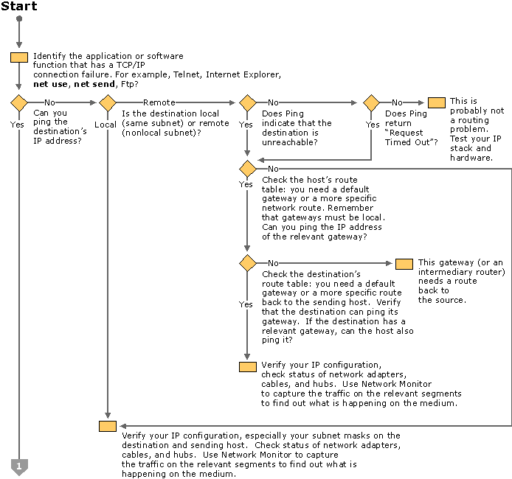
Figure 22.23 TCP/IP Troubleshooting Flowchart (Part 1 of 3)
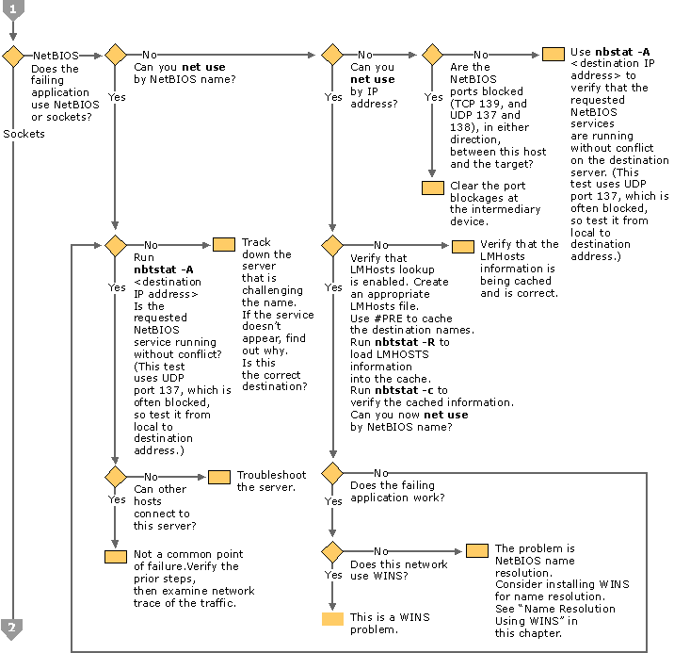
Figure 22.24 TCP/IP Troubleshooting Flowchart (Part 2 of 3)
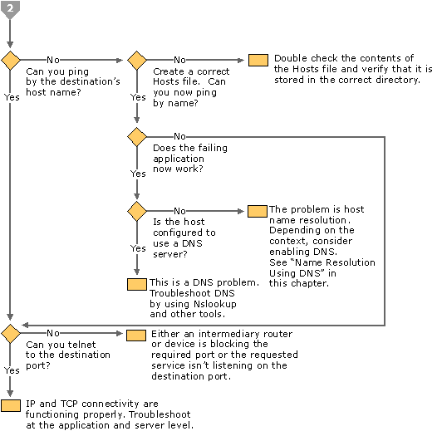
Figure 22.25 TCP/IP Troubleshooting Flowchart (Part 3 of 3)
The first step is to determine which application is failing. Typically, this is Telnet, Internet Explorer, net use, or another application that uses NetBIOS or Sockets to find network resources. Making this determination helps with the next step, which is to determine whether the problem is a host name or NetBIOS name resolution problem.
The easiest way to distinguish host name problems from NetBIOS name resolution problems is to find out whether the failing application uses NetBIOS or Sockets. If it uses Sockets, the problem lies with a DNS/host name resolution. If the application uses NetBIOS, the problem is with NetBIOS name resolution (broadcast, Lmhosts or WINS). Among the most common applications, the NetBIOS family includes the various net commands or the Windows NT 4.0 administrator tools. Most Internet- or intranet-based applications such as Internet Explorer and other web browsers, ftp clients and telnet use Windows Sockets.
TCP/IP Troubleshooting Tools
Table 22.12 lists the diagnostic tools discussed in this section. There are other troubleshooting tools available for TCP/IP; they are described in more detail in “Troubleshooting Tools and Strategies” in this book.
Table 22.12 TCP/IP Diagnostic Tools

Tool Used to

Hostname Display the host name of the computer.
Ipconfig Display current TCP/IP network configuration values, and update or release Dynamic Host Configuration Protocol (DHCP) allocated leases, and display, register, or flush Domain Name System (DNS) names.
Nbtstat Check the state of current NetBIOS over TCP/IP connections, update the NetBIOS name cache, and determine the registered names and scope ID.
Pathping Trace a path to a remote system and report packet losses at each router along the way.
Ping Send ICMP Echo Requests to verify that TCP/IP is configured correctly and that a remote TCP/IP system is available.
Route Display the IP routing table, and add or delete IP routes.
Tracert Trace a path to a remote system.
To view the proper syntax for each command, type /? after each command.
In addition to the TCP/IP-specific tools, the following Microsoft Windows 2000 tools and utilities might be needed in problem determination and resolution:
• Event Viewer — Tracks system errors and events.
• Control Panel — Allows changes to networking and other system components.
• Registry editors— Both Regedit.exe and Regedt32.exe allow viewing and editing of registry parameters.

Troubleshooting Name Resolution
The following section details the procedures for detecting and resolving a variety of host and NetBIOS name resolution problems.
NetBIOS Name Resolution
The following section describes the methods for detecting and resolving the most common types of NetBIOS name resolution problems.
Resolving NetBIOS Error 53
The most common symptom of a problem in NetBIOS name resolution is when the Ping tool returns an Error 53 message. The Error 53 message is generally returned when name resolution fails for a particular computer name. Error 53 can also occur when there is a problem establishing a NetBIOS session. To distinguish between these two cases, use the following procedure:
To determine the cause of an Error 53 message
1. From the Start menu, open a command prompt.
2. At the command prompt, type:
net view * \\<hostname>
where <hostname> is a network resource you know is active.
If this works, your name resolution is probably not the source of the problem. To confirm this, ping the host name, as name resolution can sometimes function properly, yet net use returns Error 53 (such as when a DNS or WINS server has a bad entry). If Ping also shows that name resolution fails (by returning the “Unknown host” message), check the status of your NetBIOS session.

To check the status of your NetBIOS session
1. From the Start menu, open a command prompt.
2. At the command prompt, type:
net view \\<ip address>
where <ip address> is the same network resource you used in the earlier procedure. If this also fails, the problem is in establishing a session.

If the computer is on the local subnet, confirm that the name is spelled correctly and that the target computer is running TCP/IP as well. If the computer is not on the local subnet, be sure that its name and IP address mapping are available in the DNS database, the Hosts or Lmhosts file, or the WINS database.
If all TCP/IP elements appear to be installed properly, use Ping with the remote computer to be sure its TCP/IP protocol is working.
Check the Lmhosts File
The name resolution problem might be in your Lmhosts file, which looks for addresses sequentially from the top down. If more than one address is listed for the same host name, TCP/IP returns the first value it encounters, whether that value is accurate or not.
You can find the Lmhosts file in \%SystemRoot%\System32\Drivers\Etc. Note that this file does not exist by default; a sample file named Lmhosts.sam exists. This file must be renamed to Lmhosts before it is used.
Note While \%SystemRoot%\System32\Drivers\Etc is the default directory for this file, exactly which Lmhosts file is consulted depends on the value of the databasepath registry entry located in: HKEY_LOCAL_MACHINE\SYSTEM\CurrentControlSet\Services \Tcpip\Parameters\
The database path tells the local computer where to look for the Lmhosts file.
Check the WINS Configuration
Make sure your computer’s WINS configuration is correct. In particular, check the address for the WINS server.
To examine your WINS configuration
1. In Control Panel, double-click Network and Dial-Up Connections.
2. Right-click Local Area Connection, and then click Properties.
3. In the Local Area Connection Properties dialog box, select Internet Protocol (TCP/IP), and then click Properties.
4. In the Internet Protocol (TCP/IP) Properties dialog box, click Advanced.
5. In the Advanced TCP/IP Settings dialog box, click the WINS tab.

In the WINS configuration dialog box, add the server’s IP address (if none is listed) and check to see whether Lmhosts lookup is enabled. Also check to see whether NetBIOS over TCP/IP is taken from the DHCP server, enabled, or disabled. If you are using DHCP for this host computer, take the value from the DHCP server. Otherwise, enable NetBIOS over TCP/IP.
Host and DNS Name Resolution
If the problem is not NetBIOS but Sockets, the problem is related to either a Hosts file or a DNS configuration error. To determine why only IP addresses, but not host names, work for connections to remote computers, make sure that the appropriate Hosts file and DNS setup have been configured for the computer.
To check host name resolution configuration
1. In Control Panel, double-click Network and Dialup Connection.
2. Right-click Local Area Connections, and then select Properties.
3. Click on Internet Protocol (TCP/IP), and then click Properties.
4. In the Microsoft TCP/IP Properties dialog box, click the Advanced tab.
5. Click the DNS tab.
6. Confirm that DNS is configured properly. If the DNS server IP address is missing, add it to the list of DNS server addresses.

Note that this procedure does not take DHCP clients into account; these clients do not have DNS servers in the list.
Check the Hosts File
If you are having trouble connecting to a remote system using a host name and are using a Hosts file for name resolution, the problem might be with the contents of that file. Make sure the name of the remote computer is spelled correctly in the Hosts file and by the application using it.
The Hosts file or a DNS server is used to resolve host names to IP addresses whenever you use TCP/IP tools such as Ping. You can find the Hosts file in \%SystemRoot%\System32\Drivers\Etc.
This file is not dynamic; all entries are made manually. The file format is the following:

172.16.48.10 testpc1 # Remarks are denoted with a #.

The IP address and friendly host name are always separated by one or more space or tab characters.
The following Hosts file problems can cause networking errors:
• The Hosts file does not contain the particular host name.
• The host name in the Hosts file or in the command is misspelled.
• The IP address for the host name in the Hosts file is invalid or incorrect.
• The Hosts file contains multiple entries for the same host on separate lines. Because the Hosts file is parsed from the top, the first entry found is used.

Check Your DNS Configuration
If you are using DNS, be sure that the IP addresses of the DNS servers are correct and in the proper order. Use Ping with the remote computer’s host name, and then use its IP address to determine whether the host address is being resolved properly. If the host name ping fails and the IP address ping succeeds, the problem is with name resolution. You can test whether the DNS servers are running by pinging their IP addresses or by opening a Telnet session to port 53 on the DNS server. If the connection is established successfully, the DNS service is working on the DNS server. After you’ve verified that the DNS service is running, you can perform Nslookup queries to the DNS server to further verify the status of the records for which you are looking.
If ping by IP address and by name fail, the problem is with network connectivity, such as basic connectivity or routing. For more information about troubleshooting network connectivity, see “Troubleshooting Routing” later in this chapter.
For a brief summary about how DNS resolves host names, see “Name Resolution Using DNS” earlier in this chapter.
DNS Error Messages
Errors in name resolution can occur when the entries in a DNS server or client are not configured correctly, when the DNS server is not running, or when there is a problem with network connectivity. To determine the cause of any name resolution problem, you can use the Nslookup tool.
Failed queries return a variety of messages, depending on whether the name cannot be resolved, whether the server does not provide a response, or the request times out. The server might be offline, the host computer might not have the DNS service enabled, or there might be a hardware or routing problem.
Troubleshooting IP Addressing
If host name resolution occurs successfully, the problem might lie elsewhere. In this case, the problem might be simply a matter of correcting the IP configuration rather than examining the name resolution process.
TCP/IP troubleshooting generally follows a set pattern. In general, first verify that the problem computer’s TCP/IP configuration is correct, and then verify that a connection and a route exist between the computer and destination host by using Ping.
Compile a list of what works and what doesn’t work, and then study the list to help isolate the failure. If link reliability is in question, try a large number of pings of various sizes at different times of the day, and plot the success rate or use the PathPing tool.
Check Configuration with Ipconfig
When troubleshooting a TCP/IP networking problem, begin by checking the TCP/IP configuration on the computer experiencing the problem. Use the ipconfig command to get the host computer configuration information, including the IP address, subnet mask, and default gateway.
When Ipconfig is used with the /all switch, it produces a detailed configuration report for all interfaces, including any configured remote access adapters. Ipconfig output can be redirected to a file and pasted into other documents. To do so, type ipconfig >directory\file name. The output is placed in the directory you specified with the file name you specified.
The output of Ipconfig can be reviewed to find any problems in the computer network configuration. For example, if a computer has been configured with an IP address that is a duplicate of an existing IP address that has already been detected, the subnet mask appears as 0.0.0.0.
If no problems appear in the TCP/IP configuration, the next step is to test the ability to connect to other host computers on the TCP/IP network.
Test Network Connection with Ping and PathPing
Ping is a tool that helps to verify IP-level connectivity; PathPing is a tool that detects packet loss over multiple-hop trips. When troubleshooting, the ping command is used to send an ICMP Echo Request to a target host name or IP address. Use Ping whenever you want to verify that a host computer can send IP packets to a destination host. You can also use the Ping tool to isolate network hardware problems and incompatible configurations.
Note If you call ipconfig /all and receive a response, there is no need to ping the loopback address and your own IP address—Ipconfig has already done so to generate the report.
It is best to verify that a route exists between the local computer and a network host by first using Ping and the IP address of the network host to which you want to connect. The command syntax is:
ping <IP address>
Perform the following steps when using Ping:
1. Ping the loopback address to verify that TCP/IP is installed and configured correctly on the local computer.

ping 127.0.0.1

If the loopback step fails, the IP stack is not responding. This might be because the TCP drivers are corrupted, the network adapter might not be working, or another service is interfering with IP.
2. Ping the IP address of the local computer to verify that it was added to the network correctly. Note that if the routing table is correct, this simply forwards the packet to the loopback address of 127.0.0.1.

ping <IP address of local host>

3. Ping the IP address of the default gateway to verify that the default gateway is functioning and that you can communicate with a local host on the local network.

ping <IP address of default gateway>

4. Ping the IP address of a remote host to verify that you can communicate through a router.

ping <IP address of remote host>

5. Ping the host name of a remote host to verify that you can resolve a remote host name.

ping <Host name of remote host>

6. Run a PathPing analysis to a remote host to verify that the routers on the way to the destination are operating correctly.

pathping <IP address of remote host>

Note If your local address is returned as 169.254.y.z, you have been assigned an IP address by the Automatic Private IP Addressing (APIPA) feature of Windows 2000. This means that the local DHCP server is not configured properly or cannot be reached from your computer, and an IP address has been assigned automatically with a subnet mask of 255.255.0.0. Restart the Windows 2000 Professional– based computer, and see if the networking problem persists.
If your local address is returned as 0.0.0.0, the Microsoft MediaSense software override started because the network adapter detects that it is not connected to a network. To correct this problem, turn off MediaSense by making sure that the network adapter and network cable are connected to a hub. If the connection is solid, reinstall the network adapter’s drivers or a new network adapter.
Ping uses host name resolution to resolve a computer name to an IP address, so if pinging by IP address succeeds, but fails by name, then the problem lies in host name resolution, not network connectivity. For more information about troubleshooting host name resolution, see “Troubleshooting Name Resolution” earlier in this chapter.
If you cannot use Ping successfully at any point, check the following:
• The local computer’s IP address is valid and appears correctly in the IP Address tab of the Internet Protocol (TCP/IP) Properties dialog box or when using the Ipconfig tool.
• A default gateway is configured and the link between the host and the default gateway is operational. For troubleshooting purposes, make sure that only one default gateway is configured. While it is possible to configure more than one default gateway, gateways beyond the first are only used when the IP stack determines that the original gateway is not functioning. Because the point of troubleshooting is to determine the status of the first configured gateway, delete all others to simplify your troubleshooting.
• IP Security is not currently enabled. In some cases, IPSec functions interfere with ping packets being sent to or from a remote host. For more information about IPSec, see “Configuring IPSec Policies” earlier in this chapter.
Important If the remote system being pinged is across a high-delay link such as a satellite link, responses might take longer to be returned. The -w (wait) switch can be used to specify a longer time-out.

Clear ARP Cache
If you can ping both the loopback address and your own IP address, the next step is to clear out the ARP cache and reload it. This can be done by using the Arp tool. Use commands arp -a or arp -g to display the cache contents. Delete the entries with arp -d <IP address>.
Verify Default Gateway
Next, look at the default gateway. The gateway address must be on the same network as the local host; if not, no messages from the host computer can be forwarded to any location outside the local network. Next, check to make sure that the default gateway address is correct as entered. Finally, check to see that the default gateway is a router, not just a host, and that it is enabled to forward IP datagrams.
Ping Remote Host
If the default gateway responds correctly, ping a remote host to ensure that network-to-network communications are operating as expected. If this fails, use Tracert to examine the path to the destination. For IP routers that are Windows NT or Windows 2000 – based computers, use the Route tool or the Routing and Remote Access administrative tool on those computers to examine the IP route table. For IP routers that are not Windows NT or Windows 2000 – based computers, use the appropriate tool or facility to examine the IP route table.
Four error messages are commonly returned by Ping during troubleshooting as shown in Table 22.13.
Table 22.13 Ping Error Messages

Error Message Meaning and Action

TTL Expired in Transit Number of required hops exceeds TTL. Increase TTL by using the ping -i switch.
Destination Host Unreachable A local or remote route does not exist for destination host. Modify the local route table or notify the router administrator.
Request Timed Out No Echo Reply messages were received due to network traffic, failure of the ARP request packet filtering, or router error. Increase wait time using the ping -w switch.
Unknown Host Destination host name cannot be resolved. Verify name and availability of DNS servers.
Check IP Security
IPSec can increase the defenses of a network, but it can also make changing network configurations or troubleshooting problems more difficult. In some cases, IPSec running on a Windows 2000 Professional– based computer can create difficulties in connecting to a remote host. If IPSec is implemented locally, turn off IPSec and attempt to run the requested network service or function.
To disable local IPSec policies
1. In Control Panel, double-click Network and Dial-up Connections.
2. Right-click the local area connection you want to change, and then select Properties.
3. Select Internet Protocol (TCP/IP), and then click Properties.
4. Click Advanced.
5. Click the Options tab.
6. Select IP Security, and then click Properties.
7. Click Do not use IPSEC, and then click OK.

If IPSec is implemented through IPSec policies at a Windows 2000 domain controller, contact the security administrator to disable the security policy for that computer.
If the problem disappears when IPSec policies are turned off, you know that the additional IPSec processing burden or its packet filtering are responsible for the problem. Contact the security administrator to permanently modify the IPSec policy for the computer.
For more information about IPSec issues, see “Configuring IPSec Policies” earlier in this chapter.
Check Packet Filtering
Any mistakes in packet filtering can make address resolution or connectivity fail. To determine if packet filtering is the source of a network problem, you must disable the TCP/IP packet filtering.
To disable TCP/IP packet filtering
1. In Control Panel, double-click the Network and Dial-Up Connections.
2. Right-click the Local Area Connection, and then click Properties.
3. Select Internet Protocol (TCP/IP), and then click the Properties tab.
4. Click Advanced, and then click Options.
5. In the Optional Settings window, click TCP/IP Filtering, and then click the Properties tab.
6. Clear the Enable TCP/IP Filtering (All Adapters) check box, and then click OK.

Try pinging an address by using its DNS name, its NetBIOS name, or its IP address. If the attempt succeeds, the packet filtering options might be misconfigured or might be too restrictive. For instance, the filtering might permit the computer to act as a Web server, but might in the process disable tools like Ping or remote administration. Restore a wider range of permissible filtering options by changing the permitted TCP, UDP, and IP port values.
If the attempt still fails, another form of packet filtering might still be interfering with your networking. For more information about Routing and Remote Access service filtering functions, see “Unicast IP Routing” in the Internetworking Guide. For more information about IPSec packet filtering, see “Internet Protocol Security” earlier in this chapter.
Troubleshooting Routing
Windows 2000 supports routing on both single- and multi-homed computers with or without the Routing and Remote Access service. The Routing and Remote Access service includes the Routing Information Protocol (RIP) and the Open Shortest Path First (OSPF) routing protocols. Routers can use RIP or OSPF to dynamically exchange routing information.
For more information about TCP/IP routing, see “Unicast IP Routing” in the Internetworking Guide. For information about troubleshooting IP multicast routing, see “IP Multicast Support” in the Internetworking Guide.
Cannot Connect to a Specific Server
To determine the cause of connection problems when trying to connect to a specific server using NetBIOS-based connections, use the nbtstat -n command to determine what name the server used to register on the network.
Nbtstat -n output lists several names that the computer has registered. A name resembling the computer’s name as shown on the desktop must be present. If not, try one of the other unique names displayed by Nbtstat.
The Nbtstat tool can also display the cached entries for remote computers from either #PRE entries in the Lmhosts file or from recently resolved names. If the name the remote computers are using for the server is the same, and the other computers are on a remote subnet, be sure that they have the computer’s mapping in their Lmhosts files or WINS servers.
Connection to Remote Host Hangs
To determine why a TCP/IP connection to a remote computer is not working properly, use the netstat -a command to show the status of all activity on TCP and UDP ports on the local computer.
A good TCP connection usually shows 0 bytes in the Sent and Received queues. If data is blocked in either queue or if the state is irregular, the connection is probably faulty. If not, you are probably experiencing network or application delay.
Examining the Routing Table with Route
For two hosts to exchange IP datagrams, they must both have a route to each other, or use default gateways that know of a route. Normally, routers exchange information with each other by using a routing protocol such as RIP. For information about how to examine and configure the local route table, see “Configuring Local Route Table” earlier in this chapter.
Examine Paths with Tracert
Tracert is a route tracing tool that uses incrementally higher values in the TTL field in the IP header to determine the route from one host to another through a network. It does this by sending ICMP Echo Request messages and analyzing ICMP error messages that return. Tracert allows you to track the path of a forwarded packet from router to router for up to 30 hops. If a router has failed or if the packet is routed into a loop, Tracert reveals the problem. After the problem router is found, its administrator can be contacted if it is an offsite router, or the router can be restored to fully functional status if it is under your control.
Troubleshooting Gateways
If you see the message “Your default gateway does not belong to one of the configured interfaces...” during setup, find out whether the default gateway is located on the same logical network as the computer’s network adapter. The easiest way to do this is to compare the network ID portion of the default gateway’s IP address with the network IDs of the computer’s network adapters. In other words, check that the bitwise logical AND of the IP address and the subnet mask equals the bitwise logical AND of the default gateway and the subnet mask.
For example, a computer with a single network adapter configured with an IP address of 172.16.27.139 and a subnet mask of 255.255.0.0 requires a default gateway of the form 172.16.y.z. The network ID of the IP interface is 172.16.0.0. Using the subnet mask, TCP/IP can determine that all traffic on this network is local; everything else must be sent to the gateway.
Additional Resources
• For more information about creating IP security policies, see “Internet Protocol Security” in the TCP/IP Core Networking Guide.
• For more information about the design and structure of the Active Directory, see chapters under “Active Directory” in the Microsoft® Windows® 2000 Server Resource Kit Distributed Systems Guide.
• For more information about Group Policy, see chapters under “Desktop Configuration Management” in the Microsoft® Windows® 2000 Server Distributed Systems Guide.
• For more information about Quality of Service, see “Quality of Service” in the TCP/IP Core Networking Guide.
• For more information about IP multicast support, see “IP Multicast Support” in the Internetworking Guide.
• For more information about configuring virtual private networks, see “Local and Remote Networking” in this book.

