Chapter 10 - Interoperability with IBM Host Systems

Microsoft® SNA Server is the Microsoft solution for integrating personal computer–based clients and servers with IBM host systems. Using SNA Server, you can provide Microsoft and non-Microsoft-based clients with secure access to IBM host data, applications, and network services. You can integrate SNA Server into your existing IBM host environment, and you can develop solutions that allow users to gain transparent access to host resources from their desktop operating system or Web browser interface.
In This Chapter
Overview of Microsoft SNA Server
Network Integration Methods
Communications with Hierarchical SNA Networks
Communications with Peer-to-Peer SNA Networks
Heterogeneous Client Services
Host Print Services
LAN-to-Host Security
Host Data Access
Host Application Integration Using COMTI
Host Transaction Integration
Web-to-Host Integration
Network Management Integration
Note The interoperability solutions in this chapter are based on Microsoft® Windows NT® version 4.0–based applications and technologies. Future versions of these applications and technologies might change. Therefore, the material included in this chapter is also subject to change.
Related Information in the Resource Kit
• For more information about IBM host systems and SNA networks, see “IBM SNA Interoperability Concepts” in this book.
• For information about configuring and managing SNA Server, see SNA Server Help and the Microsoft® BackOffice® Resource Kit.

Overview of Microsoft SNA Server
SNA Server provides you with a comprehensive solution to integrate heterogeneous networks and intranets with IBM mainframe, midrange, and AS/400 host systems, as illustrated in Figure 10.1. SNA Server is a Microsoft® BackOffice® application that runs on the Microsoft® Windows® 2000 Server operating system, providing advanced network, data, and application integration services.
SNA Server provides interoperability between host systems that run SNA or TCP/IP protocols. If your IBM host system runs SNA protocols, SNA Server provides network connectivity by acting as a secure, high performance gateway between heterogeneous clients and IBM host systems. Because SNA Server runs on Windows 2000, heterogeneous clients can connect to SNA Server through standard networking protocols such as TCP/IP, IPX/SPX, NetBEUI, Banyan VINES IP, AppleTalk, and Windows 2000 Routing and Remote Access service. SNA Server then completes the network connection to the mainframe or AS/400 system using standard IBM SNA protocols.
Once SNA or TCP/IP-based network connectivity is established, clients can use SNA Server’s advanced host integration features to gain secure access to IBM host data, applications, and network services without leaving their familiar desktop or Web browser interface.
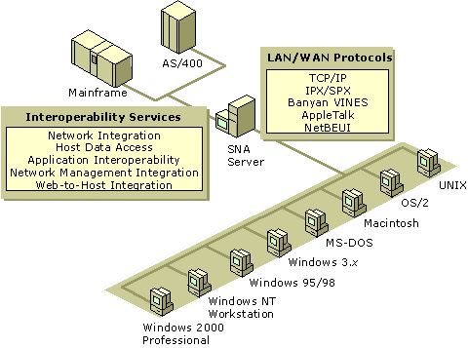
Figure 10.1 SNA Server Integrates Heterogeneous Networks with IBM Host Systems
The core of SNA Server’s power is its ability to provide a wide range of host integration services. As such, SNA Server supports interoperability at each layer of the Windows 2000 interoperability model:
Network interoperability Cross-platform network connectivity and protocols, security integration, and single sign-on. (Single sign-on allows users to log on once to access multiple servers, systems, or applications.)
Data access and integration Transparent file transfer services, Universal Data Access technologies such as OLE DB and Open Database Connectivity (ODBC), and host data replication.
Application access and integration Terminal access, integrated transaction services, Web-to-host integration, and messaging.
Network management integration Integration between Windows 2000 network management services and IBM NetView–based management services.
Network Integration Services
When implementing cross-platform interoperability solutions, the first step is to establish secure and reliable connectivity between network platforms. SNA Server integrates heterogeneous networks with IBM mainframe, midrange, and AS/400 host systems using two types of connections, server-to-host and client-to-server.
The server-to-host connections are the physical units (PUs) and logical units (LUs) that connect the SNA Server to the host system.
The client-to-server connections enable network clients and application programs to connect to SNA Server over the local area network (LAN) or wide area network (WAN).
Because SNA Server operates on Windows 2000 Server, it can support a wide range of clients and protocols and can scale to support the needs of large enterprise networks. Table 10.1 introduces the services that SNA Server provides on the network integration level.
Table 10.1 Network Integration Services

Network Integration Services Description

Supported Host Systems IBM Mainframe Systems; AS/400 Systems; Advanced System 36; System/36; System/38; and IBM compatible mainframe systems from Amdahl, Fujitsu, Hitachi, Tandem, and Unisys.
Server Capacity Up to 3,000 users operating up to 30,000 concurrent sessions on each server.
Hot Backup and Load Balancing Up to 15 computers running SNA Server can be configured to provide failover for each other. LU pools can be shared across up to 15 servers to provide load-balancing.
Host Connection Methods Supports standard connection methods including Channel (ESCON and Bus and Tag), Twinax, Open Systems Adapter (Token Ring, Ethernet, FDDI), SDLC, X.25, and DFT.
SNA Remote Access Service (SNA remote access server) Integrates the LU 6.2 transport with Windows 2000 remote access server.
Heterogeneous Client Support Microsoft® Windows® 2000 Professional, Microsoft® Windows® 95, Microsoft® Windows® 98, Microsoft® Windows® 3.x, Microsoft® MS-DOS®, Macintosh, OS/2, and UNIX.
Protocol Support SNA, TCP/IP, IPX/SPX, Named Pipes, Banyan VINES IP, and AppleTalk.
Distributed Link Service SNA Server computers can share host connections with other SNA Server computers. Allows efficient tunneling of SNA data between SNA Server computers over standard WAN infrastructures such as TCP/IP-based networks.
Downstream Connections Supports communications to PU type 2.0 devices using only SNA protocols. To downstream devices, SNA appears to be the actual host system, reducing host PU configuration requirements.
PU Pass-through Service Full SNA-capable products can connect to the host by passing PU 2.1 or PU 2.0 data through SNA Server. SNA Server behaves like an IBM 3174 cluster controller.
Integrated Single Sign-on Administrators can configure SNA Server to provide User ID and password information to the host based on Windows 2000 domain authentication credentials, eliminating the need to manage multiple sign-on combinations.
Password Synchronization Supports third-party bi-directional password synchronization for ACF2, Resource Access Control Facility (RACF), and Top Secret security.
Data Encryption Encrypts data streams between clients and SNA Server computers, isolating the transmission of cleartext data (required by many host applications) to the secure network environment in the data center.
LU Level Security Administrators can give users access to LU pools or can restrict users to specific LUs.
Bulk Migration Tool for Host Security Creates Windows 2000 domain accounts, enrolls users in the Host Security Domain, and synchronizes critical account information.
Data Access
The purpose of integrating heterogeneous networks is to provide users with cross-platform access to data and applications. Table 10.2 summarizes the advanced services SNA Server uses to provide users with access to host data and the associated host files and printing resources.
Table 10.2 Host Data Access and Integrated File and Printing Services

Database and File Transfer Services
Description

OLE DB Provider for AS/400 and VSAM Provides read/write record-level access to mainframe VSAM files and OS/400 files. Supports the development of multiple-tier applications that give users transparent access to non-relational host data.
ODBC/DRDA Driver for DB2 Applications designed to use the ODBC interface and SQL can dynamically interact with host database systems (such as DB2) using the DRDA protocol. Can also be used with OLE DB–based applications.
Shared Folders Gateway Allows users to gain access to AS/400 shared folders–based files as if they were local drives on a computer running Windows 2000 Server. Allows you to use Windows 2000 security permissions and access rights on host shared folders.
Advanced Program-to-Program Communications (APPC) File Transfer Protocol (AFTP) Service Provides access to AFTP file transfer (the SNA APPC equivalent to TCP/IP File Transfer Protocol [FTP]).
FTP-AFTP Gateway Service Allows standard FTP clients to access host AFTP files.
VSAM File Transfer Service Allows authorized users to copy mainframe VSAM files to Windows 2000 Server.
Host Data Replicator Support Acts as a gateway for the replication of host data to Microsoft® SQL Server™.
Host Print Services Allows mainframe and AS/400 print jobs to be printed on LAN-attached printers.
Application Integration
Organizations often use IBM host systems for online transaction processing (OLTP) that supports real-time, line of business applications. Traditionally, users have relied on terminal emulation programs to gain access to these host applications. However, information technology departments are increasingly deploying solutions that provide a more seamless level of integration between modern intranet services and IBM host data and applications.
Table 10.3 summarizes the services SNA Server supports to integrate desktop clients with host applications and transaction services.
Table 10.3 Integration with Host Applications and Transaction Services

Application and Transaction Integration Services
Description

Supports 3270, TN3270, TN3270E, TN3287 Terminal Emulation SNA Server includes a 3270 emulator for access to mainframe applications. SNA Server also supports third-party terminal emulation products for native access or TCP/IP-based access to mainframe applications.
Supports 5250 and TN5250 Terminal Emulation SNA Server includes a 5250 emulator for access to AS/400 applications. SNA Server also supports third-party terminal emulation products for native access or TCP/IP-based access to AS/400 applications.
COM Transaction Integrator (COMTI) for CICS and IMS Allows integration of Component Services with host CICS and IMS transactions, including distributed two-phase commit between Component Services and CICS.
Common Programming Interface for Communications (CPI-C) Communicates with applications on any platform that supports APPC and CPI-C including mainframes, AS/400s, Windows 2000, and UNIX.
Web-to-Host Integration Technologies Supports integration between host data and applications and Windows 2000–based applications such as Microsoft® Internet Information Services (IIS), SQL Server and Windows-based desktop applications.
Network Management Integration
Providing users with the ability to communicate, share data, and run applications across platforms allows organizations to develop more efficient and productive business processes. However, the integration process is not complete until network managers can monitor and control the integrated environment.
Table 10.4 summarizes the services SNA Server uses to integrate Windows 2000 Server–based management systems with IBM host management systems.
Table 10.4 Network Management Integration Services

Network Management Integration Services
Description

SNA Server Manager Single console for adding, configuring, monitoring, and controlling all SNA Server components. Allows simultaneous, remote management of subdomains, servers, services, connection, LUs, sessions, users, and groups.
Integration with Windows 2000 Server management services Full integration with Microsoft Management Console (MMC) and Windows 2000 event monitoring, security, and performance monitoring.
Integration with IBM NetView network management system Automatic reporting of host link alerts to NetView; supports Response Time Monitor (if supported by the 3270 emulator). Also supports Windows 2000 NVAlert Services and NVRunCmd for remote management of SNA Server from the host NetView console.
Network Integration Methods
Using the SNA Server features described in the preceding tables, you can connect Windows 2000–based networks to hierarchical SNA networks and Advanced Peer-to-Peer Networking (APPN) networks, and provide network integration services for your users. To accomplish this goal, you must first choose a deployment model, organize your SNA Server computers within your Windows 2000 domains, and select your LAN-to-host connection methods.
Deployment Models
Consider the following when deciding how to deploy SNA Server throughout your enterprise:
• The type of host systems with which your users need to connect.
• The location of the users who require host access.
• Your existing network infrastructure.
• The level of performance and host availability your organization requires.
• The costs of deploying and managing the systems.

To accommodate different host connectivity requirements, SNA Server offers three deployment models.
Branch Deployment Model Consists of computers running SNA Server placed away from the host system and near your users.
Centralized Deployment Model Consists of SNA gateways placed close to the host system.
Distributed Deployment Model Consists of SNA gateways placed near the host system and close to your users.
These three models can also be combined to achieve the best configuration for your enterprise. The following sections explore the advantages and disadvantages of each SNA Server deployment model and assist you in making deployment decisions based on your current network model and your interoperability goals.
Branch Deployment Model
Traditionally, enterprises deploy SNA gateways using the branch-based deployment model. Clients use LAN protocols, such as TCP/IP, to communicate with a computer running SNA Server located on the LAN in the branch office.
The computer running SNA Server, in turn, communicates with the host using SNA protocols. With the branch approach, computers running SNA Server are connected to a host through 802.2 (using routers), SDLC, or X.25 connections, as shown in Figure 10.2. Each computer running SNA Server can be administered locally or remotely using Windows 2000 Routing and Remote Access service or IBM NetView.
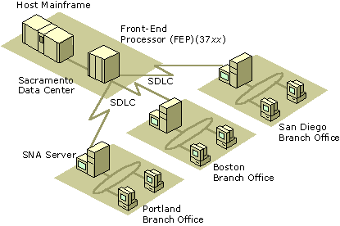
Figure 10.2 Branch-based SNA Server Deployment Model Using SDLC Connections
Advantages of the Branch Model
The branch deployment model offers four primary advantages:
Isolates SNA Traffic
A branch-based deployment model is ideal when a limited amount of bandwidth is available over the SNA Server-to-host connection. In general, network traffic is greater between the client and the computer running SNA Server. If your organization has implemented TCP/IP or another routable WAN protocol, isolating the SNA traffic over specific connections that require host connections—in this case between the SNA Server and the host—prevents unnecessary network traffic from being propagated over non-SNA WAN connections.
Leverages Existing SNA Infrastructure
The branch model is also ideal for organizations that are migrating toward a single, routable WAN protocol solution because it leverages existing investments in SNA data links. As you migrate toward an SNA-free WAN, you can tunnel SNA protocols (such as 802.2 and SDLC) from the branch office LANs to the central site LAN by deploying routers or Frame Relay Access Devices (FRADs) that support Data Link Switching (DLSw), frame relay, or Asynchronous Transfer Mode (ATM) connections.
For more information about frame relay, see RFC 1490.
Provides Flexible Support Options
Because computers running SNA Server are located physically near the clients that request host access services, local SNA Server administrators can usually manage users for their branch, responding more quickly to their needs. If necessary, however, computers running SNA Server can be configured and managed remotely across your WAN links.
Can Use Local Multi-Purpose Servers
By deploying SNA Server in branch offices, you can take advantage of other applications designed to run on Windows 2000 Server. The branch-based server can assume a number of roles in addition to performing SNA Server functions, such as messaging server, database server, and Web server. Components in the BackOffice suite of server applications can work together to provide integrated groupware solutions for your users.
Disadvantages of the Branch Model
The branch deployment model has two primary disadvantages:
Does Not Use High-Speed Mainframe Connections
In a branch-based network, you cannot implement high-speed mainframe connections such as channel attachment, Token Ring, or Ethernet. Local high-speed connections often face physical limitations or difficulty in implementing SNA protocols over a WAN connection. Traditionally, branch-based SNA gateways employ an SDLC-type solution that supports only one physical unit (PU) for each host adapter and only 254 logical units (LUs) over the connection.
Requires Sophisticated Routing
If you decide to use routers rather than dedicated SNA links to pass WAN traffic between the branch and SNA host systems, the routers must be sophisticated enough to prioritize interactive communications over the WAN, as multiple protocols in addition to SNA might be operating over the connection.
Centralized Deployment Model
In a centralized model, computers running SNA Server are deployed physically near the host to which they provide connectivity. The centralized computers running SNA Server provide 3270 and 5250 access for local and remote desktops that connect to the gateways using a routable protocol such as TCP/IP. Other desktop or server-based LU 0, LU 6.2 (APPC), or Telnet applications can connect through these gateways from anywhere on the WAN. Figure 10.3 illustrates the centralized deployment model.
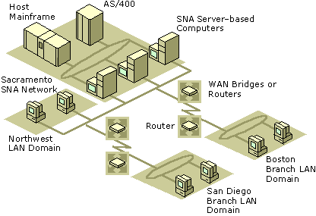
Figure 10.3 Centralized SNA Server Deployment Model Using Routers or Bridges
Advantages of the Centralized Model
The centralized model offers three primary advantages:
Supports Efficient Load Balancing and Fault Tolerance
Using the centralized model, LU pools and APPC session pairs can be configured across multiple computers running SNA Server in a logical organization called a subdomain to provide load balancing and fault tolerance services. Load balancing distributes server loads across all configured servers and prevents one server from being overworked. Fault tolerance or hot backup, ensures that other computers running SNA Server in a subdomain can automatically take over for a failed server. To your users, the switch to a backup computer is transparent. For more information about subdomains, see “Grouping Servers” later in this chapter.
Centralizes Administration
A centralized deployment model is also easier to administer and to secure than a branch-based model because all computers running SNA Server are located close to one another (in the branch-based model, SNA expertise is usually required in each branch office to maintain the servers). Also, changes to mainframe definitions can be coordinated between host and SNA Server administrators more readily if all personnel are located near one another.
Supports High-Speed Mainframe Connections
When computers running SNA Server are physically close to the SNA host, they can be linked by high-speed connections. The channel attachment method provides the highest throughput between SNA Server and a mainframe. In many cases, a channel-attached computer running SNA Server can bypass the front-end processor (FEP), thereby minimizing transaction response time. For AS/400 hosts, you can implement high-speed Token Ring or Ethernet connections.
Disadvantages of the Centralized Model
The centralized model has two primary disadvantages:
Requires an Efficient WAN Infrastructure
A centralized deployment model presupposes the existence of an efficient WAN environment. If a suitable WAN infrastructure is not in place, you must account for the cost in equipment, installation, and possible downtime while you deploy the required hardware. Because client/server transactions generate more network traffic than server/host transactions, this deployment model might yield less responsive client/server connections than a branch model.
Cannot Use Local Multipurpose Servers
With no computers running SNA Server in the branch offices, you cannot use the Windows 2000 Server–based computers, upon which SNA Server runs, as multipurpose servers. If other server applications need to be implemented at the branch locations, you need to install additional computers and hardware.
Distributed Deployment Model
The distributed deployment model combines the best elements of the branch and centralized deployment models. As shown in Figure 10.4, computers running SNA Server are deployed both in a central location near the SNA host and in the branch LANs near the clients.
Typically, the computers located near the host are linked by a high-performance connection, such as channel-attachment. These link services are then made available for distribution to the branch computers running SNA Server using Distributed Link Services, a feature that allows an SNA Server–based computer to share configured link services with other SNA Server–based computers. When implemented, the branch-based servers communicate with the SNA host through a virtual link service over a routable WAN protocol, such as TCP/IP.
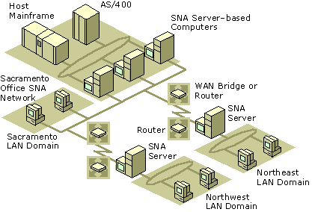
Figure 10.4 Distributed SNA Server Deployment Model
Advantages of the Distributed Model
The distributed model has the advantages of the two previous models while minimizing the disadvantages of each.
Combines the Benefits of the Branch and Centralized Models
The distributed model combines the high-capacity, server-to-host communication benefits of the centralized model with the branch model’s ability to contain heavy client/server traffic to a localized WAN segment, such as a branch office LAN.
Supports Optimal Fault Tolerance and Load Balancing
The distributed model provides even greater flexibility than the branch or centralized plans when fault tolerance and load balancing are implemented. For example, multiple computers running SNA Server at a branch location can be configured to provide hot backup and load balancing for each other. These servers in turn can be connected to the SNA host using distributed link services shared by the centralized computers running SNA Server. If any of the servers fails, the other servers at the same location can take over for the failed unit.
Uses Standard WAN Protocols
The use of Distributed Link Services can also simplify your routing and network protocol choices. For your branch offices, you can use any of the LAN protocols supported by SNA Server, including IPX/SPX. You can implement a more efficient, routable protocol like TCP/IP between the branch and central SNA Server–based computers. SNA traffic is isolated to the connection between the high-speed SNA Server–based computers and the host system. SNA protocols do not need to be routed or bridged across the WAN, thereby simplifying network management.
Disadvantage of the Distributed Model
The one possible disadvantage of the distributed model is that it might require more servers.
Depending on your requirements, deploying SNA Server–based computers both in the central location and in your branch offices could require that you deploy more servers than you would use in a centralized or branch model. However, the additional reliability and performance offered by this model, combined with the ability to eliminate multiprotocol WAN infrastructures can more than offset any requirements for additional servers.
In general, the distributed deployment model provides the most flexible and robust SNA Server solution. This strategy is recommended for medium to large network environments that require the best performance and reliability. The distributed model is also easily scalable to meet your future needs.
SNA Server Integration with Windows 2000-Based Networks
After you choose an appropriate deployment model, you need to determine how to logically group your computers running SNA Server to provide fault tolerance, hot backup, and load-balancing services. How you organize your servers affects your ability to provide secure and robust host connectivity services to your users.
Windows 2000 Domains
The Active Directory™ directory service feature of Windows 2000 Server stores information about all objects on a local or global network and makes this information easy for users and administrators to find and use.
To accommodate the needs of diverse organizations, Active Directory can be partitioned into domains, and, in larger networks, hierarchies of domain trees. A Windows 2000 domain is a group of computers and resources that shares a common user account database and security policy. Windows 2000 domains contain domain controllers which manage user accounts and control access to network resources. The remaining computers in the domain are either user workstations or servers, such as computers running SNA Server, that provide resources to domain users.
For more information about Active Directory and domains, see the Microsoft® Windows® 2000 Server Resource Kit Distributed Systems Guide.
SNA Server Subdomains
Every computer running SNA Server is a member of a Windows 2000 domain and is also a member of an SNA Server subdomain. An SNA Server subdomain is a logical grouping of SNA Server–based computers that share common configuration information. These subdomains allow clients running SNA Server Client software to use any of the SNA Server–based computers in the same subdomain to connect to the host system or systems. To the clients running SNA Server Client software, these computers appear to function as a unit, providing a single set of SNA resources.
Although SNA Server runs on the Windows 2000 Server operating system, SNA Server subdomains play no role in Windows 2000 user authentication. Rather, SNA Server relies on Windows 2000 Server to authenticate users.
Note SNA Server can be configured to use Windows 2000 domain authentication to provide secure, single sign-on to designated host system resources. For more information, see “LAN-to-Host Security” later in this chapter.
Organizing SNA Server-Based Subdomains
Each SNA Server subdomain can contain up to 15 computers running SNA Server, and a Windows 2000 domain can contain an unlimited number of SNA Server subdomains. Because they rely on Windows 2000 domain security to control access to the network, all computers running SNA Server in a particular subdomain must belong to the same Windows 2000 domain.
When you are planning the scope of an SNA Server subdomain and the location of its members, you should consider the capacity of the network link that connects the subdomain members. Whenever the subdomain configuration is changed (by adding a new user or LU, for example), the changed configuration file is propagated to all SNA Server–based computers in a subdomain whose role is set to backup. (SNA Server roles are discussed in the following section.)
To minimize unnecessary replication traffic across slow WAN connections, a subdomain should usually be contained within an Active Directory site. An Active Directory site is one or more TCP/IP subnets that are connected by high-speed links. Windows 2000 allows administrators to control and optimize inter-site replications.
In the distributed deployment model presented earlier in this chapter, you could organize all computers running SNA Server at a branch office site into one subdomain and organize the computers running SNA Server at the central site (near the host) into a separate subdomain.
SNA Server offers additional mechanisms to specifically control SNA Server replication traffic. For example, using the SNA Server Manager, you can control replication traffic by configuring a parameter called Mean Time Between Server Broadcasts. For more information about fine-tuning SNA Server replications, see the SNA Server version 4.0 documentation.
Determining SNA Server Roles
After you have established your Windows 2000 domains and your subdomains, you must assign a role to each computer running SNA Server within each subdomain.
The designation of one of the following three roles identifies which computers running SNA Server have a copy of the SNA Server configuration for the SNA Server subdomain. SNA Server Client–based computers can connect to any computer running SNA Server in the subdomain regardless of its configuration role.
Primary. Provides host connectivity services to your users and contains the master copy of the configuration file. Only one computer can be designated as the primary SNA Server in a subdomain.
Backup. Contains a read-only copy of the configuration file maintained by the primary server. Backup servers can be promoted to a primary role if the primary server fails. An SNA Server subdomain can contain up to 14 backup servers.
Member. Does not contain a copy of the configuration file. Members rely on primary and backup servers to maintain configuration information. An SNA Server subdomain can contain up to 14 member servers.
Note The concept of a backup SNA Server is different from the concept of hot backup. Hot backup is the ability of computers running SNA Server to work together to provide session support even when a server or a connection is not working. When computers running SNA Server provide hot backup, it means that LUs and other resources are configured so that they can fill in and support sessions required by other servers in the subdomain, even if another, similar resource is not available.
The primary computer running SNA Server should be the first server you install in an SNA Server subdomain. If possible, you should have one or more backup servers in the subdomain, as well, to maintain copies of the SNA Server configuration file in case the primary computer running SNA Server fails. If security is an issue, the backup servers should be kept physically secure because each one contains a copy of the SNA Server configuration file.
After you have designated one primary server and its backup servers, the remaining servers can be designated as member servers (computers running SNA Server without a configuration file).
As long as the primary server is running, you can administer SNA Server from a member server just as you would from any other server. You can also manage SNA Server from a computer running Windows 2000 Professional that has SNA Server Manager installed. You can limit the ability of users or groups to administer SNA Server by setting up SNA Server permissions.
Connection Methods
Once you have determined a suitable deployment model and subdomain configuration, you must determine:
• How to connect computers running SNA Server to the IBM host systems.
• Which network protocols to use for communications between clients and SNA Server–based computers.
• Which network protocols to use for communications between different computers running SNA Server.

Connecting SNA Server-Based Computers to IBM Host Systems
This section explores how to connect computers running SNA Server to IBM mainframe and AS/400 host systems.
Understanding SNA Server-to-Host Connections
In SNA Server terms, a host connection is the data communications path between SNA Server and a host system. For a mainframe, this connection corresponds to a physical unit definition in the Virtual Telecommunications Access Method (VTAM). A physical unit (PU) is a combination of hardware and software that provides the services needed to use and manage a particular device. On the AS/400, this connection corresponds to an Advanced Program-to-Program Communications (APPC) controller definition. For more information about IBM host connection methods and other background information about SNA networking, see “IBM SNA Interoperability Concepts” in this book.
For each physical adapter or connection, an appropriate link service is installed and configured within SNA Server. The link service is a Windows 2000 service or device driver that is used to control server-to-host communication adapters supported by SNA Server. Once configured, the link service is available for use not only on the configured SNA Server, but on any SNA Server in the subdomain using the Distributed Link Service feature of SNA Server.
Once you configure your link services, you create connections over a defined link service. As mentioned previously, a connection is the data communication path between a computer running SNA Server and the IBM host. Using a host connection, a client computer on a LAN can communicate with the mainframe system. For some link services, it is possible to define multiple connections over a single host link.
In SNA terms, the combination of a connection and the link service it uses is equivalent to a PU. In SNA networks, SNA Server provides PU 2 or PU 2.1 functionality similar to a cluster controller. For more information about cluster controller functions, see “IBM SNA Interoperability Concepts” in this book.
Understanding Server-to-Host Connection Methods
To understand the connectivity options, you should first examine the different physical connections and network protocols that SNA Server supports. Table 10.5 summarizes all common connection methods that can be used with SNA Server.
Table 10.5 SNA Server-to-Host Connection Methods

Method Throughput Characteristics

Token Ring 802.2 Data Link Control (DLC) 4 or 16 Megabits per second (Mbps) Mainframe or AS/400.Midrange performance using DLC protocol.Supports multiple host connections using a single adapter.Easy and inexpensive to implement.Suitable for a wide range of purposes.
Standard Ethernet 802.2 DLC 10 Mbps Mainframe or AS/400.Midrange performance using DLC protocol.Supports multiple host connections using a single adapter.Easy and inexpensive to implement.Suitable for light to medium network traffic conditions.Ethernet contention can degrade performance under heavy loads.
Fast Ethernet 802.2 DLC 100 Mbps Mainframe or AS/400.High performance using DLC protocol.Supports multiple host connections using a single adapter.Easy and inexpensive to implement.Suitable for higher performance connections.Ethernet contention can degrade performance under heavy loads.
Fiber Distributed Data Interface (FDDI) 802.2 DLC 100 Mbps Mainframe or AS/400.High performance using DLC protocol.Supports multiple host connections using a single adapter.Relatively expensive to implement.Suitable for higher performance connections.
Synchronous Data Link Control (SDLC) 9,600 - 19,200 bps Mainframe or AS/400.Generally low performance using SDLC protocol.Supports 256 sessions over a single host connection.Easy and inexpensive to implement.Suitable for low-traffic WAN connections.

X.25 9,600 - 19,200 bps Mainframes and AS/400.Generally low performance using Qualified Logical Link Control (QLLC) protocol.Supports 256 sessions over a single host connection.Easy and inexpensive to implement.Suitable for low-traffic WAN connections.
Distributed Function Terminal (DFT) 2.35 Mbps Mainframes only.Low to midrange performance.Supports only five sessions over a single host connection.Inexpensive.Suitable for test environments or small networks with an existing DFT-based infrastructure.
Twinax 1 Mbps AS/400 systems only.Low performance.Supports five sessions over a single host connection.Inexpensive.Suitable for AS/400 host environments with an existing Twinax infrastructure.
Channel - Bus & Tag 4.5 megabytes per second Mainframes only.High performance.Supports a high number of host connections..Expensive.Suitable for high-performance connections.
Channel - ESCON 17 megabytes per second Mainframes only.Highest performance.Supports a high number of host connections.Expensive.Suitable for conditions where maximum throughput is required.
When you choose a connection method, you should keep in mind several factors:
• The host systems to which you are connecting.
• The deployment model you are implementing.
• The host networking infrastructure that is in place.
• The expected usage level of host resources.
• The level of performance and response expected by your users.
• Cost.

In general, a high-speed Token Ring connection is a good choice when the same connection is used to connect a LAN to an SNA network that includes both a mainframe and AS/400 system. For greater performance in a dedicated mainframe environment, channel-type connections are generally recommended.
For some link services, multiple host connections are possible using a single adapter, most notably DLC and channel-type link services. Each instance of SNA Server supports up to 250 host connections, and up to four instances of SNA Server are supported on a single computer.
Connecting SNA Server to a Mainframe System
The hierarchical SNA network model provides access to a centralized processing resource from elements throughout the network. This model is most frequently associated with mainframe environments in which centralized applications are accessed from remote terminals across a network.
Devices in a hierarchical SNA network, such as terminals or cluster controllers, are called physical units (PUs). Each class of device is designated by a number. For example, the mainframe itself is known as a PU 5 device. For background information about hierarchical SNA networks, see “IBM SNA Interoperability Concepts” in this book.
SNA Server participates in a hierarchical SNA network by emulating a standard IBM PU 2, or cluster controller, and multiple LUs, which are protocols that provide a standardized format for delivery of data for specific applications, of type LU 0, LU 1, LU 2, and LU 3. This allows client computers that emulate IBM terminals and applications to communicate with the IBM host (PU 5).
SNA Server can connect to a mainframe computer in one of two ways: either directly to the PU 5, the host; or through a PU 4, a front-end processor (FEP).
Direct and Indirect Physical Connections to a Mainframe
You can make a direct physical connection (a connection that does not involve an FEP) between computers running SNA Server and a mainframe system using any of the following physical connection methods:
• Open Systems Interconnection, supporting Token Ring, Ethernet, and FDDI connections
• Bus & Tag channel connection
• ESCON channel connection

Indirect physical connections between SNA Server–based computers and a mainframe system (connections through an FEP) are also supported. These connections might be easier to implement depending on your existing infrastructure and the physical proximity of the computers running SNA Server to the mainframe. For this type of connection, one of the following methods can be used:
• Token Ring
• Ethernet
• FDDI
• SDLC
• X.25

Figure 10.5 illustrates both direct and indirect physical connections to a mainframe.
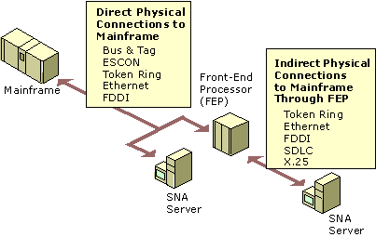
Figure 10.5 Direct and Indirect Physical Connections to a Mainframe
Logical Connections to a Mainframe
In a hierarchical SNA network, SNA Server emulates a cluster controller and supports all standard protocols:
• LU 2 for 3270 terminal sessions.
• LU 1 or 3 for SCS or 3270 printer sessions.
• LU 6.2 for APPC and Common Programming Interface for Communications (CPI-C) applications.
• LU 0, 1, 2, or 3 for LU application (LUA) Request User Interface (RUI) general-purpose, customized applications.

Any combination of these protocols can be used over a given physical connection, as illustrated in Figure 10.6.
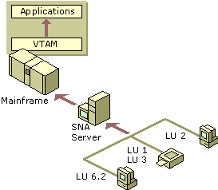
Figure 10.6 Logical Connections to a Mainframe
Connecting SNA Server to an AS/400 System
In the peer-oriented SNA network model, all computers on the network can communicate directly with each other. Advanced Peer-to-Peer Networking (APPN) is the architecture developed by IBM that enables distributed data processing. APPN defines how components communicate with each other, and the level of network-related services, like routing sessions, that are supplied by each computer in the network. For background information about SNA APPN, see “IBM SNA Interoperability Concepts” in this book.
In an APPN network, SNA Server emulates a type 2.1 physical unit device (PU 2.1). SNA Server operates as an APPN low entry network (LEN) node and communicates with other APPN nodes using the Advanced Program-to-Program Communications (APPC) or LU 6.2 protocol.
Computers running SNA Server can connect directly to an AS/400 using several connection methods, as shown in Figure 10.7:
• SDLC
• 802.2/DLC (Token Ring, Ethernet, FDDI)
• X.25
• Twinax
• Frame Relay

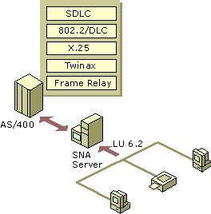
Figure 10.7 SNA Server Connections in a Peer-Oriented Network
Choosing Network Protocols
After your SNA Server–based computer-to-host connection is determined, you must choose the protocol or protocols to use for two additional SNA Server communication paths: between clients and SNA Server–based computers, and between different SNA Server–based computers.
You can use one protocol for both, or you can use a combination of different protocols, provided that all servers share at least one client/server protocol and use it for server-to-server communication.
Deploying a single protocol across your WAN is the easiest way to manage your network communications.
However, you might decide to gradually implement SNA Server throughout your enterprise. In this case, you need to use existing protocols for certain connections. For example, you could use TCP/IP for server-to-server communications and use IPX/SPX for client-to-server communications. Similarly, other combinations of supported protocols can be used, provided that all the SNA Server–based computers share one protocol and use that protocol for server-to-server and client-to-server communication.
Choosing Client/Server Network Protocols
Computers running SNA Server Client software can communicate through a number of LAN protocols:
• TCP/IP
• IPX/SPX
• Named Pipes
• Banyan VINES IP
• AppleTalk

TCP/IP is quickly becoming the standard network protocol for client/server applications. Its high performance and support for sophisticated routing features make it suitable for many WAN environments. In many cases, TCP/IP is the best protocol choice for your network, especially if TCP/IP is already deployed to some degree in the LAN segment on which servers and clients running SNA Server reside.
If you deploy TCP/IP, it is recommended that you assign static IP addresses to SNA Server–based computers because it is easier to administer workstations that have a fixed SNA Server address. For computers that run SNA Server Client software, you can use the Dynamic Host Configuration Protocol (DHCP) to dynamically allocate client IP addresses without difficulty.
For more information about TCP/IP and DHCP, see the Microsoft® Windows® 2000 Server Resource Kit TCP/IP Core Networking Guide.
SNA Server Client Software
SNA Server Client software allows workstations to support SNA Server advanced host integration features. SNA Server Client software also provides application programming interfaces (APIs) that are used by third-party vendors to gain access to IBM host systems and applications. Third-party vendors provide 3270 and 5250 terminal emulators and additional host integration utilities.
SNA Server Client software creates network transport independence, allowing clients and applications to communicate using any of SNA Server’s programmatic interfaces.
At this time, client software is available for the following platforms:
• Windows NT
• Windows 95
• Windows 3.x
• MS-DOS
• IBM OS/2
• Macintosh (third-party)
• UNIX (third-party)

Note SNA Server Client software is not required for clients that use TCP/IP for services such as TN3270, TN5250, and AFTP. Applications, such as TN3270 emulators, communicate directly with these services rather than using the SNA Server client/server interface.
For information about the host communication services and SNA application programming interfaces that SNA Server can support for each client platform, see “Heterogeneous Clients Services” later in this chapter.
Choosing Server-to-Server Network Protocols
Computers running SNA Server can communicate with each other using any of the following methods:
• TCP/IP
• IPX/SPX
• Named Pipes
• Banyan VINES IP

For more information about configuring protocols and optimizing server-to-server network traffic, see the SNA Server version 4.0 documentation.
Communications with Hierarchical SNA Networks
In traditional hierarchical SNA networks, remote terminals access centralized mainframe applications across a network.
This model uses the information display protocol for IBM mainframe computers known as 3270. This protocol facilitates conversations between the mainframe and devices such as terminals, printers, and controllers. SNA Server can provide access to these mainframe resources through the definition and assignment of 3270 LUs.
Once you have established the physical connection from SNA Server to the mainframe, you need to determine the types of 3270 connectivity that your users need.
3270 Access
SNA Server provides 3270 connectivity through dependent 3270 LUs. 3270 LUs are dependent because they require a mainframe to function. Each 3270 LU defined within SNA Server is configured to use an existing connection to the mainframe system and corresponds to a matching LU resource allocated on the host computer, usually specified within VTAM. The 3270 LU definition in SNA Server is identified by a number and a user-specified name. The number matches the number of the corresponding LU resource on the mainframe.
The 3270 LU is further classified by the type of service provided over the connection. Like PUs, LU types are designated by numbers. For example, 3270 display data streams are known as LU 2. A 3270 LU , as shown in Figure 10.8, can be configured as one of the following:
• Display (LU 2)
• Printer (LU 1 or LU 3)
• Application (LUA)
• Downstream

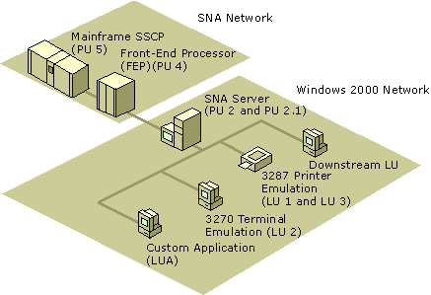
Figure 10.8 3270 Connectivity Using SNA Server
SNA Server Client software must be installed on each client that uses SNA Server LU services. The client software manages communications between a 3270 application and the server running SNA Server. Applications designed to use the SNA Server Client API use the LUs defined within SNA Server to establish a communications link from the client to the mainframe through SNA Server.
The link between the LU definition in SNA Server and the host LU resource is called a session. Sessions can be permanent and automatically started during initialization, or established on an as-needed basis. Concurrent sessions can share the same physical devices and communications links.
Using LU Pools
Although you can create individual LUs and assign them to users and groups, using LU pools to manage and deploy a large number of LUs is a more efficient method of administering these resources. LU pools are groupings of LUs that allow you to maximize access to these LUs, as shown in Figure 10.9. A user, an application, or a downstream system can access the LUs as long as any LU assigned to the pool is free. If any one of the pooled LUs ceases to function, another free LU in the pool is used.
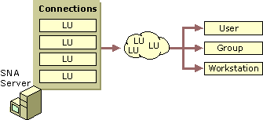
Figure 10.9 Creating and Assigning LU Pools
LU pools also allow groups of intermittent users to use a limited number of host resources more efficiently. Dedicating LUs to specific users who occasionally require host access wastes host resources. Using a pool, you can assign a smaller number of LUs to a group of users who require sporadic access. For example, if a group of 100 users requires host access 25 percent of the time, assigning a pool of 25 LUs to the group might fulfill their needs.
Assigning LUs to Workstations
LUs (and LU pools) can also be assigned to workstations rather than users, effectively locking LUs to a specific computer. This configuration makes it easier for users to find and access different resources.
For example, suppose you have 150 employees who share 50 workstations, each of which has a printer attached. Instead of assigning 50 printer LUs to a pool and making the pool available to each user, you can add each of the workstations to SNA Server and assign a printer LU to each workstation. Doing so allows users to log on to any of the 50 workstations, and the printer that is attached to the workstation is available in the list of LUs.
Providing Fault Tolerance
LU pools can also provide fault-tolerant connections to users. When a particular resource such as a host connection fails, hot backup allows for a similarly configured resource to automatically fill in and support the needed functions, as shown in Figure 10.10. Hot backup can be implemented across host connections on the same server or across several servers in a domain. Hot backup is a recommended strategy for any size enterprise and helps to provide reliable host access to your users.
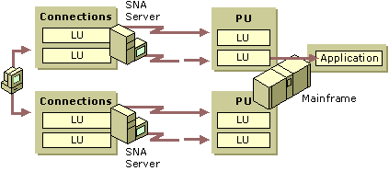
Figure 10.10 Hot Backup Across Connections and Servers
Providing Load Balancing
Load balancing is closely related to hot backup. Load balancing evenly distributes sessions across multiple host connections and multiple servers using 3270 LU pooling. For example, if you have two connections that each support ten 3270 display LUs, load balancing ensures that free LUs are allocated evenly from the two connections to users. Load balancing is implemented when a pool is configured with LUs from multiple servers or connections.
TN3270 Access
TN3270 is a type of Telnet service that allows access to mainframe computers over a TCP/IP network. Users can connect to mainframes using a TN3270 client and the TN3270 service provided with SNA Server, as shown in Figure 10.11.
The TN3270 service supports the following protocols:
• TN3270 for display sessions
• TN3287 for printer sessions
• TN3270E for extended display and print sessions

The TN3270 service uses SNA Server features to provide mainframe access and to address issues such as security and redundancy when the data communications path between the client and server contains one or more unsecured segments.
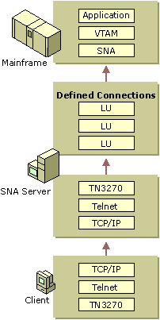
Figure 10.11 TN3270 Communications Through SNA Server
Because the TN3270 service communicates with SNA Server using the LUA API, LUA-type connections and LUs must be configured on the server. Once configured, LUAs and LU pools can be assigned to the TN3270 service and made available for use by TN3270 clients requesting mainframe access.
As with all TCP/IP services, TN3270 requires a free TCP port in which clients can locate the TN3270 service. The TN3270 service defaults to port 23, the same port as standard Telnet services. Because no two services can share the same TCP port, it is recommended that you change the TN3270 service to use TCP port 24 or some other unused TCP port. When attempting to connect to the TN3270 service from a client application, you must also specify the new TCP port within the application’s connection settings.
Providing Hot Backup and Load Balancing
As described in “SNA Server Integration with Windows 2000–based Networks” earlier in this chapter, a Windows 2000 domain can contain one or more SNA Server subdomains. Like 3270 LUs, LUA LUs from multiple servers in different subdomains can be assigned to the TN3270 service. This allows you to distribute client sessions among the participating servers in the subdomain, thereby balancing the load.
Creating redundant connections to the mainframe and assigning them to a TN3270 service increases service availability. If one server fails, a client can still access LUA LUs on a different server. If no other SNA Server–based computers are used in a particular site, you can increase fault tolerance and available bandwidth by configuring a single server with redundant host links.
Assigning LUs to IP Addresses
Just as you can assign 3270 LUs to a user or workstation, you can restrict access to LUA LUs or pools by specifying an IP address or subnet mask for clients that must access the resource. If a workstation has a name that can be resolved using name resolution services like DHCP, DNS, or WINS, the name can be associated with the resource instead of the individual workstation. For information about TCP/IP addressing and services, see the TCP/IP Core Networking Guide.
Restricting access to clients with specific IP addresses or workstation names increases the security of the LUA resources. For more information about host security issues, see “LAN-to-Host Security” later in this chapter.
Downstream Connections
In hierarchical SNA environments, you configure 3270 communications between SNA nodes using SNA protocols. Usually those nodes are SNA Server–based computers and mainframes. A downstream system, however, is an SNA node that uses SNA Server as a PU gateway, as shown in Figure 10.12. To the downstream system, the SNA Server–based computer appears to be the actual mainframe providing the PUs and 3270 LUs.
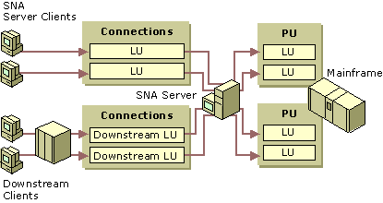
Figure 10.12 Downstream Connections Using SNA Server
A downstream system in this type of environment must be a PU 2 device. For example, an IBM 3745 cluster controller can be a downstream device. A client running a terminal emulator that emulates a PU 2 and acquires LU sessions from the SNA Server–based computer can also be a downstream device.
On the computer running SNA Server, two connections are required to support downstream systems:
• A host connection between the server and the mainframe. This can be any standard physical connection method supported by the mainframe.
• A downstream connection between the server and the downstream system. This physical connection can be an 802.2/DLC, SDLC, or X.25 connection.

Once configured, SNA Server can manage the downstream LUs in a manner similar to how it manages other LUs, including assigning them to LU pools.
This type of configuration is useful in environments where the downstream system is unable to communicate directly with the mainframe because of hardware or network incompatibilities that the intermediate SNA Server–based computer can resolve.
Using SNA Server as a PU concentrator can also help reduce host configuration requirements. LUs from one or more PUs can be shared with multiple downstream devices, alleviating the need to configure each downstream device in VTAM on the mainframe system. The result is a more efficient use of host resources.
For more information about communications with hierarchical SNA networks, see the SNA Server version 4.0 documentation.
Communications with Peer-to-Peer SNA Networks
Devices in peer-oriented SNA networks participate in Advanced Peer-to-Peer Networking (APPN). Each APPN device, known as a type 2.1 physical unit (PU 2.1) can communicate directly with other PU 2.1 devices using Advanced Program-to-Program Communications (APPC) sessions.
Each PU 2.1 device relies on its own intelligence and does not require constant access to a centrally located host system.
Note Although networks that use APPC are usually associated with AS/400 host systems, mainframe systems can also use APPC-based networking.
In an AS/400 environment, APPC is used for a variety of applications including 5250 access and file transfers. Programs that use APPC to communicate are called transaction programs (TPs). APPC TPs use LU 6.2 names to gain access to other systems and other transaction programs.
For background information about APPN networking, see “IBM SNA Interoperability Concepts” in this book.
APPC Using SNA Server
With SNA Server, a TP such as a 5250 terminal emulator might use an APPC LU alias to communicate with another TP. In this case, the LU alias maps to an LU name that is actually used to communicate with the TP on the other system.
When a client/server network TP requests a conversation with a TP on the AS/400 (the remote system), SNA Server (the local system) acts on behalf of the client request and negotiates an LU 6.2 to LU 6.2 session to the AS/400. The data sent or received from the AS/400 TP is handled by the server and sent to the client TP over the selected client/server protocol. Figure 10.13 shows an APPC conversation using SNA Server.
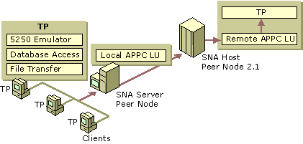
Figure 10.13 APPC Conversation Using SNA Server
Note In Figure 10.13, the perception of local and remote LUs depends on the system you are configuring. When configuring SNA Server, the local APPC LU corresponds to SNA Server and the remote LU corresponds to the AS/400. If you view the configuration from the AS/400 perspective, the AS/400 is the local APPC LU and SNA Server is the remote LU.
Common Programming Interface for Communications
Common Programming Interface for Communications (CPI-C) is an application programming interface (API) that uses the LU 6.2 communications architecture. Many organizations implement CPI-C because several platforms that support APPC can use CPI-C, including AS/400 and mainframe systems, Windows 2000, and several UNIX-based operating systems. CPI-C comprises a set of C programming language routines that allow applications on computers to communicate with one another to accomplish a processing task, such as copying a file or accessing a remote database.
CPI-C programming provides a mechanism called client-side information that associates a set of parameters with a specified CPI-C symbolic destination name. The CPI-C program uses the symbolic destination name to initialize a conversation using APPC LUs that are associated with the CPI-C symbolic name.
SNA Server supports the CPI-C API and provides for configuration of CPI-C parameters. For more information about programming using the CPI-C API, see the SNA Server version 4.0 documentation.
APPC Applications
APPC can be used to support a wide range of applications including:
• 5250 terminal access.
• TN5250 terminal access.
• APPC file transfers, including Shared Folders access.

5250 Access
AS/400 display sessions are provided through APPC using the 5250 data stream. Computers running SNA Server provide APPC access to AS/400s using 5250 emulation clients. Clients can only communicate with AS/400s using APPC.
To support 5250 services, the local APPC LU acts as an identifier for local SNA Server–based clients; the remote APPC LU identifies the AS/400 system. Figure 10.14 shows the local and remote LUs used for this configuration.
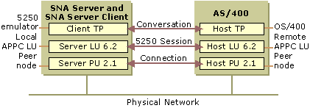
Figure 10.14 Components of 5250 Access Through SNA Server
TN5250 Access
TN5250 is a Telnet service that allows users to access AS/400 systems over a TCP/IP network using an appropriate TN5250 client terminal emulator. The TN5250 service provided with SNA Server enables any TN5250 client to connect to the AS/400 system by means of SNA Server, without installing or configuring TCP/IP on the AS/400 system, as illustrated in Figure 10.15. Full 5250 terminal emulation functions are supported by the service, as well as fault tolerance and security features similar to those provided with the TN3270 service.
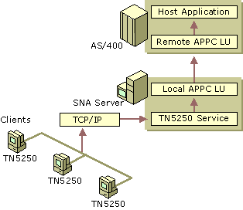
Figure 10.15 TN5250 Access Through SNA Server
APPC File Transfers
Although it is possible to perform file transfers between the client and the host system using $INDFILE or other mechanisms, APPC file transfers offer a robust and high performance alternative to emulator-based solutions.
SNA Server supports three host file transfer mechanisms based on APPC connectivity:
• APPC File Transfer Protocol (AFTP)
• FTP to AFTP Gateway
• Shared Folders

The file transfer method that you choose to deploy depends on the type of host system in your enterprise (mainframe or AS/400) and on the type of file transfer capabilities you wish to provide to your users.
APPC File Transfer Protocol
The APPC File Transfer Protocol (AFTP) is a client/server application that provides file transfer capabilities using APPC and LU 6.2 (FTP protocol is used on TCP/IP networks in a similar way). AFTP supports functions similar to standard FTP, including the ability to send, receive, and rename files, as well as to manipulate directories on a remote system.
The AFTP service is installed and configured on the computer running SNA Server (or an SNA Server–based client) to allow AFTP client software (provided with SNA Server) to access specific directories on the server.
For more information about configuring and using AFTP, see the SNA Server version 4.0 documentation.
FTP-AFTP Gateway Service
The FTP-AFTP gateway service gives TCP/IP users the ability to access and manipulate files on a mainframe or an AS/400 using a conventional FTP client without installing TCP/IP on the host, as shown in Figure 10.16. The service transparently converts incoming client FTP requests into AFTP commands and manages the communications and data between the two services. This capability can be used interactively by FTP users, or through applications that need access to SNA host data.
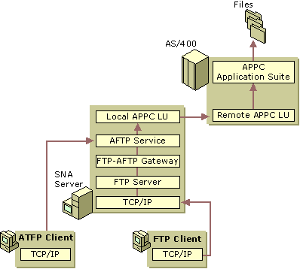
Figure 10.16 APPC FTP and FTP-AFTP Gateway Services
To run the FTP-AFTP Gateway Service, you must first install the FTP or AFTP client software as well as the AFTP service on the SNA Server–based computer.
Shared Folders
Users on workstations that do not have the SNA Server Client software installed, but who still require file transfer capabilities with an AS/400 host, can use the Shared Folders Gateway Service provided by SNA Server. With this service, network users can share or store files on the AS/400 system as though it were another volume on the SNA Server–based computer, as shown in Figure 10.17.
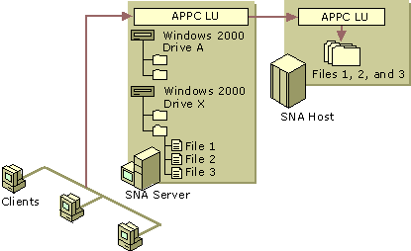
Figure 10.17 Using the Shared Folders Gateway Service
APPC Deployment Strategies
In most cases, deployment strategies are effective for APPC LUs regardless of the application that the LUs support. When deploying APPC connections with SNA Server, you should consider how to use the following types of LUs and LU configurations:
• Independent LUs
• Dependent LUs
• LU pools

Using Independent APPC LUs
An independent LU can communicate directly with a peer system and does not need the support of a host computer. Independent APPC LUs, as used in AS/400 APPN networks, provide the ability to run multiple, concurrent, parallel sessions between a local and remote LU pair.
When configuring independent APPC LUs, you should note that when SNA Server is used to communicate with a TP on a mainframe over an independent APPC LU, the host system must be running VTAM V3R2 or later. The version of Advanced Communication Function/Network Control Function (ACF/NCP) required on the mainframe is dependent on the type of FEP used. For 3725 systems, ACF/NCP V4R3 or later is required. For 3745 systems, ACF/NCP V5R2 or later is required.
For information about configuring independent APPC LUs, see the SNA Server version 4.0 documentation.
Using Dependent APPC LUs
A dependent local APPC LU requires the support of a mainframe to communicate with a remote TP. Dependent APPC LUs cannot be used to communicate with AS/400s. Unlike independent APPC LUs, dependent APPC LU only allow one session per LU.
Dependent APPC LUs are useful when configuring SNA Server to communicate with a mainframe using a version of VTAM earlier than V3R2 because independent LUs are not supported in earlier VTAM versions. SNA Server provides support for dependent APPC LUs. However, use independent LUs whenever possible.
When configuring APPC dependent LUs, you should specify the network name and LU name, even though they are not required. They are used by software running on the SNA Server–based computer, such as the Windows 2000 event log. For example, if a remote APPC LU is partnered with a dependent local APPC LU, naming the remote APPC LU helps to identify any events associated with it in the Windows 2000 event log.
For more information about configuring dependent APPC LUs, see the SNA Server version 4.0 documentation.
Using APPC LU Pools
Although you can create individual LUs and assign them to users and groups, using LU pools to manage and deploy a large number of LUs lets you administer these resources more efficiently.
LU pools also allow groups of intermittent users to use a limited number of host resources more efficiently. Dedicating LUs to specific users who occasionally require host access wastes host resources. Using a pool, you can assign a smaller number of LUs to a group of users who require sporadic access. For example, if a group of 100 users require host access 25 percent of the time, assigning a pool of 25 LUs to the group might meet their requirements.
For information about configuring LUs, see the SNA Server version 4.0 documentation and the Microsoft® BackOffice® Resource Kit.
Providing Fault Tolerance
In the AS/400 environment, SNA Server uses a combination of LU names and LU aliases over one or more servers to achieve transparent fault-tolerant connections to an AS/400 host, as shown in Figure 10.18.
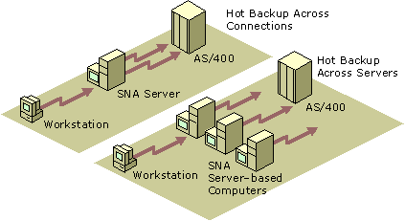
Figure 10.18 Hot Backup Across Connections and Servers
A single computer running SNA Server can use multiple connections to provide fault tolerance. To use this method, two or more APPC connections to the same AS/400 are configured as hot backups for one another. If one of the connections fails, the clients are reconfigured to select a working configuration.
SNA Server can also use multiple SNA Server–based computers as backups for one another. If one of the servers fails, the clients are shifted from the failed server to a working server.
Using a combination of hot backup methods across both connections and servers is recommended to maintain a high level of host availability in your enterprise.
For more information about configuring hot backup for APPC connections, see the SNA Server version 4.0 documentation.
TN5250 IP Settings
IP settings assigned to the TN5250 definitions allow TN5250 clients to connect to the AS/400. By default, the TN5250 definition is not assigned an IP address or a subnet mask. This allows any TN5250 client to connect to the AS/400.
You can restrict access to the TN5250 service by specifying the IP address or subnet mask of a client workstation. When these values are specified, only clients whose IP or subnet mask match those specified in the TN5250 configuration are allowed access to the AS/400 through the TN5250 service. You can also specify the workstation name in place of the IP, and use a WINS, DHCP, or other name resolution service to resolve a friendly name to an IP address.
SNA Remote Access Service
SNA Remote Access Service (SNA remote access server) integrates the LU 6.2 transport of SNA Server with Windows 2000 Routing and Remote Access service, allowing administrators to create virtual LAN connections between Windows 2000 systems across an existing SNA network. Figure 10.19 shows how, using SNA remote access server, the SNA network acts as a network backbone, passing network traffic between the Windows 2000 systems bridged with the host system.
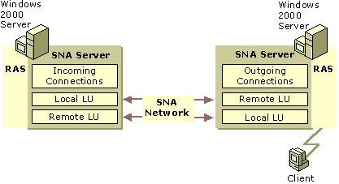
Figure 10.19 SNA Remote Access Service (SNA Remote Access Server)
The functions available with SNA remote access server are the same as those for remote access server over ISDN or X.25 except for the dial-back connection feature, which is not supported by SNA remote access server. SNA remote access server supports either the Windows 2000 Server Routing and Remote Access service or Windows 2000 Routing and Remote Access service client, depending on whether the computer on which SNA remote access server is installed, is an SNA Server–based server or client. In addition, a computer running Windows 2000 Professional, SNA Server Client software, and SNA remote access server can dial out through the SNA Server–based computer that is running SNA remote access server.
Because legacy SNA networks might include smaller bandwidth links like SDLC, and because LAN traffic typically generates more network traffic than can be effectively handled by slower connections, care should be taken to resolve bandwidth needs before deploying SNA remote access server in your enterprise.
For information about configuring SNA remote access server, see the SNA Server version 4.0 documentation.
Heterogeneous Client Services
SNA Server supports the LU types (and equivalent Telnet-based applications) and application programming interfaces (APIs) that support the most commonly used configurations for many desktop operating systems, including:
• Microsoft® Windows NT®
• Windows 95
• Windows 3.x
• MS-DOS
• IBM OS/2
• Macintosh
• UNIX-based operating systems

Integrating Heterogeneous Clients with Mainframes
Table 10.6 summarizes SNA Server client-to-mainframe services supported on each desktop platform.
Table 10.6 Heterogeneous Client to Mainframe Integration

Desktop Platform LU Types/Telnet Services SNA APIs

MS-DOS LU0, LU1, LU2, LU3, and LU6.2. TN3270, TN3287, and TN3270E. APPC, CPI-C, Common Service Verb (CSV), and LUA Request User Interface (RUI).
Windows 3.x, Windows for Workgroups LU0, LU1, LU2, LU3, and LU6.2. TN3270, TN3287, and TN3270E. APPC, CPI-C, CSV, LUI RUI, LUA Session Level Interface (SLI), and ODBC/DRDA.
OS/2 LU0, LU1, LU2, LU3, and LU6.2. TN3270, TN3287, and TN3270E. APPC, CPI-C, CSV, LUA RUI, and LUA SLI.
Macintosh TN3270, TN3287, and TN3270E. (Uses Telnet-based services.)
UNIX1 LU0 and LU6.2. TN3270, TN3287, and TN3270E. APPC, CPI-C, CSV, and LUA RUI.
Windows 95 and Windows 98 LU0, LU1, LU2, LU3, and LU6.2. TN3270, TN3287, and TN3270E. APPC, CPI-C, CSV, LUA RUI, LUA SLI, ODBC/DRDA, and AFTP.
Microsoft® Windows NT® Workstation 4.0 and Windows 2000 Professional LU0, LU1, LU2, LU3, and LU6.2. TN3270, TN3287, and TN3270E. APPC, CPI-C, CSV, LUA RUI, LUA SLI, ODBC/DRDA, and AFTP.

1 The UNIX client can use services beyond the Telnet-based services by using a third-party UNIX client for SNA Server developed by Parker Software in cooperation with Microsoft. For more information about the UNIX client for SNA Server, see http://www.microsoft.com/.
Session Types with Mainframes
SNA Server supports standard terminal and printer sessions with LU types 0 through 3. LU 0 is a device-independent LU used mainly in the financial industry to support teller terminals and automatic teller machines. LU types 1 and 3 are used to support printer emulation programs on client and server computers, including SNA Server’s Host Print Service. LU type 2 provides terminal emulation support for a broad range of client 3270 emulator programs.
LU 6.2 supports Application Program-to-Program Communications (APPC), Common Programming Interface for Communications (CPI-C) and Common Service Verb (CSV). These APIs allow client- and server-based transaction programs and other processes to communicate with host systems, such as those running under IBM Customer Information Control System (CICS) and Information Management System (IMS). An example of a transaction-based process is a magnetic credit card reader at a point-of-sale terminal, such as a computer-based cash register that communicates from a branch store location to the home office through an SNA Server connection. The process to validate the cardholder’s credit status uses APPC as the API supporting the transaction.
Host Utilities with Mainframes
As shown in Table 10.6, SNA Server offers a number of utilities that complement standard terminal and printer emulation sessions. One such utility is APPC File Transfer Protocol (AFTP). AFTP is part of a group of applications supported by the IBM APPC applications suite running on OS/390, MVS, VM, or OS/400.
As a server-based solution, AFTP works with SNA Server’s FTP-to-AFTP gateway to provide a seamless means for clients to send and receive flat files to and from host systems. SNA Server converts the FTP commands to AFTP and uses APPC between the SNA Server–based computer and the host system. This allows the client to use an open TCP/IP protocol, while the host runs only its native SNA protocols. The result is greater efficiency and simplified management at the client and the host system.
Application Programming Interfaces with Mainframes
SNA Server includes a Software Development Kit (SDK), with online documentation and source code examples. This SDK provides the means to build complete AFTP, APPC, CPI-C, CSV, and LUA solutions, as well as add-on products to SNA Server core functionality. LUA is a customizable API that allows you to develop either at a low level in the SNA protocol stack, at the Request User Interface (RUI), or at a higher level, at the Session Level Interface. These APIs are commonly used by large institutional organizations building upon their legacy of banking and insurance applications, many of which had previously relied upon specialized control unit devices, such as the IBM 4147 financial series controller.
One series of APIs not directly supported by the SNA Server SDK are, High Level Language API (HLLAPI), Extended HLLAPI (EHLLAPI), and Windows HLLAPI (WinHLLAPI).
SNA Server APIs comply with the Windows Open Service Architecture (WOSA) guidelines. This means that on all Windows operating systems, the SNA Server APIs are WOSA versions: WinAPPC, WinCPI-C, and WinCSV.
Several independent software vendors (ISVs) contributed to the WOSA SNA API standards, among them IBM and Novell. Most major Windows SNA ISVs support WOSA APIs directly in their products, including Andrew, Attachmate, Eicon, NetManage, NetSoft, Wall Data, and WRQ. SNA Server’s APIs comply with the standards published for other common operating systems as well. For example, on MS-DOS and OS/2, SNA Server APIs are binary compatible with IBM’s Communications Manager/2 standards.
SNA client emulation vendors also support host connectivity through SNA Server by adapting their products to support the SNA Server Function Management Interface (FMI)—also called the Emulator Interface Specification (EIS). The FMI or 3270 EIS API is encapsulated in the SNA Server Client software. The emulator communicates with this SNA Server Client software, which in turn communicates with SNA Server through an SNA Server client/server connection. When you use a full-featured 3270 emulator with SNA Server, you are connecting to the SNA Server through the FMI. FMI supports LU types 1 through 3.
Integrating Heterogeneous Clients with AS/400 Systems
SNA Server supports the LU types (and equivalent Telnet-based applications) and application programming interfaces (APIs) that support the most commonly used configurations for all popular desktop operating systems. Table 10.7 describes in detail SNA Server client-to-AS/400 services.
Table 10.7 Heterogeneous Client-to-AS/400 Integration

Desktop Platform LU Types/Telnet Services SNA APIs

MS-DOS LU 6.2 (terminal and printer emulation) and TN5250. APPC and CPI-C.
Windows 3.x, Windows for Workgroups LU 6.2 and TN5250. APPC, CPI-C, CSV, EHNAPPC, and ODBC/DRDA.
OS/2 LU 6.2 and TN5250. APPC, CPI-C, and CSV.
Macintosh TN5250. (Uses Telnet-based services.)
UNIX1 TN5250. APPC, CPI-C, and CSV.
Windows 95 and Windows 98 LU 6.2 and TN5250. APPC, CPI-C, CSV, EHNAPPC, ODBC/DRDA, and AFTP.
Windows NT Workstation 4.0 and Windows 2000 Professional LU 6.2 and TN5250. APPC, CPI-C, CSV, EHNAPPC, ODBC/DRDA, and AFTP.

1 The UNIX client can use services beyond the Telnet-based services by using a third-party UNIX client for SNA Server developed by Parker Software in cooperation with Microsoft. For more information about the UNIX client for SNA Server, see http://www.microsoft.com/sna.
Session Types with AS/400 Systems
SNA Server supports all AS/400 session types on most popular desktop operating systems using LU type 6.2. Some older client emulators use LU type 4 for printer emulation and LU type 7 for terminal emulation. However, SNA Server and most modern client emulators support standard 5250 terminal and printer emulation through LU type 6.2 and APPC.
SNA Server supports Macintosh and UNIX clients through the TN5250 Service, which provides basic terminal emulation. However, teamed with the Host Print Service, Shared Folders Service, and FTP-to-AFTP Gateway, SNA Server can satisfy all Macintosh and UNIX client needs.
Host Utilities with AS/400 Systems
Utilities based on a computer running SNA Server offer administrative control of client-to-AS/400 connectivity. For example, SNA Server offers an optional Shared Folders Service that allows any Windows 2000 Server–based client to access AS/400 files without any special SNA software or protocols being installed on the client computer. Another example is the Host Print Service, which places printer emulation on the computer running SNA Server. Both of these utilities concentrate administration at the server and alleviate the need for configuration of advanced features on the clients.
Application Programming Interfaces with AS/400 Systems
AS/400 connectivity through SNA Server is fully compatible with EHNAPPC and supports the full range of Client Access/400 functions, including shared folders, virtual print, and file transfer. EHNAPPC is the standard Windows-based API supported by IBM’s PC Support and Client Access/400 (CA/400) products. IBM has presented EHNAPPC to its ISV community as the way to write Windows-based applications that integrate with the AS/400.
The SNA Server Client software for Windows 32-bit operating systems can also support 16-bit Windows-based APPC and CPI-C applications that map the 16-bit APPC and CPI-C APIs to the native 32-bit SNA APIs. This allows users to run many of the 16-bit Windows-based applications that work with SNA Server in Windows 32-bit environments.
For more information about configuring and managing SNA Server Client software, see the SNA Server version 4.0 documentation.
Host Print Services
SNA Server supports three methods of printing host information to local or network-accessible printer resources.
Screen printing Allows any 3270 or 5250 emulator to print what is on the display using the print screen features of the client operating system. The printer output can be directed to a printer attached to the client or to a network-accessible resource.
Client-based redirected printing Delivers an SNA host printer data stream (such as 3287) to the appropriate emulation application running on an SNA Server-based client. The client software converts the data stream into data that can be output to a locally attached or network-accessible printer resource.
Server-based redirected printing Uses a server process to convert SNA host printer data streams into data that can be redirected to a locally attached or network-accessible printer resource defined with the Windows 2000 Server Printer Manager.
The first two methods are provided using third-party products. The third method is supported by the SNA Server Host Print Service and third-party products.
SNA Server Host Print Service
The Host Print Service provides server-based 3270 and 5250 printer emulation, allowing host applications to print to a LAN printer supported by Windows 2000 Server or Novell NetWare. You can administer all Host Print Service functions using SNA Server Manager and control print characteristics, such as margin control and fonts. Printer output can also be redirected to files that are saved with incremental file names.
Each host printer definition also allows printing filters to be associated with print sessions. Filters are provided through third-party applications that allow the Host Print Service to participate in APF and other specialized print environments.
Mainframe Printing
For mainframe environments, shown in Figure 10.20, the Host Print Service supports both LU 1 and LU 3 print data streams, including transparent print jobs sent by host-based print preprocessors.
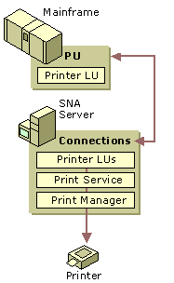
Figure 10.20 Mainframe Printing
To print 3270 print jobs, you need to perform the following steps in SNA Server Manager:
• Define the session name, which is a descriptive name to identify different printers on the network.
• Create a 3270 printer LU.
• Assign the LU to the print session.

For more information about configuring mainframe print sessions, see the SNA Server version 4.0 documentation.
AS/400 Printing
For AS/400 printing, shown in Figure 10.21, the Host Print Service supports standard SCS line printing, and pass-through support for host-based 3812 graphics printing emulation using the IBM Host Print Transform function.
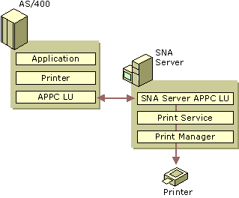
Figure 10.21 AS/400 Printing
For more information about configuring an AS/400 print session and customizing printer output, see the SNA Server version 4.0 documentation.
LAN-to-Host Security
As your network becomes integrated with the Internet and other external networks, the threat of unauthorized access to your network resources grows significantly. When you plan your networking environment, you must strike the right balance between protecting your resources and allowing your users unobstructed access.
As you plan how to secure your SNA Server environment, you should consider methods to:
• Authenticate users who require host resources.
• Control access to host resources.
• Control sensitive data flowing between workstations and host applications.
• Maintain security while connecting your host network to external sources like the Internet.
• Make host resources easier to access for authenticated users, yet maintain a secure and easy-to-administer host environment.

The following sections address each of these issues and describe how to implement SNA Server security features and Windows 2000 security features to create a secure LAN-to-host environment.
For more information about Windows 2000 security, see the Distributed Systems Guide.
Authentication
When SNA Server receives a request for access to a host resource, such as an LU for a terminal session, the server must have some way to verify the request. User validation is a fundamental security issue that is addressed using one of two methods depending on the type of service being requested: domain authentication or workstation authentication.
Domain Authentication
A Windows 2000 Active Directory domain is a group of computers that share a common user account database and have a common security policy. An Active Directory domain contains domain controllers that store security information and replicate that information to other domain controllers.
Within a Windows 2000 domain, computers running SNA Server are logically grouped into entities called subdomains, as shown in Figure 10.22. Each SNA Server subdomain can contain up to 15 SNA Server–based computers. A Windows 2000 domain can contain an unlimited number of these subdomains.
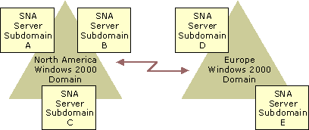
Figure 10.22 SNA Server Subdomains Located in Windows 2000 Domains
SNA Server relies on the Windows 2000 domain to provide authentication services to users requesting access to host resources, as shown in Figure 10.23.
Only users who have been validated by Windows 2000 security can gain access to resources provided by servers in the SNA Server subdomain.
Domain authentication is used to verify the identity of users who request resources provided by the following services:
• 3270 or 5250 terminal access from workstations using SNA Server Client software.
• AS/400 Shared Folders Gateway Service.
• Host Print Services.
• APPC, CPI-C, or LUA that use SNA Server APIs.

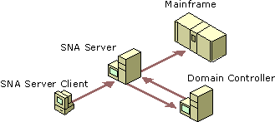
Figure 10.23 Domain Authentication Process for 3270 Terminal Access
Each user who needs access to SNA Server resources must have a Windows 2000 domain account. Once enrolled as a Windows 2000 domain user, the user’s account is added to the SNA Server subdomain. After a user is added to the SNA Server subdomain, you can allocate specific SNA resources to that user.
Note Each computer running SNA Server also needs its own Windows 2000 domain account through which SNA Server services are run. SNA Server uses this account to log on to the domain to perform such functions as host printing and data encryption using the Distributed Link Services.
Resource Allocation
In most cases, you need to control who can access SNA Server resources in your environment. The method you use to secure those resources depends on your host environment and the types of services you wish to offer your users.
3270 Terminal Access
Users or groups who require access to 3270 sessions from workstations using SNA Server Client applications must be members of the SNA Server subdomain. By virtue of their subdomain membership, users and groups are also members of the Windows 2000 domain of which the subdomain is a part. Once enrolled in the SNA Server subdomain, you can assign specific 3270 (LU type 2) resources to the appropriate accounts. Users can access only the specific resources you allocate to them.
To maintain security in your environment, it is recommended that you use domain security to authenticate users, and then limit their access by assigning them only specified resources.
5250 Terminal Access and APPC Access
Users who want Advanced Peer-to-Peer Communications (APPC) access need not be defined in the SNA Server subdomain, but they must be members of the Windows 2000 domain. For 5250 terminal access using a computer running SNA Server Client software within the network, the AS/400 supplies the required logon security for access to the AS/400. For APPC access programmed into specific applications, security is maintained through the actual programmatic conversation, if required.
TN3270 and TN5250 Services
TN3270 and TN5250 services are secured by specifying client workstation IP addresses that have permission to use the resources provided. In the case of TN3270E clients, a workstation name can be specified in place of the client IP address. The method used to verify workstations can also be used to allow only specified IPs to request resources allocated to them.
Shared Folder Services
Access to AS/400 shared folders that are made available to Windows 2000 domain users using the Shared Folders Gateway Service can be controlled by specifying permissions for the resulting shared volumes and files. Permissions are set using the standard Windows 2000 method for local shares.
In some cases, you might want to provide open-ended access to LUs provided by SNA Server. To allow unrestricted access through Windows 2000 domain–authenticated services, you can use the Guest account or the Everyone group account.
To provide access using the Guest account, enable the account in the Windows 2000 domain as described in Windows 2000 Server Help. Add the Guest account to the SNA Server subdomain, and assign LUs to the account.
To provide access using the Everyone account, add the Everyone account to the SNA Server subdomain and assign LUs to the account.
To allow unrestricted access to TN3270 or TN5250 services, you can create LUs without specifying an IP or workstation name for each.
Data Encryption
SNA Server allows you to encrypt data for client-to-server and server-to-server communications, as shown in Figure 10.24.
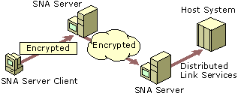
Figure 10.24 Model of Client-to-Server and Server-to-Server Data Encryption
Client-to-server encryption prevents information from being sent in plaintext between computers running SNA Server Client software and computers running SNA Server. Data encryption enhances network security on the client-to-server communications path for all applications using SNA Server Client connections, including 3270/5250 emulators and APPC logon IDs and passwords. Data encryption can be enabled on a user-by-user basis using the SNA Server Manager.
Server-to-server encryption can be used to provide secure communications across your network, the Internet, or any other wide area network (WAN). If a user enables data encryption, information transferred through the Distributed Link Services is secure.
Firewall Support
A firewall is a network security device that restricts access to network resources by allowing traffic only through specified port numbers. In many instances, the services of a firewall are provided in conjunction with a network route that bridges two network segments together.
If the SNA Server address is known, the client workstation configures the appropriate port and destination IP of the computer running SNA Server in the client software (1477 and 128.124.1.2, respectively, in Figure 10.25 below). Alternatively, the SNA Server–based computer’s service port numbers can be changed to the port number requested by the client.
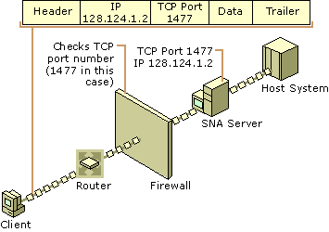
Figure 10.25 Using SNA Server with a Firewall
If the SNA Server address is not known, the SNA Server IP transport replaces the real destination IP address with the address of a firewall. The firewall then maps the connection request to the actual computer running SNA Server. This takes place when the transport opens a connection to an SNA Server–based computer for application sessions or a sponsor connection.
SNA Server supports firewalls primarily on TCP/IP networks. It is also possible to implement firewalls on IPX/SPX or Banyan VINES networks. Consult your network documentation for information about configuring a firewall in your specific installation.
Host Security Integration
In an enterprise-wide computing environment, users are likely to access different networking environments as they go about their day-to-day routines. A user might begin the day by turning on a computer running Windows 2000 Professional, logging on to a Windows 2000–based network, and then accessing an AS/400 database application through a terminal emulator.
Each system with which the user comes into contact enforces its own security requirements and logon procedures. For example, a Windows 2000 domain account might require a six-character user name and an eight-character, mixed-case password, whereas a mainframe environment might require a seven-character user name and seven-character alphanumeric password.
Frequently, users have to remember several different combinations of user names and passwords to gain access to various resources on the network. Despite policies to the contrary, users who must maintain multiple passwords often resort to writing their passwords down and keeping them in a convenient location near their computer, compromising network security.
One of SNA Server’s most powerful security features is its ability to integrate the Windows 2000 domain security environment with your host security system. The Host Security Integration feature is a combination of tools and services that automate the process of synchronizing passwords and logging on to the different systems. Using these tools can help your users uphold corporate security standards and ease the administration required to maintain user accounts on your network and your host system.
Host Security Integration Components
Host Security Integration uses a host security domain concept to manage user accounts on your network and your host system. Your host security domain defines the different security domains that share a common user accounts database. A simple security domain can consist of a host domain, a Windows 2000 domain, and an SNA Server subdomain, as shown in Figure 10.26.
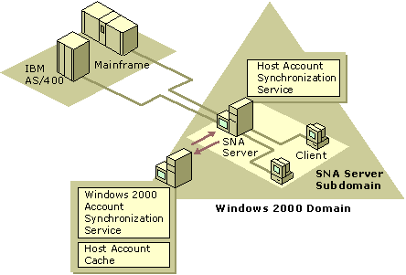
Figure 10.26 Elements of a Typical Host Security Domain
Host Security Integration is composed of three separately installable components:
• Host Account Cache
• Host Account Synchronization Service
• Windows 2000 Account Synchronization Service

Host Account Cache
The Host Account Cache maintains an encrypted database that maps host user accounts to Windows 2000 domain user accounts. The Host Account Cache is a Windows 2000 service that is installed on Windows 2000 domain controllers. For smaller networks, SNA Server itself might be installed on a Windows 2000 domain controller and, therefore, can be used to store the Host Account Cache.
Optionally, a backup Host Account Cache can be installed on any other Windows 2000 domain controller. The backup cache maintains a local copy of the user database for recovery purposes, or to eliminate network traffic for single sign-on lookups when installed on the same computer as SNA Server.
Host Account Synchronization Service
Host Security Integration is an SNA Server installation option that contains the Host Account Synchronization Service. This service can be installed on primary, backup, or member computers running SNA Server within the SNA Server subdomain. For more information about SNA Server roles, see “Determining SNA Server Roles” earlier in this chapter.
You can also install the service on non-SNA Server-based computers. The Host Account Synchronization Service supports third-party interfaces to various host security databases, allowing you coordinate password changes between the Windows 2000 security domain and the host security domain.
The Host Account Synchronization Service is not necessary if you use the single sign-on feature with manual password updates in which the administrator or users store host account information in the Host Account Cache through the Host Account Manager application (UDConfig). For more information about using the UDConfig tool, see the SNA Server version 4.0 documentation and the Microsoft® BackOffice® Resource Kit.
Windows 2000 Account Synchronization Service
The Account Synchronization component can automatically synchronize the passwords for your host accounts and Windows 2000 domain accounts. This component includes the Windows 2000 Password Synchronization Service and must be installed even if automatic password synchronization is not used because it coordinates the internal operation of other services.
The Windows 2000 Account Synchronization Service is installed on a Windows 2000 domain controller. Only one instance of the Windows 2000 Account Synchronization Service can be designated as primary; all others must be backup servers.
The ability to synchronize passwords from the Windows 2000 domain to an AS/400 security domain is built into SNA Server. Third-party products can provide enhanced synchronization services, such as two-way and automatic synchronization, to other host systems.
Password Synchronization Options
When you define your host security domain, a Windows 2000 group account is automatically created with the same name. User accounts are then added to the group to specify them as members of the host security domain. Once a host security domain is defined, two types of password synchronization options are available to you:
The Replicated option assumes that you would like to have the same user name or password on each security domain defined in the host security domain.
The Mapped option allows you to have different account names and passwords in each security domain. A database controlled by the Host Account Cache Service maintains the associations between the various accounts and passwords.
You can specify either of these options for the user name and either of them for the password of a user account. For example, you can choose to map the user names but replicate passwords across the different security domains. This allows you to have the same password but different user names on the different systems in the host security domain.
Once defined, host connections are assigned to the domain. SNA Server uses the assignment to look up the host mapping for a Windows 2000 user based on the session he or she is trying to open. A defined host connection can only be assigned to one security domain at a time.
After the connections are assigned to a host security domain, you can add users to the security domain by adding user accounts to the Windows 2000 group account created earlier. For each account associated with the host security domain, you can enable password synchronization options and automated logon features commonly referred to as single sign-on services. Single sign-on allows users to log on to their host account automatically if they are already logged on to their Windows 2000 domain account.
If you are planning to map user names, perform and store the initial mapping of host user names to Windows 2000 domain user names in the Host Account Cache.
Automating Password Synchronization
Within the SNA Server network, automated one-way LAN-to-AS/400 password synchronization is supported without any additional tools or products. In this scenario, the Host Account Synchronization Service, the Windows 2000 Account Synchronization Service, and the AS/400’s host security system are interoperable and provide password synchronization for SNA Server users.
In other corporate network environments, third-party tools are required when implementing automated, two-way password synchronization or mainframe support. On a network, the Host Account Synchronization Service, the Windows 2000 Account Synchronization Service, and third-party security integration dynamic-link libraries (DLLs) cooperate with each other to support password synchronization. On the host, third-party products are usually required to facilitate password synchronization.
These components collectively allow two-way password synchronization between Windows 2000 and AS/400 or mainframe host computers. Changes made on one host can be replicated to other Windows 2000 or host computers. Similarly, changes to your Windows 2000 security domain can be automatically sent to all host computers.
Host-Initiated Changes
For host-initiated changes, third-party software must be installed on the host system to trap password changes initiated by users logged on to the host computer, and on the SNA Server–based computer to receive changes from the host.
When a change is made on the host system, the host computer sends notification of changes to a third-party product’s security integration DLL, which is installed on the computer running SNA Server. The DLL then forwards the host-initiated changes to the Host Account Synchronization Service. This service then locates the network address of the primary Windows 2000 Account Synchronization Service using the resource location of the master Host Account Cache.
After the Host Account Cache is located, the Host Account Synchronization Service sends password changes to the Host Account Cache service using encrypted remote procedure call (RPC) messages. Once the changes are received by the service, it propagates the appropriate changes in all security domains defined in the host security domain.
Windows 2000-Initiated Changes
Windows 2000–initiated password synchronization works in a similar manner to host-initiated changes.
The Windows 2000 Account Synchronization Service is installed on a domain controller in one or more Windows 2000 domains. An associated DLL, installed in the same location, receives notice of any password changes that arise in the Windows 2000 domain, regardless of how the change was initiated. The DLL sends Windows 2000–initiated changes to the Windows 2000 Account Synchronization Service using encrypted RPC messages. Once the change is received, the service propagates the appropriate changes in all affected security domains.
Automating Logons
SNA Server can also automate the process of logging on to your host system as shown in Figure 10.27. This feature, commonly called single sign-on support, automatically logs users on to all security systems in a host security subdomain once they have been validated by any system within the subdomain. For example, if a user is logged on to the Windows 2000 domain, single sign-on can automate logon processes to host systems that are encompassed by the defined host security domain.
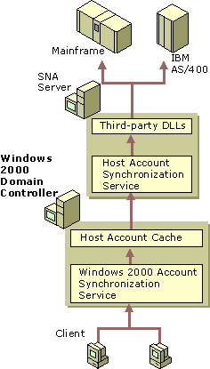
Figure 10.27 Automatic Logon Process
The following steps describe the automatic logon process, as illustrated in Figure 10.27:
Step 1
When a user starts a terminal emulator or other SNA application on a client workstation, the application works with the SNA Server subdomain to perform a resource location operation to determine which SNA Server–based computer and connection to use to open the session.
The SNA application provides a replacement keyword as a placeholder for security information during the session initialization phase. The exact format of this keyword is dependent on the type of LU session being established. For example, the string “MS$SAME” is used for APPC or CPI-C applications.
SNA Server detects the replacement keyword and determines the Windows 2000 user name under which the client is logged on. Because this step requires the support of Windows 2000 domain authentication, the ability to be logged on automatically is only supported for users running native client/server sessions (for example, sessions using a computer running SNA Server Client).
Note TN3270 users are not supported because the TN3270 service cannot determine the client’s Windows 2000 user name.
Step 2
Once the user name is determined, the computer running SNA Server uses the resource location to locate the Host Account Cache in the SNA Server subdomain. The cache might be located on either the actual computer running SNA Server or on a Windows 2000 domain controller in the SNA Server subdomain depending on your installation. SNA Server then sends a lookup message to the Host Account Cache that contains the Windows 2000 user name and password, and requests the corresponding host user name and password.
The Host Account Cache service verifies that the Windows 2000 account exists in the database, and that the account is a member of the Windows 2000 group in the host security domain. If either check fails, the user record is purged from the Host Account Cache.
Step 3
If all checks pass, the service replies to the computer running SNA Server with a message containing the appropriate host account user name and password in an encrypted RPC network message.
Step 4
SNA Server inserts the host account name and password into the SNA data stream, and sends a regular session initialization request to the host computer.
Step 5
The host computer receives the regular session initialization request containing the correct host account information and authenticates the user.
SNA Server natively supports single sign-on to an AS/400 host system. Single sign-on features are also available for APPC and CPI-C applications on both mainframes and AS/400 systems using third-party products. For a list of supported third-party vendors, see the SNA Server Web site at http://www.microsoft.com/.
For more information about SNA Server security and security integration, see the SNA Server version 4.0 documentation and the Microsoft® BackOffice® Resource Kit.
Host Data Access
One of the primary purposes of integrating Windows 2000 networks with IBM host systems is to provide users with access to host data. Host systems have long excelled at providing database-related services. In many mid- to large-sized companies, host databases are used to store and process large amounts of information needed by users across an enterprise network. Because of their availability and performance, host systems continue to play a large role in data warehousing strategies for many organizations.
As companies adopt LAN-based desktop computers, many organizations are looking for ways to integrate host database systems to develop new client/server applications accessible from a user’s workstation. Using SNA Server, you can access host data sources through one of the following features:
• Open Database Connectivity (ODBC) Driver for DB2, for access to Distributed Relational Database Architecture (DRDA) database systems using ODBC interfaces.
• OLE DB Provider for AS/400 and VSAM, for record-level access of host data using OLE DB data access interfaces.

The following section describes how each feature is used and which data access method best suits a particular scenario.
Host Data Access Using ODBC
SNA Server lets applications designed to use the Open Database Connectivity (ODBC) interface and Structured Query Language (SQL) commands access host databases. Using the ODBC Driver for DB2, ODBC-enabled applications can be used to access and manipulate databases on a host system that uses the Distributed Relational Database Architecture (DRDA) protocol to manage distributed data without requiring a host-based database gateway. Drivers are provided for Windows NT, Windows 2000, Windows 95, Windows 98, and Windows 3.x. SNA Server–based clients are installed during the client setup process.
Figure 10.28 depicts host data access using the ODBC Driver for DB2.
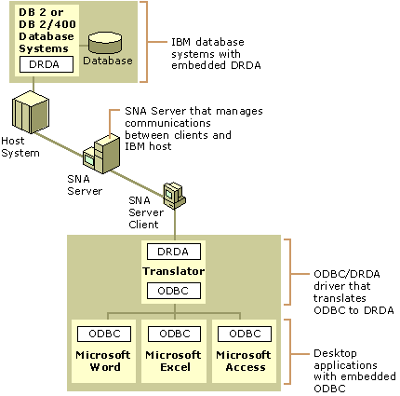
Figure 10.28 Host Data Access Using the ODBC Driver for DB2
The ODBC Driver operates by translating commands between the SQL and DRDA systems as shown in Figure 10.28. Each driver accepts SQL requests from a client application through ODBC, translates them to DRDA commands, and then sends them to the host system. The host processes the DRDA commands and returns the results to the driver on the client computer through SNA Server. The driver then converts the DRDA information to SQL data and passes the data back to the client application using the ODBC interface.
The ODBC Driver supports the following features:
• Transaction commit and rollback
• Asynchronous processing
• Canceled queries
• Primary and foreign keys
• Four levels of transaction isolation

The driver also supports the ability to pass SQL strings directly to the host database with translation. Supported database systems include:
• DB2 for MVS
• SQ/DS for VM and VSE
• DB2/400 for OS/400

For information about specific ODBC functions and data types supported by the ODBC Driver, see the SNA Server version 4.0 online documentation.
Host Data Access Using OLE DB
SNA Server provides record-level access to mainframe and AS/400 files using the OLE DB Provider for AS/400 and VSAM feature.
Leveraging the advantages of OLE DB as a common interface to dissimilar data sources, as shown in Figure 10.29, OLE DB Provider for AS/400 and VSAM lets you:
• Customize solutions for reading from and writing to AS/400 and mainframe file systems without first migrating the information to the client/server platform.
• Integrate nonstructured data with desktop and server-based databases and tools.
• Develop applications using high-level interfaces, such as Microsoft® ActiveX® Data Objects (ADO), which support Microsoft® Visual Basic® (VB), Microsoft® Visual C++® (VC++), Microsoft® Visual J++™ (VJ++), Microsoft® Visual Basic® for Applications (VBA), and Microsoft Scripting.

By providing applications with the ability to access and manipulate host files at the record level, you can leverage investments in host-based storage, management, backup, and security systems.
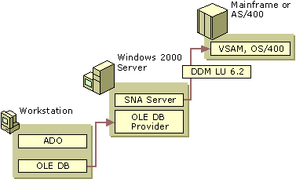
Figure 10.29 Host Data Access Using OLE DB Provider for AS/400 and VSAM
OLE DB Provider uses the record-level input/output (RLIO) protocol of the IBM Distributed Data Management (DDM) architecture (level 2 and higher). This feature is implemented as a source DDM requester and is interoperable with target DDM server implementations on most popular host environments, including MVS/ESA, OS/390, and OS/400.
Client applications communicate with a host database through an APPC (LU 6.2) connection to the host system established between the SNA Server Client software and SNA Server.
OLE DB Provider supports the following features:
• File and record locking
• File and record attribute preservation
• Indexed and sequential record access
• Fixed and variable logical record length

OLE DB Provider supports a variety of data file types for mainframe and AS/400 systems. For mainframe systems, OLE DB Provider supports SAM data sets, including BSAM and QSAM; VSAM data sets, including ESDS, KSDS, RRDS, VRRDS; alternate index for ESDS and KSDS data sets; and PDS/PDSE members. For AS/400, OLE DB Provider supports keyed and non-keyed physical files and logical files.
Complete information about using the OLE DB Provider for VSAM and AS/400 is provided in the SNA Server Software Development Kit, included with SNA Server.
Choosing a Host Data Access Method
The method with which you choose to integrate host databases depends on how you want to provide access to the database systems.
Enterprises that want to use ODBC-aware applications and SQL commands to access and manipulate tables on the host can use the ODBC/DRDA Driver. The widespread support of ODBC in many desktop applications, such as Microsoft® Excel and Microsoft® Access, makes it easy to create host-driven client/server solutions based on existing desktop applications.
In many environments, the OLE DB Provider for AS/400 and VSAM feature can be configured to perform the same functionality as the ODBC/DRDA Driver. In enterprises where little or no SQL expertise is present, however, OLE DB Provider is the better choice because no SQL understanding is required to access and manipulate host tables.
OLE DB support for the ADO interface in a wide variety of development environments, such as VB and VC++, also makes OLE DB Provider a good choice for highly customized client/server applications.
Host Application Integration Using COMTI
As SNA networks are integrated with client/server-based networks, many organizations are investigating ways to leverage the power of host systems to run new client/server applications accessible from the personal computer. One method is by using SNA Server’s COM Transaction Integrator (COMTI) feature for IBM’s Customer Information Control System (CICS) and IBM’s Information Management System (IMS).
COMTI simplifies the process of creating applications that consist of Automation clients running on the desktop or server with COBOL servers running under CICS or IMS. Any application or development platforms that support Distributed COM (DCOM) and Automation can use COMTI components. For example, an application written in VB, VBA, or VBScript, can provide access to host data from within Excel. This feature can also be used through Web browsers that connect to Microsoft® Internet Information Services (IIS).
COMTI provides an interface between Automation components and mainframe-based applications. Running on Windows 2000 Server, components appear as simple Automation servers that developers can easily add to their application. Behind the scenes, however, COMTI functions as a proxy that communicates with an application running on IBM's Multiple Virtual Storage (MVS) operating system.
Applications that run in part on Windows platforms and in part on the mainframe are distributed applications. COMTI supports all distributed applications that adhere to Automation and DCOM specifications, although not all parts of the application have to adhere to these standards.
COMTI is composed of three parts:
• The Component Builder, which is used to create Automation components.
• Microsoft Management Console (MMC), which is used to manage components created with the Component Builder.
• The COM Transaction Integrator Runtime, which provides the Automation server interface for each component created with the Component Builder and which communicates with the mainframe programs. The run time operates within Component Services.

COMTI directly supports any transaction program (TP) that executes in CICS and is structured to use either distributed program linking or Advanced Program-to-Program Communications (APPC) verbs. It also directly supports IMS applications that are structured to use the IMS Message Queue. Because COMTI can access CICS programs, developers can extend the client application calls even further by using CICS to access any other program on an MVS mainframe, such as DB2.
Figure 10.30 shows how SNA Server can be integrated with a host application. A client application uses the COMTI feature hosted by Component Services to access a TP running on the mainframe. The specific TPs supported by the feature are IBM’s CICS and IBM’s IMS. An example of this type of distributed application is one that reads a mainframe-based DB2 database to update data in a SQL Server database on a Windows 2000–based server.
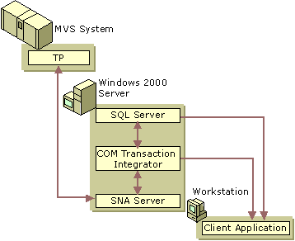
Figure 10.30 Integration with a Host Application
The client components can run on any platform that supports DCOM, including:
• Microsoft® Windows NT® Server
• Microsoft® Windows NT® Workstation
• Windows 95 and Windows 98

Because DCOM is language-independent, developers can build their client applications using the languages and tools with which they are most familiar. Common client/server application development environments include:
• Visual Basic (VB)
• Visual Basic for Applications (VBA)
• Visual C++ (VC++)
• Visual J++ (VJ++)
• Borland Delphi
• Sybase Powerbuilder
• Microfocus Object COBOL

Once created, the client components can make calls to the COMTI Automation object (or any other Automation object) registered on the computer running Windows 2000 Server.
Complete information about using COMTI, including sample applications, can be found in SNA Server COM Transaction Integrator Help.
Host Transaction Integration
Many organizations use host computer systems to support real-time transaction processing applications, such as IBM’s CICS. These applications are accessed through interactive sessions with the host system, such as a 3270 or 5250 session supported by a terminal emulator.
We have already described how the SNA Server’s COMTI feature can be used to access simple mainframe applications at the program level. This feature becomes an even more powerful tool when used to extend applications that use Windows 2000 Server Component Services. Windows-based applications that use Component Services can coordinate transactions with mainframe-based CICS applications.
When coupled with Component Services, COMTI can be used for a variety of purposes:
• Windows developers can describe, execute, and administer special Component Services objects that access CICS or IMS transaction programs (TPs).
• Mainframe developers can make mainframe TPs available to Windows-based Internet and intranet applications.
• Component Services component designers can include mainframe applications within the scope of Component Services two-phase commit transactions.

Developers using Component Services in their applications can decide which parts of the application require a transaction and which parts do not. COMTI extends this choice to the mainframe, as well, by handling both calls that require transactions and calls that do not.
For applications that require full integration between Windows-based two-phase commit and mainframe-based Sync Level 2 transactions, COMTI provides all the necessary functionality without requiring you to change the client application. Also, no executable code needs to be placed on the mainframe, and little or no changes to the mainframe TPs are required. The client application does not need to distinguish between the COMTI component and any other Component Services component reference.
Figure 10.31 illustrates how a Windows-based client application implicitly uses the Distributed Transaction Coordinator (DTC) to coordinate a distributed transaction involving SQL Server and a CICS transaction program. The DTC is the part of Component Services that coordinates two-phase commit transactions.
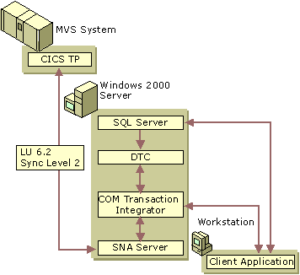
Figure 10.31 Integration with Host Transaction System
Complete information about using COMTI, including sample applications, can be found in the SNA Server version 4.0 documentation.
Transaction and Data Access Scenarios
COMTI should be considered for the following scenarios:
• Application-level database integration.
• COM integration with CICS and IMS.
• ADO access to legacy data.
• Integration of mainframe applications that own and control the host data. Transaction programs (TPs) often contain logic and data structures that define the rules for accessing host data. In some cases, these applications also contain integrity checks and consistency constraints. In these cases, accessing the host data through these TPs is the only safe option.
• Positioning of mid-tier applications to take advantage of the scalability benefits Component Services provides in addition to providing mainframe application access.
• Deployment of high-integrity, distributed transaction systems that span Windows 2000, MVS/CICS, and other Extended Architecture (XA)–compliant environments that are Component Services-enabled.
• Mainframe connectivity only.

OLE DB Provider should be considered for these scenarios:
• Record-level or file-level database integration.
• OLE DB and ADO access to legacy data.
• Rewriting of business rules, such as “Year 2000” solutions.
• Direct access to host data without going through the host SQL processor.
• Mainframe and AS/400 connectivity.

In some cases, you might choose to use both COMTI and OLE DB Provider to develop a complete host-connectivity solution.
Sample applications that use COMTI are installed when the COMTI component is selected during SNA Server setup. For more information about using the samples, see the samples folder on the SNA Server CD.
Web-to-Host Integration
The growth of the Internet and its related technologies has given corporate information technology departments new ways to extend client/server computing applications to both internal and external users. Information and resources that exist on internal, proprietary systems can now be accessed from a broader user base, giving corporations more ways to utilize their current investments in technology.
Enterprise networking is also experiencing a resurgence in popularity; the size of corporate databases that store mission-critical data continues to grow. As companies continue to use mainframe and AS/400 host systems for database hosting, transaction processing, and other applications, many organizations are investigating methods of integrating host networks with the Web.
SNA Server and Web Technology
The Microsoft Web-to-host model uses SNA Server to provide Web-to-host connectivity between an IBM host system and a Web server, such as IIS. In this model, as shown in Figure 10.32, Web browsers and servers communicate using the HTTP and TCP/IP protocols over the network. The Web server, in turn, communicates with SNA Server using a defined server interface, such as the Internet Server Application Programming Interface (ISAPI). The SNA Server–based computer then communicates with the host system using the SNA protocol over a defined connection.
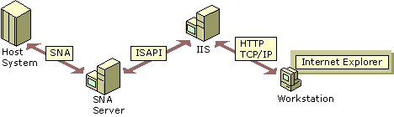
Figure 10.32 Web-to-Host Communications
The components illustrated in Figure 10.32 might be deployed on one or more computers across your enterprise. For example, smaller enterprises might be able to deploy a Web server and SNA Server on the same Windows 2000 Server–based computer and still maintain the desired server response levels. As the number of server and connection requests increases, it is recommended that the Web server and SNA Server applications be installed on separate Windows 2000 Server–based computers.
IIS is the recommended Web server for Windows 2000 Server–based systems because of its tight integration with the management and administrative features of the operating system. Integration with Windows 2000 Server also lets you easily couple IIS with other BackOffice applications, such as SQL Server or Microsoft® Exchange Server, in order to Web-enable enterprise applications such as database access and e-mail.
Web-to-Host Access Methods
SNA Server provides host-connectivity services for Web-based users in several ways. The following Web-to-host solutions are commonly adopted by enterprises:
• Browser-based terminal access solutions, which display 3270 and 5250 data streams in a Web browser window.
• Web-to-host data access solutions, which provide access to relational or non-relational host data through a Web browser.
• Web-to-host application access solutions, which provide access to transaction systems through a Web browser.

The following sections detail options for deploying SNA Server in each of these scenarios and describe the environments in which each is best deployed.
Browser-Based Terminal Access
Using a Web browser to provide access to host applications through a traditional 3270 or 5250 terminal interface is a simple and effective way of providing terminal access to your users. This Web-to-host solution is ideal if your user base is already familiar with the character-based terminal interface and is adept at using existing host applications. In most environments where this solution is deployed, existing host access technology is already in place, either through dumb terminals or software-based emulators.
SNA Server can provide browser-based terminal emulation through the deployment of SNA Server Web Client, as shown in Figure 10.33. SNA Server Web Client provides terminal emulation features through an ActiveX control that is part of a package downloaded to a user’s browser from a Web server such as IIS. Once downloaded and invoked, the control establishes a connection with the sponsor SNA Server computer that provides a connection to the host system.
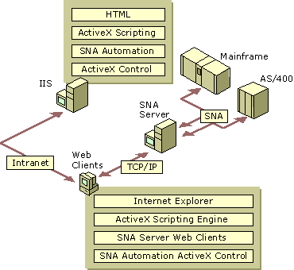
Figure 10.33 SNA Server Web Client Terminal Access Installation
Using this method, no configuration is required on the client workstation because all connection information is specified by the administrator before SNA Server Web Client is downloaded into the browser. When a user downloads the ActiveX package, the connection information is contained in the download, allowing SNA Server Web Client to automatically establish a connection to the host system.
Once SNA Server Web Client software is downloaded to the client workstation, it does not need to be downloaded again unless the browser detects a newer version of the software on the Web server; this can speed up the client startup time and minimizes the load on your server. Because SNA Server Web Client software is distributed from a central location, updates and changes to host configurations are easily propagated to your users the next time they start the SNA Server Web Client application.
SNA Server Web Client is currently available for Windows NT, Windows 2000, Windows 95, and Windows 98–based clients running Internet Explorer 3.02 or later. Both 3270 and 5250 terminal emulation clients are provided.
Complete information about configuring and installing SNA Server Web Client is provided in the SNA Server version 4.0 documentation.
Web-to-Host Data Access
As mentioned earlier, host systems are ideal platforms on which to provide large-scale database services for enterprises. Using SNA Server, Web technology can extend host database access to a broader range of users.
A common way to integrate Web technology with host databases is to use the rich-text capabilities of HTML to create visually appealing, user-friendly interfaces for character-based host database systems.
For example, a Web browser could be used to collect database queries on an HTML form. The queries could then be transferred, using ISAPI or some other common gateway interface, from the Web server to a service that can communicate with the host database system. The results of the query could then be formatted into HTML and viewed through the user’s browser.
SNA Server is an ideal tool for deploying Web-to-host data access solutions because it can provide host database access without the need for host code or a modified database system. Using a feature such as OLE DB Provider, you can extend a wide range of services to Web users. Figure 10.34 illustrates how different data access components integrate with SNA Server and other services to provide access to host data files from a Web browser.
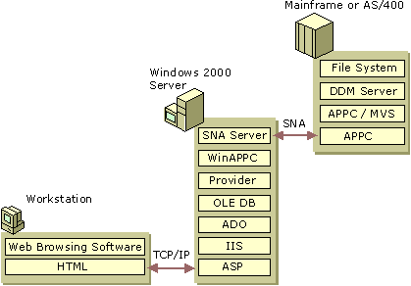
Figure 10.34 Web Access to Host Data File System
In the browser, the user loads and inputs data into an Active Server Page (ASP) hosted by the Web server (IIS). The ASP then sends the data through the ActiveX Data Objects (ADO) interface to the OLE DB Provider feature of SNA Server.
In this scenario, the OLE DB Provider uses the APPC record-level input/output (RLIO) protocol of the IBM Distributed Data Management (DDM) architecture (level 2 and higher) to communicate with the host database. This entire process is transparent to the host system and to the user.
The SNA Server OLE DB Provider is implemented as a source DDM requester and is interoperable with target DDM server implementations on most popular host environments, including MVS/ESA, OS/390, and OS/400.
Web-to-Host Application Access
A Web browser can also be used to access TPs that operate on a mainframe, such as CICS or IMS applications. Using SNA Server’s COMTI feature, you can develop client/server applications that use Web browsers to interact with mainframe transaction systems. Because CICS programs can access DB2 databases, COMTI can also provide programmatic access to DB2 on a mainframe.
You can use any technique for accessing COM objects from the browser because COMTI creates a standard COM Automation server component that acts as a proxy for the mainframe CICS or IMS TPs. Figure 10.35 illustrates the components that could be involved in creating a Web application that uses server-side scripting to dynamically create objects and invoke methods.
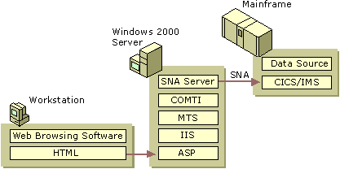
Figure 10.35 Web Access to Host Transaction System
Other applications that use technologies such as Remote Data Services (RDS) and client-side scripting can also be developed. In these scenarios, object creation and method invocation are launched from a client script executed on the server and the RDS control directs records back to the client over HTTP. Retrieved records can then be bound to an HTML grid control for display purposes.
For more information about sample applications that use these Web-to-host technologies, see the samples folder on the SNA Server CD.
Network Management Integration
Your LAN-to-host integration project is not complete until you can manage the integrated network environment. SNA Server provides integrated management services that enable you, or your IBM host system administrators, to manage SNA Server from:
• Windows 2000 Professional–based computers.
• Remote computers, using SNA Server Remote Access Service (SNA remote access server).
• IBM NetView applications running on an IBM host system.

SNA Server Management Services
You can configure and manage SNA Server using a graphical user interface application, SNA Server Manager, or from the command-line interface.
SNA Server Manager is a graphical Microsoft Management Console (MMC) snap-in that supports simultaneous monitoring, diagnosis, and management of SNA Server resources and services, including:
• SNA Server subdomains
• Computers
• Configurations
• Link services
• Connections
• LUs
• Sessions
• Services
• Users

SNA Server Manager integrates the administration of all services provided by SNA Server including TN3270 Service, TN5250 Service, Host Print Service, Shared Folders Gateway Service, and Host Security Integration.
With SNA Server Manager, you can view all computers running SNA Server in an SNA Server subdomain, and manage multiple subdomains at the same time, allowing for central configuration and administration of all SNA Server resources throughout an enterprise network.
You can remotely configure and manage computers running SNA Server across all common protocols, including:
• TCP/IP
• IPX/SPX
• Banyan VINES IP
• Named Pipes
• Windows 2000 Routing and Remote Access service

SNA Server Manager runs on any computer running Windows 2000 Professional that is configured with SNA Server Client. In addition, SNA Server Manager allows more than one administrator to simultaneously view and manage the same SNA Server subdomain.
Note SNA Server also provides a command-line management interface that allows you to store and use configuration commands in command files. For more information about command-line management functions, see the SNA Server version 4.0 documentation. and the Microsoft® BackOffice® Resource Kit.
Integration with Windows 2000 Management Services
Because SNA Server is a BackOffice application, SNA Server Manager is tightly integrated with the Windows 2000–based MMC snap-ins, including:
• User Manager
• System Monitor
• Event Viewer

Integration with User Manager provides a common user account database and security system for Windows 2000 users, SNA Server Client–based computers, and users of other BackOffice applications. Integration with System Monitor allows you to configure performance counters that monitor the SNA traffic volumes of your SNA Server–based computers. With Event Viewer you can quickly identify the type and sequence of events leading up to problems on any SNA Server subdomain.
For more information about managing SNA Server resources and services from the Windows 2000 MMC, see the SNA Server version 4.0 documentation and the Microsoft® BackOffice® Resource Kit.
Integration with IBM NetView Management Services
SNA Server can also support integrated management services with IBM NetView network management systems that run on IBM mainframes, as shown in Figure 10.36.
The NetView reporting system sends alerts and other information between a host system and the computers that connect to it. NetView functionality can be extended to encompass the Windows 2000/SNA Server environment through the following services:
• NVAlert service
• NVRunCmd service
• Response Time Monitor
• Link Alerts for SDLC and Token Ring

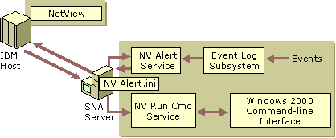
Figure 10.36 SNA Server Communication with IBM NetView
NVAlert Service
As shown in Figure 10.36, the NVAlert service sends events from the Windows 2000 event logs to IBM NetView system on the host computer. The events are sent as standard NetView alerts. NVAlert can send two categories of events: events generated by the Windows 2000 operating system and events generated by Windows 2000–based applications.
The events can be forwarded to the NetView console display on the host system or to a host system log file. NVAlert determines which events to forward to the NetView console by reading the NVAlert.ini file.
NVRunCmd Service
The NVRunCmd service allows commands issued from a host system NetView console to be carried out on the computer running Windows 2000 and SNA Server. The NVRunCmd service also returns the command results to the host NetView console in standard character or number formats.
Response Time Monitor
The Response Time Monitor (RTM) is an IBM host function that works in conjunction with NetView and 3270 sessions to measure the length of time it takes for a host to respond during a 3270 session. The SNA Server Response Time Monitoring tool allows you to specify when RTM should send data and to define the triggers that cause RTM to register that the host has responded.
Link Alerts for SDLC and Token Ring
When a Synchronous Data Link Control (SDLC) or Token Ring connection fails, SNA Server logs diagnostic information, called link alerts, about the connection failure. The alerts are logged in a log file that can be viewed using the Windows 2000 Event Viewer.
The link alerts are also used to build a network management vector transport (NMVT) alert, which includes probable causes and suggested actions for the alert. If a connection on the server running SNA Server has been designated for NetView, and the connection is active, the NMVT alert is sent on that connection.
For more information about SNA Server management services, including integration with Windows 2000 and IBM host management services, see the SNA Server version 4.0 documentation.
Additional Resources
• For more information about updated versions of SNA Server, evaluation disks, and white papers, see the SNA Server link on the Web Resources page http://windows.microsoft.com/windows2000/reskit/webresources.

