Chapter 7 - Analyzing Processor Activity

After memory consumption, processor activity is the most important thing to monitor in your system. A busy processor might be efficiently handling all the work on your computer, or it might be overwhelmed. Examine processor activity to tell the difference. Use performance counters and Microsoft® Windows® 2000 Resource Kit tools to measure processing activity and to determine how to improve performance if necessary.
In This Chapter
Overview of Processor Monitoring and Analysis
Establishing a Baseline for Processor Performance
Recognizing a Processor Bottleneck
Processes in a Bottleneck
Threads in a Bottleneck
Advanced Topic: Changing Thread Priority to Improve Performance
Eliminating a Processor Bottleneck
Related Information in the Resource Kit
• For information about using System Monitor graphs and counter logs, see “Overview of Performance Monitoring” in this book.
• For information about implementing and optimizing multiprocessor systems, see “Measuring Multiprocessor System Activity” in this book.

Overview of Processor Monitoring and Analysis
Uniprocessor monitoring and analysis involve many variables. The following steps summarize in-depth monitoring and analysis of processor activity.
• Establish a baseline for processor performance that is reflective of your system’s typical workload. Perform this step to characterize your system’s workload and identify how applications use the system.
• Examine overall processor usage by viewing processor queue length and processor utilization (also referred to as processor time). Perform this step to obtain an overview of how heavily system resources are used.
• Examine activity that adds to the processing load, such as high rates of interrupts and context switches. Perform this step to determine the efficiency of your system.
• Examine individual processes and their percentage of the overall processor time. Perform this step to learn about the processes on your system.
• Examine the threads— the units of work that make up a process—for each individual process and each thread’s processor usage. Perform this step to learn about thread utilization on the system.
• Evaluate thread priorities and change them to see if this provides better performance. (Microsoft does not recommend this is as a long-term solution, but suggests it for testing purposes.) Perform this step to learn how threads interact and to determine which threads are preempting other, lower-priority threads.

Figure 7.1 illustrates the role of processor monitoring in overall system monitoring.
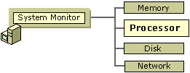
Figure 7.1 Role of Processor Monitoring in Overall Monitoring Sequence
Before you begin the monitoring process, become familiar with the counters designed to measure processor activity and the Windows 2000 Resource Kit tools that can give you more information about processor workload and performance. The following sections summarize these counters and tools.
Processor Counters
The System, Processor, Process, and Thread objects contain counters that provide useful information about the work of your processor. Examine the following counters for details about computer processes.
Table 7.1 Processor Counters

Object Counter Description

System Context Switches/sec The average rate per second at which context switches among threads on the computer. High activity rates can result from inefficient hardware or poorly designed applications. Compare these counters with Processor\% Privileged Time, Processor\% User Time, and Processor\% Interrupt Time. See “Monitoring Interrupts” and “Monitoring Context Switches” later in this chapter.
Processor Interrupts/sec The average rate per second at which the processor handles interrupts from applications or hardware devices. High activity rates can indicate hardware problems. Compare these counters with Processor\% Privileged Time, Processor\% User Time, and Processor\% Interrupt Time. See “Monitoring Interrupts” and “Monitoring Context Switches” later in this chapter.
System Processor Queue Length An instantaneous count of threads that are in the processor queue. See “Observing Processor Queue Length” later in this chapter.
Processor % Processor Time The percentage of time the processor was busy during the sampling interval. This counter is equivalent to Task Manager’s CPU Usage counter. See “Examining the Processor Time Counter” later in this chapter.For the value of total processor utilization systemwide, use the Processor(_Total)\% Processor Time counter.
Process % Privileged Time The percentage of time a process was running in privileged mode. See “Processes in a Bottleneck” later in this chapter.
Process % Processor Time The percentage of time the processor was busy servicing a specific process.
Process % User Time The percentage of time a process was running in user mode.
Process Priority Base Windows 2000 schedules threads of a process to run according to their priority. Threads inherit base priority from their parent processes. The base priority level of the process can range from lowest to highest: Idle, Normal, High, or Real Time.
Thread Thread State A numeric value indicating the execution state of the thread.
The system numbers threads from 0 through 5; the states seen most often are 1 for ready, 2 for running, and 5 for waiting. Threads with a state of 1 are in the processor queue.
Thread Priority Base The base priority level (from 1 through 31) for the thread based on the priority class of the process. Windows 2000 schedules threads of a process to run according to their priority. Threads inherit base priority from their parent processes.
Thread Priority Current The current priority level of a thread. This level can vary during operation.
Thread Context Switches/sec The average rate per second at which the processor switches context among threads. A high rate can indicate that many threads are contending for processor time. See “Threads in a Bottleneck” later in this chapter.
Thread % Privileged Time The percentage of time a thread was running in privileged mode.
Thread % User Time The percentage of time a thread was running in user mode.
Note Because System Monitor samples processor time, the values for processor time counters reported by the Processor, Process, and Thread objects might underestimate or overestimate activity on your system that occurs before or after collection of the sample.
In addition to the preceding list of objects and counters, the Job Object and Job Object Details objects provide information about processor usage. These performance objects are installed by default for monitoring job object performance. The job object makes it possible for developers to manage groups of processes by their processor usage and other factors. For example, job objects make it possible for applications to restrict the amount of processor time a process consumes; this is called process throttling. Process throttling is useful in Web-based administration applications for limiting the amount of processor capacity a site uses over a defined interval, thus avoiding bottlenecks and freeing processor capacity for other tasks. You might also use the job object to manage sharing of CPU time among groups of jobs. In addition to supporting process throttling, job objects help developers control the active number of processes, process identifiers (IDs), priority classes, and processor affinity. For information about creating applications using the job object, see the Platform Software Development Kit (SDK) link on the Web Resources page at http://windows.microsoft.com/windows2000/reskit/webresources. For a discussion of application support and job objects, see Getting Started in Windows 2000 Help.
Resource Kit Tools for Processor Monitoring
The Resource Kit companion CD contains utilities to help you understand and experiment with processor performance, as listed in Table 7.2.
Table 7.2 Performance Utilities

Utility name Description

CPUStres Simulates processor workload.
Qslice Provides a graphical display of processor usage by process.
Establishing a Baseline for Processor Performance
Begin your monitoring routine with an examination of processor usage under your normal workload. By doing so, you can begin to establish a baseline or reference point for processor usage. The baseline is generally not a single value, but a range within which processor usage can fluctuate and still provide acceptable performance. You can use the baseline to identify trends, such as increasing processor demands over time, or to recognize problems that arise from a sudden change.
Selecting Counters for Baseline Monitoring
To determine the baseline, use the following counters to create logs of processor usage over an extended period (from several weeks to a month).
• Processor\% Processor Time
• System\Processor Queue Length

Be aware of the Idle process when monitoring processor usage. The Idle process runs a thread on each processor. This thread runs when the system is not already running the thread of an active user or system process. System Monitor and Task Manager both use the Idle process to calculate time when the processor is not busy. You can see processor time for the Idle process on the Processes tab in Task Manager (called the System Idle Process) or by tracking the Process(Idle)\% Processor Time counter in System Monitor. Notice that the Total instance for this counter includes processor time for the Idle process. To measure the Idle process, use the Process(Idle)\% Processor Time counter, or use the Processes tab in Task Manager. Zero idle time could mean that the processor is handling a lot of work, but it could also mean that the processor or central processing unit (CPU) is overloaded.
Selecting Times for Baseline Monitoring
To monitor processor activity, log the counters of the System, Processor, Process, Thread, PhysicalDisk, and Memory counters for at least several days at an update interval ranging from 15 minutes to an hour. (Use much shorter intervals for bottleneck detection.) Include network counters such as Bytes Total/sec (on the Network Interface object) if you suspect that network traffic might be interrupting the processor too frequently. Because excessive demand on memory and disk resources can cause bottlenecks that appear to affect your processor’s performance, also include disk and memory counters in your monitoring configuration to help you determine the true source of any processor bottleneck.
If any applications running on the computer have counters, use these counters to monitor their activity and monitor these values along with system counter values.
Track the values reported at various times of day—for example, while users are logging on or off, while backups are being done, and so forth. As you are monitoring values for these counters, you might see occasional spikes. Typically, you can exclude these from your baseline; the range of values that seem to appear consistently are the ones that constitute your baseline.
Note Keep in mind application overhead and disk-space usage when you set your monitoring frequency. Frequent updating demands more work and more file storage capacity from your computer. In general, you should experiment with different update intervals to balance these considerations against the level of detail you require for your monitoring data. For more information about how to monitor performance, see Windows 2000 Professional Help.
The longer you log, the more accurate your baseline will be. Processor use might be a problem only at certain times of the day, week, or month, and you are likely to see patterns in your workload that are correlated with changes in processor activity if you log for a longer duration. You can even use the log service to schedule monitoring at critical times to determine whether your processor is operating efficiently. During these critical times, you might want to log over intervals as short as every two seconds to get an accurate picture of processor usage on your system. This will help you isolate those applications that heavily stress your processor for further investigation and monitoring.
Recognizing a Processor Bottleneck
Processor bottlenecks occur when the processor is so busy that it cannot respond to requests for time. Although a high rate of processor activity might indicate an excessively busy processor, a long, sustained processor queue is a more certain indicator. As you monitor processor and related counters, you can recognize a developing bottleneck by the following conditions:
• Processor\% Processor Time often exceeds 80 percent.
• System\Processor Queue Length is often greater than 2 on a single-processor system.
• Unusually high values appear for the Processor(_Total)\Interrupts/sec or System\Context Switches/sec counters.

The most common causes for processor bottlenecks are insufficient memory or excessive numbers of interrupts from disk or network input/output (I/O). To investigate these possible causes, see the following chapters:
• “Evaluating Memory and Cache Usage” in this book
• “Examining and Tuning Disk Performance” in this book
• “Monitoring Network Performance” in this book

Also, the Processor(_Total)\Interrupts/sec counter value might rise dramatically if you’ve recently added many new applications or users. During periods of low activity the only source of interrupts might be the processor’s timer ticks; these are periodic events that increment a processor hardware timer. These occur approximately every 10 to 15 milliseconds, or about 66 to 100 interrupts per second. Interrupt rates vary depending on system workload, including network packets per second and disk I/O operations per second. Watch for interrupt values that fall out of a normal range (expect these to be in the 1000s of interrupts on Microsoft® Windows® 2000 Server and from 200 to 300 on Microsoft® Windows® 2000 Professional). If Processor\% Interrupt Time exceeds 20 to 30 percent per processor, it might indicate that the system is generating more processor interrupts than it can handle. If this is the case, you might need to upgrade some of your components. For more information, see “Monitoring Network Performance” in this book.
If a processor bottleneck does not exist but you are dissatisfied with system performance, and you have ruled out memory and other hardware factors, consider the following options to improve CPU response time or throughput:
• Schedule processor-intensive applications to run when the system load is low. Use Scheduled Tasks in Control Panel or the at command to do this.
• Upgrade to a faster processor. Upgrading to a higher-speed processor with a larger L2 cache will expedite processing regardless of your system’s workload.
When upgrading to a faster processor, check with the chip vendor to ensure that you use the correct memory speed for the chip. Incompatible memory speed could cause a computer with a faster processor to appear to run more slowly than a computer with a slower processor.
Note Using multiple processors rather than switching to a faster one might not automatically improve performance in a dramatic manner. For example, a 200-megahertz (MHz) dual-processor computer might not perform equally to a 400-MHz uniprocessor computer with all workloads because of overhead inherent in synchronization. Because scaling can incur some overhead, it is important to be aware of the factors involved and how to manage them. For more information, see “Measuring Multiprocessor System Activity” in this book.

If conditions do not warrant immediate processor replacement, begin monitoring processor activity and system performance as described in the following sections.
Examining the Processor Time Counter
The Processor\% Processor Time counter determines the percentage of time the processor is busy by measuring the percentage of time the thread of the Idle process is running and then subtracting that from 100 percent. This measurement is the amount of processor utilization. Although you might sometimes see high values for the Processor\% Processor Time counter (70 percent or greater depending on your workload and environment), it might not indicate a problem; you need more data to understand this activity. For example, high processor-time values typically occur when you are starting a new process and should not cause concern.
Note The value that characterizes high processor utilization depends greatly on your system and workload. This chapter describes 70 percent as a typical threshold value; however, you may define your target maximum utilization at a higher or lower value. If so, substitute that target value for 70 percent in the examples provided in this section.
To illustrate, consider that Windows 2000 allows an application to consume all available processor time if no other thread is waiting. As a result, System Monitor shows processor-time rates of 100 percent. If the threads have equal or greater priority, as soon as another thread requests processor time, the thread that was consuming 100 percent of CPU time yields control so that the requesting thread can run, causing processor time to lessen. For a discussion of priority and scheduling, see “Threads in a Bottleneck” later in this chapter.
If you establish that processor-time values are consistently high during certain processes, you need to determine whether a processor bottleneck exists by examining processor queue length data. Unless you already know the characteristics of the applications running on the system, upgrading or adding processors at this point would be a premature response to persistently high processor values, even values of 90 percent or higher. First, you need to know whether processor load is keeping important work from being done. You have several options for addressing processor bottlenecks, but you need to first verify their existence.
If you begin to see values of 70 percent or more for the Processor\% Processor Time counter, investigate your processor’s activity further, as follows:
• Examine System\Processor Queue Length.
• Identify the processes that are running when Processor\% Processor Time and System\Processor Queue Length values are highest.

Observing Processor Queue Length
A collection of one or more threads that is ready but not able to run on the processor due to another active thread that is currently running is called the processor queue. The clearest symptom of a processor bottleneck is a sustained or recurring queue of more than two threads. Although queues are most likely to develop when the processor is very busy, they can develop when utilization is well below 90 percent. This can happen if requests for processor time arrive randomly and if threads demand irregular amounts of time from the processor. For more information about monitoring and adjusting thread scheduling, see “Threads in a Bottleneck” later in this chapter.
The System\Processor Queue Length counter shows how many threads are ready in the processor queue, but not currently able to use the processor. Figure 7.2 shows a sustained processor queue with utilization ranging from 60 to 90 percent. Notice that the default scale for the Processor Queue Length counter value is 10. Therefore, System Monitor graphs a queue that is two threads long as 20. You can change the scale factor using the Data properties tab in System Monitor.
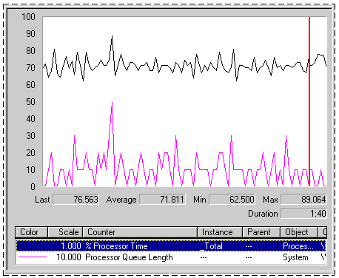
Figure 7.2 Sustained Processor Queue with Rising Processor Usage
In Figure 7.2, the line across the top represents Processor(_Total)\% Processor Time. The lower line is System\Processor Queue Length.
Figure 7.3 shows a sustained processor queue accompanied by processor use at or near 100 percent.
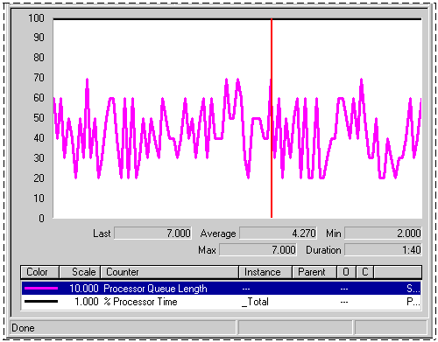
Figure 7.3 Sustained Processor Queue with Maximum Processor Usage
Figure 7.4 illustrates how a processor bottleneck interferes with your computer’s performance. It shows that when a processor is already at 100 percent utilization, starting another process does not accomplish more work.
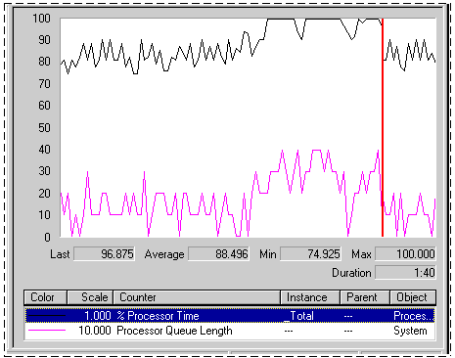
Figure 7.4 Saturated Processor
In Figure 7.4, the dark line running across the top of the graph is Processor(_Total)\% Processor Time. The line below it is System\Processor Queue Length. Midway through the sample interval, a process with three threads was started. The graph illustrates that the queue increased as a result of this added workload. Some of the threads of the added process might be in the queue, or they might be running, having displaced the threads of a lower-priority process. Nonetheless, because the processor was already at maximum capacity, it can accomplish no additional work.
If your system’s counter values appear similar to those in Figure 7.4, this indicates a bottleneck. Logging, over time, will reveal any patterns associated with the bottleneck. For example, you might find that bottlenecks occur when certain processes are running or at a certain time of day. In this case, you might be able to eliminate the bottleneck by balancing the workload between computers—that is, running the process on another, less loaded computer.
However, if sustained queues appear frequently, you need to investigate the processes that are running when threads collect in the queue. To determine this:
• Identify the processes that are consuming processor time. Determine whether a single process or multiple processes are active during a bottleneck. Running processes appear in the Instance box when you select the Process\% Processor Time counter. For more information, see “Processes in a Bottleneck” later in this chapter.
• Scrutinize the processor-intensive processes. Determine how many threads run in the process and watch the patterns of thread activity during a bottleneck.
• Evaluate the priorities at which the process and its threads run. You might be able to eliminate a bottleneck merely by adjusting the base priority of the process or the current priorities of its threads. However, Microsoft does not recommend this as a long-term solution. Use Task Manager to find the base priority of the process.
Note Different guidelines apply for queue lengths on multiprocessor systems. For busy systems (those having processor utilization in the 80 to 90 percent range) that use thread scheduling, the queue length should range from one to three threads per processor. For example, on a four-processor system, the expected range of processor queue length on a system with high CPU activity is 4 to 12.
On systems with lower CPU utilization, the processor queue length is typically 0 or 1.

There are other objects that track processor queue length. The Server Work Queues\Queue Length counter reports the number of requests in the queue for the processor on the selected server. For more information about monitoring the Server Work Queues object, see “Monitoring Network Performance” in this book.
Monitoring Interrupts
Sharply rising counts for interrupts can affect your processor’s performance, and you should investigate their cause. The Processor\Interrupts/sec counter reports the number of interrupts the processor is servicing from applications or hardware devices. You should expect interrupts to range upward from 1,000 per second for computers running Windows 2000 Server and upward from 100 per second for computers running Windows 2000 Professional. This interrupt rate is dependent on the rate of disk I/O operations per second and network packets per second. If your interrupt counter values are out of range, there might be hardware problems such as a conflict between the hard-disk controller and a network adapter. You can use System Information and Device Manager in the Computer Management console to check for problems with the disk controller or network adapter.
You might want to monitor interrupts along with I/O activity involving both disks and network cards. Use the Disk Reads/sec or Disk Writes/sec counters on the PhysicalDisk object to monitor disk I/O as described in “Examining and Tuning Disk Performance” in this book. Use the network transmission counters to monitor network activity as described in “Monitoring Network Performance” in this book. You can tell if interrupt activity is becoming a problem by determining the ratio of interrupts to I/O operations. An optimal ratio is one interrupt to four or five I/O operations. A one-to-one correspondence between these factors indicates poor performance and requires action.
If network or disk I/O is involved, you should consider upgrading to a controller and a driver that support interrupt moderation or interrupt avoidance. Interrupt moderation allows a processor to process interrupts more efficiently by grouping several interrupts to a single hardware interrupt. Interrupt avoidance allows a processor to continue processing interrupts without new interrupts being queued until all pending interrupts are complete. For more information about managing interrupts from network adapters, see “Monitoring Network Performance” in this book.
High values for % Processor Time for threads of the System process can also indicate a problem with a device driver.
Monitoring Context Switches
A context switch occurs when the kernel switches the processor from one thread to another—for example, when a thread with a higher priority than the running thread becomes ready. Context switching activity is important for several reasons. A program that monopolizes the processor lowers the rate of context switches because it does not allow much processor time for the other processes’ threads. A high rate of context switching means that the processor is being shared repeatedly—for example, by many threads of equal priority. A high context-switch rate often indicates that there are too many threads competing for the processors on the system.
Note The rate of context switches can also affect performance of multiprocessor computers. For information about how to monitor and tune context-switch activity on multiprocessor systems, see “Measuring Multiprocessor System Activity” in this book.
You can view context switch data in two ways:
• The System\Context Switches/sec counter in System Monitor reports systemwide context switches.
• The Thread(_Total)\Context Switches/sec counter reports the total number of context switches generated per second by all threads.

Although these counters might vary slightly due to sampling, generally they will be nearly equal.
Figure 7.5 plots System\Context Switches/sec during a transient bottleneck.
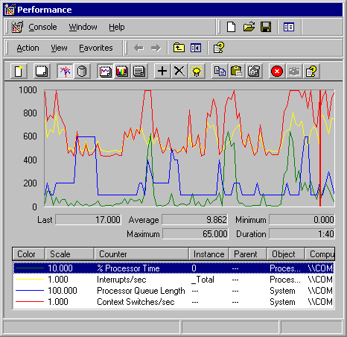
Figure 7.5 Systemwide Context Switches During a Processor Bottleneck
In Figure 7.5, Processor(_Total)\% Processor Time jumps to about 60 percent during the sample interval. System\Processor Queue Length (scaled by a factor of 10), shows that the queue varies from 2 to 6, with a mean near 4. System\Context Switches (shown scaled by a factor of 10), reveals an average of about 750 switches per second. A rate of context switches from 500 to 2,000 per second might indicate a problem with a network adapter or a device driver or that you are using an inefficient server-based application that spawns too many threads.
The Pviewer utility on the on the Windows 2000 operating system CDreports context switch data.For information about installing and using the Windows 2000 Support Tools and Support Tools Help, see the file Sreadme.doc in the \Support\Tools folder of the Windows 2000 operating system CD.
Processes in a Bottleneck
After you have identified a processor bottleneck, you next need to determine whether a single process is using the processor or whether the processor is being consumed by running many processes. To do this, log processor time used by each process running on your computer, as follows:
• Select the Process object.
• Select the % Processor Time counter.
• Select each process instance.
Important All processes that are running will appear in the Instance box listed by the name of the associated executable program (for example, Windows Explorer appears as “explorer” in the Instance box). Note that if you are running multiple instances of the same executable program, System Monitor lists these under the identical name; thus, you will need to track these by their process identifiers. You can find the process identifier by using the Process\Process ID counter or by adding the PID column in Task Manager. For more information, see “Threads in a Bottleneck” later in this chapter.

For more information about MS-DOS-based (shown as NTVDM for Windows NT Virtual DOS Machine) and Win16-based processes that appear differently in the user interface. See “Overview of Performance Monitoring” in this book.
Identifying Active Processes
To determine the processing load generated by your typical workload, include the instances for the processes that you normally run. If you find that you don’t normally use some processes (such as background services) that are already running, stop these processes and measure the impact on your processing load. This might be an easy way to improve your computer’s processing efficiency. However, before doing so, make sure you understand the possible effects. To stop a service, complete the following procedure.
To stop a service
1. Click Start, point to Programs, and then click Administrative Tools.
2. Click Computer Management, and then, in the console that appears, click Services and Applications.
3. Under Services and Applications, double-click Services.
4. Right-click the name of a service, and then click Stop.

Isolating Processor-Intensive Workloads
If the threads of a process are using a high percentage of CPU time, the process should be analyzed to determine if the application’s performance can be optimized. For information about improving application performance, see the Platform Software Development Kit (SDK) link on the Web Resources page at http://windows.microsoft.com/windows2000/reskit/webresources. If optimization does not yield satisfactory results, you need to add processor resources.
Device driver problems can cause high % Processor Time values for the System process. In addition, if you have screen savers running on your system, note that they use a large amount of processor time, particularly ones that use OpenGL (a software interface that supports production of high-quality, three-dimensional color imaging). Monitor your screen saver executable and, if necessary, change to one that uses less processor time. (Typically this is only applicable to servers.)
If a single process is using the processor, the chart line associated with that process will be the highest one in the graph, such as in Figure 7.6, which is an actual histogram of a processor bottleneck caused by a single process. Running CPU Stress, a utility on the Windows 2000 Resource Kit companion CD, produced the results shown in this example.
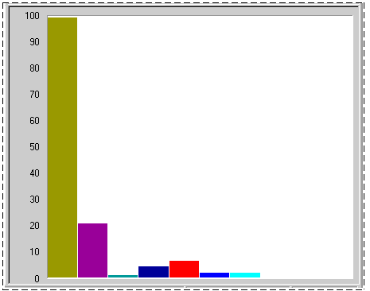
Figure 7.6 Processor Bottleneck Caused by a Single Process
This histogram shows that a single process (represented by the tallest bar) is highly active during a bottleneck; its threads are running for more than 90 percent of the sample interval. If this pattern persists and a long queue develops, it is reasonable to suspect that the application running in the process is causing the bottleneck.
Note that a highly active process is a problem only if a queue is developing. If you are not satisfied with response time and throughput, you can choose to upgrade to a faster processor to achieve better performance.
If you suspect that an application is causing a processor bottleneck, stop using the application for a few days or move it to a different computer. Another option is to schedule the process to run outside of peak operating hours. Then log processor use again. If the problem disappears, it is likely that the application caused it.
Reducing Single-Process Bottlenecks
If you cannot use another computer and you have access to the application source code, you can tune the application to increase efficiency. Start by using a profiler, an analysis tool that you can use to examine the run-time behavior of your programs. Profiling enables you to analyze how the application is spending processor time. The Platform Software Development Kit (SDK) includes tools and methods for profiling and optimizing applications, including instructions for developing performance counters to monitor the inner workings of your application. To tune an application to be less CPU-intensive, use SDK utilities such as Call Attributed Profiler (CAP) or File I/O Synchronization Win32 API Profiler (FIOSAP). You can also use APIMon and Kernprof, which are included on the Windows 2000 Resource Kit companion CD.
If tuning efforts do not reduce the application’s load on your processor, or if you do not have access to the application source code, you can:
• Consider adding a processor or upgrading the one you have. If your application is multithreaded, adding a processor can alleviate a bottleneck because multithreaded applications can run on multiple processors. However, single-threaded applications will not benefit because the system cannot distribute their thread activity across processors; these applications need faster processors or need to run on a computer with extra processing capacity. In general, a faster CPU will probably result in a greater performance gain than installing additional processors because the management of the work performed by multiple CPUs also consumes processor time.
• Investigate the activity of threads in the process. For more information about examining thread behavior and changing thread scheduling patterns to ensure that the necessary processes get processor time, see “Threads in a Bottleneck” later in this chapter. This section also contains instructions for determining whether a process is single-threaded or multithreaded; this distinction is important in making an upgrade decision.
• If processor use continues to create a bottleneck even without the application that you first suspected, repeat the preceding steps and carefully monitor the processes that are active when the queues are longest.
• Consider replacing the application with one that has been optimized to run under Windows 2000.

Observing Processor Consumption by Multiple Processes
Figure 7.7 shows a histogram of processor time for many active processes. This example was produced by running two instances of CPU Stress, which consumes processor cycles at the priority and activity levels you specify.
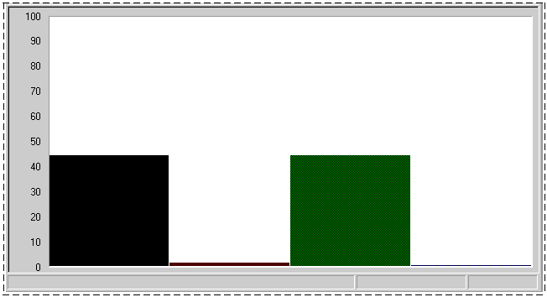
Figure 7.7 Processor Time for Multiple Active Processes
In this example, two processes are consuming the processor while sharing it nearly equally. Although each process is using only 45 percent of the processor, the result is the same as a single process using 90 percent of processor time.
Figure 7.8 shows System\Processor Queue Length during this bottleneck.
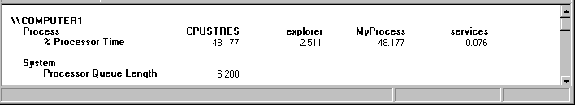
Figure 7.8 Processor Queue Length During Activity of Many Processes
In Figure 7.8, Processor\% Processor Time for all processes is close to 100 percent during the sample interval. System\Processor Queue Length reveals a long queue, averaging over six threads.
Figure 7.9 shows Task Manager during the same bottleneck. It shows that two CPU Stress processes are each using about half of the time of the single processor on the computer. (Task Manager shows current values, so you need to watch the display to see changes in processor use for each process.)
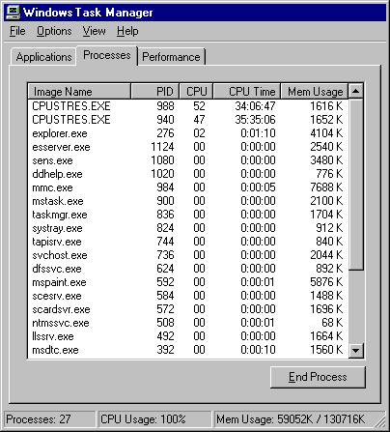
Figure 7.9 CPU Usage for Multiple Processes in Task Manager
At this point, you can choose to add a processor or upgrade the one you have, or you can investigate the activity further by researching thread behavior. Although a faster processor might help this situation somewhat, multiple-process bottlenecks are best resolved by adding another processor. Multithreaded processes, including multithreaded Windows 2000 services, benefit the most from additional processors because their threads can run simultaneously on multiple processors. You might want to partition the processes among the processors for optimal efficiency. For more information, see “Measuring Multiprocessor System Activity” in this book.
To find out more about how a particular process uses the processor, examine the Process\% User Time and Process\% Privileged Time counters, followed by Thread object counters, as described in the following section.
For more information about determining if your application is multithreaded, see “Threads in a Bottleneck” later in this chapter. You might also want to find out whether all threads in a multithreaded process are active during bottlenecks. The benefit of adding processors depends on whether you have a lot of active threads. You could find, as a result of monitoring, that threads in a process are inactive most of the time, so adding a processor to handle these inactive threads is a waste of money and capacity.
For more information about the benefits of adding processors to manage a larger workload (called scaling) and how to determine whether scaling is appropriate, see “Measuring Multiprocessor System Activity” in this book.
Threads in a Bottleneck
Investigate the individual thread or threads of the process or processes running during a bottleneck to understand more about the activity consuming the processor. Monitor the following factors to understand how thread activity is contributing to the problem, whether the cause is a single process or multiple processes:
• The number of threads in each process that is running during a bottleneck
• The amount of processor time a thread is consuming
• The priority level at which threads are scheduled to run
• The amount of time the threads are using the processor in privileged mode

You can use performance counters to analyze thread activity and adjust thread scheduling to allow more processor time for bottlenecked processes.
Apart from adjusting the thread’s scheduling priority, you cannot alter thread behavior without changing the program code of the associated application. However, if you have access to application source code, you can write counters to monitor thread activity at a lower level. For more information, see the Platform Software Development Kit (SDK) link on the Web Resources page at http://windows.microsoft.com/windows2000/reskit/webresources.
Single vs. Multiple Threads in a Bottleneck
Bottlenecks can result from activity of multiple threads in a single process, single threads in multiple processes, or multiple threads in multiple processes. Because these problems require different solutions, you need to first distinguish their causes.
To study threads during a bottleneck, log counters of the Processor, Process, and Thread objects for several days at an update interval of 60 seconds. This will allow you to look at thread activity during typical operating conditions and help you associate that activity with processor usage.
Important Performance counter values for threads are subject to error when threads are stopping and starting. Faulty values sometimes appear as large spikes in the data. For more information, see “Overview of Performance Monitoring” in this book.
To determine whether a process is single-threaded or multithreaded
1. Right-click the Windows task bar and select Task Manager.
2. In Task Manager, click the Processes tab and, on the View menu, click Select Columns.
3. In the Select Columns dialog box, select the Thread Count check box, and then click OK.
This column shows the total number of threads associated with the process.

Figure 7.10 illustrates how Task Manager displays the number of threads running in a process, and the name of the process.
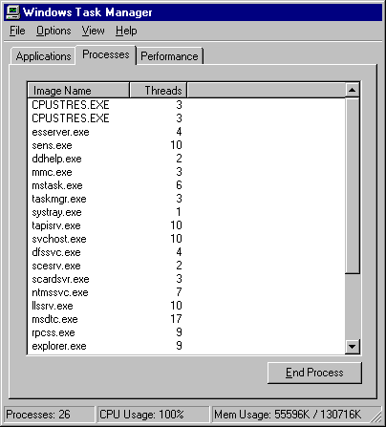
Figure 7.10 Number of Threads Initiated by a Process Shown in Task Manager
In System Monitor or Counter Logs, select the Thread object and look at all instances listed in the Instance box. If there are several thread identifiers (IDs) listed, then the process is multithreaded. Figure 7.11 illustrates multiple threads of a process as they are listed in the Instances box in the System Monitor user interface.
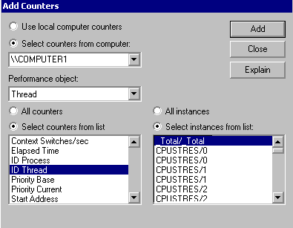
Figure 7.11 Thread Instances Shown When Adding Counters in System Monitor
System Monitor identifies threads by process name and thread number. The order in which the threads appear on the chart depends on the order in which you add them to your chart. The thread number shown in the Instance box represents the order in which the threads started, and it can change even as the process runs.
Thread identifiers are valid only during the lifetime of the thread; they are recycled when the thread terminates. Thread numbers can change while running, so it is best to monitor by thread identifier. The Tlist utility provides thread identifier information. For information about Tlist, see Windows 2000 Support Tools Help. For information about installing and using the Windows 2000 Support Tools and Support Tools Help, see the file Sreadme.doc in the \Support\Tools folder of the Windows 2000 operating system CD.
If a process is multithreaded, adding a processor will help improve performance. If it is single-threaded, you can improve performance by using a faster processor. These solutions are more advanced and more relevant to developers who also might want to tune the problem applications.
Charting Processor Usage Per Thread
Observing processor time by threads in a process provides additional information about the activity of the processor during a bottleneck. System Monitor provides the Thread\%Processor Time counter for monitoring processor usage for each thread in a running process. If you have determined that a process is single-threaded, you do not need to track the processor time for the process’s thread because this will be nearly identical (except for small variations due to sampling) to the processor time you recorded when tracking the process itself.
Figure 7.12 shows Thread\% Processor Time for all initialized threads during a bottleneck. Each bar of the histogram represents the processor time of a single thread.
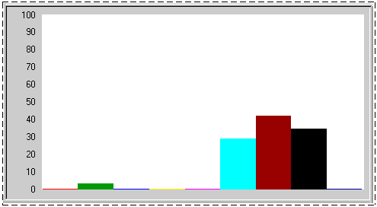
Figure 7.12 View of Threads and Processor Usage
Figure 7.12 shows that the three threads of the CPU Stress process are dominating the pattern of processor use, although a few other threads are getting some processor time.
If your thread activity appears similar to the preceding figure and a long queue is developing, some applications on your system are probably not getting enough processor time to run as efficiently as you would like. To investigate the threads of the process and how they use the processor, monitor context switching and user-mode vs. kernel-mode CPU usage, as described in the following sections.
Context Switches
The Thread\Context Switches/sec counter in System Monitor provides another perspective on how the operating system schedules threads to run on the processor. A context switch occurs when the kernel switches the processor from one thread to another. A context switch might also occur when a thread with a higher priority than the running thread becomes ready or when a running thread must wait for some reason (such as an I/O operation). The Thread\Context Switches/sec counter value increases when the thread gets or loses the time of the processor.
In the course of a context switch, at least two threads are changing their thread state. However, one of the threads may be the idle thread of a given processor. A careful examination of context switch data reveals the patterns of processor use for a thread and indicates how efficiently a thread shares the processor with other threads of the process or other processes.
The System\Context Switches/sec counter that reports systemwide context switches should be close to if not identical to the value provided by the _Total instance of the Thread\Context Switches/sec counter. Monitoring over time should help you determine the range by which the two counters’ value might vary.
Interpret the data cautiously. A thread that is heavily usingthe processor lowers the rate of context switches because it does not allow much processor time for other processes’ threads. A high rate of context switching means that the processor is being shared repeatedly—for example, by many threads of equal priority. It is a good practice to minimize the context switching rate by reducing the number of active threads on the system. The use of thread pooling, I/O completion ports, and asynchronous I/O can reduce the number of active threads. Consult your in-house developers or application vendors to determine if the applications you are running provide tuning features that include limiting the number of threads.
A context switching rate of 300 per second per processor is a moderate amount; a rate of 1000 per second or more is high. Values at this high level may be a problem.
You can determine whether context switching is excessive by comparing it with the value of Processor\% Privileged Time. If this counter is at 40 percent or more and the context-switching rate is high, then you can investigate the cause for high rates of context switches.
User Mode and Privileged Mode
You can determine the percentage of time that threads of a process are running in user and privileged mode. User mode is the processing mode in which applications run. Privileged or kernel mode is the processing mode that allows code to have direct access to all hardware and memory in the system. Developers might want to know how much time a process is spending in each mode and what function is using the processor in this way.
I/O operations and other system services run in privileged (kernel) mode; user applications run in user mode. Unless they are graphics-intensive or I/O-intensive (such as file and print services), most applications should not be processing much work in kernel mode.
System Monitor has % Privileged Time and % User Time counters on the System, Processor, Process, and Thread objects. These counters are described in “Processor Counters” earlier in this chapter. System Calls/sec is also a useful indicator of privileged time usage because application calls to the operating system are handled in privileged mode.
In the user time and privileged time counters, System Monitor displays the proportion of total processor time that the process is spending in user or privileged mode.
Figure 7.13 is a System Monitor report on the proportion of user and privileged time for three processes.
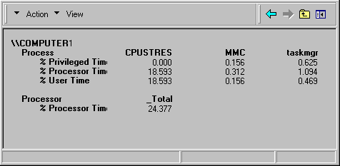
Figure 7.13 User and Privileged Time for Processes
In Figure 7.13, Microsoft Management Console (MMC), the process in which System Monitor is running, is running mainly (80 percent) in privileged mode. Taskmgr, the Task Manager process, is also running mainly in privileged mode (70 percent), though this proportion varies significantly as the process runs. In contrast, CpuStres, the process for the CPU Stress test program, runs entirely in user mode all of the time.
Figure 7.14 shows the proportion of user and privileged time for each thread of the Task Manager process.
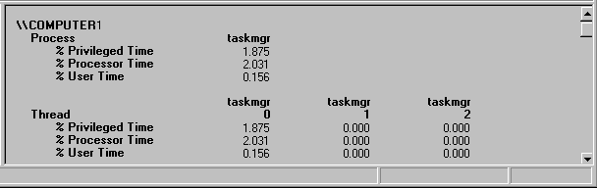
Figure 7.14 User and Privileged Time for a Process and Its Threads
The Process Viewer (Pviewer.exe) utility displays the proportion of user and privileged time for each running process and, separately, for each thread in the process. In Process Viewer, the user and privileged mode percentages for each process always total 100 percent because idle time is included. However, in System Monitor the percentages for each process reflect the amount of nonidle processor time actually used in each mode and instead total the amount of nonidle time. Therefore, the value for each process might not total 100 percent. To see the process times add up to 100 percent, combine the percentages for all processes including the Idle process.
For information about Pviewer, see Windows 2000 Support Tools Help. For information about installing and using the Windows 2000 Support Tools and Support Tools Help, see the file Sreadme.doc in the \Support\Tools folder of the Windows 2000 operating system CD.
Advanced Topic: Changing Thread Priority to Improve Performance
After observing the threads that use the greatest amount of processor time, monitor the dispatch states of the threads. This will tell you which threads are running and which threads are ready. Most important, monitoring thread states on your system can help you identify which threads are piling up in the queue and which threads are actively running at various times.
The Thread\Thread State counter provided by System Monitor reports the current execution state (also known as dispatch state) of a thread. System Monitor reports thread state as a numeric value from 0 through 7, corresponding to whether the thread is ready, running, terminated, and so on.
Table 7.3 lists the thread states you will typically see.
Table 7.3 Typical Thread States

Thread state Description

0 Initialized.
1 Ready. The thread is prepared to run on the next available processor.
2 Running.
3 Standby. The thread is about to use the processor.
4 Terminated.
5 Waiting. The thread is not ready to run, typically because another operation (for example, involving I/O) must finish before the thread can run.
6 Transition. The thread is not ready to run because it is waiting for a resource (such as code being paged in from disk).
7 Unknown. The thread is in an unknown state.
To determine which threads are contending for the processor, track the states of all threads in the system using System Monitor. Figure 7.15 shows a histogram. The vertical maximum for the chart is set to 10 to make it easier to see the values; an alternative for easier viewing is to display the thread-state values in a report view.
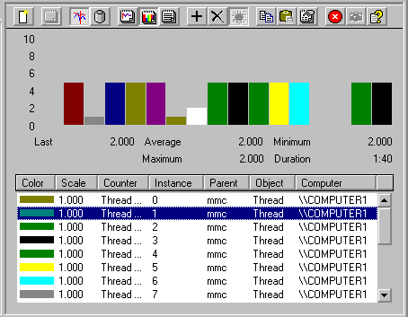
Figure 7.15 Display of Thread States
Notice that the preceding figure plots a thread of the MMC process with the steady value of 2 for running. This is the thread of the System Monitor snap-in that is collecting the data that you are monitoring. As long as System Monitor is running, one of its threads will be shown to be running. Other threads’ state values alternate between 1 for ready and 5 for waiting.
Plotting thread-state data in a chart rather than a histogram might make it easier to view the switching of thread states. Note in Figure 7.16 how a process’s thread moves from the waiting state (plotted on the chart at 5) to the ready state (plotted on the chart at 1).
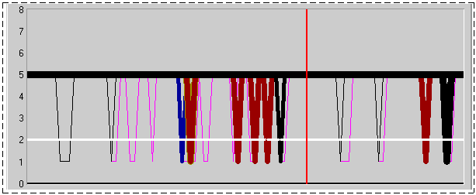
Figure 7.16 Changing Thread States
To find out how long threads remain in a particular state, log Thread\Thread State and, when the log is completed, export it to Microsoft Excel. A sample log is shown in Figure 7.17.
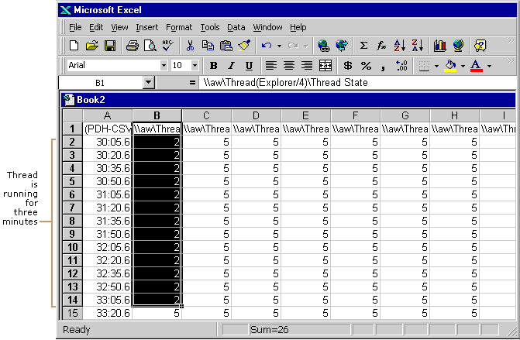
Figure 7.17 Sample Log Output Viewed in Microsoft Excel
By looking at log output, you can get an idea of the length of time that a thread remains in a state by totaling the number of seconds that elapsed until the thread’s state changed. However, it is important to note that, due to the fact that sampling omits some data, you might not see all of the state changes that occur.
In addition, the Thread\Thread Wait State counter and Perfmon4.exe on the Windows 2000 Resource Kit companion CD give you information about why a thread is in a waiting state.
The value reported for Thread Wait Reason is a code. The Counters Help file on the Windows 2000 Resource Kit companion CD provides descriptions for these codes.
Examining and Adjusting Thread Priority
Examining thread context switching and thread state gives you information about when threads in a bottleneck are being scheduled to run by the operating system and when threads are being held in the queue prior to running. Although the operating system is inherently designed to optimize the scheduling of threads, you have some control over this behavior, to adjust for situations in which scheduling behavior on your system is unsatisfactory. This section describes how you can determine a thread’s scheduling priority and how you can adjust thread priority to reduce bottlenecks and allow blocked threads to run.
Important To ensure optimum performance on production systems, Microsoft recommends that you adjust priorities of processes first in a test environment. In addition, you should make these adjustments only if you have an in-depth understanding of priority settings and their effect on other processes and the operating system.
Priority Class and Priority
Under the preemptive multitasking strategy built into Windows 2000, threads and processes are assigned a priority for scheduling purposes. A thread’s priority determines the order in which it is scheduled to run on the processor.
A thread’s priority is based on the priority class of its parent process. The four process priority classes are:
• Idle. Screen savers and other processes that periodically update the display typically use the Idle class.
• Normal. The default priority class for a process is Normal.
• High. Processes that run in the High priority class receive the majority of processor time.
• Real Time. Many kernel-mode system processes, such as those that manage mouse and keyboard input and other device operations, run in the Real Time priority class.

Each process’s priority class sets a range of priority values (between 1 and 31, where 1 is lowest and 31 is highest), and the threads of that process have a priority value that is within that range. (Priority 0 is reserved for system use.) If the priority class is Real Time (priorities 16 through 31), the thread’s priority cannot change while the thread is running. If you have at least one priority 31 thread running, other threads cannot run.
On the other hand, threads running in all other priority classes are variable, meaning that the thread’s priority can change while the thread is running. For threads in the Normal or High priority classes (priorities 1 through 15), the thread’s priority can be raised or lowered by up to a value of 2 but cannot fall below its original, program-defined base priority. When the base priority is adjusted to optimize scheduling, the resulting value is called the thread’s dynamic priority.
Table 7.4 associates each process priority class with relative thread priorities, ranked from highest priority to lowest. Notice that the highest priority class is Real Time and the lowest is Idle.
Table 7.4 Process Priority Classes With Relative Thread Priorities

Process priority classes

Thread priorities Real time High Normal Idle

Time critical 31 15 15 15
Highest 26 15 10 6
Above normal 25 14 9 5
Normal 24 13 8 4
Below normal 23 12 7 3
Lowest 22 11 6 2
Idle 16 1 1 1
Thread Scheduling
The scheduling routines of the operating system run the highest-priority ready thread uninterrupted during a quantum (also known as a time slice—the maximum amount of time a thread can run before the system checks for another ready thread of the same priority to run). If a higher-priority thread becomes ready during the quantum, the lower-priority thread is interrupted and the higher-priority thread is run. Otherwise, threads running at the same priority are scheduled in a round-robin fashion, switching among threads in order, and run until the quantum expires.
In general, Windows 2000 always runs the highest-priority ready thread. However, there are optimization strategies built into the operating system to address situations in which the default scheduling methods would cause problems. The following sections describe these strategies.
Foreground Process Scheduling
The scheduler runs a foreground process at a higher priority, which means it tends to get more time slices than background processes. In addition, the scheduler ensures that those time slices are longer than the ones allocated to background processes. As a result, the foreground process is much more responsive than other processes because it is scheduled more often, and when it is scheduled it continues running longer before being preempted. By default, Windows 2000 Professional defines short, variable quanta for applications and gives a foreground application a priority boost. On the other hand, Windows 2000 Server has longer, fixed quanta with no priority boost for foreground applications, allowing background services to run more efficiently. To see foreground process scheduling in action, monitor the processor time for a process and move its window to the bottom of the stack. Note that the time value allocated to that process falls immediately. Then move the process to the top of the stack and note that the processor time value rises immediately. See Figure 7.18 for an illustration.
Automatic Priority Boost
The operating system automatically boosts the thread’s priority enough for the low-priority thread to complete its operation and release the resource. After raising a thread’s dynamic priority, the scheduler reduces that priority by one level each time the thread completes a time slice (quantum), until the thread drops back to its base priority.
For information about how you can change thread priority, see “Determining and Tuning Priority” later in this chapter.
Determining and Tuning Priority
If a system has high rate of CPU utilization, it is generally best to add processing power by upgrading to a faster processor or to add a processor for symmetric multiprocessing (SMP). However, if you find that some threads are consistently unable to get processor time, you can adjust the thread’s priority to allow them to run temporarily. Adjusting thread priority is not recommended as a long-term solution but is a useful illustration of the effect of thread priority on thread activity. Although this section covers elevating priority to allow a process to run, you can also lower the priority of a process if you want it to run in the background while nothing else is running.
Windows 2000 and the Windows 2000 Resource Kit companion CD include several utilities for monitoring the base priority of processes and threads and the dynamic priority of threads. They include:
• In Windows 2000: System Monitor and Task Manager.
• With Support Tools on the Windows 2000 operating system CD: Pviewer.
Warning Changing priorities might destabilize the system. Increasing the priority of a process might prevent other processes, including system services, from running. Decreasing the priority of a process might prevent it from running, not merely force it to run less frequently. In addition, lowering priority does not necessarily reduce the amount of processor time a thread receives; this happens only if it is no longer the highest-priority thread.

System Monitor
System Monitor lets you watch and record—but not change—the base and dynamic priorities of threads and processes. System Monitor has priority counters on the Process and Thread objects:
• Process\Priority Base
• Thread\Priority Base
• Thread\Priority Current

Figure 7.18 is a chart of the base priorities of several processes. The Idle process (the white line at the bottom of the chart) runs at a priority of Idle (0), so it never interrupts another process.
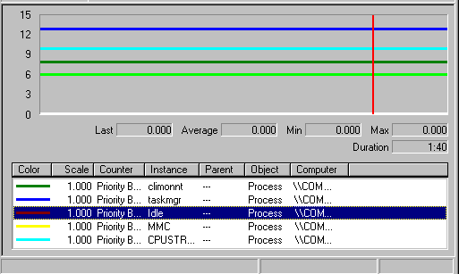
Figure 7.18 Processes and Their Base Priorities
Figure 7.19 is a chart of the dynamic priority of the single thread in the Paintbrush utility (Mspaint.exe) as it changes in response to user actions. The base priority of the thread is 8 (Foreground Normal). During this period of foreground use, the dynamic priority of the thread is 14, but drops to 8 when other processes need to run.
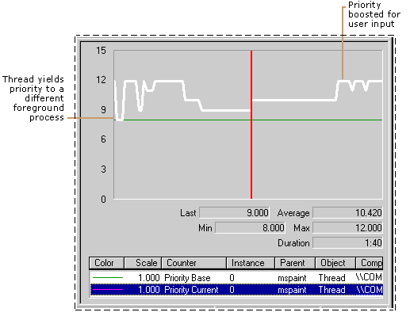
Figure 7.19 Processes Showing Base and Current Priorities
Task Manager
Task Manager presents and lets you change the base priority of a process, but it does not monitor threads. Base priorities changed with Task Manager are effective only as long as the process runs. For more information, see Task Manager online Help or see “Overview of Performance Monitoring” in this book.
Important In order to make this change, your user account must have permission to increase scheduling priority. By default, only user accounts in the Domain Admins or Administrator groups in Windows 2000 Server or Power User groups in Windows 2000 Professional have this permission.
To change the base priority of a process
1. In Task Manager, click the Processes tab.
2. Right-click a process name. Its menu appears.
3. Click Set Priority, and then click a new base priority.
Caution Problems can arise if multiple processes are running at the High priority class level. Avoid setting more than one process to run at this level.

The change in priority is effective at the next Task Manager update; you need not restart the process.
Process Viewer
Process Viewer (Pviewer.exe), one of the Support Tools on the Windows 2000 operating system CD, lets you monitor process and thread priority and change the base priority class of a process. For information about installing and using the Windows 2000 Support Tools and Support Tools Help, see the file Sreadme.doc in the \Support\Tools folder of the Windows 2000 operating system CD.
Start Command
When you begin processes from a command prompt using the start command, you can specify a base priority for the processes for that run. To see all of the start options, type start /? at the command prompt.
You can change the priority class of a process to Real Time by using start /realtime at the command prompt or by using Task Manager. Note that changing the priority from /normal to /high or to /realtime can cause severe degradation of performance of other tasks. Note also that setting a processor-bound application to Real Time priority could cause the computer to stop responding.
Windows 2000 Configuration and Process Priority
Windows 2000 Professional is configured by default to assign variable, short quanta to applications and to boost applications in the foreground. In contrast, Windows 2000 Server is configured to assign long, fixed quanta without any foreground boost to support the efficiency of background services. You can simulate the behavior of one type of operating system when the other type of system is installed—that is, simulate Windows 2000 Server behavior on a Windows 2000 Professional installation, or vice versa. Figure 7.20 shows the interface that you use for changing application response on an installation of Windows 2000 Server.
To access the Performance Options dialog box
1. In Control Panel, double-click System.
2. Click the Advanced tab, and then click Performance Options.

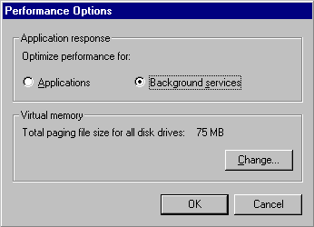
Figure 7.20 Performance Options Dialog Box in System Properties
It is easiest to see a change in thread priority as a result of resetting Performance Options if you shut down and then restart the computer. Changes in quantum type and length are so minute they are often undetectable to the user.
Testing Priority Changes
The previous sections described changing thread priority so that, under bottleneck conditions, threads can run more efficiently. Unfortunately, when processor capacity is already stretched to its limit, boosting priorities of blocked threads might not eliminate or reduce processor bottlenecks. In this case, it is best to add processor capacity.
Figure 7.21 shows threads of different priorities contending for processor time. It demonstrates the changing distribution of processor time among processes of different priorities as demand for processor time increases. (This test was conducted using the utility CPU Stress.)
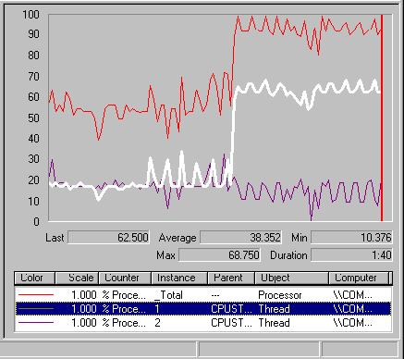
Figure 7.21 CPU Time Allocation to Threads Based on Priorities
This chart shows two threads of the same process running on a single-processor computer. Notice the values for processor time for the _Total instance and for threads 1 and 2.
Figure 7.22 shows two threads of the same process running on a single-processor computer. Figures 7.23, 7.24, and 7.25 provide more detail about how processor usage by threads of CPUStres changed in relation to each thread’s priority.
In Figure 7.22, the two threads running CPUStres start out at the same low level of activity and run at the same priority—Normal.
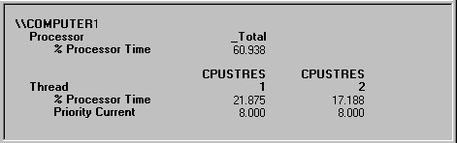
Figure 7.22 Comparison of Threads at Normal Priority
Then, if you increase the priority of Thread 1 to Above Normal, and increase its activity level to moderate, you should notice a slight drop in CPU time for Thread 2, as shown in Figure 7.23.
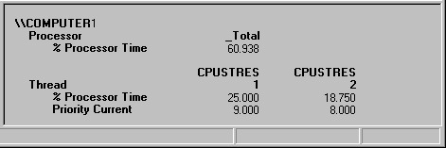
Figure 7.23 Comparison of Threads at Normal and Above Normal Priority
Resetting priority for both threads to Normal while running at a higher rate of activity causes each process to consume a large share of processor time, as shown in Figure 7.24. Total processor usage is consistently and extremely high.
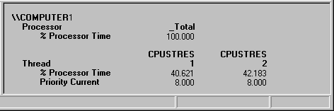
Figure 7.24 Comparison of Normal-Priority Threads Under Slightly Different Loads
Finally, raising the priority level of Thread 1 to Above Normal while maintaining its heightened level of activity results in a much greater allocation of processor time to the higher-priority thread and a dramatic drop in processor time for Thread 2, as shown in Figure 7.25.
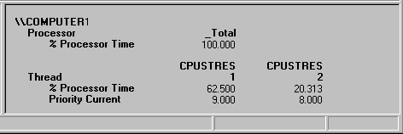
Figure 7.25 Normal Threads Under Substantially Different Loads
These results demonstrate that when the processor has extra capacity, increasing the priority of one thread has little effect on the processor time allotted to each of the competing threads. However, when the processor is at its busiest, increasing the priority of one of the threads, even by one priority level, causes the higher-priority thread to get the vast majority of processor time.
In fact, when all processor time is consumed, Thread 2 might not have been scheduled at all were it not for priority boosts. Windows 2000 uses priority boosts to give processor time to lower-priority ready threads that would not otherwise be able to run. This is especially useful when a thread in low priority is waiting for an I/O operation.
Eliminating a Processor Bottleneck
If you determine that you do have a processor bottleneck, some of the following steps can shorten the processor queue and reduce the burden on your processor. Monitor processor usage and processor queue length after every change to determine the impact on resource usage and overall system operation.
• Upgrade to a faster processor. A faster processor improves response time and throughput for any type of workload.
Make sure to use a processor with the largest processor cache that is practical. The size of the processor cache is important for your system’s performance. You can typically choose from 512 KB to 2 MB for the L2 cache. (The primary cache is determined by what type of processor is installed.)
• Add another processor. If the process you are running has multiple, active threads that are processor-intensive, then it is a prime candidate for a multiprocessor system. It is important that most of the threads be active while the process is running; otherwise, the additional processing power might be wasted. To be certain the process will benefit from an additional processor, verify that most threads are active (that is, consuming a moderate to high amount of processor time). You can see this by monitoring thread state.
For more information on upgrading to multiple processors, see “Measuring Multiprocessor System Activity” in this book.
• Analyze the application and optimize it if necessary by using the performance utilities in the Platform SDK.
• Upgrade your network or disk adapters. In general, 32-bit, intelligent adapters are recommended. Intelligent adapters provide better overall system performance because they allow interrupts to be processed on the adapter itself, relieving the processor of this work.
Try to obtain adapters that have optimization features such as interrupt moderation and features for networking, such as card-based TCP/IP checksum support.

Additional Resources
• For more information about how Windows 2000 manages processes and threads, including a discussion of its scheduling strategies, see Inside Windows NT, Second Edition, available from Microsoft Press.

