Chapter 8 - Examining and Tuning Disk Performance

The disk system handles the storage and movement of programs and data on your system, giving it a powerful influence on your system’s overall responsiveness. The Performance console provides disk-specific counters that enable you to measure disk activity and throughput, and instructs you on strategies to improve disk performance. In addition, it also covers tools found on the Microsoft® Windows® 2000 Resource Kit companion CD that can assist you in determining which programs are putting the greatest demand on your disk system.
In This Chapter
Disk Monitoring Concepts
Configuring the Disk and File System for Performance
Working with Disk Counters
Establishing a Baseline for Disk Usage
Investigating Disk Performance Problems
Resolving Disk Bottlenecks
Evaluating Cache and Disk Usage by Applications
Related Information in the Resource Kit
• For more information about disks and file systems, see “Disk Concepts and Troubleshooting” and “File Systems” in this book.
• For more information about system monitoring, see “Overview of Performance Monitoring” in this book.
• For more information about evaluating memory usage, see “Evaluating Memory and Cache Usage” in this book.

Disk Monitoring Concepts
You need to observe many factors in determining the performance of a disk system. These include the level of utilization, the rate of throughput, the amount of disk space available, and whether a queue is developing for their disk systems. It is also important to monitor other types of activity that arise from disk operations, such as interrupts generated by the disk system and paging activity, because of their influence on other resources, such as processor or memory.
Figure 8.1 illustrates the importance of monitoring disk systems in relation to the overall performance of your system.
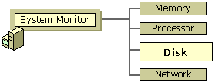
Figure 8.1 Role of Disk Monitoring in System Monitoring
Many of these factors are interrelated. For example, if utilization is high, transfer rates (throughput) might peak, and a queue might begin to form. These conditions might result in increased response time and cause performance to slow. Although disk space doesn’t directly affect the disk’s transfer rate, when extremely low, disk space can also have an influence on response time because applications that read and write data can’t do so as efficiently. Detect these performance issues through monitoring before they cause problems.
This chapter covers the following stages of a disk-monitoring strategy:
• Configuring the disk and file system for best performance
• Working with disk counters to monitor your disk space and disk efficiency
• Establishing a baseline for disk performance
• Investigating performance problems

Configuring the Disk and File System for Performance
The type of file system you are using affects your disk performance. The way in which the disk aligns tracks and sectors during format also affects performance. You should configure the file system and the disk’s track and sector alignment for optimal performance.
Configuring Your File System
In general, the NTFS file system is the recommended file system for its advantages in terms of reliability and security, and it is required for large drive sizes. However, these advantages come with some overhead. You can disable some functionality to improve NTFS performance as follows:
• Disable creation of short names. By default, NTFS generates the style of file name that consists of eight characters, followed by a period and a three-character extension for compatibility with MS-DOS and Microsoft Windows 3.x clients. If you are not supporting these types of clients, you can turn off this setting by changing the default value of the \NtfsDisable8dot3NameCreation registry entry (in HKEY_LOCAL_MACHINE\SYSTEM\CurrentControlSet\Control\Filesystem) to 1.
• Disable last access update. By default NTFS updates the date and time stamp of the last access on directories whenever it traverses the directory. For a large NTFS volume, this update process can slow performance. To disable automatic updating, change the value of the NtfsDisableLastAccessUpdate registry entry (in HKEY_LOCAL_MACHINE\SYSTEM\CurrentContolSet\Control\Filesystem)\ to 1.
• Reserve appropriate space for the master file table. Add the NtfsMftZoneReservation entry to the registry as a REG_DWORD in HKEY_LOCAL_MACHINE\SYSTEM\CurrentControlSet\Control\FileSystem. When you add this entry to the registry, the system reserves space on the volume for the master file table. Reserving space in this manner allows the master file table to grow optimally. If your NTFS volumes generally contain relatively few files that are typically large, set value of this registry entry to 1 (the default). Typically you can use a value of 2 or 3 for moderate numbers of files, and 4 (the maximum) if your volumes tend to contain a relatively large number of files. However, make sure to test any settings greater than 2 because these higher values cause the system to reserve a much larger portion of the disk for the master file table.
Caution Do not use a registry editor to edit the registry directly unless you have no alternative. The registry editors bypass the standard safeguards provided by administrative tools. These safeguards prevent you from entering conflicting settings or settings that are likely to degrade performance or damage your system. Editing the registry directly can have serious, unexpected consequences that can prevent the system from starting and require that you reinstall Windows 2000. To configure or customize Windows 2000, use the programs in Control Panel or Microsoft Management Console (MMC) whenever possible.

For information about changing the registry, see Windows 2000 online Help.
Bypassing I/O Counts
By default, Task Manager continuously measures data for process I/O operations that you can select and display under the Processes tab in Task Manager. In a multiprocessor environment, this data is shared by the processors on which the process runs. When a process that generates considerable disk and network I/O, such as a database service, runs on several processors, updating the shared measurements of process I/O and global I/O operations can slow the system. You can improve the performance of I/O-intensive operations on SMP systems if you configure the system to bypass the global I/O counters and Task Manager process I/O counters. To do so, add the CountOperations entry to the registry as a REG_DWORD in HKEY_LOCAL_MACHINE\SYSTEM\CurrentControlSet
\Control\Session Manager\I/O System\. Set the entry value to 0. When so configured, Task Manager no longer provides per-process I/O measurements. For more information about Task Manager, see “Overview of Performance Monitoring” earlier in this book.
Configuring Disk Alignment
Windows 2000 has an internal structure called the master boot record (MBR) that limits the maximum number of hidden sectors to 63. (For more information about the master boot record, see “Disk Concepts and Troubleshooting” in this book.) This characteristic of the MBR causes the default starting sector for disks that report more than 63 sectors per track to be the 64th sector. As a result, when programs transfer data to or from disks that have more than 63 sectors per track, misalignment can occur at the track level, with allocations beginning at a sector other than the starting sector. This misalignment can defeat system optimizations of I/O operations designed to avoid crossing track boundaries.
Additional disk-design factors make proper alignment even more difficult to achieve. For example, track information reported by disks is not always accurate. In addition, many disks have different numbers of sectors on different tracks (as might be the case with the outer bands versus the inner bands). Diskpar.exe, a sample program on the Windows 2000 Resource Kit companion CD, shows how you can use Windows 2000 APIs to obtain and set partition information. By applying the same functions used in this tool, you can avoid performance loss due to disk misalignment on disks with large track sizes and alignment optimizations.
Working with Disk Counters
Windows 2000 includes counters that monitor the activity of physical disks (including removable media drives) and logical volumes. The PhysicalDisk object provides counters that report physical-disk activity; the LogicalDisk object provides counters that report statistics for logical disks and storage volumes. These counters measure disk throughput, queue length, usage, and other data. The interrelationships between different aspects of disk performance make it useful to monitor them simultaneously. The operating system enables a driver called Diskperf.sys to activate the disk monitoring counters. By default, the operating system activates only the PhysicalDisk performance counters. Users must activate the LogicalDisk counters manually using the diskperf command. See the following procedure for activating disk counters with the diskperf command.
To use the diskperf command to enable LogicalDisk object counters
• At the command prompt, type diskperf – yv

The diskperf command takes the following syntax:
diskperf [ – y[d|v] | – n[d|v]] [\\computer_name]
Use – y to enable counters and –n to disable counters. To specify the type of counters, include d for physical disk drives or v for logical disk drives or storage volumes. When the operating system starts up, it automatically sets the diskperf command with the – yd switch to activate physical disk counters. For more information about using the diskperf command, type diskperf – ? at the command prompt.
The PhysicalDisk object counters provide data on activity for each of the physical disks in your system; the LogicalDisk object counters provide data on logical volumes in your system. The System Monitor user interface identifies physical disks by number starting with 0. If you are monitoring logical disks, it identifies these by drive letter. For logical disks consisting of multiple physical disks, the disk instances might appear as 0 C and disk 1 C, where logical drive C: consists of physical drives 0 and 1.
When monitoring logical volumes, remember that they might share a physical disk and your data might reflect contention between them. If you have a spanned, striped, or mirrored volume with disk controllers that support hardware-enabled redundant array of independent disks (RAID) volumes, the counters report physical disk data for all disks in the stripe or mirror as if they are a single disk. For disks with controllers that use software-enabled RAID, the counters report disk data for each physical disk.
Use the counters described in Table 8.1 to measure disk space, disk throughput, and disk utilization.
Table 8.1 Performance Objects and Counters for Disk Monitoring

Counter Description

LogicalDisk\% Free Space Reports the percentage of unallocated disk space to the total usable space on the logical volume. When calculating the _Total instance, the %Free Space counters recalculate the sum as a percentage for each disk.There is no % Free Space counter for the PhysicalDisk object.
LogicalDisk|PhysicalDisk
\Avg. Disk Bytes/Transfer Measures the size of input/output (I/O) operations. The disk is efficient if it transfers large amounts of data relatively quickly.Watch this counter when measuring maximum throughput.To analyze transfer data further, use Avg. Disk Bytes/Read and Avg. Disk Bytes/Write.
LogicalDisk|PhysicalDisk
\Avg. Disk sec/Transfer Indicates how fast data is being moved (in seconds). Measures the average time of each data transfer, regardless of the number of bytes read or written. Shows the total time of the read or write, from the moment it leaves the Diskperf.sys driver to the moment it is complete.A high value for this counter might mean that the system is retrying requests due to lengthy queuing or, less commonly, disk failures.To analyze transfer data further, use Avg. Disk sec/Read and Avg. Disk sec/Write.
LogicalDisk|PhysicalDisk
\Avg. Disk Queue Length Tracks the number of requests that are queued and waiting for a disk during the sample interval, as well as requests in service. As a result, this might overstate activity. If more than two requests are continuously waiting on a single-disk system, the disk might be a bottleneck. To analyze queue length data further, use Avg. Disk Read Queue Length and Avg. Disk Write Queue Length.
LogicalDisk|PhysicalDisk
\Current Disk Queue Length Indicates the number of disk requests that are currently waiting as well as requests currently being serviced. Subject to wide variations unless the workload has achieved a steady state and you have collected a sufficient number of samples to establish a pattern.An instantaneous value or snapshot of the current queue length, unlike Avg. Disk Queue Length, Avg. Disk Read Queue Length, and Avg. Disk Write Queue Length, that reports averages.
LogicalDisk|PhysicalDisk
\Disk Bytes/sec Indicates the rate at which bytes are transferred and is the primary measure of disk throughput.To analyze transfer data based on reads and writes, use Disk Read Bytes/sec and Disk Write Bytes/sec, respectively.
LogicalDisk|PhysicalDisk
\Disk Transfers/sec Indicates the number of read and writes completed per second, regardless of how much data they involve. Measures disk utilization.If value exceeds 50 (per physical disk in the case of a stripe set), then a bottleneck might be developing.To analyze transfer data based on reads and writes, use Disk Read/sec and Disk Writes/sec, respectively.
LogicalDisk \Free Megabytes Reports the amount of bytes on the disk that are not allocated. There is no Free Megabytes counter for the PhysicalDisk object.
LogicalDisk|PhysicalDisk
\Split IO/sec Reports the rate at which the operating system divides I/O requests to the disk into multiple requests. A split I/O request might occur if the program requests data in a size that is too large to fit into a single request or if the disk is fragmented. Factors that influence the size of an I/O request can include application design, the file system, or drivers. A high rate of split I/O might not, in itself, represent a problem. However, on single-disk systems, a high rate for this counter tends to indicate disk fragmentation.
LogicalDisk|PhysicalDisk
\% Disk Time Reports the percentage of time that the selected disk drive is busy servicing read or write requests. Because this counter’s data can span more than one sample, and consequently overstate disk utilization, compare this value against % Idle Time for a more accurate picture.By default this counter cannot exceed 100 percent; however, you can reset the registry to allow System Monitor to display percentages exceeding 100 percent if appropriate. For information about this adjustment and other aspects of performance data collection and reporting, see “Performance Objects” in “Overview of Performance Monitoring” in this book.
LogicalDisk|PhysicalDisk
\% Disk Write Time Reports the percentage of time that the selected disk drive is busy servicing write requests.
LogicalDisk|PhysicalDisk
\% Disk Read Time Reports the percentage of time that the selected disk drive is busy servicing read requests.
LogicalDisk|PhysicalDisk
\% Idle Time Reports the percentage of time that the disk system was not processing requests and no work was queued. Notice that this counter, when added to % Disk Time, might not equal 100 percent, because % Disk Time can exaggerate disk utilization.
When working with the disk-time or disk-queue length counters, be aware of the following limitations that might yield unlikely counter values.
• The % Disk Read Time and % Disk Write Time counters can exaggerate disk time. This is because they report busy time based on the duration of the I/O request, which includes time spent in activities other than reading to or writing from the disk. It then sums up all busy time for all requests and divides it by the elapsed time of the sample interval. If multiple requests are in process at a time, the total request time is greater than the time of the sample interval; as a result, reported disk utilization can exceed actual utilization.
• Counter values that report sums can be misleading for multidisk systems. When you look at the _Total instance for the % Disk Time or disk-queue counters on a multidisk system, the counters report values totaled for all disks and do not divide these totals over the number of disks in use. Therefore, in a system with one idle disk and one disk that is 100 percent busy, it can appear as if all disks are 100 percent busy.

The following sections describe how you can use disk-monitoring counters to observe available space on the disk and to observe the efficiency of disk operations as you become acquainted with your system’s disk performance.
Monitoring Disk Space
It is important to monitor the amount of available storage space on your disk because programs might fail due to an inability to allocate space. In addition, low disk space might make it impossible for your paging file to grow to support virtual memory. Fragmentation also has this effect. For information about setting the paging file size for optimal performance, see “Evaluating Memory and Cache Usage” in this book.
Use the % Free Space and Free Megabytes counters to monitor disk space. If the available space is becoming low, you might want to run Disk Cleanup in the Disk Properties dialog box, compress the disk, or move some files to other disks. Notice that disk compression incurs some performance loss.
Another option is Remote Storage, which enables you to create virtual disk storage out of tape or optical drives. When you use this service, infrequently accessed files are moved to tape or to other media storage. Remote Storage volumes are well suited for data that you need to access only at certain intervals, such as quarterly reports. For more information about remote storage options, see “Data Storage and Management” in this book.
If you are using NTFS and you want to restrict the amount of space allocated by individual users, use the Quota tab in Disk Properties. Notice that using quotas results in a small performance loss. If you are not using NTFS, you can set an alert on the % Free Space counter to track dwindling disk space.
Note Free space on a Distributed file system (Dfs) share can change as you move from one directory to another within a Dfs share namespace. Thus, when accessing network shares, do not assume that the amount of free space you see at the root is available throughout the entire tree.
Even if you are not currently short on disk space, you need to be aware of the storage requirements for applications you are running. Complete the following procedure to determine whether your disk has adequate space for your needs.
To evaluate the adequacy of your system’s disk capacity
1. For best results, start with 1 GB (although the minimum disk size required to install the operating system might be lower).
2. Add the total size of all applications.
3. Add the size of the paging file (this depends on the amount of memory; this size should be at least twice that of system memory).
4. Add the amount of disk space budgeted per user (if a multiuser system), multiplied by the number of users.
5. Multiply by 130 percent to allow room for expansion (this percentage can vary based on your expected growth).

The result is the size of disk you need.
Note Although not exactly a disk-storage issue, disk fragmentation slows the transfer rate and seek times of your disk system and you should monitor for increasing disk fragmentation. On single-disk systems, you can use the Split IO/sec counter to determine the degree of fragmentation of your disks. Defragment the disk if this counter rate is consistently high and run Disk Defragmenter periodically to keep stored data organized for best performance.
Figure 8.2 shows a graph of disk counters including % Free Space. Notice that the % Free Space counter begins to rise approximately half way through the graph. This illustration shows changes that result from deleting files on the disk.
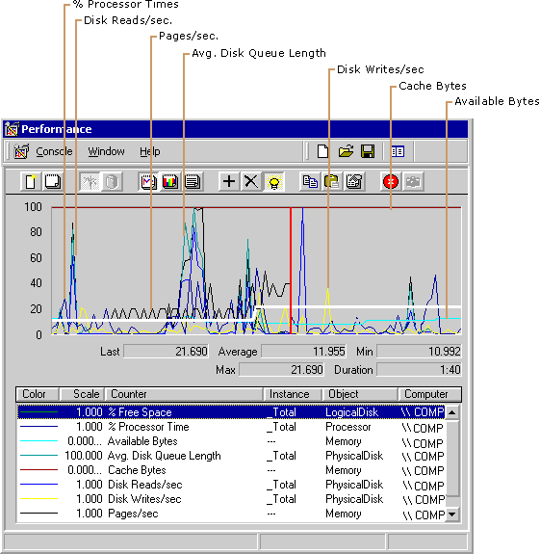
Figure 8.2 Increase in % Free Space Counter
Monitoring Disk Efficiency
Along with disk capacity, you should consider disk throughput when evaluating your starting configuration. Use the bus, controller, cabling, and disk technologies that produce the best throughput that is practical and affordable. Most workstations perform adequately with the most moderately priced disk components. However, if you want to obtain the best performance, you might want to evaluate the latest disk components available.
If your configuration contains different types of disks, controllers, and buses, the differences in their designs can have an influence on throughput rates. You might want to test throughput using these different disk systems to determine if some components produce less favorable results overall or for certain types of activity, and replace those components as needed. In addition, the use of certain kinds of volume-set configurations can offer performance benefits. For example, using stripe sets can provide better performance because they increase throughput by enabling multiple disks to service sequential or clustered I/O requests. System Monitor supports monitoring volume sets with the same performance objects and counters provided for individual disks. Notice that hardware-based RAID devices report all activity to a single physical disk and do not show distribution of disk operations among the individual disks in the array. For more information about using striped volumes, see Windows 2000 online Help.
Be aware of the seek time, rotational speed, access time, and the data transfer rate of your disks by consulting manufacturer documentation. Also consider the bandwidth of cabling and controllers. The slowest component determines the maximum possible throughput, so be sure to monitor each component.
To compare the performance of different disks, monitor the same counters and activity on the disks. If you find differences in performance, you might want to distribute workload to the better performing disk or replace slower performing components.
Preparing for Comparison Testing
If you want to know more about the volume and rate of activity through the disk system, monitor the reading and writing activity as described in the following sections. Before you begin to test disk efficiency, complete the following steps to ensure valid results:
• When testing disk performance, log performance data to another physical disk or computer so that it does not interfere with the disk you are testing. If you cannot do this, log to another logical volume on the drive, or measure monitoring overhead during an idle period and subtract that overhead from your data to ensure your results include only disk-specific data and not overhead from other activity.
• Monitor individual instances whenever practical. Summed values and the _Total instance can provide overstated values. For more information about interpreting counter data, see “Working with Disk Counters” earlier in this chapter.
• Remember to defragment your disk before testing. If your disk is nearly full, the remaining free space is likely to be fragmented, which adds to the seek time of I/O write operations as the disk looks for each sector of free space.
• Ensure that disks being monitored are not compressed or encrypted, to avoid having these features add overhead during monitoring. However, if you plan to use these features, testing performance with the features deployed can yield results that are more representative of your production environment.

The following are suggested tests to perform to learn about your disk system’s performance.
Testing Maximum Throughput
A maximum throughput test tells you about one of the limits of your system. To conduct a maximum throughput test, you can use one of the request-generation programs that are publicly available on the World Wide Web. Use the following counters on the PhysicalDisk and LogicalDisk objects for this test:
• Avg. Disk Read Queue Length
• Avg. Disk Bytes/Read
• Avg. Disk sec/Read
• Disk Read Bytes/sec
• Disk Reads/sec

Figure 8.3 illustrates a test of maximum throughput. Notice that the values for Disk Read Bytes/sec and Avg. Disk Read Queue Length become extremely high in this graph.
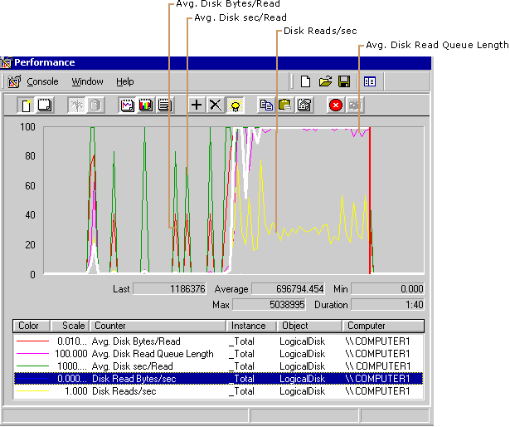
Figure 8.3 A Disk Reaching Maximum Throughput
After you determine the maximum throughput for your disk, you can adjust the load on your disk so it does not become a bottleneck.
Testing Reading vs. Writing
Some disks and disk configurations perform better when reading than when writing. You can compare the reading and writing capabilities of your disks by reading from a physical disk and then writing to the same physical disk. To measure reading from and writing to disk, log the Logical and Physical Disk objects in System Monitor, then chart the counters shown in Table 8.2.
Table 8.2 Counters for Measuring Reading and Writing

For information on Counters for reads Counters for writes

Average size of the request Avg. Disk Bytes/Read Avg. Disk Bytes/Write
Average duration of the request Avg. Disk sec/Read Avg. Disk sec/Write
Rate of transfer for the type of request Disk Read Bytes/sec Disk Write Bytes/sec
Rate at which requests are processed Disk Reads/sec Disk Writes/sec
You might see some variations in the time it takes to read from or write to disk on standard disk configurations. For example, disks with fast write caches can complete write operations very quickly if there is sufficient idle time between random writes. Also, if reads are sequential, read operations might also occur very quickly, provided the disk has had time to prefetch data. Prefetching data is the process whereby data that is expected to be requested is read ahead into the onboard cache.
On RAID 5 volumes and stripe sets, reading is faster than writing. When you read, you read only the data; when you write, you read, modify, and write the parity, as well as the data. The exception to this rule is full-stripe writes. If entire stripes are being written, there is no need to read the old data or parity.
Mirrored volumes also are usually faster at reading than writing, and are faster at writing than RAID 5 volumes. When a mirrored subsystem gets a read request, it chooses one of the two or more disk sources to service the request, in a round-robin fashion, or based on disk utilization.
When you start writing to the disk during a read operation that you are monitoring, you will notice some dips in the curves of graphed data for read activity. This is because the application doing the reads must stop briefly to allow the write operation to proceed and then, when the write is finished, the read operation resumes. You can observe this as Performance Logs and Alerts service logs data.
Figure 8.4 shows the effect of writing on the efficiency of the reads. Notice how the increase of reading activity is accompanied by a slight decrease in writing.
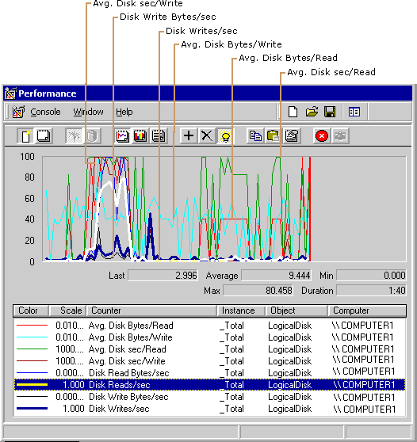
Figure 8.4 How I/O Operations are Affected by Competing Activity
Establishing a Baseline for Disk Usage
Start your disk monitoring process by establishing a baseline, which is the level of performance you can expect during typical usage and workloads. Establishing a baseline consists of collecting and analyzing data about typical disk usage under typical disk load.
Data Collection
Monitor disk counters along with counters from other objects. The following is a list of recommended counters.
• LogicalDisk\% Free Space
• PhysicalDisk\Disk Reads/sec
• PhysicalDisk\Disk Writes/sec
• PhysicalDisk\Avg.Disk Queue Length
• Memory\Available Bytes
• Memory\Cache Bytes
• Memory\Pages/sec
• Processor(All_Instances)\% Processor Time
• System\Processor Queue Length

For server computers add networking counters. These include the following:
• Network Segment\% Net Utilization (you must enable the Network Monitor Driver protocol to use this counter).
• Transmission counters such as Segments/sec, Datagrams/sec, or Frames/sec (for the object installed by the networking protocol in use).
• Application counters such as Server\Bytes Transmitted/sec or Server\Bytes Received/sec for the Server service

Figure 8.5 depicts a typical display for collecting overall system performance data.
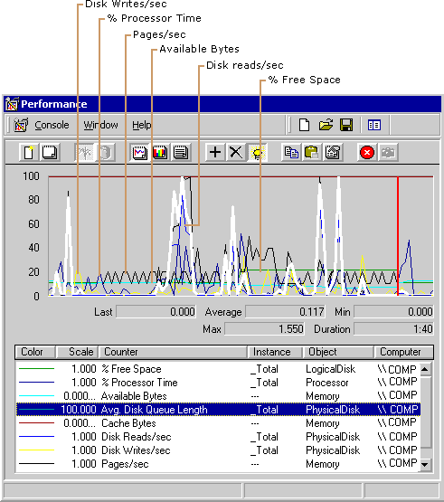
Figure 8.5 Counter Configuration for Baseline Monitoring
Observe activity at various times of day over a range of intervals, starting with one day, one week, one month, and so on. Over time a pattern develops, and you can see that the data tends to fall consistently within a particular range of values — that resulting range is your baseline.
You can monitor for short intervals such as two to five seconds, if your workload is characterized by random bursts of heavy activity. Otherwise 60-second intervals are adequate. If system demands fluctuate during the day, you might want to take shorter samples during periods of heaviest activity and longer samples when activity is tapering off.
For best results during monitoring, try to isolate the disk so that workload unrelated to your test does not affect your results. If you are logging performance to a disk that you are monitoring, values for the disk reflect a small amount of writing activity for that logging.
Data Analysis
While analyzing values at specific times, notice the type of work being performed on your system. Knowing the schedule and nature of your workload is important if you need to reschedule that work or distribute to other systems for better performance.
When interpreting log data, remember the limitations of the performance counters that report sums or that report disk time. The counters sum the totals rather than recalculate them over the number of disks. In addition, disk-time percentage counters cannot exceed 100 percent. Instead, use the Avg. Disk Queue Length, Avg. Disk Read Queue Length, and Avg. Disk Write Queue Length counters to display disk activity as a decimal, rather than a percentage, so that it displays values over 1.0 (100 percent). Then, remember to recalculate the values over the whole disk configuration.
Note Although disk-time percentage counters cannot exceed 100 percent by default, you can reset the registry to allow System Monitor to display percentages exceeding 100 percent if appropriate. For information about this adjustment and other aspects of performance data collection and reporting, see “Performance Objects” in “Overview of Performance Monitoring” in this book.
In general, you can exclude spiking values from your baseline, but make sure you understand what causes them. For example, if you run a weekly backup every Friday night it is acceptable to see out-of-range disk values during that time. But it is important that you know why the spikes are happening. If the pattern starts to shift or you feel that the baseline performance is not satisfactory, use additional counters to monitor disk activity and usage as described in the following sections. You might need to upgrade resources as described in “Resolving Disk Bottlenecks” later in this chapter. If you have access to source code for applications that are in use, you might want to fine-tune these for more efficient data access.
When counter values fall outside the range established for your baseline, follow the instructions contained in “Investigating Disk Performance Problems” later in this chapter. If you encounter a problem or need information about how to improve performance, see “Resolving Disk Bottlenecks” later in this chapter.
Investigating Disk Performance Problems
Several conditions must exist in order for you to determine that a disk bottleneck exists. These are a sustained rate of disk activity well above your baseline, persistent disk queues longer than two per disk, and the absence of a significant amount of paging. Without this combination of factors, it is unlikely that you have a bottleneck. However, if you suspect a disk-specific performance problem, monitor the following types of counters:
• Paging counters (under the Memory object): Pages/sec, Page Reads/sec, Page Writes/sec
• Usage counters: % Disk Time, % Disk Read Time, % Disk Write Time, % Idle Time, Disk Reads/sec, Disk Writes/sec, Disk Transfers/sec
• Queue-length counters: Avg. Disk Queue Length, Avg. Disk Read Queue Length, Avg. Disk Write Queue Length, Current Disk Queue Length
• Throughput counters: Disk Bytes/sec, Disk Read Bytes/sec, Disk Write Bytes/sec

Note Although not reflected in disk activity, the rate of interrupt generation by your disk hardware can have a systemwide performance impact. Disk I/O can sometimes generate a sufficient number of interrupts to slow the performance of the processor. Although this does not constitute a “disk” bottleneck, it is a processor bottleneck caused by the disk system that can slow the responsiveness of the whole computer. For more information about monitoring disk interrupts and reducing their impact on system performance, see “Analyzing Processor Activity” in this book.
The following sections describe how you interpret the values of these counters to reveal or rule out a bottleneck.
Monitoring Paging
The symptoms of a memory shortage are very similar to those of a disk bottleneck. When physical memory is scarce, the system starts writing the contents of memory to disk and reading in smaller blocks more frequently (this process is called paging). The less memory you have, the more the disk is used, resulting in a greater load on the disk system. Therefore, it’s important to monitor memory counters along with disk counters when you suspect a performance problem with your disk system.
Monitor paging activity along with disk reading and writing, using the following counters:
• Avg. Disk Queue Length
• Disk Reads/sec
• Disk Writes/sec
• Memory\Pages/sec
• Memory\Page Reads/sec
• Memory\Page Writes/sec

Figure 8.6 shows how a memory shortage can cause disk counters to indicate a problem.
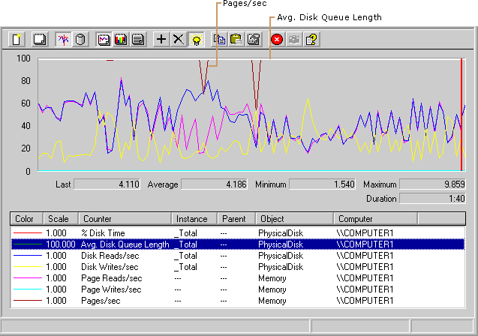
Figure 8.6 Paging Activity Compared with Disk Activity
Notice that this figure shows a long disk queue, accompanied by a high rate of paging. Compare the number of page reads against the number of disk reads to see how many times the system accessed the disk to retrieve pages that were not found in memory, or to write pages to free up memory for new data coming in from the disk. When these values are high, the system does not have sufficient memory. Without inclusion of the memory counters to reveal this behavior, you might have assumed that the disk was inadequate. Upgrading the disk in this situation would not have cured the problem.
For more information about measuring memory and identifying memory shortages, see “Evaluating Memory and Cache Usage” in this book.
Monitoring Usage
In general, a high-performance disk is capable of about 50 to 70 random or up to 160 sequential I/O operations per second. The components you are using, as well as the request size, bus speed, and other factors, determine your system’s capacity. Judge the maximum acceptable usage that your system can sustain based on your experience. Disk-time values should not consistently exceed the rate you’ve established as your baseline for performance. Consistent values in the 70 percent to 85 percent range are a definite cause for concern. However, if a queue is developing, lower percentages might indicate a disk that is unable to handle the load. If you see extremely high rates of disk usage, investigate the factors that might be responsible. Monitoring Disk Transfers/sec (a counter with values equal to the sum of Disk Reads/sec and Disk Writes/sec) or the individual counters Disk Reads/sec and Disk Writes/sec can show you the number of requests for service by the disk; the values of these counters provide a measure of disk demand.
If your workloads consist of random bursts of high activity, you might see high activity rates followed by long periods of idle time. If you only look at the average counter values with these types of workload, it can appear that your disk isn’t very busy even though it was bottlenecked during those bursts of high activity. To determine how well your disk system is handling these bursts, sample at short intervals when the activity occurs.
Note The disk time counters can yield inaccurate values when multiple disks are in use. You can compensate for this by monitoring % Idle Time and comparing its value with the values reported by the % Disk Time, % Disk Read Time, and % Disk Write Time counters.
Figure 8.7 depicts maximum disk usage and the development of a queue.
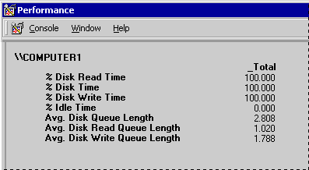
Figure 8.7 High Disk Time Values
Monitoring Queue Length
To determine the number of I/O requests queued for service, track Avg. Disk Queue Length for LogicalDisk or PhysicalDisk. Notice that this might overstate the true length of the queue, because the counter includes both queued and in-service requests. If the value of Avg. Disk Queue Length exceeds twice the number of spindles, then you are likely developing a bottleneck. With a volume set, a queue that is never shorter than the number of active physical disks indicates that you are developing a bottleneck.
Figure 8.8 shows a disk bottleneck with high disk usage and a long queue.
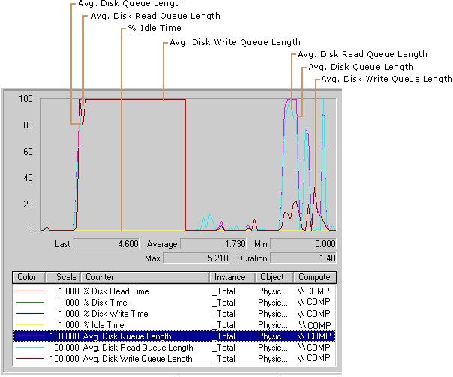
Figure 8.8 High Disk Usage and a Long Queue
Resolving Disk Bottlenecks
A disk that is developing a bottleneck might cause the entire system to slow. If you determine that disk resources are responsible for an overall decrease in system performance, you need to find a solution quickly. Although you might assume that installing another disk offers a quick fix, the right solution to your performance problem depends on the cause of the bottleneck.
Adding a disk is an appropriate solution if you can move files to a new disk, if you can create a stripe set, or if you are out of space. However, for disk-space problems only, you might want to compress your drive, provided that the processor has available cycle to handle the compression activity and that your disk requests are typically large. For a multiuser system, you can also implement disk quotas to restrict growth of user files.
If your disk system is too slow, consider the following alternative steps:
• Rule out a memory shortage. When memory is scarce, the Virtual Memory Manager writes more pages to disk, resulting in increased disk activity. Because low memory is a common cause of bottlenecks, make sure that this is not the source of the problem before adding hardware. Also, make sure to set the paging file to an appropriate size as described in “Evaluating Memory and Cache Usage” in this book.
• Defragment the disk using Disk Defragmenter. For information about using Disk Defragmenter, see Windows 2000 online Help.
• Use Diskpar.exe on the Windows 2000 Resource Kit companion CD to reduce performance loss due to misaligned disk tracks and sectors.
• Use stripe sets to process I/O requests concurrently over multiple disks. The type you use depends on your data-integrity requirements. If your applications are read-intensive and require fault tolerance, consider a RAID 5 volume. Use mirrored volumes for fault tolerance and good I/O performance overall. If you do not require fault tolerance, implement stripe sets for fast reading and writing and improved storage capacity. When stripe sets are used, disk utilization per disk should fall due to distribution of work across the volumes and overall throughput should increase.
When using stripe sets, make sure to use the optimal size of stripe for your workload. In general, the stripe size should be a multiple of the size of the average request.
If you find that there is no increased throughput when scaling to additional disks in a stripe set, you might be experiencing a bottleneck due to contention between disks for the disk adapter. You might need to add an adapter to better distribute the load.
• Place multiple drives on separate I/O buses, particularly if a disk has an I/O-intensive workload.
• Distribute workload among multiple drives. For example, for database applications, you might want to put transaction logs on a separate spindle from data. Notice that writing to a log file is a sequential operation and tends to be more efficient than the random operations typical of accessing data in a database.
If you are unsure of a suitable distribution for network applications, track users and the files they work with in order to plan an efficient distribution by means of the auditing capability of the NTFS file system. This tells you which disks are getting the most usage and help you determine whether you should redistribute workloads. For more information about auditing, see Windows 2000 Server Help.
Windows Clustering and Distributed File System provide solutions for load balancing on different drives. For more information about these technologies, see “Distributed File System” in the Microsoft® Windows® 2000 Server Resource Kit Distributed Systems Guide.
• Limit your use of file compression or encryption. These features can add some overhead and you should use them sparingly if not required by your enterprise and if performance is critical.
• When obtaining disk systems, use the most intelligent and efficient components available for your disk system, including controller, I/O bus, cabling, and the disk. Upgrade to faster-speed or wider-bandwidth components as necessary. These measures generally decrease transfer time and improve throughput. Use intelligent drivers that support interrupt moderation or interrupt avoidance to alleviate the interrupt activity for the processor due to disk I/O.

Evaluating Cache and Disk Usage by Applications
If you are an application developer, you might want to know if your programs read and write data efficiently to and from the disk, as well as how they utilize locality and manage the file-system cache. This section provides information to help you identify situations in which you can improve the I/O performance of applications.
Random and Sequential Data Access
Comparing random versus sequential operations is one way of assessing application efficiency in terms of disk use. Accessing data sequentially is much faster than accessing it randomly because of the way in which the disk hardware works. The seek operation, which occurs when the disk head positions itself at the right disk cylinder to access data requested, takes more time than any other part of the I/O process. Because reading randomly involves a higher number of seek operations than does sequential reading, random reads deliver a lower rate of throughput. The same is true for random writing. You might find it useful to examine your workload to determine whether it accesses data randomly or sequentially. If you find disk access is predominantly random, you might want to pay particular attention to the activities being done and monitor for the emergence of a bottleneck.
For workloads of either random or sequential I/O, use drives with faster rotational speeds. For workloads that are predominantly random I/O, use a drive with faster seek time.
For workloads that have high I/O rates, consider using stripe sets because they add physical disks, increasing the system’s ability to handle concurrent disk requests. Notice, however, that stripe sets enabled in software can cause an increase in consumption of the processor. Hardware-enabled RAID sets eliminate this impact on the processor but increase the consumption of processing cycles on the hardware RAID adapter.
Note Even when an application reads records sequentially, if the file is fragmented throughout the disk or disks, the I/O will not be sequential. If the disk-transfer rate on a sequential or mostly sequential read operation deteriorates over time, run Disk Defragmenter on the disk and test again. When fragmentation occurs, data is not organized in contiguous clusters on the disk. Fragmentation slows performance because back-and-forth head movement is slow.
I/O Request Size
The size of requests and the rate at which they are sent are important for evaluating the way applications work with the disk. If you are an application developer, you can use the counters, such as Avg. Disk Bytes/Read, that reveal these types of information about I/O requests.
It is typically faster and more efficient to read a few large records than many small ones. However, transfer rates eventually peak due to the fact that the disk is moving blocks of data so large that each transfer occurs more slowly—although its total throughput is quite high. Unfortunately, it is not always easy to control this factor. However, if your system is used to transfer many small units of data, this inefficiency might help to explain, though not resolve, high disk use.
Requests should be at least 8 KB, and, if possible, 64 KB. Sequential I/O requests of 2 KB consume a substantial amount of processor time, which affects overall system performance. However, if you can be sure that only 2 KB of data is necessary, doing a 2 KB I/O is the most efficient, because a larger I/O wastes direct memory access (DMA) controller bandwidth. As the record size increases, the throughput increases and the transfer rate falls because it takes fewer reads to move the same amount data.
Using 64 KB requests results in faster throughput with very little processor time. Maximum throughput typically occurs at 64 KB, although some devices might have a higher maximum throughput size. When transferring data blocks greater than 64 KB, the I/O subsystem breaks the transfers into 64-KB blocks. Above 64 KB, the transfer rate drops sharply, and throughput levels off. Processor use and interrupts also appear to level off at 64 KB.
Investigating Disk Usage by Applications
Applications rarely read or write directly to disk. Instead, application code and data is typically mapped into the file system cache and copied from there into the working set of the application. When the application creates or changes data, the data is mapped into the cache and is then written back to the disk in batches. The disk is used only when an application requests a single write-through to disk or it instructs the file system not to use the cache at all for a file, usually because it is doing its own buffering. For this reason, tracking the cache and memory counters provides a way of investigating disk usage by your application. You can find information about monitoring cache and memory counters in “Evaluating Memory and Cache Usage” earlier in this book.
When monitoring disk usage by applications, you might find that applications that submit all I/O requests simultaneously tend to produce exaggerated values for the % Disk Time, % Disk Read Time, % Disk Write Time, and Avg. Disk sec/Transfer counters. Although throughput might be the same for applications that submit I/O requests intermittently, the values of counters that time requests will be much lower. It is important to understand your applications and factor their I/O methods into your analysis.
If you are writing your own tools to test disk performance, you might want to include the FILE_FLAG_NO_BUFFERING parameter in the open call for your test files. This instructs the Virtual Memory Manager to bypass the cache and go directly to disk.

