Appendix A - OSI Model

In the early years of networking, sending and receiving data across a network was confusing, because large companies such as IBM, Honeywell, and Digital Equipment Corporation had individual standards for connecting computers. It was unlikely that applications operating on different equipment from different vendors could communicate. Vendors, users, and standards bodies needed to agree upon and implement a standard architecture that would allow computer systems to exchange information even though they were using software and equipment from different vendors.
In 1978, the International Standards Organization (ISO) introduced a networking model, called the Open Systems Interconnection (OSI) model, as a first step toward standardizing data communications standards to promote multi-vendor network interoperability.
The OSI model consists of layers, each with a specific set of network functions. The model specifies the set of protocols and interfaces to implement at each layer and provides guidelines for implementation of the interfaces between layers.
In This Appendix
OSI Layers
Data Flow in the OSI Model
Vertical Interface Terminology in the OSI Model
Related Information in the Resource Kit
• For more information about the Windows 2000 networking architecture, see “Windows 2000 Networking Architecture” in this book.

OSI Layers
Each layer of the OSI model exists as an independent module. In theory, you can substitute one protocol for another at any given layer without affecting the operation of layers above or below.
The design of the OSI model is based on the following principles:
• A layer should be created only when an additional level of abstraction is required.
• Each layer should perform a well-defined function.
• The function of each layer should be chosen with the goal of defining internationally standardized protocols.
• The layer boundaries should be chosen to minimize the information flow across the interfaces.
• The number of layers should be large enough to enable distinct functions to be separated, but few enough to keep the architecture from becoming unwieldy.

Figure A.1 shows the layers in the OSI model, beginning with the physical layer, which is closest to the network media.
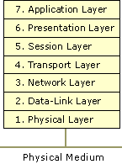
Figure A.1 Layers of the OSI Model
Physical Layer
The physical layer is the lowest layer of the OSI model. This layer controls the way unstructured, raw, bit -stream data is sent and received over a physical medium. This layer is composed of the electrical, optical, and physical components of the network. The physical layer carries the signals for all of the higher layers.
To better accommodate the characteristics of the physical medium and to assist in bit and frame synchronization, data encoding modifies the simple, digital signal pattern (1s and 0s) used by the computer.
Data encoding determines:
• Which signal pattern represents a binary 0 and a binary 1.
• How the receiving station recognizes when an encoded bit starts.
• How the receiving station delimits a frame.

The physical components (such as wiring, connectors, and pin-outs) determine:
• Whether an external transceiver is used to connect to the medium.
• How many pins the connectors have and what role each pin performs.

The transmission technique determines whether the encoded bits are transmitted by means of baseband (digital) signaling or broadband (analog) signaling.
The physical means of transmission,such as a network adapter or fiber optic adapter, determines whether it is appropriate to transmit bits as electrical or optical signals.
Data-Link Layer
The data-link layer provides error-free transfer of data frames from one computer to another over the physical layer. The layers above this layer can assume virtually error-free transmission over the network.
The data-link layer provides the following functions:
• Establishment and termination of logical links (virtual-circuit connection) between two computers identified by their unique network adapter addresses.
• Control of frame flow by instructing the transmitting computer not to transmit frame buffers.
• Sequential transmission and reception of frames.
• Providing and listening for frame acknowledgment, and detecting and recovering from errors that occur in the physical layer by retransmitting non-acknowledged frames and handling duplicate frame receipts.
• Management of media access to determine when the computer is permitted to use the physical medium.
• Delimiting of frames to create and recognize frame boundaries.
• Error-checking of frames to confirm the integrity of the received frame.
• Inspection of the destination address of each received frame and determination of whether the frame should be directed to the layer above.

Note While the services of the data-link layer provide for reliable delivery of data, many routable protocol suites such as TCP/IP and IPX/SPX do not provide for, nor utilize reliable data-link layer delivery services. Instead, reliable data delivery is provided by protocols operating at the transport layer.
Network Layer
The network layer controls the operation of the subnet. It determines what physical path the data takes based on the network conditions, the priority of service, and other factors.
The network layer provides the following functions:
• Transfer of frames to a router if the network address of the destination does not indicate the network to which the computer is attached.
• Control of subnet traffic to allow an intermediate system to instruct a sending station not to transmit its frames when the router’s buffer fills up. If the router is busy, the network layer can instruct the sending station to use an alternate router.
• Fragmentation of frames by a router when the size of a link to a downstream router’s maximum transmission unit (MTU) is smaller than the frame size. The frame fragments are reassembled by the destination station.
• Resolution of the logical computer address (on the network layer) with the physical network adapter address (on the data-link layer), if necessary.

The network layer at the transmitting computer must build its header in such a way that the network layers of the subnet’s intermediate systems can recognize the header and use it to route the data to the destination address.
In the network layer and the layers below it, the peer protocols are between each computer and its immediate neighbor, which is often not the ultimate destination. The source and destination computers may be separated by many intermediate systems.
The network layer eliminates the need for higher layers to know anything about the data transmission or intermediate switching technologies used to connect systems. The network layer is responsible for establishing, maintaining, and terminating the connection to intermediate systems in the communication subnet.
Transport Layer
The transport layer ensures that messages are delivered in the order in which they are sent and that there is no loss or duplication.
The size and complexity of a transport protocol depends on the type of service available from the network and data-link layers. For a reliable network layer or data-link layer with virtual-circuit capability, such as the LLC layer of NetBEUI, the transport layer is required only to pass the data through to the next layer. If the network layer or data-link layer is unreliable or supports only datagrams, like the IP layer of TCP/IP and the IPX layer of IPX/SPX do, the transport layer includes sequencing and acknowledgment, and associated error detection and recovery.
Functions of the transport layer include the following:
• Accepting messages from the layer above and, if necessary, splitting them into segments.
• Providing reliable, end-to-end message delivery with acknowledgments.
• Instructing the transmitting computer not to transmit when no reception buffers are available.
• Multiplexing several process-to-process message streams or sessions onto one logical link and tracking which messages belong to which sessions.

The transport layer can accept large messages, but there are strict size limits imposed by the layers at the network level and lower. Consequently, the transport layer must break up the messages into smaller units, called segments, and attach a header to each frame.
If the lower layers do not maintain sequence, the transport header must contain sequence information, which enables the transport layer on the receiving end to present data in the correct sequence to the next higher layer.
Unlike the lower layers that have protocols that are concerned with connecting to immediately adjacent nodes or computers, the transport layer and the layers above it are true source-to-destination layers, also known as end-to-end layers. These upper layers are not concerned with the details of the underlying communications facility. Software for these layers communicates with similar software on the destination computer by using message headers and control messages.
Session Layer
The session layer establishes a communications session between processes running on different computers and can support message-mode data transfer.
Functions of the session layer include the following tasks:
• Permits application processes to register unique process addresses, such as NetBIOS names. The session layer uses these stored addresses to help resolve the addresses of network adapters from process addresses.
• Establishing, monitoring, and terminating a virtual-circuit session between two processes identified by their unique process addresses. A virtual-circuit session is a direct link that exists between the sender and receiver.
• Delimiting messages to add header information that indicates where a message starts and ends. The receiving session layer can then refrain from indicating the presence of any message data to the overlying application until the entire message is received.
• Performing message synchronization. Message synchronization is the coordination of the data transfer between the sending session layer and the receiving session layer. Synchronization prevents the receiving session layer from being overrun with data. This transfer is coordinated with acknowledgement messages (ACKs). ACKs are sent back and forth between both ends of the transfer and notify of the state of the receiving buffer to accept additional data.
• Performing other support functions that allow processes to communicate over the network, such as user authentication and resource-access security.

Presentation Layer
The presentation layer serves as the data translator for the network. This layer on the sending computer translates the data sent by the application layer into a common format. At the receiving computer, the presentation layer translates the common format to a format known to the application layer.
The presentation layer provides the following functions:
• Character-code translation, such as from ASCII to EBCDIC.
• Data conversion, such as bit order reversal, CR to CR/LF, and integer to floating point.
• Data compression, which reduces the number of bits that need to be transmitted.
• Data encryption and decryption, which secures data for transmission across a potentially insecure network. One use of encryption is for transmission of a password to a receiving computer.

Application Layer
The application layer serves as the window for users and application processes to access network services. The application layer provides the following functions:
• Resource sharing and device redirection
• Remote file access
• Remote printer access
• Interprocess communication support
• Remote procedure call support
• Network management
• Directory services
• Electronic messaging, including e-mail messaging
• Simulation of virtual terminals

Data Flow in the OSI Model
The OSI model presents a standard data flow architecture, with protocols specified in such a way that the receiving layer at the destination computer receives exactly the same object as sent by the matching layer at the source computer. Figure A.2 shows the OSI model data flow.
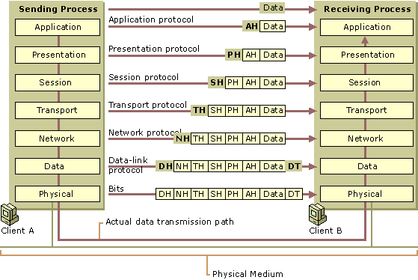
Figure A.2 OSI Model Data Flow
The sending process passes data to the application layer. The application layer attaches an application header and then passes the frame to the presentation layer.
The presentation layer can transform data in various ways, if necessary, such as by translating it and adding a header. It gives the result to the session layer. The presentation layer is not aware of which portion (if any) of the data received from the application layer is the application header and which portion is actually user data, because that information is irrelevant to the presentation layer’s role.
The process of adding headers is repeated from layer to layer until the frame reaches the data link layer. There, in addition to a data-link header, a data-link trailer is added. The data-link trailer contains a checksum and padding if needed. This aids in frame synchronization. The frame is passed down to the physical layer, where it is transmitted to the receiving computer.
On the receiving computer, the various headers and the data trailer are stripped off one by one as the frame ascends the layers and finally reaches the receiving process.
Although the actual data transmission is vertical, each layer is programmed as if the transmission were horizontal. For example, when a sending transport layer gets a message from the session layer, it attaches a transport header and sends it to the receiving transport layer. The fact that the message actually passes through the network layer on its own computer is unimportant.
Vertical Interface Terminology in the OSI Model
In addition to defining an idealized network architecture and the network functions allocated to each layer, the OSI model also defines a standard set of rules that govern the interfaces between layers.
The active protocol elements in each layer are called entities, typically implemented by means of a software process. Entities in the same layer on different computers are called peer entities. For example, the TCP/IP protocol suite contains two entities within its transport layer: Transmission Control Protocol (TCP) and User Datagram Protocol (UDP).
Layer n-1, the layer directly below the entities of layer n, implements services that are used by layer n.
For data transfer services, OSI defines the terminology for the discrete data components passed across the interface and between peer entities. Figure A.3 illustrates vertical interface entities.
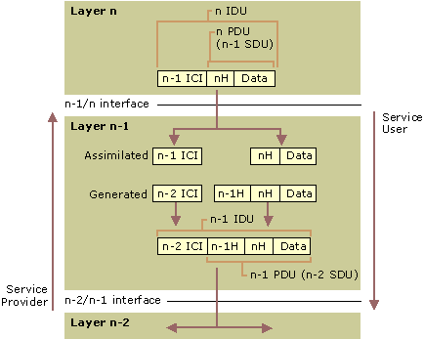
Figure A.3 Vertical interface entities
• The layer-n entity passes an interface data unit (IDU) to the layer-(n–1) entity.
• The IDU consists of a protocol data unit (PDU) and some interface control information (ICI). The ICI is information, such as the length of the SDU, and the addressing information that the layer below needs to perform its function.
• The PDU is the data that the layer-n entity wishes to pass across the network to its peer entity. It consists of the layer-n header and the data that layer n received from layer (n+1).
• The layer-n PDU becomes the layer-(n–1) service data unit (SDU), because it is the data unit that will be serviced by layer n.
• When layer n–1 receives the layer-n IDU, it strips off and “considers” the ICI, adds the header information for its peer entity across the network, adds ICI for the layer below, and passes the resulting IDU to the layer n–2 entity.

Problems can occur in the data path between two network stations, including errant, restricted, or even halted communication.

